Below are detailed responses to the questions provided,
Once the document is uploaded, the system automatically extracts key policy details using PyPDF2 and simple text detection techniques.
The chatbot attempts to read and display:
- Insurance Company Name (from the filename or text if available)
- Policy Number
- Plan Name
- Sum Insured
Need to be modified more, to extract everything properly. As some of the documents are using different wordings.

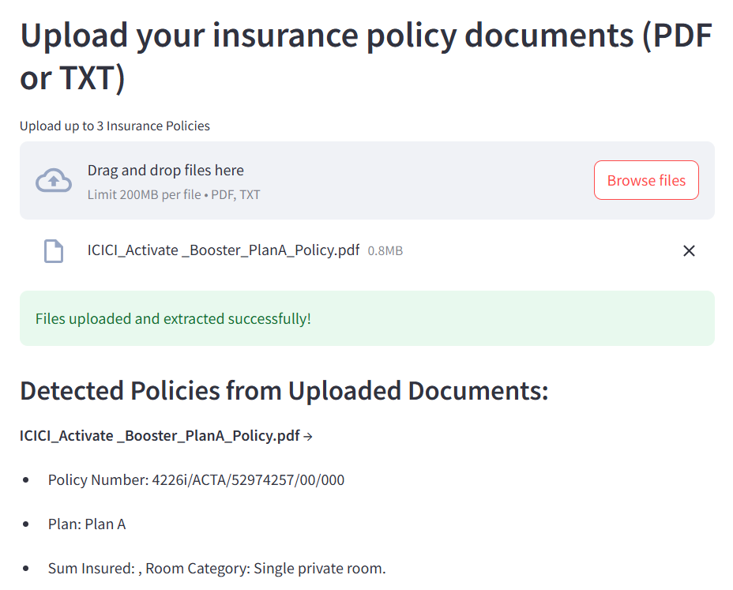
From the below pictures I can say that the result validates that the chatbot’s responses are strictly tied to:
- The uploaded user insurance documents
- The internal insurance document database (ChromaDB)
It does not pull answers from random external sources, ensuring reliable and controlled responses.

