**BAYERO UNIVERSITY KANO**

**Faculty of Computer Science and Information Technology**

**Department of Computer Science**



**On**

**ATTENDANCE MANAGEMENT SYSTEM**

**Subject**

**Web Technologies**

***SUBMITTED BY:***

***MUJAHID YAKUBU BAITA***

***CST/15/COM/00275***

***Under the guidance of***

***MAL. SAGIR MUSA TANIMU***

**CERTIFICATION**

This entitled as Minor Project Report by (Mujahid Yakubu Baita) on Attendance Management System meets the requirements governing the award degree of Bachelors in Computer Science and is approved for its contribution to knowledge and literary representation.



ABSTRACT

Over the years the manual attendance system has been carried across most of educational institutions. To overcome the problem of manual attendance, now we are using a web based attendance management system, which can be implemented on any computer. This system is being developed to maintain easy access of information from the database. The application makes use of Wordpress Framework . It tracks all the details of a student attendance from day one to end of the course. The conventional method of taking attendance by calling names or signing is very time consuming, insecure and hence inefficient.

Keywords — Web based attendance management system

**DEDICATION**

I dedicate this report to my parents –Alh. Yakubu Yusuf Baita and Hajiya Hauwa Garba Muhammad who has always been a source of motivation to me and to my supervisor Sagir Musa Tanimu who always been the guider and the motivator throughout the exercise.

**ACKNOWLEDGEMENT**

My utmost gratitude goes to the almighty and ever-living God, for His divine grace from which I have always benefited from. In Him I live, move and have my being.

My profound gratitude also goes to my project supervisor who supports me and guides me throughout this project.

**CHAPTER ONE**

INTRODUCTION

* 1. BACKGROUND OF THE STUDY

Attendance is a basic and most important criteria needed in all the education system. Attendance is used as a record to assess student consistency in participate the class. Therefore, student is required to attend all teaching activities held by the institutions. Once attendance is below the required policy, the student will be subjected to further action or suspended from taking the final exam depend on the respective institutions they are in. This impractical method will lead to fraud on number of absentees by students. Beside, this method also easily allow for impersonation as some student may purposely sign on another student’s name. Besides, lecturer needs to analyze manually every attendance sheet to identify the number of absentees for both lecture and lab classes correspond to subject. Then, lecturer needs to count and calculate percentage of present of all the students manually to identify when warning letter need to be given to the student depend on his or her number of absents without providing any medical certificate or notice. As a result, it is time consuming, increase number of works of the lecturer and prone to human error as it is difficult to ascertain whether the calculation made was correct. Moreover, student needs to spend unnecessarily time during class session to sign on the attendance sheet. This also disturbing and student may lose focus when the attendance sheet is passing around during the class session. Therefore, Student Attendance Management System is proposed to help or reduce lecturer’s work. This system facilitates to access or manage the attendance information of all the classes. Student by default is assumed to be present as number of present will be higher than the absentees for most of the attendance report. After that, lecturer is allowing to change or modify absentee’s attendance data. The system will automatically count the number of absents and the percentage of present for all the students based on the subject classes. Once the number of absents exceed the attendance policy, appropriate warning letter will be generated automatically to be given to the absentee. Hence, this system provides a tedious work in maintaining attendance records besides saving time to analyze every attendance list and assuring the calculation made was error-free.

* 1. PROBLEM STATEMENT

Based on the observation, there is no available student attendance system in Universiti Teknikal Malaysia Melaka (UTeM). UTeM is still practicing the manual way of taking daily attendance. Lecturer distributes attendance sheet to be sign by student during class session or personally marked the attendance sheet one by one by calling out student name accordingly. However, the attendance sheet can be lost easily and the whole attendance process is tending to human mistake. Consequently, data loss may happen and the data in attendance list might be inaccurate due to deception. Besides, lecturer needs to manually analyze number of absences and calculate the percentage of present from the attendance list collected or recorded. Lecturer needs to identify number of absentees based on each subject with the respective classes that he or she taught. At the end of the semester, lecturer required to calculate the percentage of present of each student to make sure the student can take their final exam for the respective subject. Therefore, it is time consuming and the result of calculation might go wrong when lecturer missed out some of the data in the attendance record. In addition, lecturer needs to manually write all the details about the attendance data to the appropriate documents when needed. Warning letter will be distributed to the student when the student total number of absences is 3 or 6 time from the total class session according to UTeM’s student attendance policy. On the other hand, attendance report also needs to be filled in by all the lecturers at the end of the semester based on each subject taught. This is to determine whether all the students met the university attendance policy before student is allow to take the final exam. However, all the attendance data need to be analyzed manually first before warning letter and attendance report document can be filled in. All this work has indirectly increases lecturers' work.

This system developed will reduce the manual work and avoid redundant data. By maintaining the attendance manually, then efficient reports cannot be generated. The system can generate efficient weekly, consolidate report based on the attendance. As the attendances are maintained in registers it has been a tough task

for admin and staff to maintain for long time. Instead the software can keep long and retrieve the information when needed.

* 1. AIMS AND OBJECTIVES

**AIMS**

The aims of this project are to carry out a careful study of the existing system of attendance management and design a computerized method that will help to minimize storage space and keep all records in the computer for future references.

**Unique and special features**

* Concrete Functionality
* Efficiency and Accuracy
* Framework
* Web service

**OBJECTIVE**

The objectives of developing Student Attendance Management System are identified based on the review of the problem statements. The purposes are listed as below:

1. To store, access and manage student attendance data for every lecture and lab classes.

* All the student attendance data will be stored and managed through Student Attendance Management System.
* This system enables lecturer to add, view, make changes or delete on subjects, classes, students and attendance accordingly. Moreover, saving attendance records into the system will be more secured as compared to paper-based records.

1. To automatically calculate number of absences and the percentage of  
   present of the students based on subjects with respective lecture and lab  
   classes.

* Student Attendance Management System enhances calculation process to be more accurate and fast. This system by default will do the analysis, which are counting the number of absences and calculate the percentage of present of all the students based on the input data. Hence, the calculated value can be ascertained and trusted as the calculation process is developed to run automatically within the system.

1. To generate warning letter, attendance report and attendance list  
   automatically and accurately along with the required details and in correct  
   format.
2. Student Attendance Management System will helps to analyze all the attendance data inserted and then verified either each of the students is following the university attendance policy. If the attendance policy is being violated, the system will automatically generate warning letter, either in Malay or English language to the respective student. The attendance report will be generated based on the overall attendance of the student for the particular subject. On the other hand, attendance list can be printed out easily when required as the data is ready to be obtained from the system with the format based on the manual attendance sheet. Therefore, attendance report, attendance list and warning letter will be filled, displayed and printed based on the analysis made from the inputted student attendance details with the approved format.
   1. SCOPE AND LIMITATION OF THE STUDY

SCOPE: This Software is mainly focused and only accommodates the computerized attendance exercise due to the time and resource constraint.

LIMITATION: This Software is limited to cover only all the manual procedure involved during the attendance management.

Technology Used:

* Framework: Wordpress
* System Requirement
* Minimum RAM: 256 MB
* Hard Disk: 40 GB
* Processor: Intel Pentium 4
* Operating System: Windows OS, Linux OS, UNIX OS and Mac OS.

**METHODOLOGY**

This Software will be implemented using wordpress framework with wordpress plugins which is a functional script of the framework and themes which serve as the Graphical User Interface (GUI).

**1.5 SIGNIFICANCE OF THE STUDY**

With the growth in information technology, this study offers numerous values to the attendance management process in Nigeria. All the records will be stored on the computer with the help of the database program.

**CHAPTER TWO**

* 1. INTRODUCTION

This chapter contains overview of the broad area and review of developmental technologies and platforms used as well as the review of related works concerning the Computerized Attendance Management System.

Nowadays many schools are using a manual monitoring system and most of the time they accidentally loss their attendance sheet so that they cannot properly monitor the attendance of their Teachers.

Attendance Monitoring System is a gate pass management system by inputting their user name and password that will monitor the presence of the teachers of the school. This will lessen the work of the school personnel in checking the identity of every teacher. It maintains the daily record of the teachers in log in and log out from school. This study is conducted for the enhancement of the existing manual attendance recording in form of a fully developed monitoring system of Children of Fatima School Inc.

Children of Fatima School Inc. was founded and established in October 1995. The persons behind were MA. PRESENTACION G. PINEDA and WILFREDO R. JESALVA (who became its first principal), with the support of MR. ALEJANDRO F. PINEDA, and MRS. VICTORIA G. PINEDA

The School started to operate and open classes in June 1996, after but had established its credibility and had met all the requirements, of Children of Fatima School Dau was issued government recognition E-023 s 1998 and s-004 s 1998. The school offers Nursery, Kindergarten, Pre-Elementary and Secondary Education. Children of Fatima School Inc. is contributing tremendously to the promotion of its objectives of providing for the intellectual, socio-cultural, moral, and spiritual up liftmen of the pupils/students not only in Dau, but also in other towns in Pampanga. Thus, Children of Fatima School of Mabalacat with government recognition E-078 s 2004, s-031 s 2006 was opened in school year 2002-2003, and Children of Fatima School of Sto. Tomas opened in school year 2005-2006 with government recognition E-058 s 2007, S-062 s 2007 to cater to the people of Sto. Thomas and its environs.

In this study, the proponents aim to provide a better way of monitoring the attendance of Children of Fatima Inc. In order for the Administrator can handle faster and easy way of recording and monitoring the daily attendance of the teachers. The system will provide an efficient way of record keeping activity. This study aims to provide better results of Teachers Attendance Monitoring System that can cover up with the school needs.

Theoretical framework is the combine idea of the proponents to the stated system.

The study of this procedure is important because many schools encounter the same problem during their attendance monitoring. It may become stepping stone in a more organize and productive system of procedures in the future. This study wants to help other school’s to be innovated involving the use of computerization inside the campus and also for future proponents that will be involve in this kind of study.

* 1. ATTENDANCE MANAGEMENT SYSTEM PROCESS

In the present system all work is done on paper. The whole session attendance is stored in register and at the of the session the reports are generated. We are not interested in generating report in the middle of the session or as per the requirement because it takes more time in calculation. At the end of session, the students who don’t have 75% attendance get a notice.

**2.2.1 PROPOSED SYSTEM**

To overcome the drawbacks of the existing system, the proposed system has been evolved. This project aims to reduce the paper work and saving time to generate accurate results from the student’s attendance. The system provides with the best user interface. The efficient reports can be generated by using this proposed system.

* Advantages of Proposed System
  + - It is trouble-free to use.
    - It is a relatively fast approach to enter attendance
    - Is highly reliable, approximate result from user
    - Best user Interface
    - Efficient reports
  1. REVIEW OF RELATED WORKS
* Web Based Student Information Management S.R.Bharamagoudar et al., this paper assist in automating the existing manual system. It can be monitored and controlled remotely. This paper provides accurate information always. All years together gathered information can be saved and can be accessed at any time. The purpose is to design a college website which contains upto date information of the college. That should improve efficiency of college record management.
* Attendance Management System G.Gangagowri et al., this system is used Way to SMS software. This software is used to send SMS easily to their parent’s. This system can store their data about the students and those cares absent student details. It is an efficient method to store the attendance in the Web Site rather than wasting the paper. It also updates the student report directly on the server reducing the faculty’s time on logging from the computer.
* Online Student Attendance System P. N. Garad et al, in this project, we gave access to three users i.e. Admin, Student, Others. This project is based on client-server. Here, the serve is Tomcat and client is JSP. In this project teachers or the admin will be filling attendance and sending message to the student who is absent. They will have privilege to fill attendance form, update attendance form, send message to the guardian’s account whose child is absent, also those attendance is less than 75%, and they also have privilege to send message to the students whose fees are pending. he staff can also view the message whenever they want and also can modify the details of students. Parents have privilege to view attendance and to view message sent by the teacher. Students also have their account with the privilege to view message sent by the subject teacher and to view the attendance.
* Web Based Coaching Institute Management System Mayuri Kamble et al, “Coaching Institute Management System” software developed for an institute has been designed to achieve maximum efficiency and reduce the time taken to handle the storing activity. It is designed to replace an existing manual record system thereby reducing time taken for calculations and for storing data. The system is strong enough to withstand regressive daily operations under conditions where the database is maintained and cleared over a certain time of span. The implementation of the system in the organization will considerably reduce data entry, time and also provide readily calculated reports.
* Classroom Attendance Application Pranjul Khare1 et al, the scope of the project is the system on which the software is installed, i.e. the project is developed as an ANDROID application, and it will work for a particular institute. Android is a mobile operating system (OS) based on the Linux kernel and currently developed by Google with a user interface based on direct manipulation. RAD approaches to software development have put less emphasis on planning tasks and more emphasis on development. It has revealed that an online system for recording and reporting students ’attendances is indeed a needed application in order to make the process more efficient and time-saving where more than 70% of the sample group agreed to that matter.
  1. LITERATURE REVIEW TABLE

|  |  |  |  |  |  |
| --- | --- | --- | --- | --- | --- |
| **YEAR** | **AUTHOR(S)** | **OBJECTIVES** | **METHODOLOGY** | **FINDINGS** | **PROBLEMS** |
| 2017 | Monica.C, Nithya.R, Prarthana.M, Sonika.S.V, Dr.M.Ramakrishna | Data of student has been computerized without using any manual effort. | The design is expressed in sufficient detail so as to enable all the developers to understand the underlying architecture of Attendance system. | The Existing system is a manual entry for the Admin and also Faculty. Here the attendance will be carried out in the hand written registers. Maintaining the records for the Faculty is a tedious job. The retrieval of the information is not as easy as the records are maintained in the registers. | The requirements for the Software to work are much (Java, Tomcat, PHP, Perl, MySQl, Apache Web Server) etc.  A final version was not made as of then. |
| 2016 | Anusha V Pai, Atul Krishna, Kshama P M, Menita Correa | Analyzed report of the pattern of student attendance and time management | This methodology contains three major phases, a.ka, attendance marking, attendance management and report generation. User authentication is one of the major factors in attendance monitoring system. | Data accuracy is maintained, within a short span of time | Unable to create final, precise representation of the knowledge and research-based theory available topic |
| 2016 | Abdoulrahmaine Mohammad, Mohammad Elmi Hassan, Muslim Musa, | Create a Window application to be used in place of old paper based user Employee Salary manage process | In this we study it capable of eliminating time wasted during manual collection of attendance and for the educational administration | The new system has been designed as per the user requirements so as to fulfill almost all them.  -User friendly  -Report Generation  -Less paper work | Existing system requires lot of paper work. Loss of even a single  register/record led to difficult situation because all the papers are needed  to generate the reports. |
| 2017 | Shivani Jijankar, Anand Dhore, Arti Sanganwar, Kapil Chalkhure, Prof Vikramsingh R. Parihar | we have proposed a system which will not only make the entire process simple, but will also provide a well-structured and analyzed report of the pattern of student attendance and time management | In this we study it capable of eliminating time wasted during manual collection of attendance and for the educational administration | All the data is stored in the database. The Client accesses this data using internet. The database is accessed via Server and the application works in the browser. | It requires hardware for execution (RFID) which may lead to another cost |

* 1. SUMMARY

In this paper we have analyzed four (4) papers based student attendance system. Based on the studied literature, we have found that there is still scope of improvement in the said system. In terms of performance and efficiency, this project has provided a convenient method of attendance marking compared to the traditional method of attendance system. By using databases, the data is more organized. This system is also a user friendly system as data manipulation and retrieval can be done via the interface, making it a universal attendance system. Thus, it can be implemented in either an academic institution or in organizations.

**CHAPTER THREE**

SYSTEM ANALYSIS AND DESIGN

3.1 INTRODUCTION

Analysis can be defined as breaking up of any whole so as to find out their nature, function etc. It defines design as to make preliminary sketches of; to sketch a pattern or outline for plan. To plan and carry out especially by artistic arrangement or in a skillful wall. System analysis and design can be characterized as a set of techniques and processes, a community of interests, a culture and an intellectual orientation.

This chapter will provide the detail analysis of the current manual system of attendance management system and problem of the current system l. It also aimed to determine how the new system will be achieved and fact finding technique used in the development of the automated system of attendance management system.

**3.2 DESCRIPTION OF THE CURRENT SYSTEM**

The Existing system is a manual entry for the students. Here the attendance will be carried out in the hand written registers. It will be a tedious job to maintain the record for the user. The human effort is more here. The retrieval of the information is not as easy as the records are maintained in the hand written registers. This application requires correct feed on input into the respective field. Suppose the wrong inputs are entered, the application resist to work. so the user finds it difficult to use.

**3.3 SOFTWARE DEVELOPMENT LIFE CYCLE MODEL**

The system development life cycle (SDLC) is a conceptual model used in project management that describes the stages involved in an information development project, from the feasibility study through maintenance of the completed software application.

For this project the **Incremental Software Development Model** (Figure 3.1) will be used.

Outline Description

Final Version

Initial Version

Intermediate Versions

Specification

Development

Validation

Concurrent Activities

**Figure 3.1:** Incremental Software development model

**3.4 DESCRIPTION OF THE PROPOSED SYSTEM**

To overcome the drawbacks of the existing system, the proposed system has been evolved. This project aims to reduce the paper work and saving time to generate accurate results from the student’s attendance. The system provides with the best user interface. The efficient reports can be generated by using this proposed system.

**3.4 Advantages of Proposed System**

* It is trouble-free to use.
* It is a relatively fast approach to enter attendance
* Is highly reliable, approximate result from user
* Best user Interface
* Efficient reports

**3.5 REQUIREMENT ENGINEERING**

This is also known as Requirement Analysis; it is the process of determining user expectations for a new or modified system. This is divided into Functional and Non-Functional Requirements.

* + 1. FUNCTIONAL REQUIREMENTS

This defines the function of a system or its component. It deals with what the system should do or provide for users. Functional requirements for this software includes:

* The Admin and the Teacher Shall be able to Login into the System using their unique username and password.
* The Admin shall be able to add students, teachers, courses, classes, holidays, check attendance and validate teacher’s attendance.
* The Teacher shall be check attendance, generate report of student and manage exams.
* The attendee shall provide all the necessary registration details.

**3.5.2 NON-FUNCTIONAL REQUIREMENTS**

Non-Functional requirements are requirements that specifies criteria that can be used to judge the operation of a system, rather than specific behaviors. Non-Functional requirements for this software includes:

* The System Should be easy to use by the Admin, Teachers and students. And should be Organized in a way that user errors are minimized.
* The System Should Be Secure from Unauthorized Usage and Access.
  1. REQUIREMENT ANALYSIS

**USE CASE:** Use cases (Figure 3.2) are scenario based in the UML which identify the actors in an interaction and which describe the interaction itself.

Admin

Teacher

Student

**Figure 3.2:** Use Case Diagram

* 1. SYSTEM DESIGN

System design is the process of defining the architecture, components, modules, interface, and data for a system to satisfy specified requirement. this could also be seeing as the application of the knowledge of System Analysis and Design to product development. System design is said to be the descriptive in nature of what the system is and what it does and shows how the expected program is to be operated.

Online Birth Registration System

**STUDENT**

+FirstName: Varchar

+MiddleName: Varchar

+LastName: Varchar

+Dateof Birth: Varchar

+Address: Varchar

+Reg No/Employee Id: Varchar

+State: Varchar

+Gender: Varchar

+Register ()

**LOGIN**

+Username: Varchar

+Password: Varchar

+Login ()

**ADMIN/TEACHER**

+Name: Varchar

+Password: Varchar

+Email

+Class

+Register ()

+Add Members ()

+Check Attendance ()

+Set Event ()

+Set Exams Mark ()

+Add Subject, Class & Exams ()

+Login ()

**CHAPTER FOUR**

IMPLEMENTATION AND TESTING

**4.1 INTRODUCTION**

This chapter describes and shows how this standalone system is implemented, developed and tested, using the appropriate necessary programming languages, tools and technology.

**4.2 IMPLEMENTATION**

System or Software Implementation is the conversion of the System Requirements into an executable and working system.

* + 1. IMPLEMENTATION CHOICES

The Online Attendance Management System works as Web application system. It was implemented using WordPress which include HTML, CSS, JavaScript, PHP, and MySQL was used for the database and the Integrated Development Environment (IDE) used was Sublime Text 3.0. XAMPP was used as the offline local server.

**WordPress:** is a [free and open-source](https://en.wikipedia.org/wiki/Free_and_open-source_software) [content management system](https://en.wikipedia.org/wiki/Content_management_system) (CMS) based on [PHP](https://en.wikipedia.org/wiki/PHP) & [MySQL](https://en.wikipedia.org/wiki/MySQL). Features include a [plugin architecture](https://en.wikipedia.org/wiki/Plug-in_(computing)) and a [template system](https://en.wikipedia.org/wiki/Web_template_system). It is most associated with [blogging](https://en.wikipedia.org/wiki/Blog) but supports other types of web content including more traditional [mailing lists](https://en.wikipedia.org/wiki/Electronic_mailing_list) and [forums](https://en.wikipedia.org/wiki/Internet_forum), media galleries, and [online stores](https://en.wikipedia.org/wiki/Shopping_cart_software). Used by more than 60 million websites, including 33.6% of the top 10 million websites as of April 2019, WordPress is the most popular [website](https://en.wikipedia.org/wiki/Website) management system in use. WordPress has also been used for other application domains such as [pervasive display systems](https://en.wikipedia.org/wiki/Digital_signage) (PDS).

WordPress was released on May 27, 2003, by its founders, [Matt Mullenweg](https://en.wikipedia.org/wiki/Matt_Mullenweg) and [Mike Little](https://en.wikipedia.org/wiki/Mike_Little), as a [fork](https://en.wikipedia.org/wiki/Fork_(software_development)) of *b2/cafelog*. The software is released under the [GPLv2](https://en.wikipedia.org/wiki/GNU_General_Public_License#Version_2) (or later) license.

To function, WordPress has to be installed on a [web server](https://en.wikipedia.org/wiki/Web_server), either part of an [Internet hosting service](https://en.wikipedia.org/wiki/Internet_hosting_service) like [WordPress.com](https://en.wikipedia.org/wiki/WordPress.com) or a computer running the software package WordPress.org in order to serve as a [network host](https://en.wikipedia.org/wiki/Host_(network)) in its own right. A local computer may be used for single-user testing and learning purposes.

**Hyper Text Mark-up Language (HTML):** is the standard [markup language](https://en.wikipedia.org/wiki/Markup_language) for creating [web pages](https://en.wikipedia.org/wiki/Web_page) and [web applications](https://en.wikipedia.org/wiki/Web_application). With [Cascading Style Sheets](https://en.wikipedia.org/wiki/Cascading_Style_Sheets) (CSS) and [JavaScript](https://en.wikipedia.org/wiki/JavaScript), it forms a triad of [cornerstone](https://en.wikipedia.org/wiki/Cornerstone) technologies for the [World Wide Web](https://en.wikipedia.org/wiki/World_Wide_Web).

[Web browsers](https://en.wikipedia.org/wiki/Web_browser) receive HTML documents from a [web server](https://en.wikipedia.org/wiki/Web_server) or from local storage and [render](https://en.wikipedia.org/wiki/Browser_engine) the documents into multimedia web pages. HTML describes the structure of a web page [semantically](https://en.wikipedia.org/wiki/Semantic_Web) and originally included cues for the appearance of the document.

[HTML elements](https://en.wikipedia.org/wiki/HTML_element) are the building blocks of HTML pages. With HTML constructs, [images](https://en.wikipedia.org/wiki/HTML_element#Images_and_objects) and other objects such as [interactive forms](https://en.wikipedia.org/wiki/Fieldset) may be embedded into the rendered page. HTML provides a means to create [structured documents](https://en.wikipedia.org/wiki/Structured_document) by denoting structural [semantics](https://en.wikipedia.org/wiki/Semantics) for text such as headings, paragraphs, lists, [links](https://en.wikipedia.org/wiki/Hyperlink), quotes and other items. HTML elements are delineated by *tags*, written using [angle brackets](https://en.wikipedia.org/wiki/Bracket#Angle_brackets). Tags such as <**img** /> and <**input** /> directly introduce content into the page. Other tags such as <**p**>surround and provide information about document text and may include other tags as sub-elements. Browsers do not display the HTML tags, but use them to interpret the content of the page.

HTML can embed programs written in a [scripting language](https://en.wikipedia.org/wiki/Scripting_language) such as [JavaScript](https://en.wikipedia.org/wiki/JavaScript), which affects the behavior and content of web pages. Inclusion of CSS defines the look and layout of content. The [World Wide Web Consortium](https://en.wikipedia.org/wiki/World_Wide_Web_Consortium) (W3C), maintainer of both the HTML and the CSS standards, has encouraged the use of CSS over explicit presentational HTML since 1997

**Cascading Style Sheet (CSS):** is a [style sheet language](https://en.wikipedia.org/wiki/Style_sheet_language) used for describing the [presentation](https://en.wikipedia.org/wiki/Presentation_semantics) of a document written in a [markup language](https://en.wikipedia.org/wiki/Markup_language) like [HTML](https://en.wikipedia.org/wiki/HTML). CSS is a cornerstone technology of the [World Wide Web](https://en.wikipedia.org/wiki/World_Wide_Web), alongside HTML and [JavaScript](https://en.wikipedia.org/wiki/JavaScript).

CSS is designed to enable the separation of presentation and content, including [layout](https://en.wikipedia.org/wiki/Page_layout), [colors](https://en.wikipedia.org/wiki/Color), and [fonts](https://en.wikipedia.org/wiki/Typeface). This separation can improve content [accessibility](https://en.wikipedia.org/wiki/Accessibility), provide more flexibility and control in the specification of presentation characteristics, enable multiple [web pages](https://en.wikipedia.org/wiki/Web_page) to share formatting by specifying the relevant CSS in a separate .css file, and reduce complexity and repetition in the structural content.

Separation of formatting and content also makes it feasible to present the same markup page in different styles for different rendering methods, such as on-screen, in print, by voice (via speech-based browser or [screen reader](https://en.wikipedia.org/wiki/Screen_reader)), and on [Braille-based](https://en.wikipedia.org/wiki/Braille_display) tactile devices. CSS also has rules for alternate formatting if the content is accessed on a [mobile device](https://en.wikipedia.org/wiki/Mobile_device).

The name *cascading* comes from the specified priority scheme to determine which style rule applies if more than one rule matches a particular element. This cascading priority scheme is predictable.

The CSS specifications are maintained by the [World Wide Web Consortium](https://en.wikipedia.org/wiki/World_Wide_Web_Consortium) (W3C). Internet media type ([MIME type](https://en.wikipedia.org/wiki/MIME_media_type)) text/css is registered for use with CSS by [RFC 2318](https://tools.ietf.org/html/rfc2318) (March 1998). The W3C operates a free [CSS validation service](https://en.wikipedia.org/wiki/W3C_Markup_Validation_Service#CSS_validation) for CSS documents.

In addition to HTML, other markup languages support the use of CSS including [XHTML](https://en.wikipedia.org/wiki/XHTML), [plain XML](https://en.wikipedia.org/wiki/Plain_Old_XML), [SVG](https://en.wikipedia.org/wiki/Scalable_Vector_Graphics), and [XUL](https://en.wikipedia.org/wiki/XUL).

**JavaScript:** often abbreviated as **JS**, is a [high-level](https://en.wikipedia.org/wiki/High-level_programming_language), [interpreted](https://en.wikipedia.org/wiki/Interpreted_language) [programming language](https://en.wikipedia.org/wiki/Programming_language) that conforms to the [ECMA Script](https://en.wikipedia.org/wiki/ECMAScript) specification. JavaScript has [curly-bracket syntax](https://en.wikipedia.org/wiki/List_of_programming_languages_by_type#Curly-bracket_languages), [dynamic typing](https://en.wikipedia.org/wiki/Dynamic_programming_language), [prototype-based](https://en.wikipedia.org/wiki/Prototype-based_programming) [object-orientation](https://en.wikipedia.org/wiki/Object-oriented_programming), and [first-class functions](https://en.wikipedia.org/wiki/First-class_function).

Alongside [HTML](https://en.wikipedia.org/wiki/HTML) and [CSS](https://en.wikipedia.org/wiki/CSS), JavaScript is one of the core technologies of the [World Wide Web](https://en.wikipedia.org/wiki/World_Wide_Web). JavaScript enables interactive [web pages](https://en.wikipedia.org/wiki/Web_page) and is an essential part of [web applications](https://en.wikipedia.org/wiki/Web_application). The vast majority of [websites](https://en.wikipedia.org/wiki/Website) use it, and major [web browsers](https://en.wikipedia.org/wiki/Web_browser) have a dedicated [JavaScript engine](https://en.wikipedia.org/wiki/JavaScript_engine) to execute it.

As a multi-paradigm language, JavaScript supports [event-driven](https://en.wikipedia.org/wiki/Event-driven_programming), [functional](https://en.wikipedia.org/wiki/Functional_programming), and [imperative](https://en.wikipedia.org/wiki/Imperative_programming) (including [object-oriented](https://en.wikipedia.org/wiki/Object-oriented_programming) and [prototype-based](https://en.wikipedia.org/wiki/Prototype-based_programming)) [programming styles](https://en.wikipedia.org/wiki/Programming_paradigm). It has [APIs](https://en.wikipedia.org/wiki/Application_programming_interface) for working with text, [arrays](https://en.wikipedia.org/wiki/Array_data_type), dates, [regular expressions](https://en.wikipedia.org/wiki/Regular_expression), and the [DOM](https://en.wikipedia.org/wiki/Document_Object_Model), but the language itself does not include any [I/O](https://en.wikipedia.org/wiki/Input/output), such as [networking](https://en.wikipedia.org/wiki/Computer_network), [storage](https://en.wikipedia.org/wiki/Data_storage), or [graphics](https://en.wikipedia.org/wiki/Computer_graphics) facilities. It relies upon the host environment in which it is embedded to provide these features.

Initially only implemented [client-side](https://en.wikipedia.org/wiki/Client-side) in web browsers, JavaScript engines are now embedded in many other types of host software, including [server-side](https://en.wikipedia.org/wiki/Server-side) in web servers and databases, and in non-web programs such as word processors and [PDF](https://en.wikipedia.org/wiki/Portable_Document_Format) software, and in runtime environments that make JavaScript available for writing mobile and desktop applications, including desktop widgets.

The terms *Vanilla JavaScript* and *Vanilla JS* refer to JavaScript not extended by any frameworks or additional libraries. Scripts written in Vanilla JS are plain JavaScript code.

Although there are similarities between JavaScript and [Java](https://en.wikipedia.org/wiki/Java_(programming_language)), including language name, [syntax](https://en.wikipedia.org/wiki/Syntax_(programming_languages)), and respective [standard libraries](https://en.wikipedia.org/wiki/Standard_library), the two languages are distinct and differ greatly in design. JavaScript was influenced by programming languages such as [Self](https://en.wikipedia.org/wiki/Self_(programming_language)) and [Scheme](https://en.wikipedia.org/wiki/Scheme_(programming_language)).

**PHP:** is a [general-purpose programming language](https://en.wikipedia.org/wiki/General-purpose_programming_language) originally designed for [web development](https://en.wikipedia.org/wiki/Web_development). It was originally created by [Rasmus Lerdorf](https://en.wikipedia.org/wiki/Rasmus_Lerdorf) in 1994; the PHP [reference implementation](https://en.wikipedia.org/wiki/Reference_implementation) is now produced by The PHP Group. PHP originally stood for *Personal Home Page*, but it now stands for the [recursive initialism](https://en.wikipedia.org/wiki/Recursive_initialism) *PHP: Hypertext Preprocessor*.

PHP code may be executed with a [command line interface](https://en.wikipedia.org/wiki/Command-line_interface) (CLI), embedded into [HTML](https://en.wikipedia.org/wiki/HTML) code, or it can be used in combination with various [web template systems](https://en.wikipedia.org/wiki/Web_template_system), web content management systems, and [web frameworks](https://en.wikipedia.org/wiki/Web_framework). PHP code is usually processed by a PHP [interpreter](https://en.wikipedia.org/wiki/Interpreter_(computing)) implemented as a [module](https://en.wikipedia.org/wiki/Plugin_(computing)) in a web server or as a [Common Gateway Interface](https://en.wikipedia.org/wiki/Common_Gateway_Interface) (CGI) executable. The web server combines the results of the interpreted and executed PHP code, which may be any type of data, including images, with the generated web page. PHP can be used for many programming tasks outside of the web context, such as [standalone](https://en.wikipedia.org/wiki/Computer_software) [graphical applications](https://en.wikipedia.org/wiki/Graphical_user_interface)and robotic [drone](https://en.wikipedia.org/wiki/Unmanned_aerial_vehicle) control.

The standard PHP interpreter, powered by the [Zend Engine](https://en.wikipedia.org/wiki/Zend_Engine), is [free software](https://en.wikipedia.org/wiki/Free_software) released under the [PHP License](https://en.wikipedia.org/wiki/PHP_License). PHP has been widely ported and can be deployed on most web servers on almost every [operating system](https://en.wikipedia.org/wiki/Operating_system) and [platform](https://en.wikipedia.org/wiki/Computing_platform), free of charge.

The PHP language evolved without a written [formal specification](https://en.wikipedia.org/wiki/Formal_specification) or standard until 2014, with the original implementation acting as the [*de facto*](https://en.wikipedia.org/wiki/De_facto) standard which other implementations aimed to follow. Since 2014, work has gone on to create a formal PHP specification.

**MySQL:** MySQL is an Oracle-backed open source relational database management system ([RDBMS](https://searchdatamanagement.techtarget.com/definition/RDBMS-relational-database-management-system)) based on Structured Query Language ([SQL](https://searchsqlserver.techtarget.com/definition/SQL)). MySQL runs on virtually all platforms, including [Linux](https://searchdatacenter.techtarget.com/definition/Linux-operating-system), [UNIX](https://searchdatacenter.techtarget.com/definition/Unix) and [Windows](https://searchwindowsserver.techtarget.com/definition/Windows). Although it can be used in a wide range of applications, MySQL is most often associated with web applications and online publishing.

**XAMPP:** XAMPP is a software distribution which provides the Apache web server, MySQL database (actually MariaDB), Php and Perl (as command-line executables and Apache modules) all in one package. It is available for Windows, MAC and Linux systems. No configuration is necessary to integrate Php with MySQL. It is a great fit for this course and provides a relatively

painless installation and way to manage the configuration changes. Also provided is PhpMyAdmin which gives a GUI tool for managing your MySQL databases.

* + 1. SAMPLE INTERFACES

**Login:** The admin, teacher or students will insert his username and password in the provided spaces and click on the LOGIN button (Figure 1.1).

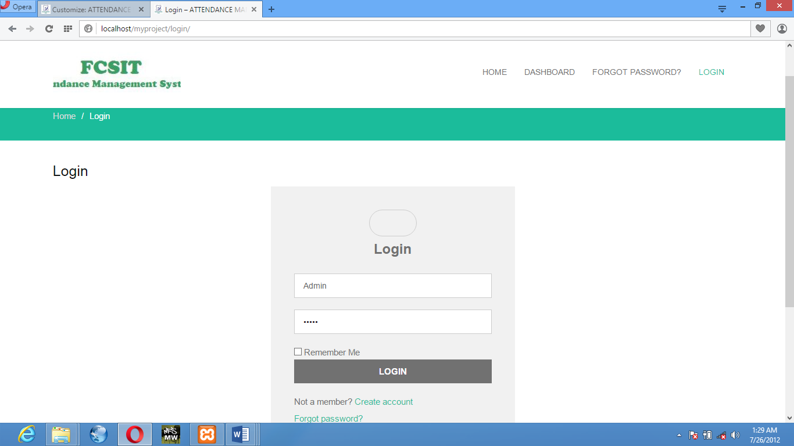

**Figure 1.1:** Login Interface

**Home Page:** After Login in this window will open as the homepage which will allow admin, teacher or student to navigate to his/her dashboard (Figure 4.2).

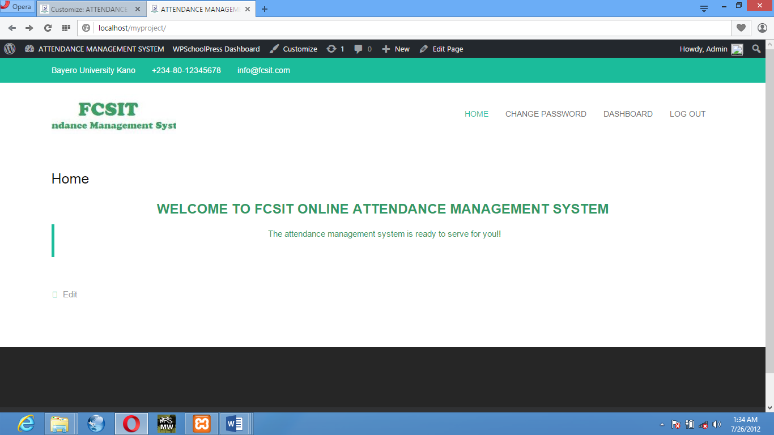

**Figure 1.2:** Homepage Interface

**Dashboard:** The window that allows admin to

* Add Student
* Add Teacher
* Add parent
* Add Subject
* Add Class
* Check Attendance
* Create/Check Event
* Send Notification

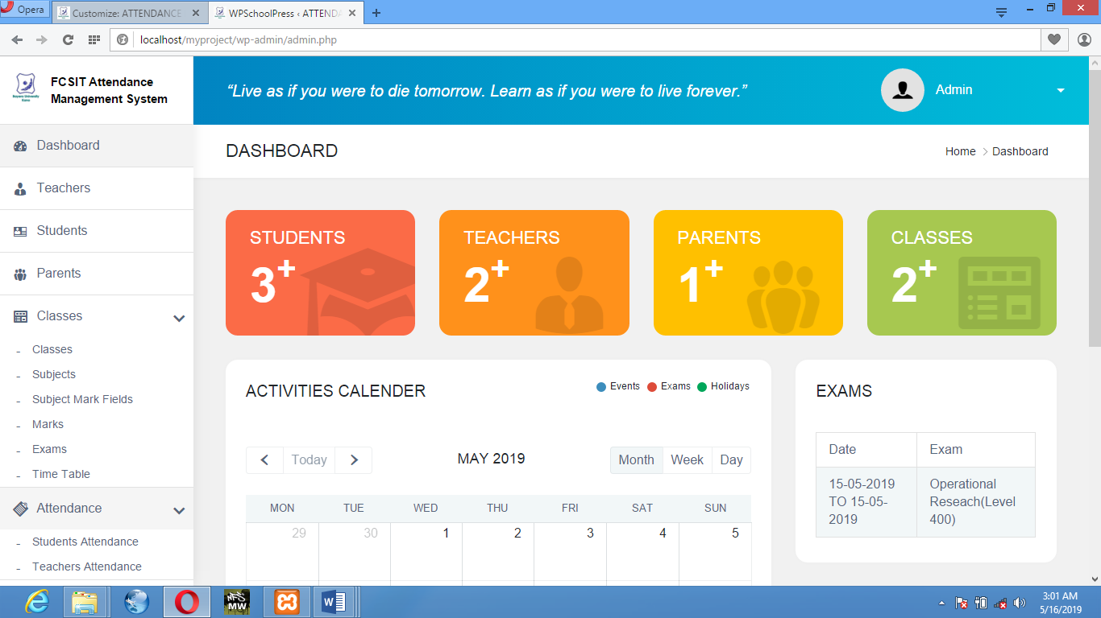

**Figure 1.3:** Dashboard Interface

**ADD STUDENT:** The window that allow admin to add student, view student or edit his profile if needed.

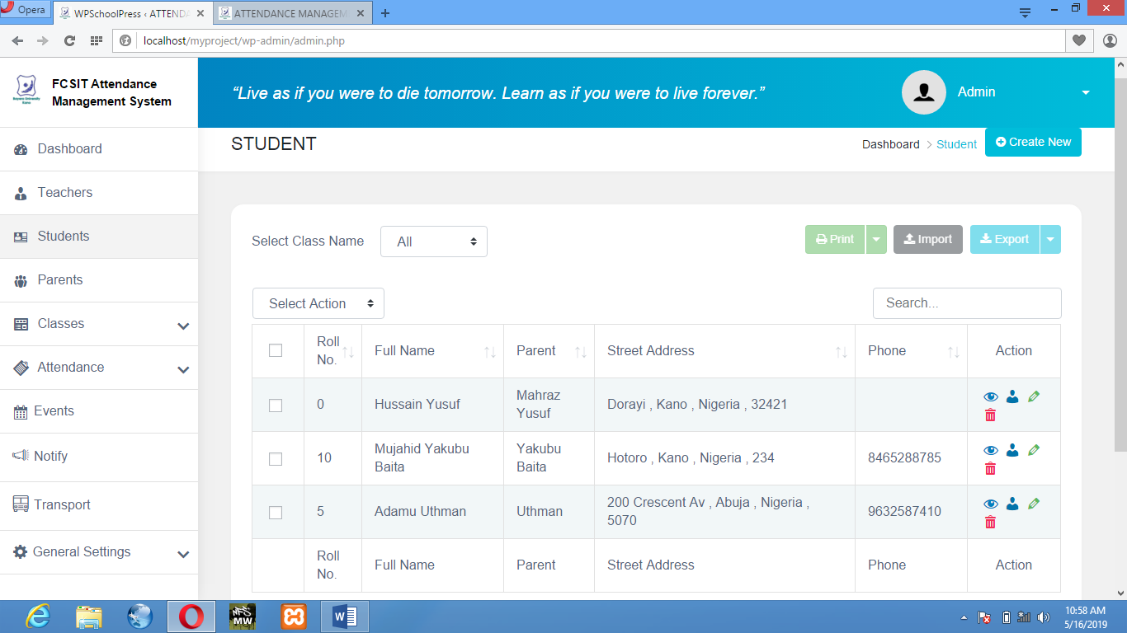

**Figure 1.4:** Student list

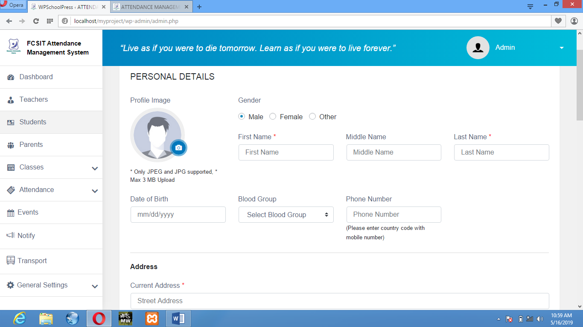

**Figure 1.1.1:** Add Student personal details

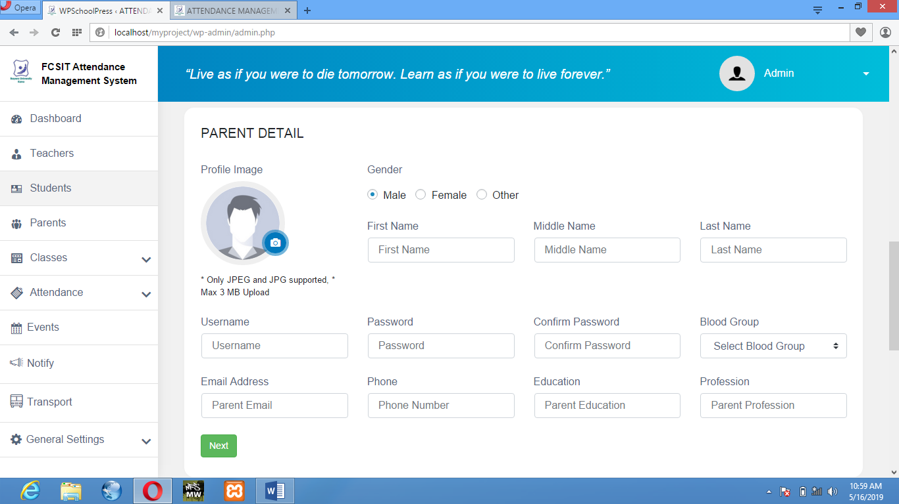

**Figure 1.1.2:** Add Student parent details

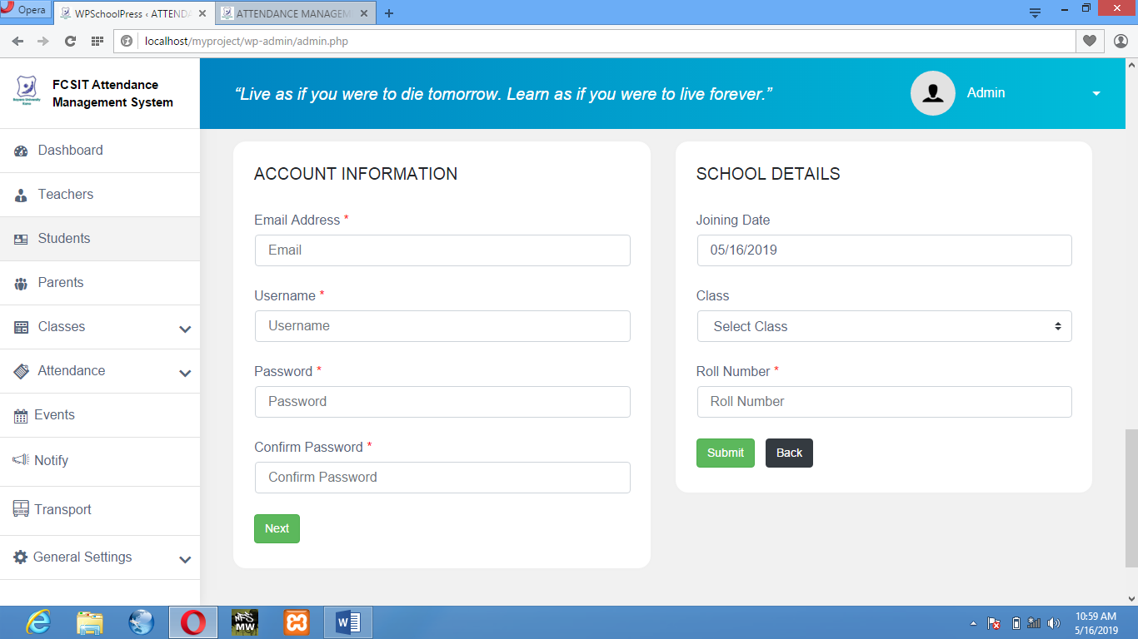

**Figure 1.1.3:** Add Student Account Info & School details.

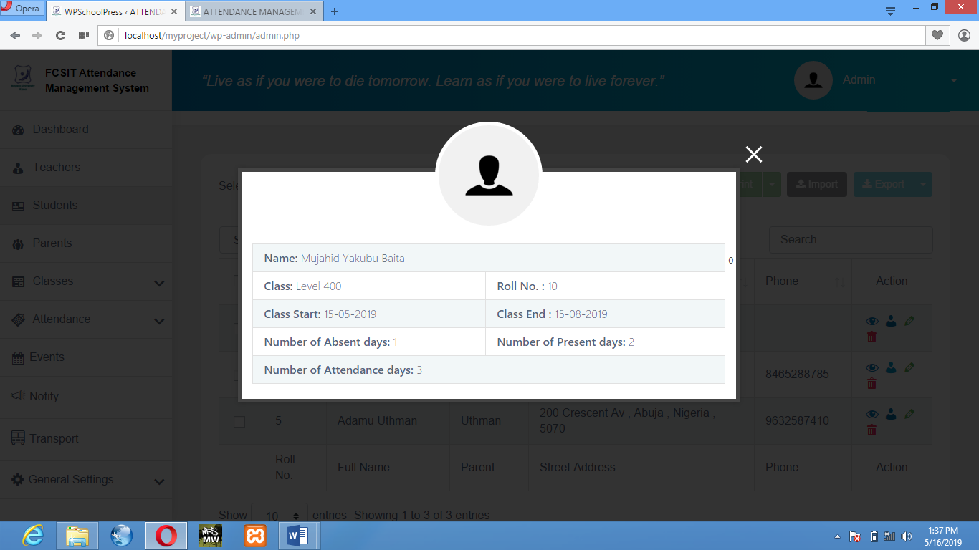

**Figure 1.1.4:** Student Overview

**ADD SUBJECT:** This window allows admin to add/remove subject for a class to a specific teacher.

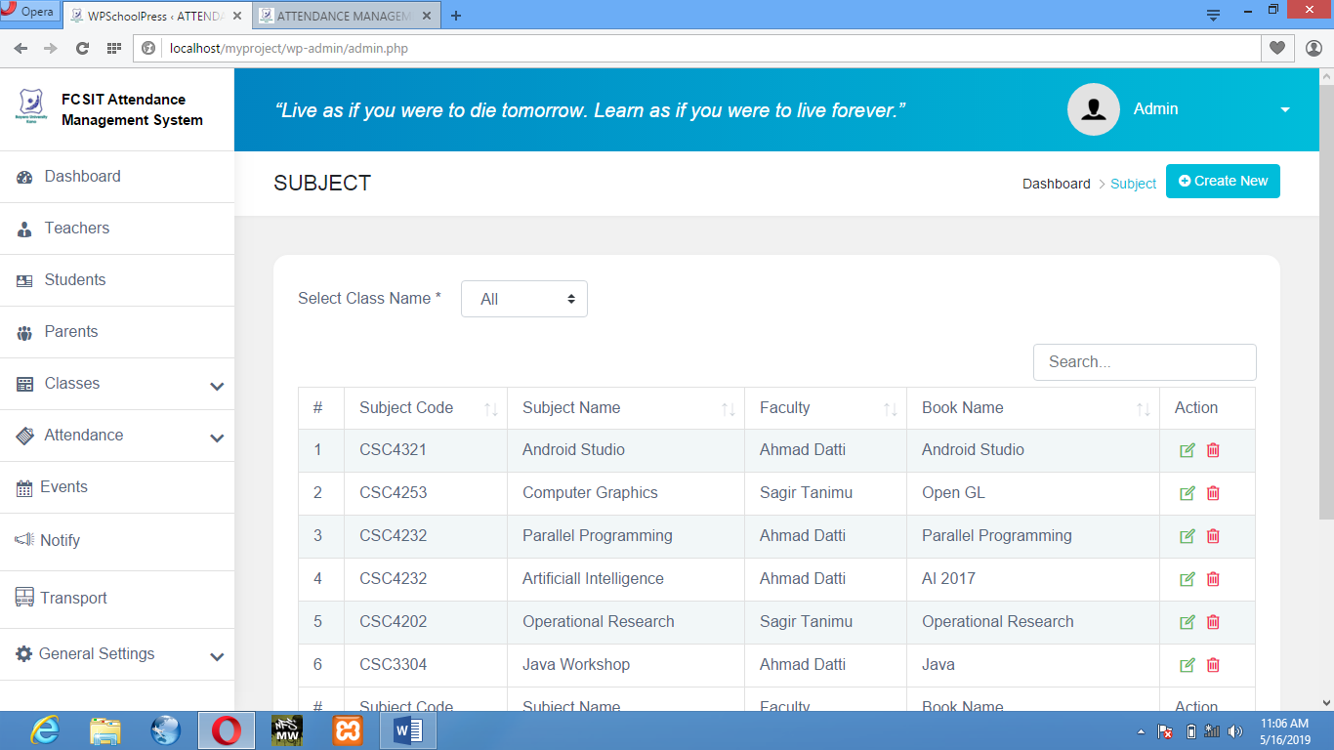

**Figure 1.2:** View Subject

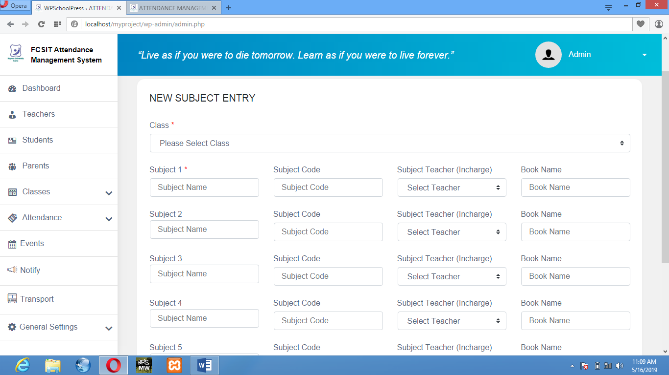

**Figure 1.2.1:** Add Subject

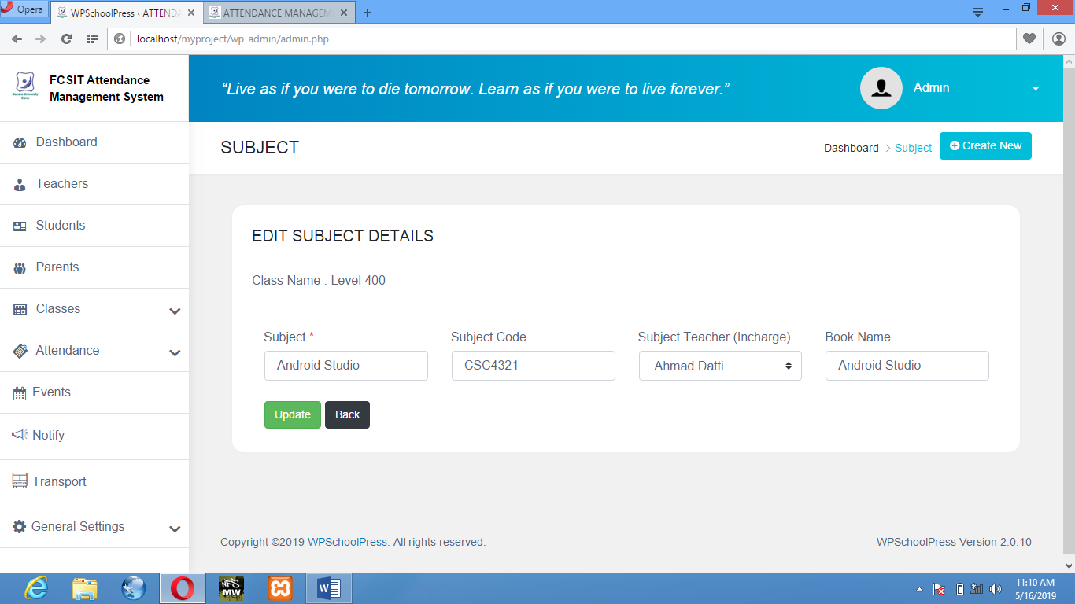

**Figure 1.2.2:** Edit Subject Details.

**CHECK ATTENDANCE:** This window will allow Admin/Teachers to add/view attendance for a Teachers/Students.

* STUDENT ATTENDANCE:

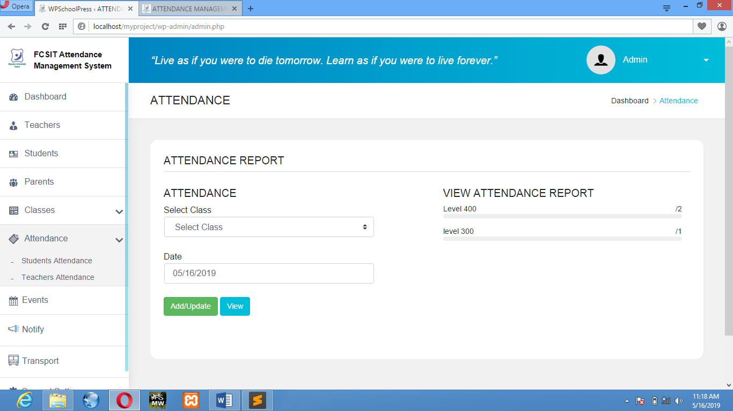

**Figure 1.3:** Attendance Report

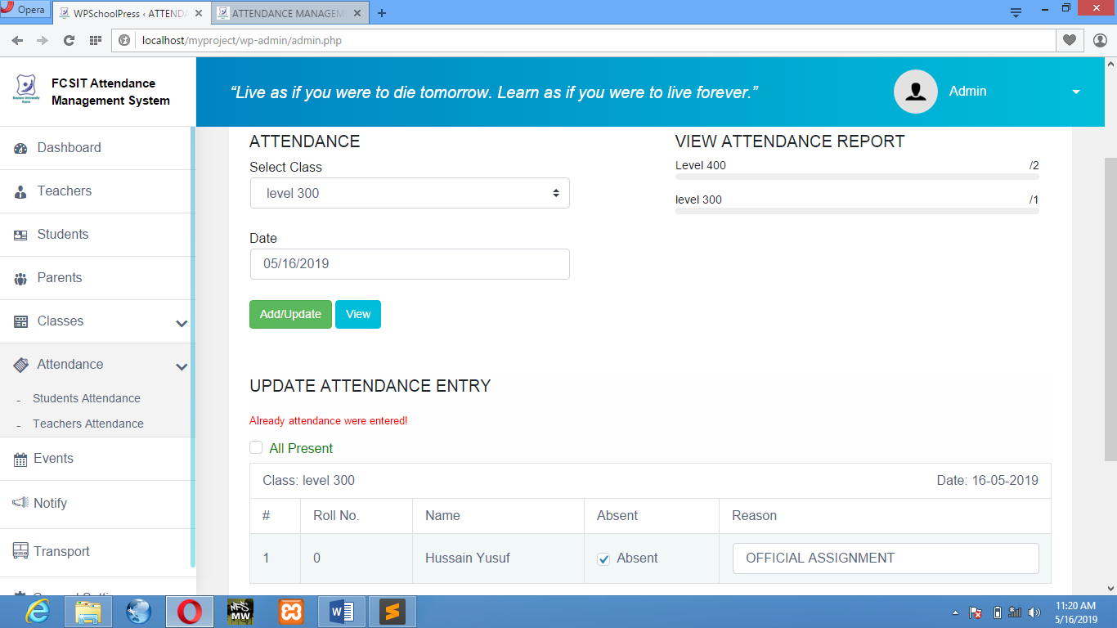

**Figure 1.3.1:** Add/Update Attendance

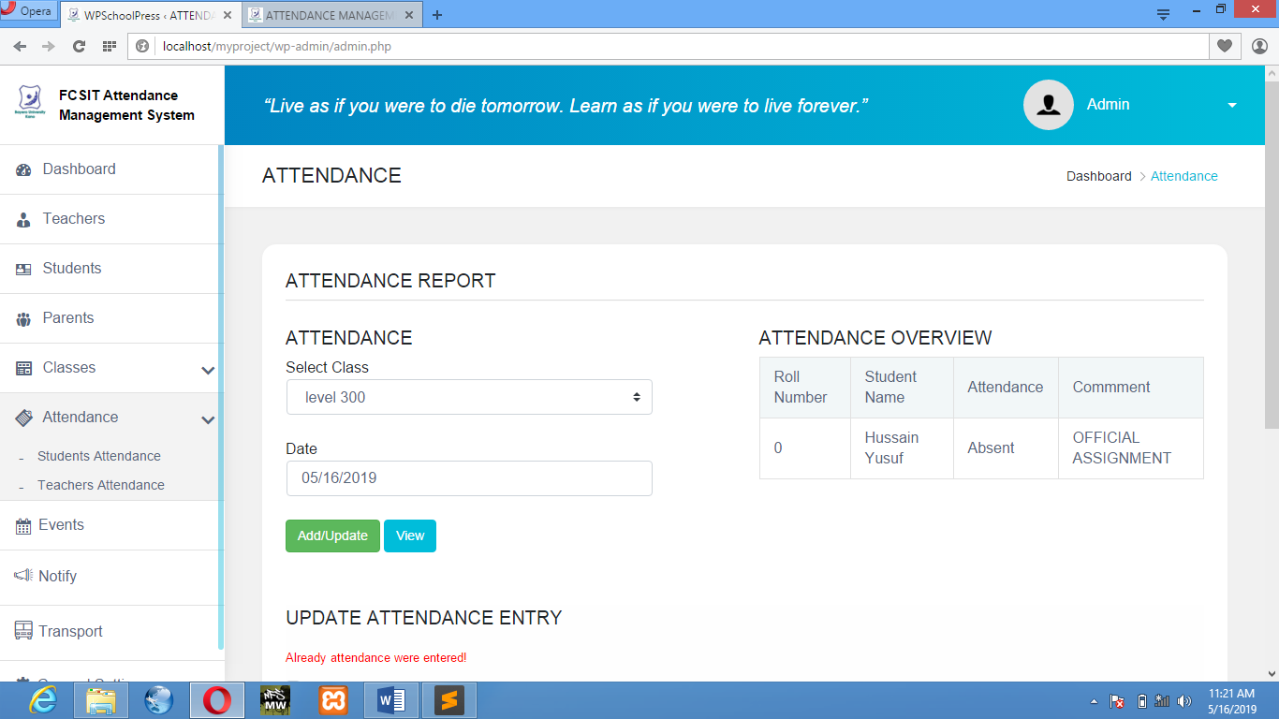

**Figure 1.3.2:** Attendance Overview

* TEACHERS ATTENDANCE

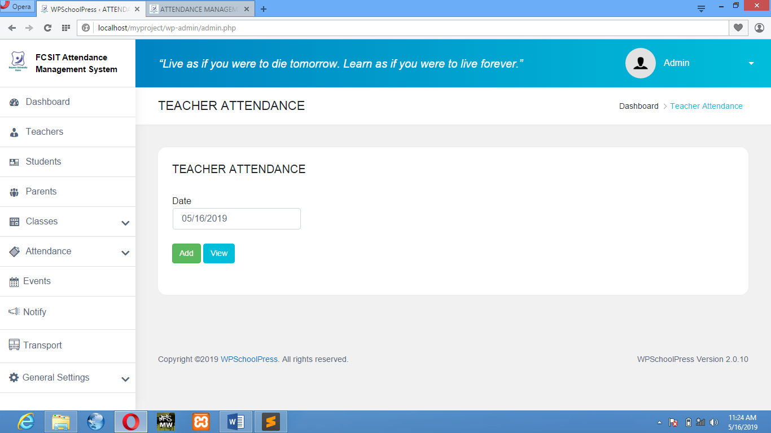

**Figure 1.4:** Teachers Attendance

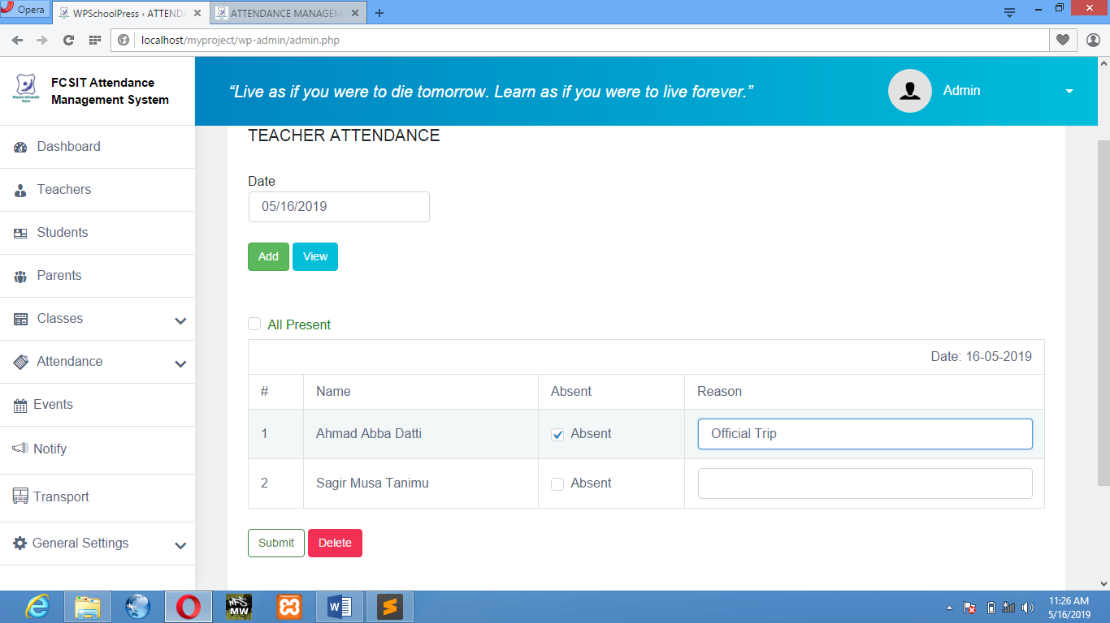

**Figure 1.4.1:** Add Teachers Attendance

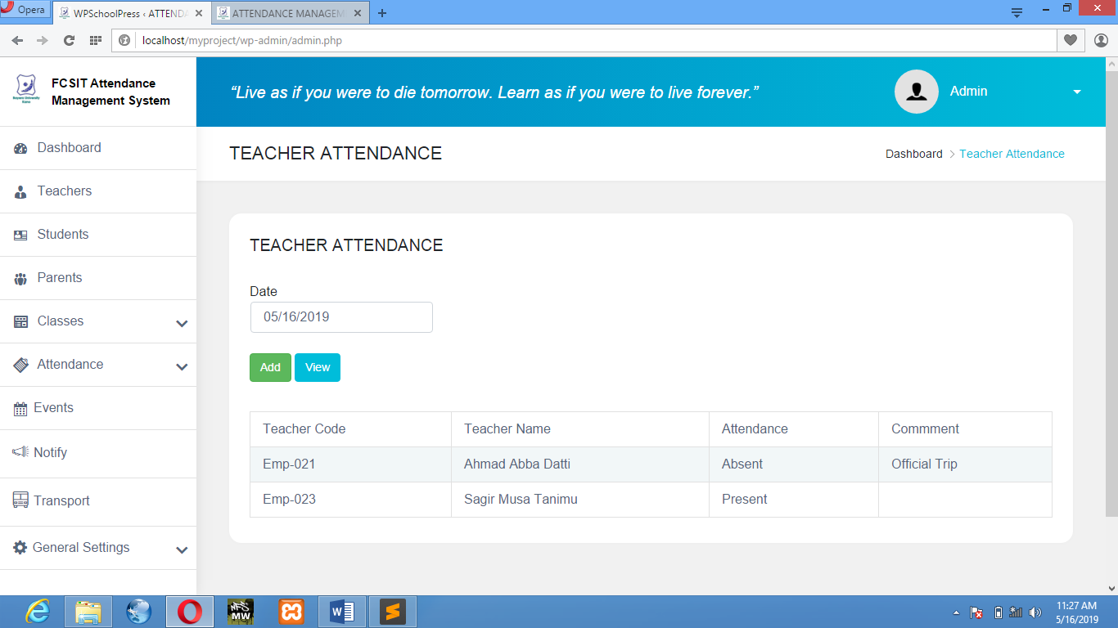

**Figure 1.4.2:** Teachers Attendance Overview

**ADD EVENT:** This window will allow Admin, Teachers or Students to add/check event of a specific day.

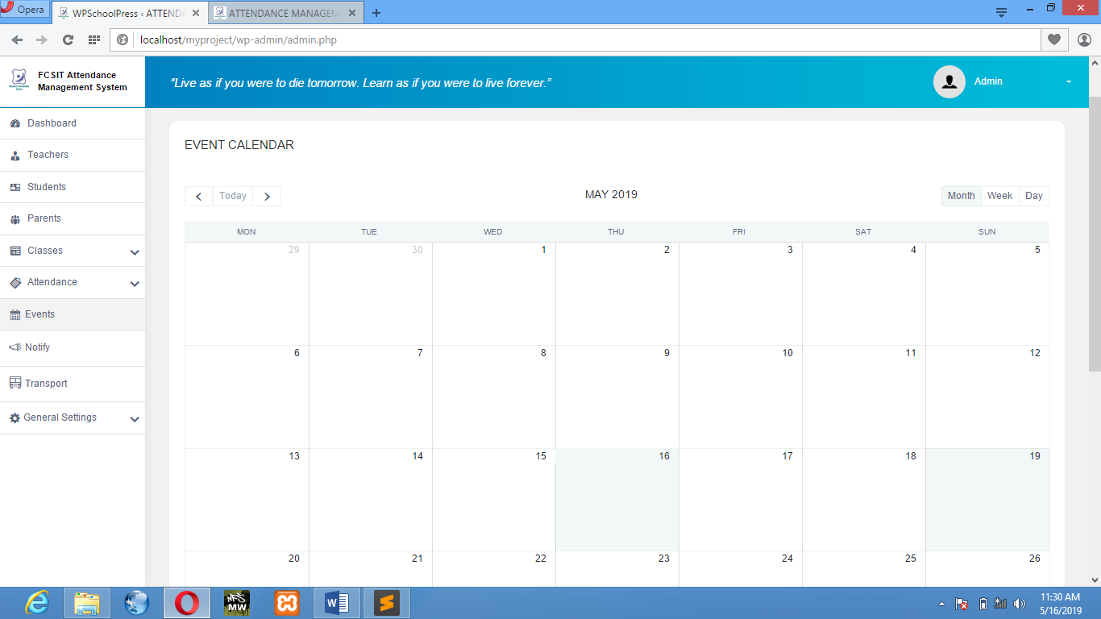

**Figure 1.5:** Event Calendar

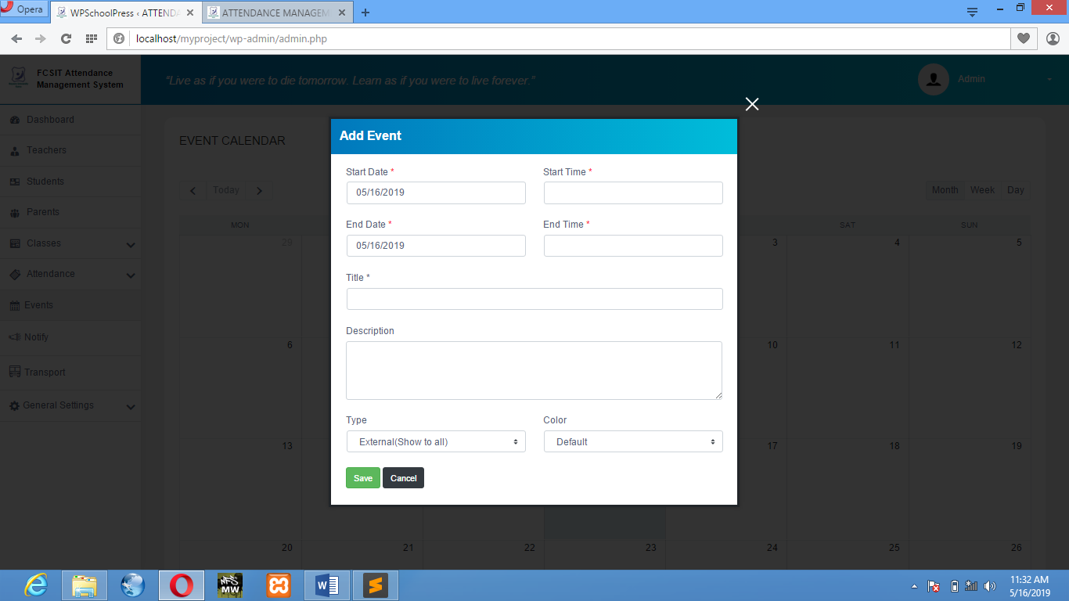

**Figure 1.5.1:** Add Event

**NOTIFICATION:** This windows allow the admin send notification to the student either by SMS/Email.

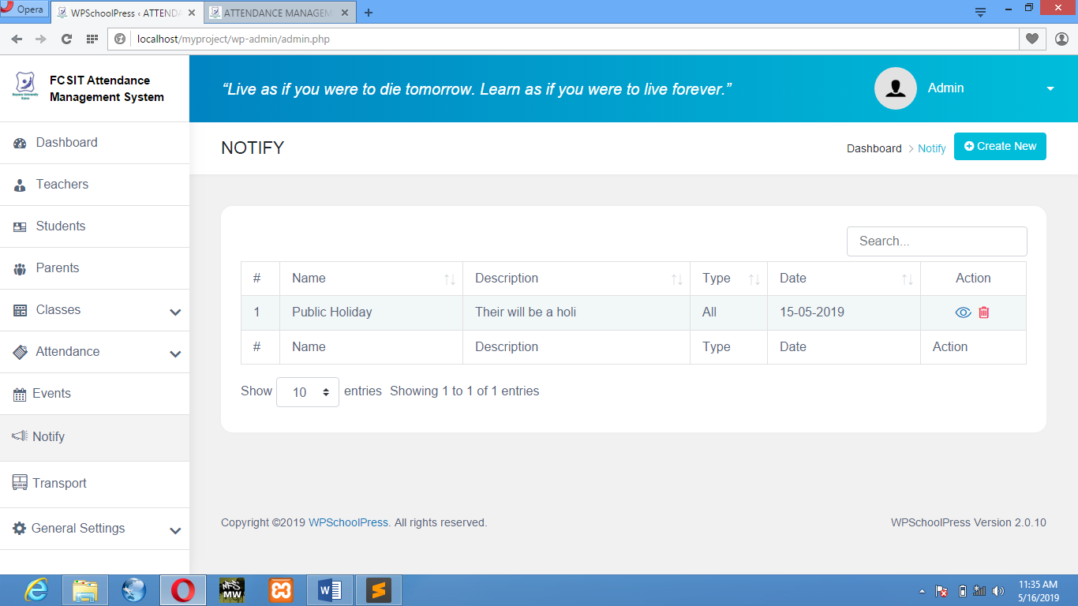

**Figure 1.6:** Notification Overview

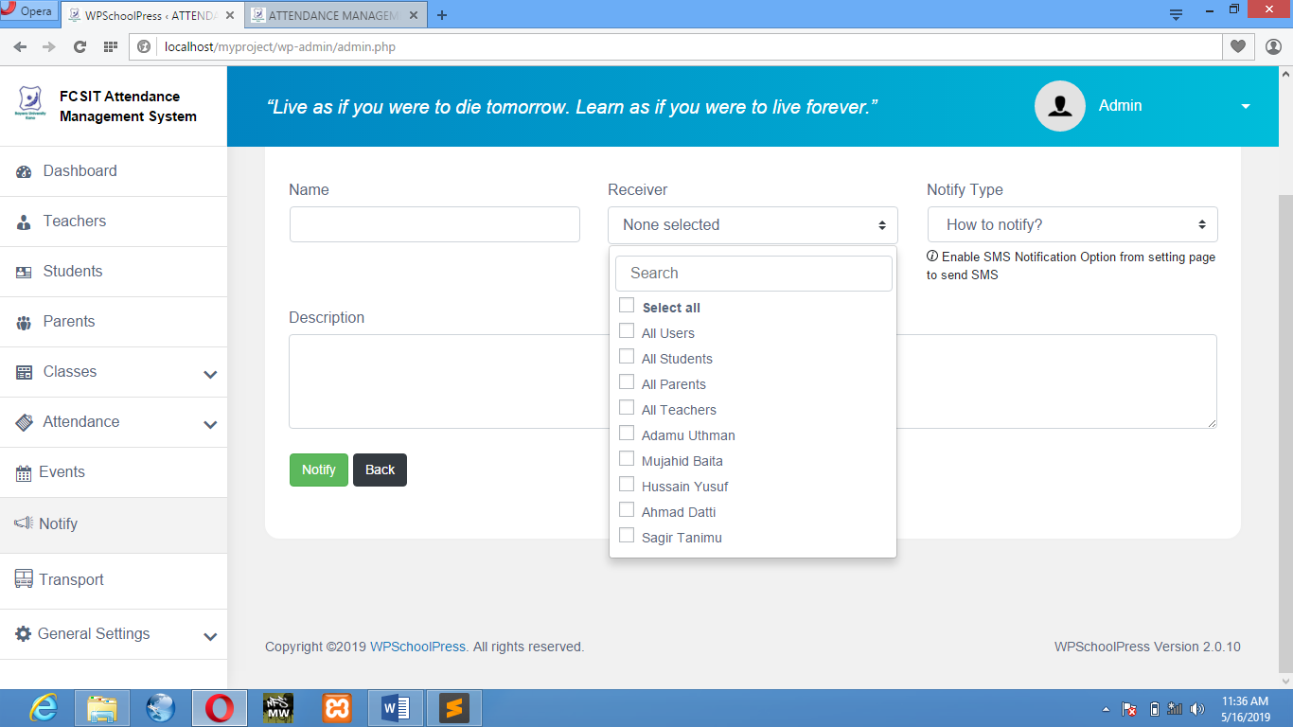

**Figure 1.6.1:** Create/Send Notification

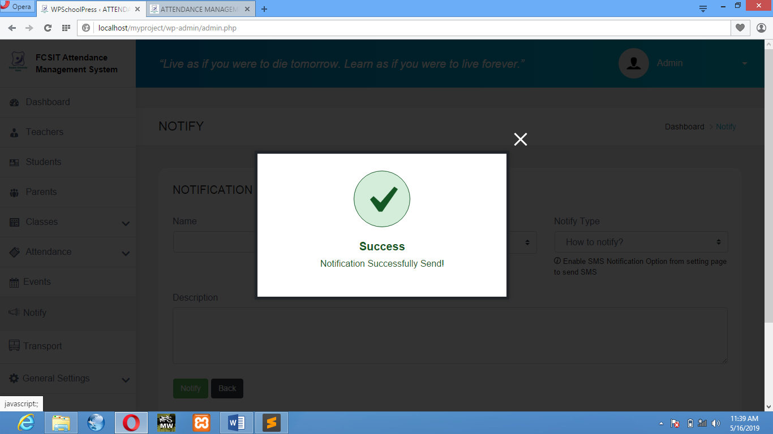

**Figure 1.6.2:** Notification Send Successful

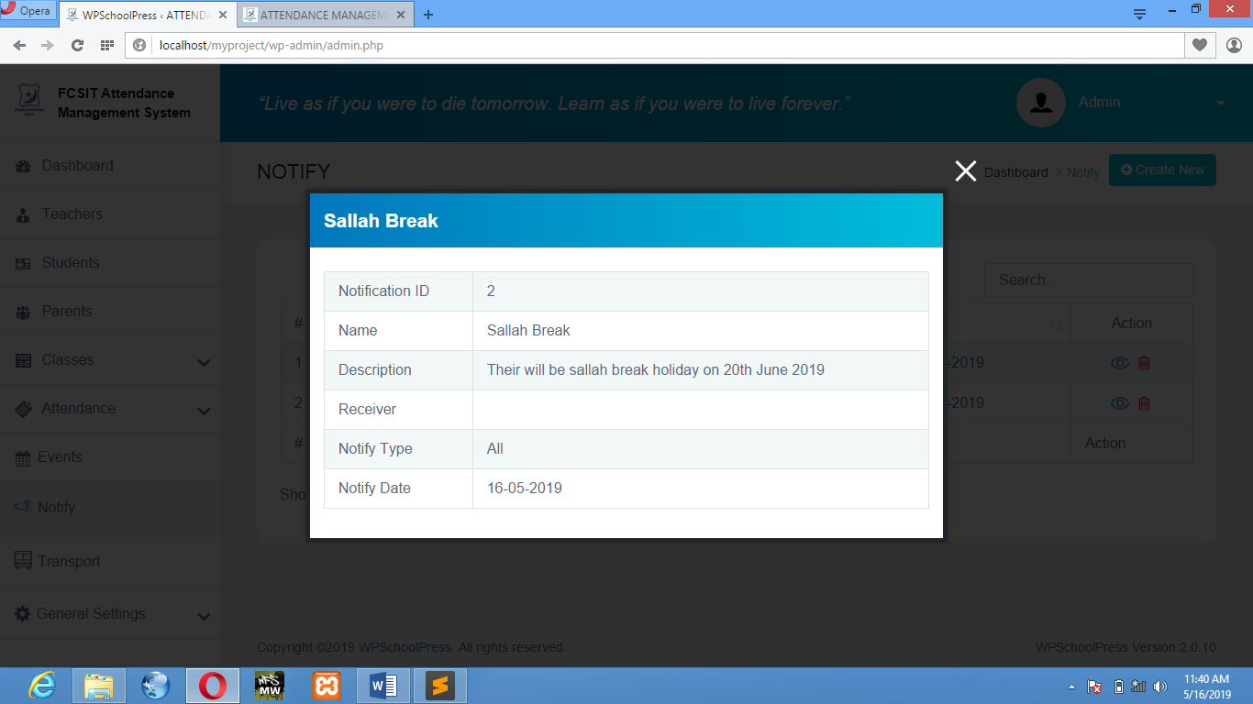

**Figure 1.6.3:** Notification Overview

* 1. SYSTEM TESTING

System testing is to check each step of the program to make sure that the designed software is working properly. The system was tested by inserting the admin username and password, then registering some people where the system excellently saved their information in the database, and it was saved successfully. Then a check attendance of student to confirm the process.

**4.3.1 Unit Testing**

The software interface and program unit functionalities of the system are tested to check how each is working (Table 4.1).

**Table 4.1 Unit Testing**

|  |  |  |
| --- | --- | --- |
| **Test Cases** | **Explanation** | **Result** |
| LOGIN | To check if only admin and teacher and student will be able to login after filling in the correct details in the available fields. Check if it was successful | pass |
| PREVIEW | To check if the admin and doctor will be able to visit their respective dashboard | Pass |
| CHECK ATTENDANCE | To check if the admin and teacher will be able to check the attendance system. Check if it was successful | Pass |
| ADD MEMBERS | To check if the admin can add students of different classes and teachers of different classes. Check if it was successful | Pass |
| CHECK EVENT | To check if the admin, teacher or student can check event. If it was successful | Pass |

**4.3.2 Integration Testing**

Integration testing is the next phase in system testing. The links interactions between MySQL or one activity and another were tested and everything was working well (Table 4.2).

**Table 4.2 Integration Testing**

|  |  |  |  |  |  |
| --- | --- | --- | --- | --- | --- |
| **Test Case ID** | **Test Case Objectives** | **Test Case Description** | **Input** | **Expected Output** | **Results** |
|  | To check the interface link between the login page and the home page. | Click on the LOGIN button. | Button clicked. | To be directed to the home page. | Pass |
| Button not clicked. | Remains unchanged. | Pass |
|  | To check the interface link between the home page and the Dashboard page. | Click on the Dashboard button. | Button clicked. | To be directed to the Dashboard. | Pass |
| Button not clicked | Remains unchanged. | Pass |
|  | To check the interface link between the Dashboard page and Attendance page | Click on Attendance button. | Button clicked. | To be directed to the Attendance page. | Pass |
| Button not clicked. | Remains unchanged. | Pass |
|  | Check the interface link between the Attendance page and View/Add Attendance. | Click on View/Add button. | Button clicked. | To be directed to View/Add Attendance window. | Pass |
| Button not clicked. | Remains unchanged | Pass |

**CHAPTER FIVE**

SUMMARY, CONCLUSION AND RECOMMENDATION

**5.1 SUMMARY**

This project a software for online Attendance Management System is developed after reviewing and analyzing the existing manual system at the investigation stage and a Use Case diagram to determine the actors of the system.

The design is implemented using Wordpress, MYSQL for database and XAMPP as the offline local server. The web application starts with login which contains Admin, teachers or student login, then the Home Page where Admin, teachers or students can either click on Dashboard to view their respective dashboard.

**5.2 CONCLUSION**

The Attendance Management System is developed using Wordpress framework fully meets the objectives of the system which it has been developed. The system has reached a steady state where all bugs have been eliminated. The system is operated at a high level of efficiency and all the teachers and user associated with the system understands its advantage. The system solves the problem. It was intended to solve as requirement specification.

**5.3 RECOMMENDATION**

As a result of the finding made during the analysis and design stages of this research work. In order to improve the effectiveness of the site to its greater height and full potential, its recommended that the following features should be added for future expansion of this project.

* E- Learning (Virtual Classes)
* A website for student forums
* Online Tutorial Classes
* Online Quiz/Exams

For the effective usage of this software and have good management of it, it is necessary to provide computer to the vital registration centers and staff should be trained to acquire knowledge on how to use the computer and new system. So that the current system needs to be change in order to meet global standard and modern challenges of information technology.

**REFRENCES:**

1. He Zonggang, Neusoft Institute of Information Dalian, Zheng Junsheng, title: “Design and implementation of Student Attendance Management system based on MVC”, 978-1-4244-4639-1/09 © IEEE 2009.
2. Aamir Nizam Ansari, Arundhati Navada, Sanchit Agarwal, Siddharth Patil, Balwant A. Sonkamble, title: “Automation of Attendance System using RFID, Biometrics, GSM Modem with .NET framework”, 978-1- 61284-774-0/11 © IEEE 2011.
3. Srinidhi MB, Romil Roy, title: “A Web Enabled Secured System for Attendance Monitoring and Real Time Location Tracking using Biometric and Radio Frequency Identification”, International Conference on Computer Communication and Informatics (IEEE ICCCI ), Coimbatore, INDIA 2015.
4. I-ChingHsu, title: “Mobile Ubiquitous Employee Attendance Monitoring System using Wireless sensor networks”, 2nd International Conference on Education Technology and Computer (IEEE ICETC) 2010.
5. Mashhood Sajid, Rubab Hussain, Muhammad Usman, title: “A Conceptual Model for Automated Attendance Marking System using Facial Recognition”, 978-1-4799-5421-6/14 © IEEE 2014.
6. Gabriel, Serme., Anderson, Santana de Oliveira., Julien, Massiera, & Yves, Roudier, title: “Enabling Message Security for RESTful Services”, IEEE 19th International Conference on Web Services, 2012.
7. Using real time computer vision algorithms in automatic attendance management systems by V Shehu, A Dika - (ITI), 2010 32nd International Conference on, 2010
8. S.R.Bharamagoudar, Geeta R.B., S.G.Totad, ”Web Based Student Information Management System”,International Journal of Advanced Research in Computer and Communication Engineering,Vol. 2, Issue 6, June 2013
9. G.Satyanarayana Reddy,Rallabandi Srinivasu,Srikanth Reddy Rikkula,Vuda Sreenivasa Rao,” Management Information System To Help Managers For Providing Decision Making In An Organization”, International Journal of Reviews in Computing, ISSN: 2076-3328, EISSN: 2076-3336
10. Published in:Computer Science and Information Technology - Spring Conference, 2009. IACSITSC '09. International Association of. Date of Conference: 17-20 April 2009 Page(s):174 - 177 Print ISBN: 978-0-7695- 3653-8
11. INSPEC Accession Number:10792151 Conference Location: Singapore DOI:10.1109/IACSIT-SC.2009.130link- http://ieeexplore.ieee.org/xpl/articleDetails.jsp?arnumber=5169333&newsearch=true&queryText=attendance%20s ystem. Publisher:IEEE
12. V.Ramesh, P.Parkavi and K.Ramar, “Predicting student performance: A statistical and data mining approach,” International Journal of Computer Applications (IJCA), vol. 63-No.8,February 2013
13. P.Meena Kumari, SK.Abdul Nabi and Puppal Priyanka,”Educational data mining and its role in educational field,” International Journal of Computer Science and Information Technologies (IJCSIT),vol. 5(2),2014
14. P.Veeramuthu and Dr.R.Periaswamy,“Application of higher education system for predicting student using data mining techniques,” International Journal of Innovative Research in Advanced Engineering(IJIRAE),vol. 1 issue 5,June 2014
15. Dr.Mohd Maqsood Ali,”Role of data mining in education sector,” International Journal of Computer Science and Mobile Computing(IJCSMC),vol 2,issue 4,April 2013
16. Suchita Borkar & K. Rajeswari, “Predicting Students Academic Performance Using Education Data Mining”, IJCSMC, Vol. 2, Issue. 7, July 2013, pg.273 – 279
17. Kumar, “An Empirical Study of the Applications of Data Mining Techniques in Higher Education”. IJACSA - International Journal of Advanced Computer Science and Applications, 2011
18. Ajay Kumar Pal & Saurabh Pal,“Data Mining Techniques in EDM for Predicting the Performance of Students”,2009

**WEBSITES**

* 1. <http://www.wordpress.org/>
  2. <http://www.academia.edu/>
  3. <http://www.stackoverflow.com/>
  4. <http://www.iproject.com>
  5. <http://www.w3schools.com/>
  6. <http://wikipedia.com/>