multi_agent.py
In this case, we want agent to take care of the entire ReAct while loop
Instead of using one Agent, we are going to create two agents.

https://docs.langchain.com/oss/python/langchain/multi-agent

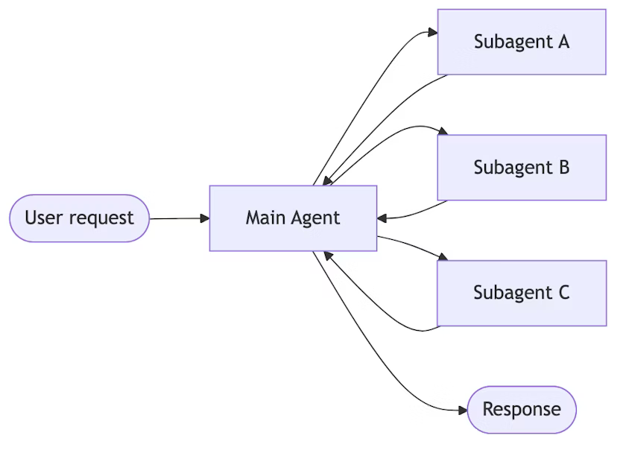
In our case, Main Agent is the ‘supervisor_agent’, supervisor_agent can use multiple sub-agents. Say you have given a big task, it can break the task into multiple tasks, first agent will do this, second agent will do that and so on. All subagents will send responses to the main agent then main agent will give the final response. The idea of the sub-agent is to help the main agent.

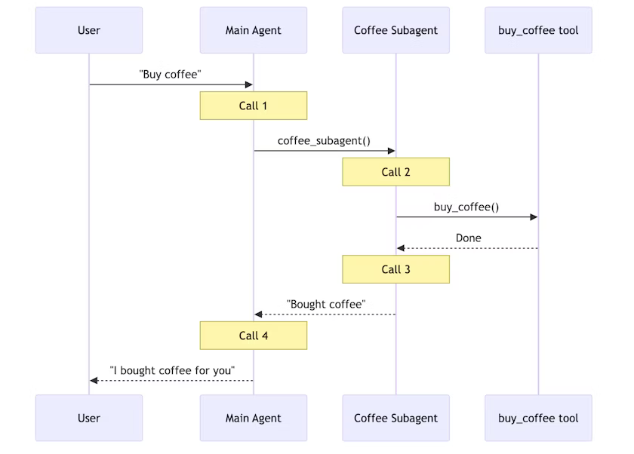

User sends query to Main agent, main agent calls the subagents, subagent can call another subagent. Then the response goes back to Main agent then Main agent gives response to the user.

We got a research_agent, which is a subagent. Main agent is ‘supervisor_agent’. In the first agent, if you observe, we are passing only search_tool. supervisor_agent uses only the tool not the agent. You have to wrap your agent into a tool. Since in this program “multi-agent.py”, we are not using LangGraph, we are wrapping that Agent into a tool. We are passing that tool to the main agent. supervisor_agent is accepting main tools that’s get_current_local_time and research_web.

supervisor_executor.invoke({“input”: query}) => first calls the supervisor_agent
supervisor_agent knows it needs the help of researcher_agent

There is a lot of loop holes in the code without LangGraph, thats what LangGraph is going to solve.

In short, User request (current local time in which country there was a FIFA worldcup in 2022) first goes into Main agent (supervisor_agent), Main agent knows there is a tool available called “search”, but this tool “search” is available with the subagent (research_agent), request goes there, gets the response (it’s in Qatar). Once that’s done, it executes another tool (not agent) available called “get_current_date_time()” and based on that response, LLM will give you the final response.

We are wrapping another agent “research_agent” inside a tool (“research_web”) so the Main agent will be using a tool
main_tools = [get_current_local_time, research_web]

Basic idea is we can create multiple agents. If you want that hierarchy, we have to create a main agent and main agent is going to call subagents.

Output:

> Entering new AgentExecutor chain...
I need to find out which country hosted FIFA 2022 and also provide the current local time.

Action: research_web
Action Input: "Which country hosted FIFA World Cup 2022?"

> Entering new AgentExecutor chain...
I know that the FIFA World Cup 2022 was held in Qatar.

Final Answer: Qatar hosted the FIFA World Cup 2022.

> Finished chain.
Qatar hosted the FIFA World Cup 2022.I have found the host country for FIFA 2022. Now I need to find the current local time.

Action: get_current_date_time
Action Input: None2026-01-14 17:31:36I now have the current local time and the information about the FIFA 2022 host country.

Final Answer: The FIFA World Cup 2022 was hosted by Qatar. Your current local time is 2026-01-14 17:31:36.
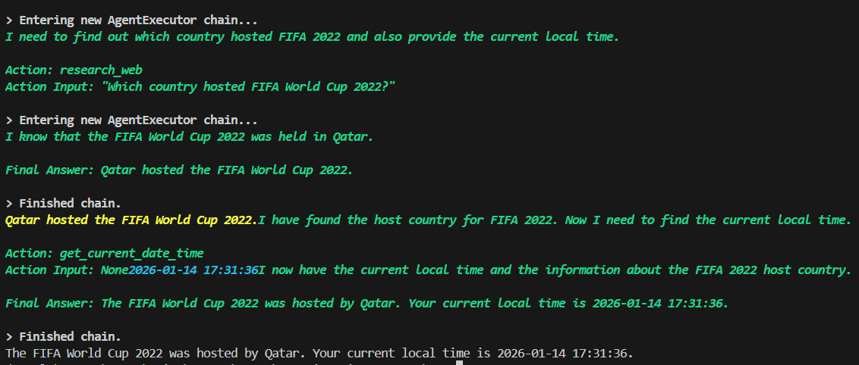

Next class we will start with LangGraph.

