How do we implement MCP in Langchain?
Model Context Protocol: When you build tools, it is only for your service. If you talk about GitHub or GoogleDrive, Slack, if these services want AI to interact with them, Say you have a ChatBot and if you want to tell GitHub to create a new repo, then GitHub has to give you this access for AI to perform this operation. So GitHub will create certain tools and these tools can be accessed from the outside world. How to make this interaction with GitHub tools? What if we can make a common protocol between this GitHub server and our Host machine, which will have a client. That protocol is MCP so we don’t have to write a lot of code on the client side.

Create uv environment
uv add dotenv
uv add langchain_openai
uv add langchain_core
uv add uv add langchain_mcp_adapters

we created main.py and ran
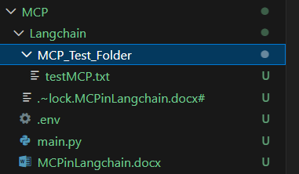

It created the file testMCP.txt

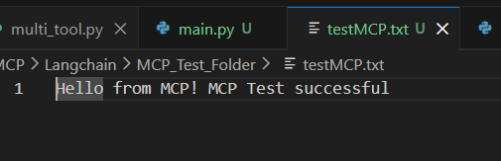

Now how to create my own MCP_server on Langchain?

uv add fastmcp
uv add langchain_community
uv add ddgs

Run mcp_server.py

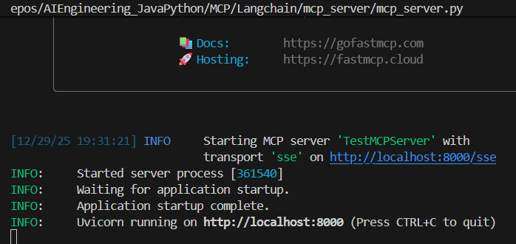

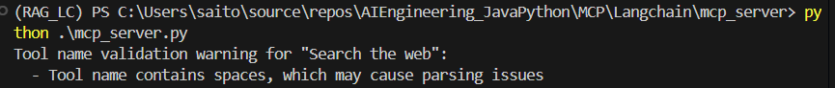

New terminal
Run mcp_client.py
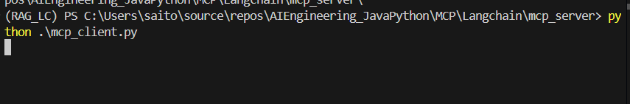
Server accepted
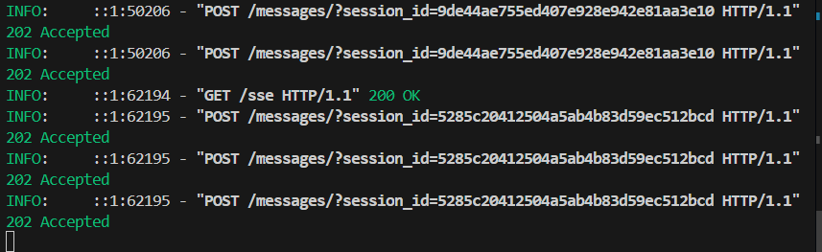

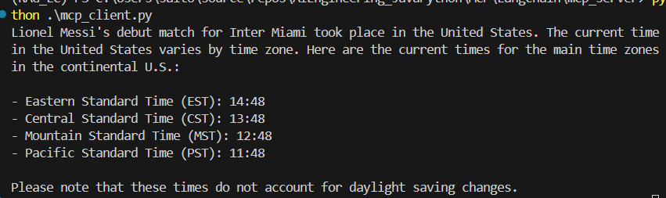

Lets comment out the Search tool and retry

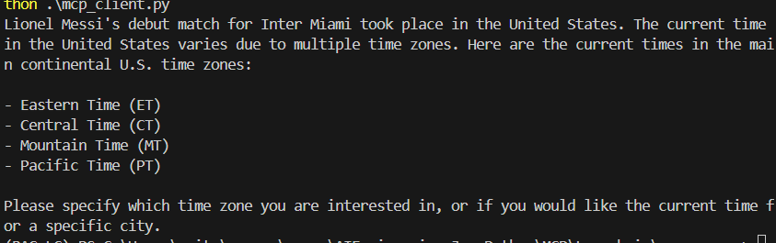
Basically it doesn’t know the time, unlike last time

