LangGraph1:
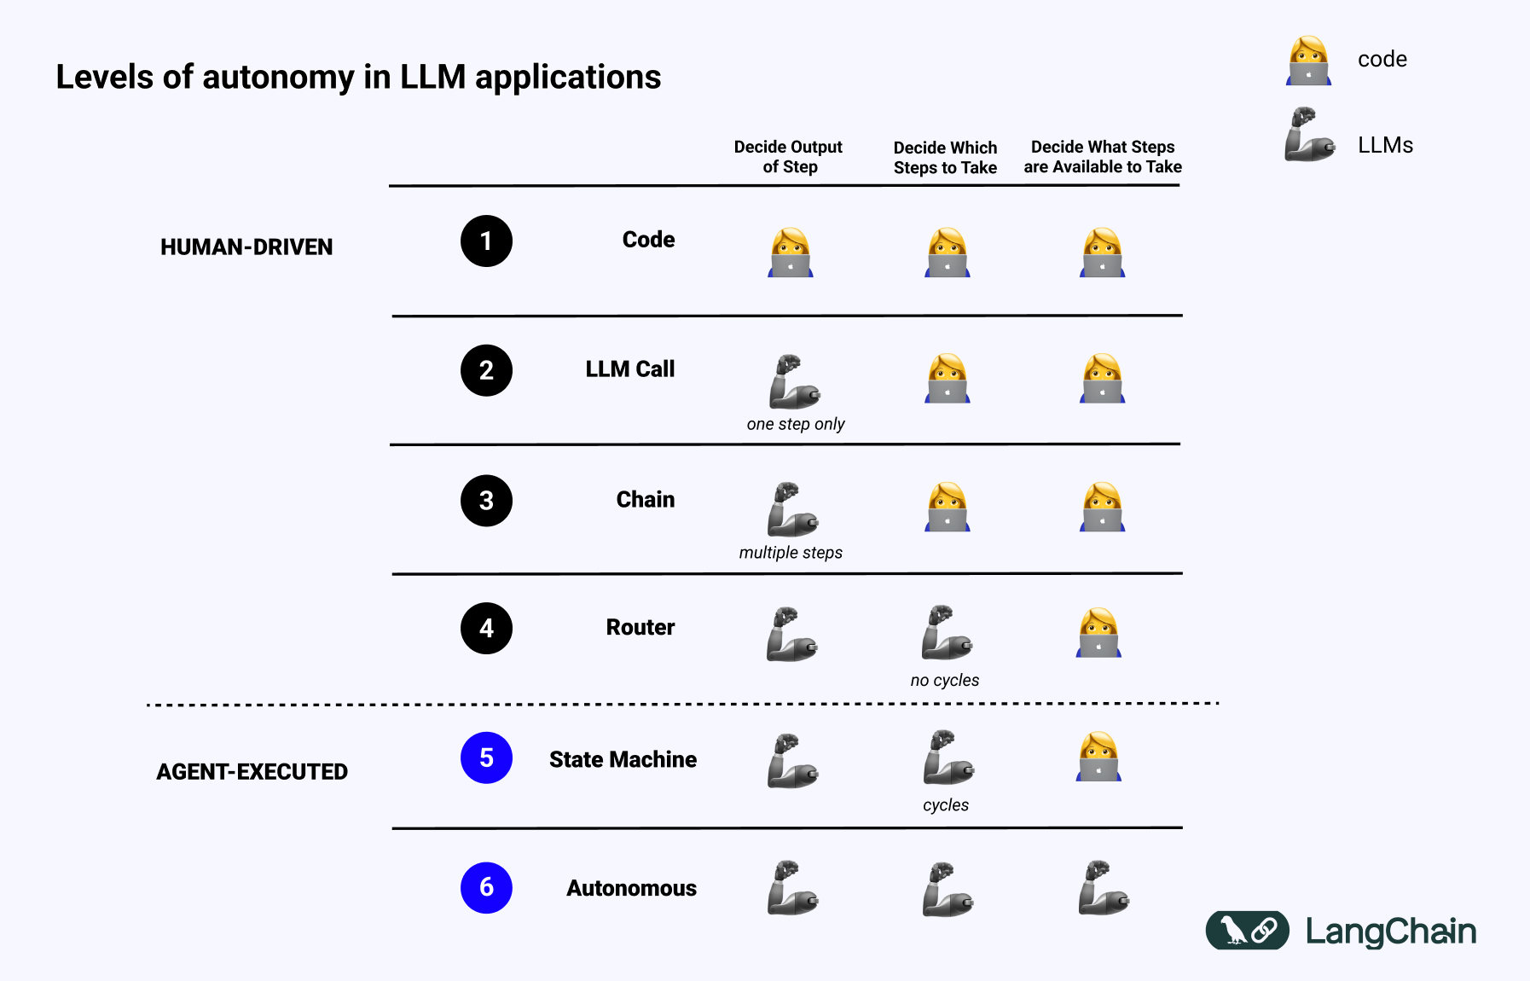
LangChain explains the importance of LangGraph. In old days, in the Phase1 Code era, everything was coded (Decide output of step, Decide which steps to take, Decide what steps are available to take). In Phase1, we write the functions, manually call the functions. Manually we call functions from functions. Then, LLM came into picture and gave us some hope and that hope is the LLM calls. In Phase2, if we need some information, we were requesting these information from LLM and LLM will give you some response, which you are going to use. Decide output of the step: this output will be given by LLM then we manually decide which steps to take (what to do with the output) and decide what steps are available to take.

