Portfolio Intelligence System

Basically AutoGen AgentChat runs on AutoGen Core to interact with each other
uv run .\world.py
warning: `VIRTUAL_ENV=C:\Users\saito\source\repos\AIAgenticEngg\.venv` does not match the project environment path `C:\Users\saito\source\repos\AIAgenticEngg\projects\agents\.venv` and will be ignored; use `--active` to target the active environment instead
** Creator has created python code for agent agent1 - about to register with Runtime
** Creator has created python code for agent agent2 - about to register with Runtime
** Agent agent1 is live
INFO:autogen_core.trace:** Agent agent1 is live
** Agent agent2 is live
INFO:autogen_core.trace:** Agent agent2 is live
agent1: Received message
agent2: Received message
Scanning folder: C:\Users\saito\source\repos\AIAgenticEngg\projects\agents\5_autogen\PortfolioIntelligenceSystem
Selecting agent for refinement: agent1
agent1: Received message
Scanning folder: C:\Users\saito\source\repos\AIAgenticEngg\projects\agents\5_autogen\PortfolioIntelligenceSystem
Selecting agent for refinement: agent2
agent2: Received message
Scanning folder: C:\Users\saito\source\repos\AIAgenticEngg\projects\agents\5_autogen\PortfolioIntelligenceSystem
Selecting agent for refinement: agent2
agent2: Received message
Scanning folder: C:\Users\saito\source\repos\AIAgenticEngg\projects\agents\5_autogen\PortfolioIntelligenceSystem
Selecting agent for refinement: agent1
agent1: Received message
Scanning folder: C:\Users\saito\source\repos\AIAgenticEngg\projects\agents\5_autogen\PortfolioIntelligenceSystem
Selecting agent for refinement: agent2
agent2: Received message
Scanning folder: C:\Users\saito\source\repos\AIAgenticEngg\projects\agents\5_autogen\PortfolioIntelligenceSystem
Selecting agent for refinement: agent2
agent2: Received message
Scanning folder: C:\Users\saito\source\repos\AIAgenticEngg\projects\agents\5_autogen\PortfolioIntelligenceSystem
Selecting agent for refinement: agent2
agent2: Received message
Scanning folder: C:\Users\saito\source\repos\AIAgenticEngg\projects\agents\5_autogen\PortfolioIntelligenceSystem
Selecting agent for refinement: agent2
agent2: Received message
Scanning folder: C:\Users\saito\source\repos\AIAgenticEngg\projects\agents\5_autogen\PortfolioIntelligenceSystem
Selecting agent for refinement: agent1
agent1: Received message
Scanning folder: C:\Users\saito\source\repos\AIAgenticEngg\projects\agents\5_autogen\PortfolioIntelligenceSystem
Selecting agent for refinement: agent2
agent2: Received message
Scanning folder: C:\Users\saito\source\repos\AIAgenticEngg\projects\agents\5_autogen\PortfolioIntelligenceSystem
Selecting agent for refinement: agent1
agent1: Received message
Scanning folder: C:\Users\saito\source\repos\AIAgenticEngg\projects\agents\5_autogen\PortfolioIntelligenceSystem
Selecting agent for refinement: agent1
agent1: Received message
Scanning folder: C:\Users\saito\source\repos\AIAgenticEngg\projects\agents\5_autogen\PortfolioIntelligenceSystem
Selecting agent for refinement: agent2
agent2: Received message
Scanning folder: C:\Users\saito\source\repos\AIAgenticEngg\projects\agents\5_autogen\PortfolioIntelligenceSystem
Selecting agent for refinement: agent1
agent1: Received message
Scanning folder: C:\Users\saito\source\repos\AIAgenticEngg\projects\agents\5_autogen\PortfolioIntelligenceSystem
Selecting agent for refinement: agent2
agent2: Received message
Scanning folder: C:\Users\saito\source\repos\AIAgenticEngg\projects\agents\5_autogen\PortfolioIntelligenceSystem
Selecting agent for refinement: agent1
agent1: Received message
Scanning folder: C:\Users\saito\source\repos\AIAgenticEngg\projects\agents\5_autogen\PortfolioIntelligenceSystem
Selecting agent for refinement: agent1
agent1: Received message
Scanning folder: C:\Users\saito\source\repos\AIAgenticEngg\projects\agents\5_autogen\PortfolioIntelligenceSystem
Selecting agent for refinement: agent2
agent2: Received message
Scanning folder: C:\Users\saito\source\repos\AIAgenticEngg\projects\agents\5_autogen\PortfolioIntelligenceSystem
Selecting agent for refinement: agent2
agent2: Received message
Scanning folder: C:\Users\saito\source\repos\AIAgenticEngg\projects\agents\5_autogen\PortfolioIntelligenceSystem
Selecting agent for refinement: agent2
agent2: Received message
Scanning folder: C:\Users\saito\source\repos\AIAgenticEngg\projects\agents\5_autogen\PortfolioIntelligenceSystem
Selecting agent for refinement: agent1
agent1: Received message
Scanning folder: C:\Users\saito\source\repos\AIAgenticEngg\projects\agents\5_autogen\PortfolioIntelligenceSystem
Selecting agent for refinement: agent2
agent2: Received message
Scanning folder: C:\Users\saito\source\repos\AIAgenticEngg\projects\agents\5_autogen\PortfolioIntelligenceSystem
Selecting agent for refinement: agent1
agent1: Received message
Scanning folder: C:\Users\saito\source\repos\AIAgenticEngg\projects\agents\5_autogen\PortfolioIntelligenceSystem
Selecting agent for refinement: agent1
agent1: Received message
Scanning folder: C:\Users\saito\source\repos\AIAgenticEngg\projects\agents\5_autogen\PortfolioIntelligenceSystem
Selecting agent for refinement: agent1
agent1: Received message
Scanning folder: C:\Users\saito\source\repos\AIAgenticEngg\projects\agents\5_autogen\PortfolioIntelligenceSystem
Selecting agent for refinement: agent1
agent1: Received message
Final portfolio report created successfully.
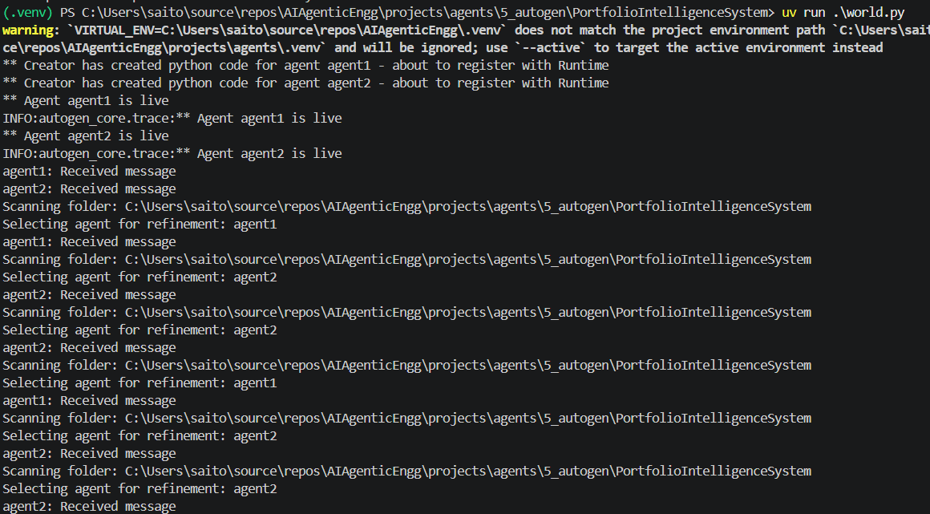

We run world.py first => it invokes CreatorAgent first => CreatorAgent creates number of agents, using the AgentTemplate => CreatorAgent runs the created Agents => CreatorAgent returns message back to world => All results are accumulated => All results passed into EvaluatorAgent for final report => EvaluatorAgent writes final_report.md and returns back to world

