Hugging Face demo

https://huggingface.co/

We will use HuggingFace with Python Jupyter notebook

In the development world, one of the things we use it GitHub, we use GitHub to create a repository where in we can share the code with the team-member. In the same way, if you want to talk about Machine learning models, dataset etc, we will do it on HuggingFace.

Hugging Face is a prominent AI company and collaborative platform that serves as a central hub for the open-source machine learning and data science community. It is often described as the "GitHub of AI" because it allows users to share, discover, and collaborate on AI models, datasets, and applications.

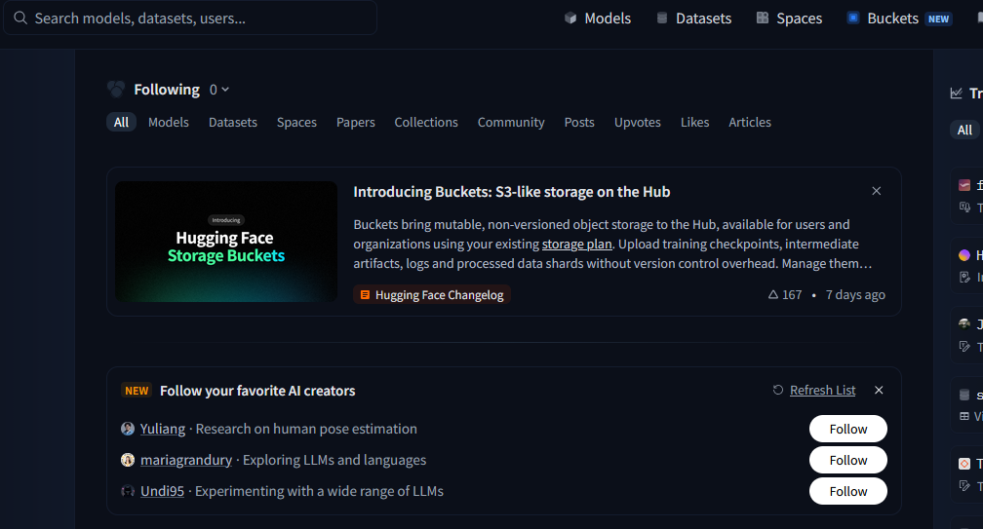
Ollama is for running open-source models locally. In the same way, if you want to run more models, maybe locally or colab, HuggingFace has different options

https://huggingface.co/models

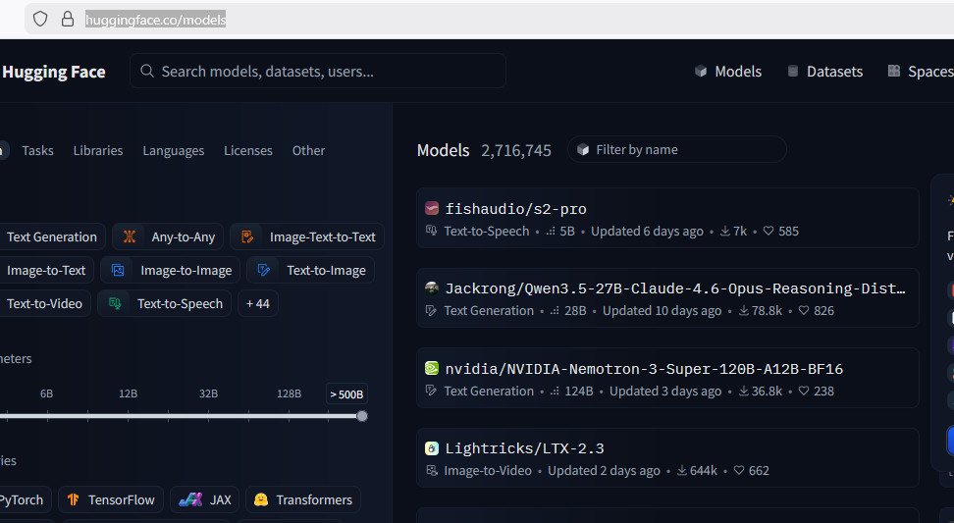
We talk about different models say from Gemini, OpenAI, Anthropic etc, say Anthropic only has text-generation models (text-to-text only, no image). But what if you are doing a task, which needs only image processing or only text-to-speech, in that case, instead of using entire large model (you could be wasting a lot of resources trying to run that model), we could use a small model and the only job of that model is to do that task for us. For OpenAI, we use a term called as ‘Model-As-A-Service’ that means we run the models on their servers and you pay only for the use. And they charge us based on tokens. The other option is, we can run models on local machines or push our model onto some cloud servers and run there. On HuggingFace, we can host our models on Spaces and run them.
https://huggingface.co/spaces

For example, Omni for text-to-video: https://huggingface.co/spaces/FrameAI4687/Omni-Video-Factory
It will run on HuggingFace server. HuggingFace gives you some quota of GPU time. It also offers private storage of 100GB
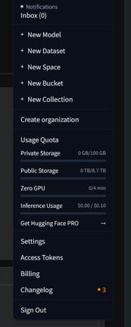

Inference usage is when you talk to the models

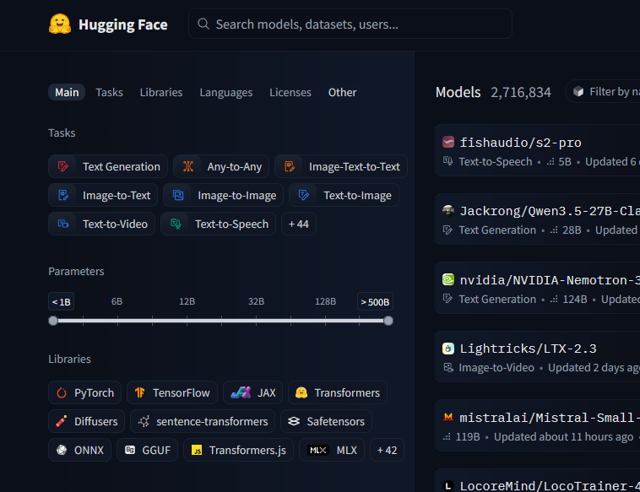
Also you can filter models based on what type of task you are going to run, based on number of parameters.

Llama3 model is free as well, but we got to fill out the form to get access
https://huggingface.co/meta-llama/Llama-3.2-1B
https://huggingface.co/settings/gated-repos to check our permissions (Gated repos)

We got to fine-tune the models, either we can tune with our own data or some data available
https://huggingface.co/datasets

Stanford IMDB dataset is the official one
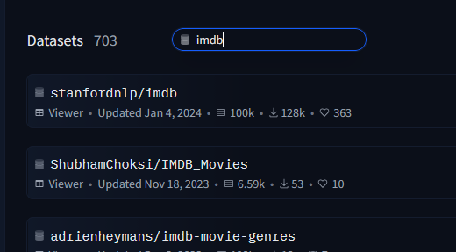

https://huggingface.co/datasets/stanfordnlp/imdb/viewer

In Data studio, we can see all the data

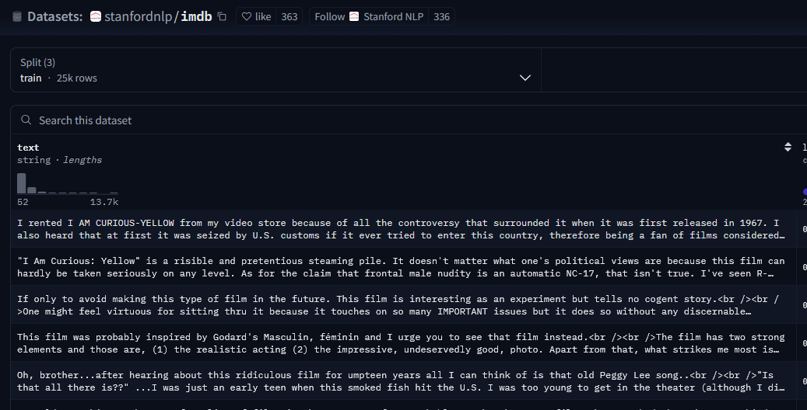
The dataset also has labels like 0 neg, 1 pos

Docs are very good. If you want to use HuggingFace, we have to connect our application to HuggingFace. To connect, we got to use HuggingFace hub.
https://huggingface.co/docs

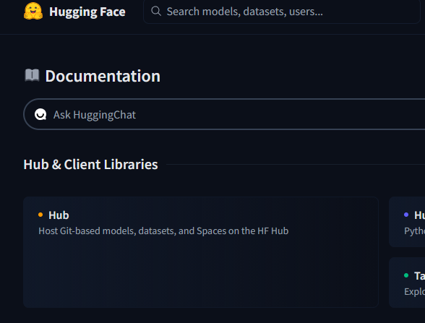

https://huggingface.co/docs/hub/index
if you want to create a web app for your ML demos, we can use Gradio

if you want to deploy your own model, we can do it here: https://huggingface.co/new
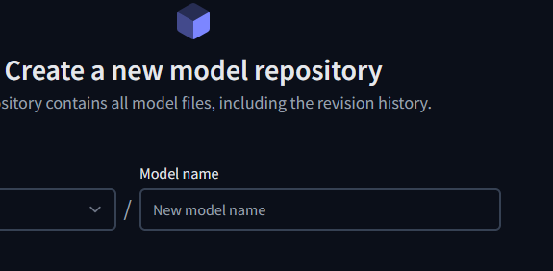

Similar to GitHub repo, we first create an ML model repo then push our model for testing or sharing like Git. We could also download a model, fine-tune and push it there

Lets use Google collab for running models

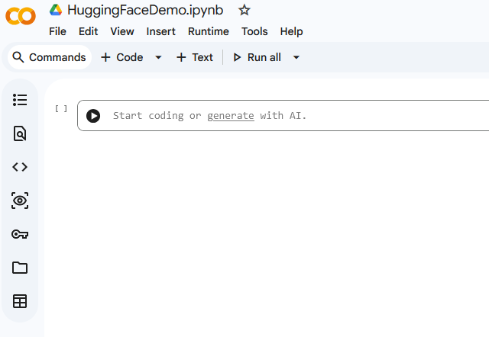

Click Connect

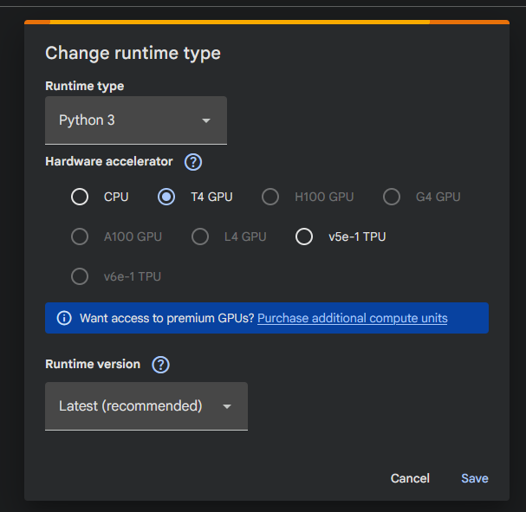

Click View resources

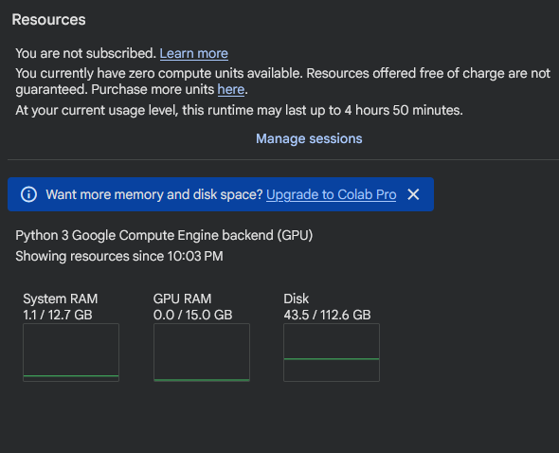

First we need to connect with Hugging Face
if Colab says it doesn’t have access to Hugging Face model, you got to look into keys

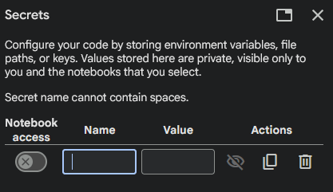

To get access tokens (one for read and write),
Go to Hugging Face => Access tokens https://huggingface.co/settings/tokens

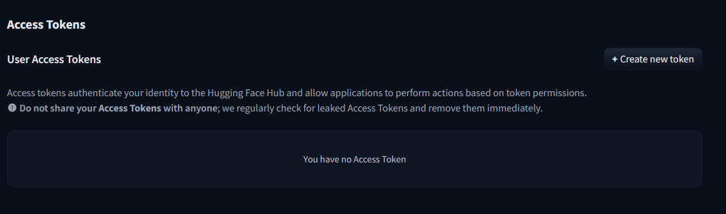
Once you add tokes into Colab, make sure to give Notebook access to the tokens

Fine-tuning results
