MCP – Model Context Protocol

LLM can answer based on what it knows already but not beyond its training. Say if you ask “What’s Java?” LLM can provide the answer. If you ask such a question where LLM has to do some extra work to provide the answer, you need to provide supportive tools like DuckDuckGoSearchRun that LLM can call otherwise LLM will hallucinate. LLM is a separate part, tools are a separate part.

Example code snippet
@GetMapping("/api/{message}")
public String home(@PathVariable String message) {
ChatResponse response = chatClient
.prompt(message)
.tools(dateTimeTool, newsTool)
.call()
.chatResponse(); //.content();

You want something and Agents do it for you and thats the functionality of Agents. Imagine the tools we have created so far are Agents because we want something and they are executing on your behalf, similar to Agents. Lets say we want to push a project to GitHub, the changes need to be added, committed with a good messaged then pushed into Git. If I change the Copilot mode to “Agent”, it can perform tasks on IDE and that means it has control on IDE. However, if I ask Copilot to push code onto Git. Can it do it? To do this, GitHub has to give that power. Say if GitHub says I want to give that capability to the developers. Ultimately, GitHub is a platform for developers and they should do something to achieve this. What if GitHub on their server have some tools pre-created for creating a repository, reading a repository, comparing the conflicts, comparing the branches, creating branches etc. In fact, GitHub already have their own tools that can connect with your LLM. You can write your own code, which can talk to the tools of GitHub so you can make that integration. Next you want to integrate with the chat platform of your company, could be Slack, Zoho etc. As soon as you push the code to GitHub, you want to notify on Slack channel. Slack needs to create some tools to achieve that. Your job is to write some Client or code that will interact with those tools. If you want to interact with remote tools, they have to be exposed via Rest API then you can call them. Slack needs to have some in-built tools and expose them to client like us. Similarly, GitHub also needs to create some tools and expose them via Rest APIs. When I work as a Developer, I interact with multiple services like GitHub, Slack, Jira etc. Even Jira needs to expose some tools in order to achieve that. When that’s done, we could even use LLM/Copilot to say “Create a new issue on Jira, Create a branch on GitHub, Post on Slack channel”. For one prompt, you are interacting with multiple services/tools. We have to write tools on our machine (Client) to interact with the tools of Slack, Jira, GitHub etc. But there is one problem, to interact with GitHub or Jira, we got to write a separate custom code. In the future, if they change any of the feature, we got to modify our code also accordingly. If they move to some other server or change AI service, we got to change in our end also. How do we solve this problem? What if all these services follow a particular standard like Rest API or JSON? First we had Nokia phone with a small pin, then micro-USBs, iPhone lightning port but now we have USB-C in all phones. If you have a standard pin, then it is easier to communicate. Similarly, what if the Servers that are exposing their Endpoints follow the same standards. And that’s possible with the help of Model-Context Protocol (MCP).
https://modelcontextprotocol.io/docs/getting-started/intro

What is the Model Context Protocol (MCP)?
MCP (Model Context Protocol) is an open-source standard for connecting AI applications to external systems. Using MCP, AI applications like Claude or ChatGPT can connect to data sources (e.g. local files, databases), tools (e.g. search engines, calculators) and workflows (e.g. specialized prompts)—enabling them to access key information and perform tasks. Think of MCP like a USB-C port for AI applications. Just as USB-C provides a standardized way to connect electronic devices, MCP provides a standardized way to connect AI applications to external systems.

MCP saves time to connect to external services. Who has built MCP? Anthropic. All major AI providers are using MCP now. Using MCP, ChatGPT or Claude can connect to data sources. Different external services like GitHub or Jira build their own MCP servers and what we are going to build is MCP clients. We have to build a client, connect with a server our job is over. Think of MCP as a USB-C port for all the AI applications.

We are going to use SpringAI for MCP
https://docs.spring.io/spring-ai/reference/api/mcp/mcp-overview.html

SpringAI provides abstraction over Java SDK, similarly, MCP provides abstraction for tool calling. In SpringAI, we can connect with different AI models from OpenAI to Gemini (Eg: spring.ai.openai.api-key=Your_API_Key, spring.ai.openai.chat.options.model=gpt-4o). Spring can connect with different databases from Oracle to MySQL etc. GitHub first needs to create an MCP server then you can create an MCP client.

MCP Host: Machine where you are writing your AI code. Our machine where we have written code in Intelij Idea is our MCP Host
MCP Client: We can create an MCP client on our MCP host
MCP Server: Server that provides those features. Say create a repository on GitHub thats one feature this Server will have. It can have multiple tools or features
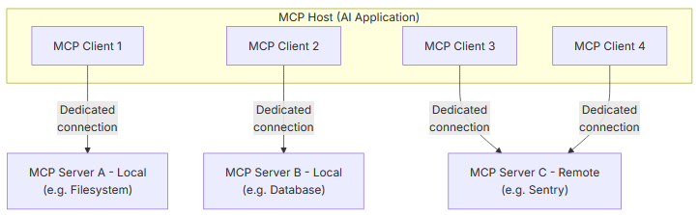

This machine is an MCP Host and we are creating an AI application. In my machine, I can create multiple MCP Clients. One MCP Client can connect to one MCP Server. Say one Server is for the Filesystem, one for Database and one for Remote service like Sentry, GitHub. We can run MCP Server running on the local machine or remote machine. For example, Sentry runs on remote machine, GitHub service runs on the remote machine. Today we will run MCP Server running on the local machine. If you want to call MCP Server, we have to call MCP Client. MCP is not a framework, it is a protocol. When you write an MCP Server, you are not doing anything extra, you are creating a tool which you are writing in the language of MCP. Different protocols use different languages. TCP have their own language to interact between two machines. HTTP has its own language to interact. When you create a tool on the Server, we (Client) have to just adopt the MCP language.

https://github.com/modelcontextprotocol

We have different SDKs available. Java SDK is basically SpringAI itself. If you want to work with Java and MCP, we have just one option, SpringAI.

If you go to Servers: https://github.com/modelcontextprotocol/servers
It shows all our Servers available
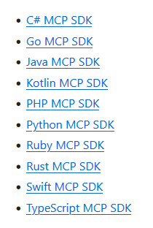

There are so many MCP servers already created, we can call them and use them

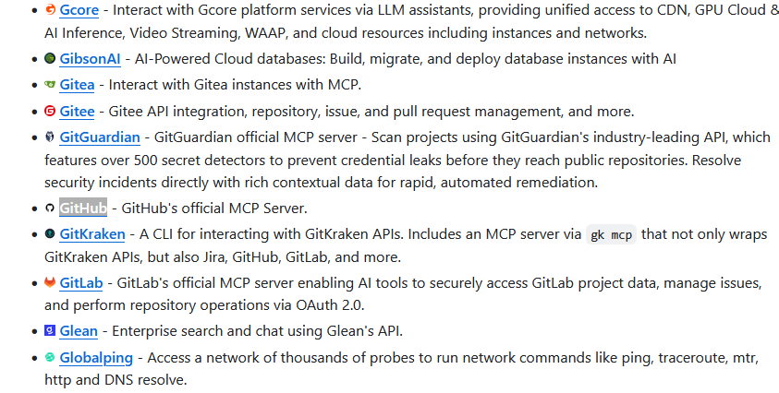

Create a new Spring project: https://start.spring.io/
Dependencies: Spring Web, OpenAI, MCP Client. We will use the existing MCP Server

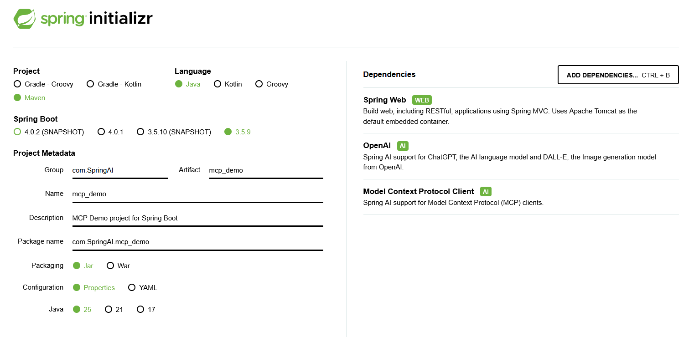
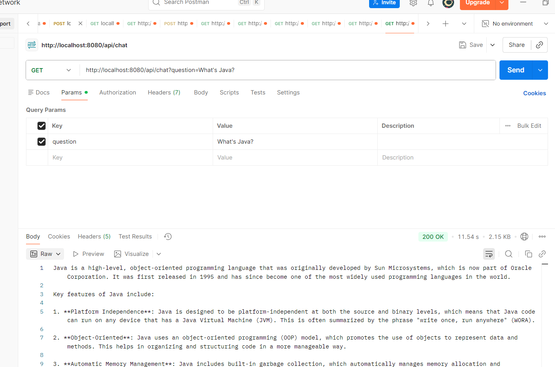

AI can do all these things but it cannot help me with for example, FileSystem: like create a folder
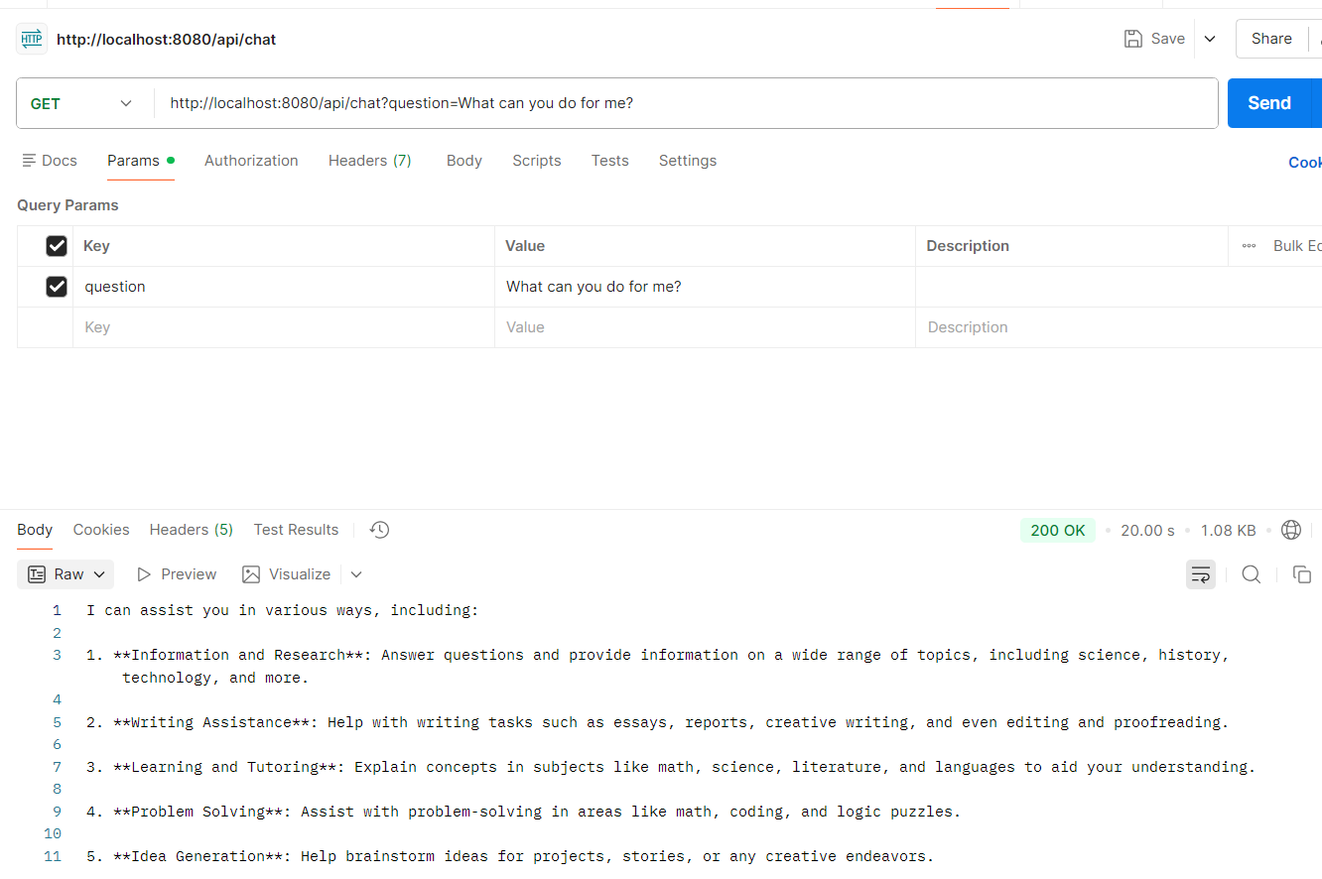
If you go to GitHub and filesystem
https://github.com/modelcontextprotocol/servers/tree/main/src/filesystem

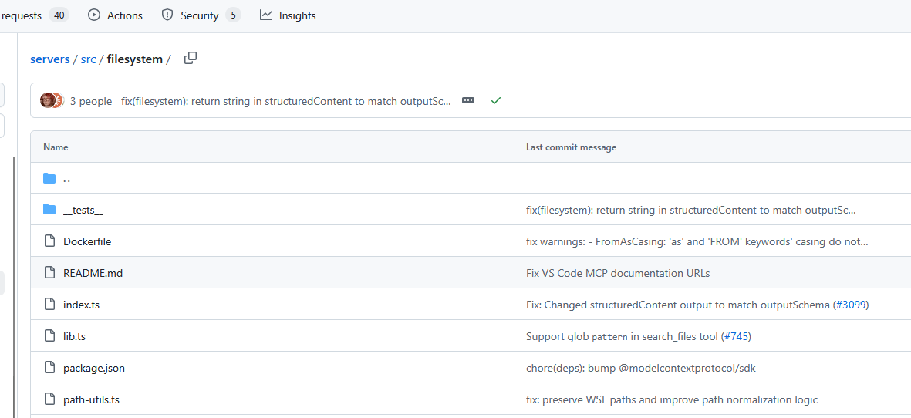

We know how to call tools. Still instead of writing our own Tool codes and calling them, we can use MCP Server that was already created

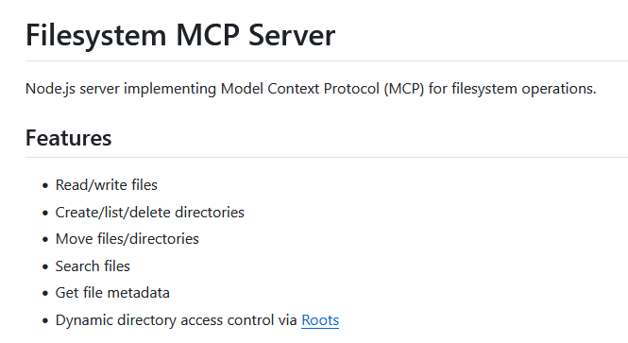

mcp-server-filesystem /path/to/dir1 /path/to/dir2
Any MCP Server can either run on local machine or remote machine. For now, we are going to run on local

We can run with either Docker or NPX

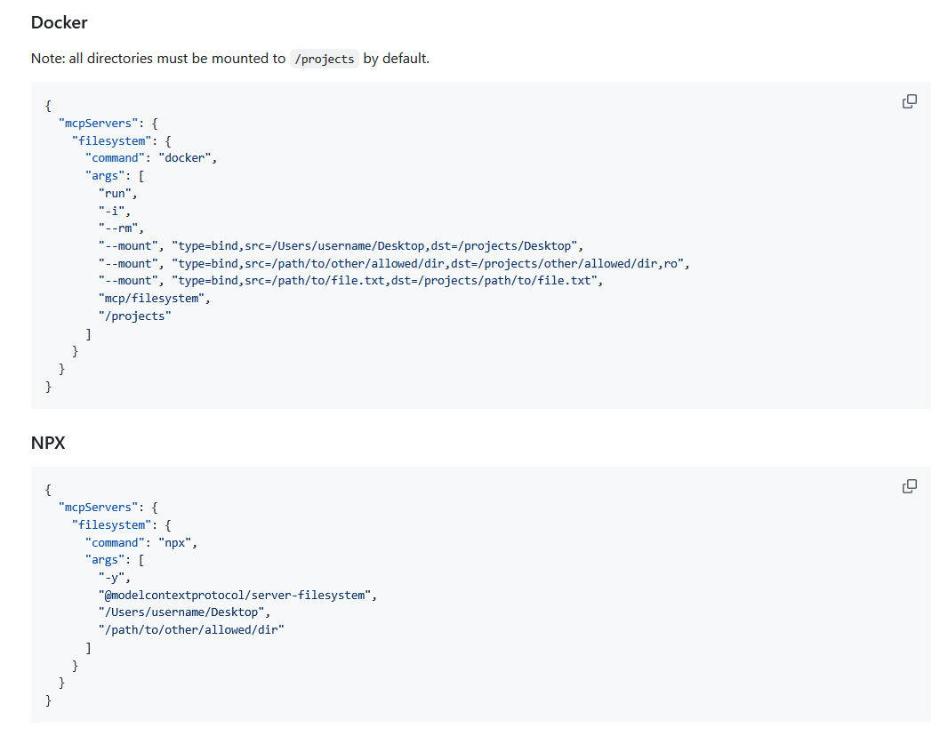
To create MCP Client: spring.ai.mcp.client.stdio.servers-configuration=classpath:mcp-servers.json
we are using stdio because it is on local

https://docs.spring.io/spring-ai/reference/api/mcp/mcp-overview.html

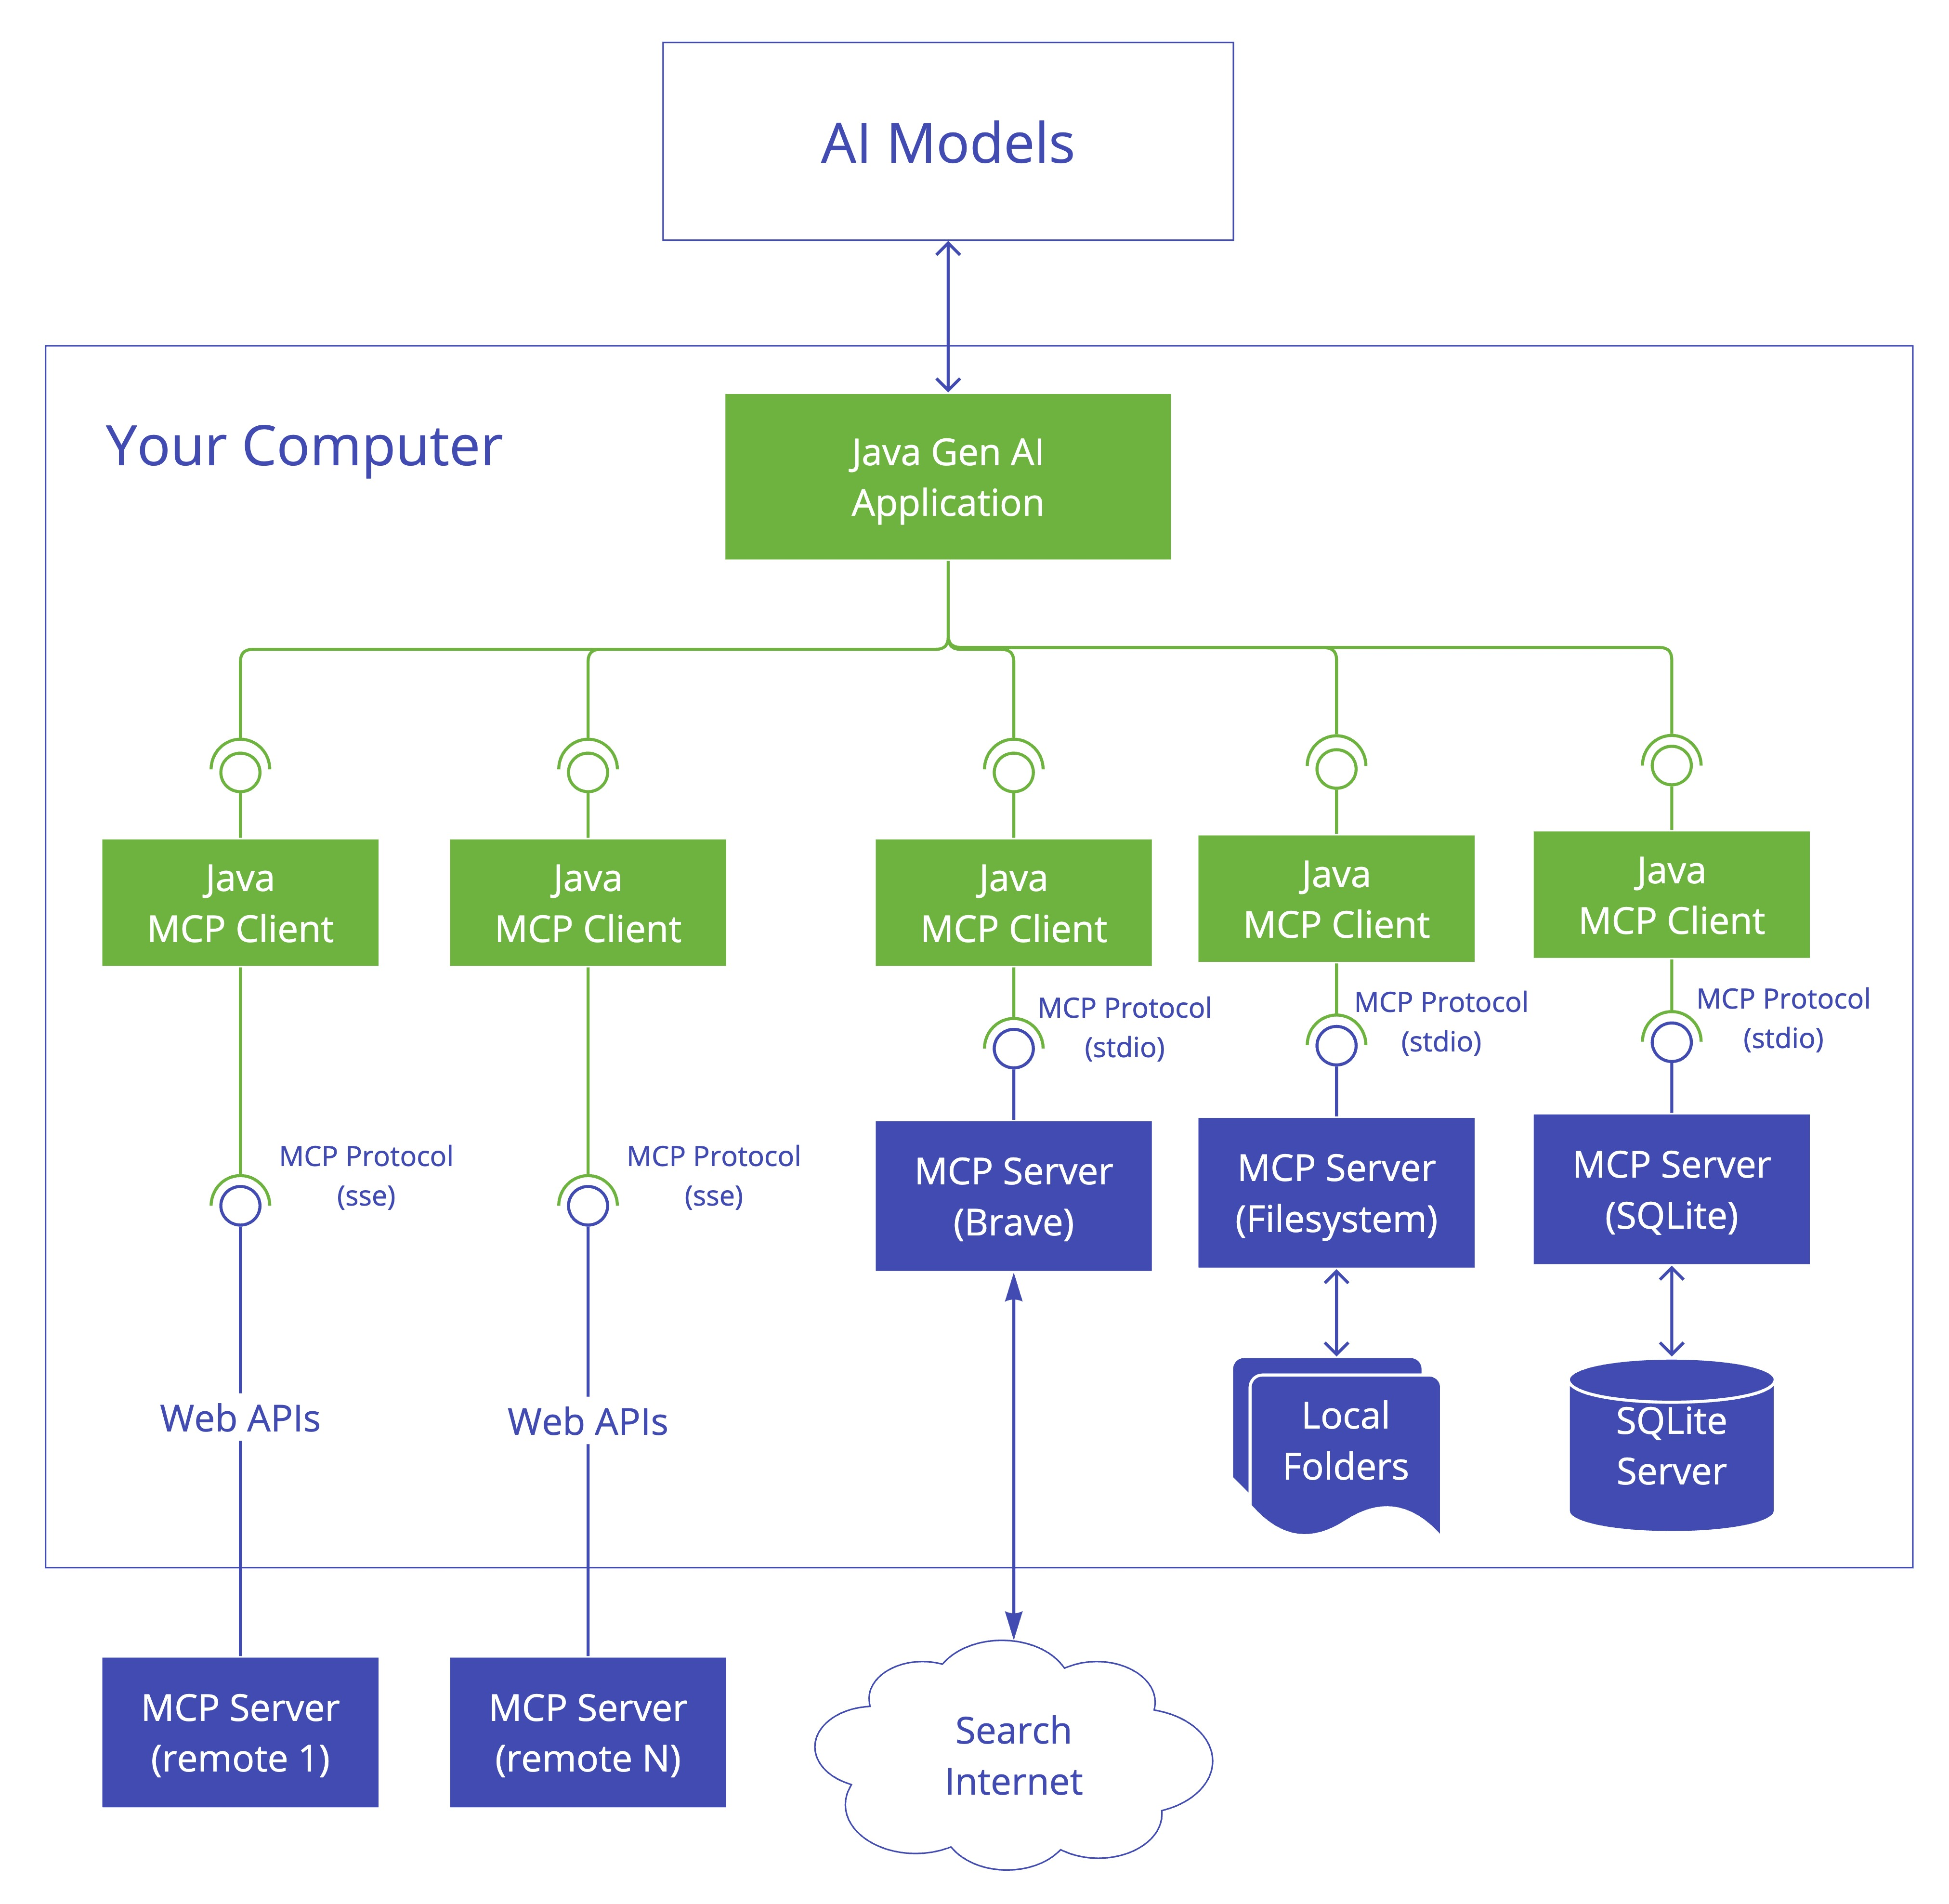

For a Java client to connect to MCP server running on local, we got to use stdio
For Java client to connect to MCP server running on remote, we got to use sse
sse is deprecated, new one is Streamable-HTTP
Which MCP Server to connect and which features we want to expose, must be specified in mcp-servers.json
servers-configuration=classpath:mcp-servers.json
in the resources folder, lets create mcp-servers.json

I have copy-pasted the NPX code

{
"mcpServers": {
"filesystem": {
"command": "npx",
"args": [
"-y",
"@modelcontextprotocol/server-filesystem",
"/Users/username/Desktop",
"/path/to/other/allowed/dir"
]
}
}
}

Check Node is installed
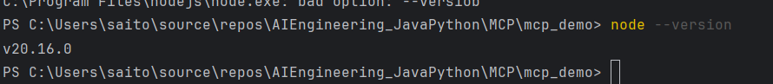

Ensure Node is in System Environment variables

This is for Windows add in the mcp-servers.json
"command": "npx.cmd"

public MCPController(ChatClient.Builder chatClientBuilder, ToolCallbackProvider toolCallBackProvider){
this.chatClient = chatClientBuilder
.defaultToolCallbacks(toolCallBackProvider)
.build();
}

Now we ask the same question

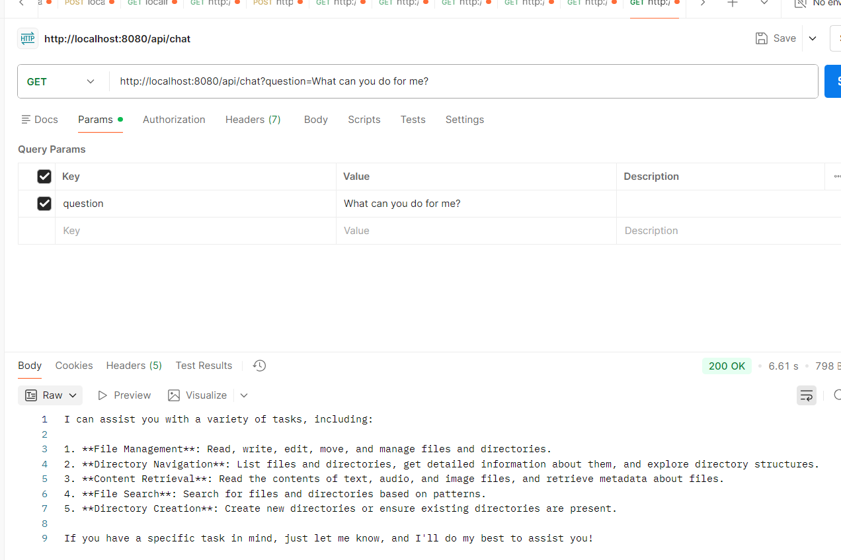

GET http://localhost:8080/api/chat?question=What can you do for me?

It says File management, Directory navigation, Content retrieval

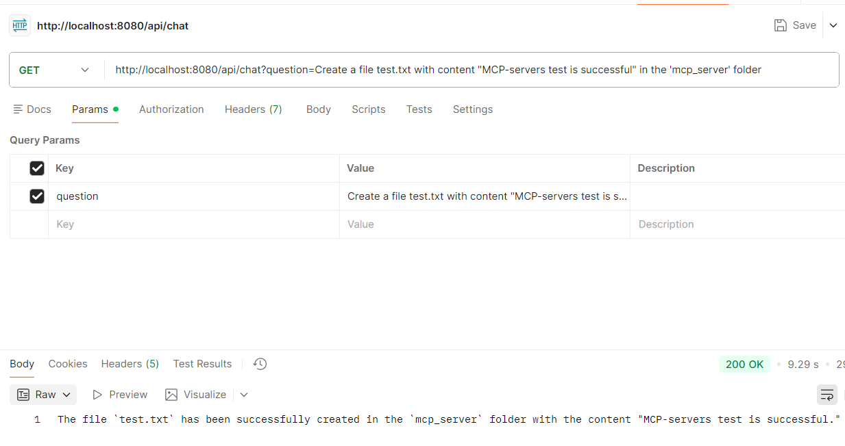
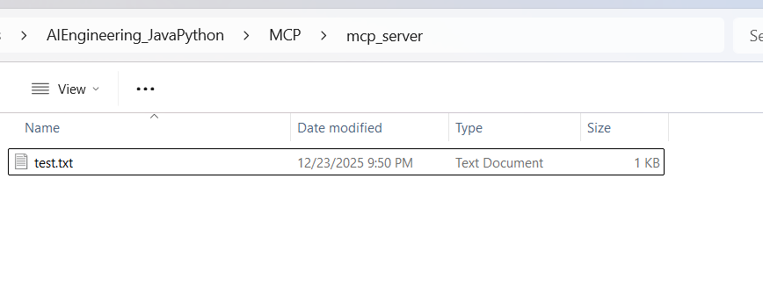
File got created
The file `test.txt` has been successfully created in the `mcp_server` folder with the content "MCP-servers test is successful."

