Environment setup:

Download Cursor for Windows
Cursor: The best way to code with AI

Install Cursor
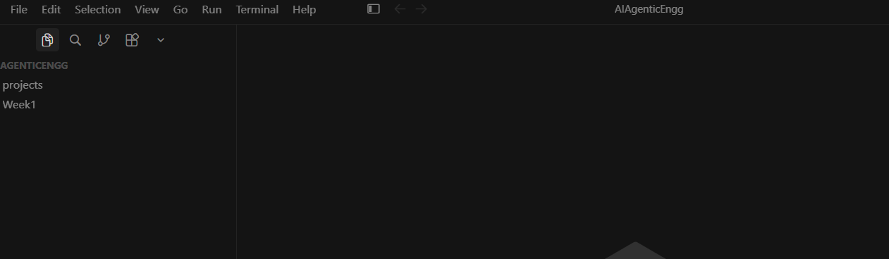
Install UV
uv

powershell -ExecutionPolicy ByPass -c "irm https://astral.sh/uv/install.ps1 | iex"

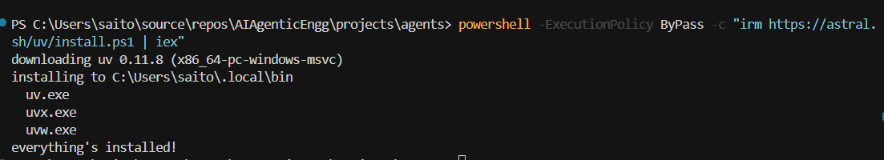
Restart Powershell
uv --version
uv 0.11.8 (0e961dd9a 2026-04-27 x86_64-pc-windows-msvc)

uv sync

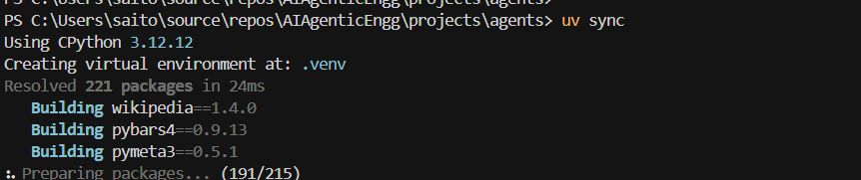

Get OpenAI API Key

Create .env file

Select Kernel => Python environment => Select our Python interpreter

