Model Evaluation

Every model has something in mind when they got started. Later they competed with others and found their strengths.
Artificial Analysis gives the benchmark:
https://artificialanalysis.ai/models
https://livebench.ai/#/?highunseenbias=true

We are going to look into model evaluation in two ways: 1. benchmark provided by this website 2. Code

We have a Jupyter notebook code to evaluate models

Different models were built for different purposes and we want to evaluate them based on our use-case

Say we want to use the models for solving mathematical problems, thats one use-case
We want a model to be very creative
We want a model to generate code - another use-case
You want to test a model whether it is smarter than humans, for this we give competitive exams to AI

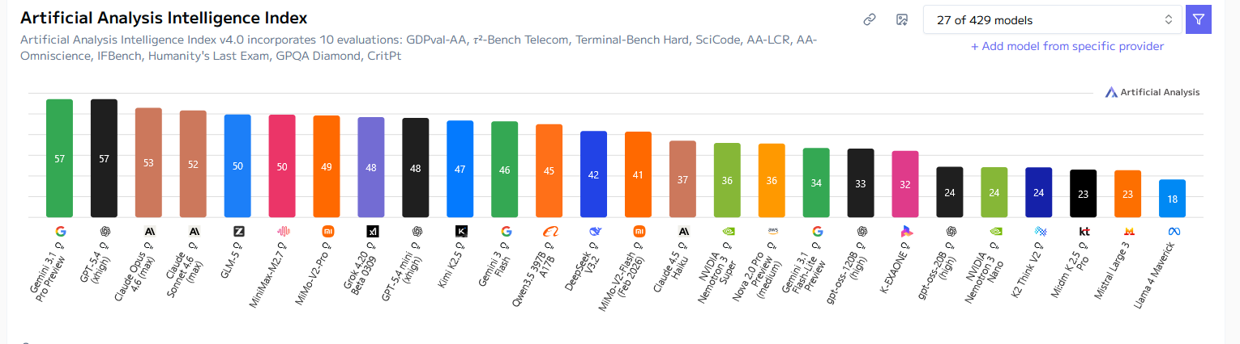
if I want to onboard a new model for comparison, I can do as well

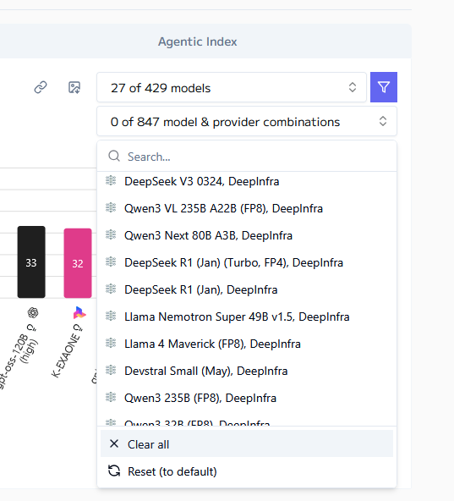

Intelligence vs Price
We need to pick highest intelligence with our available budget

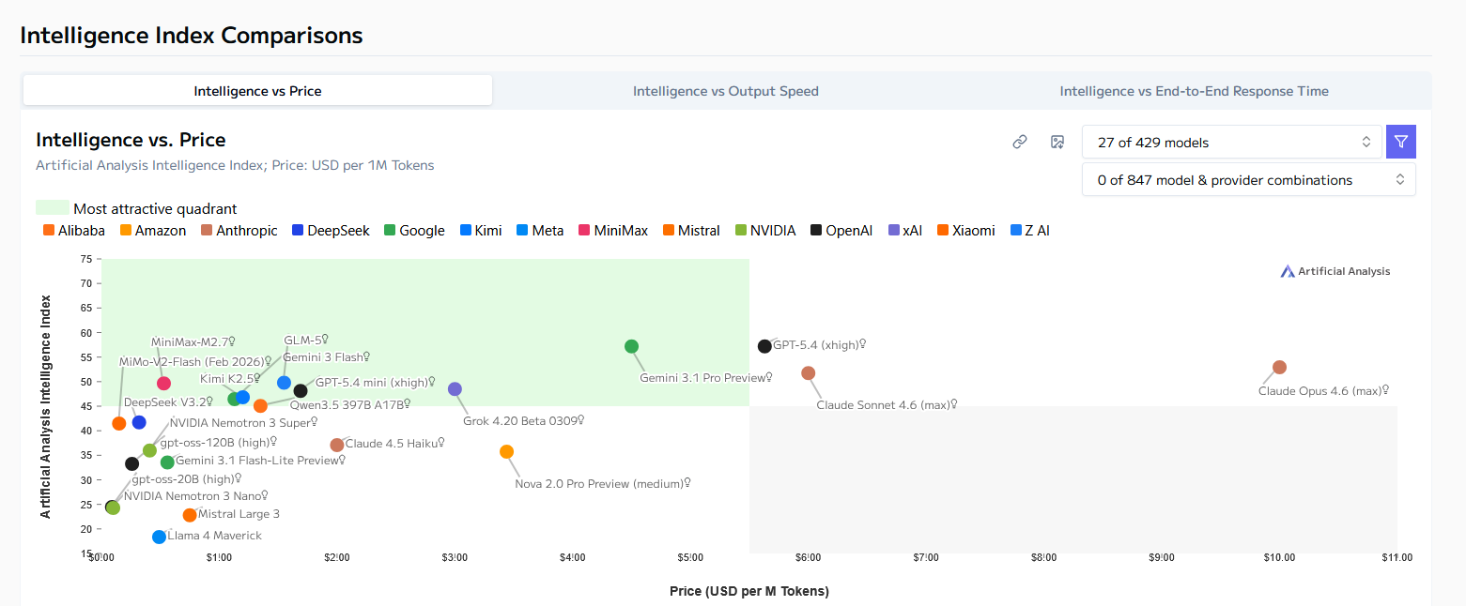

Gemini 3.1 Pro preview might be good

https://livebench.ai/#/?sort=Coding+Average&highunseenbias=true

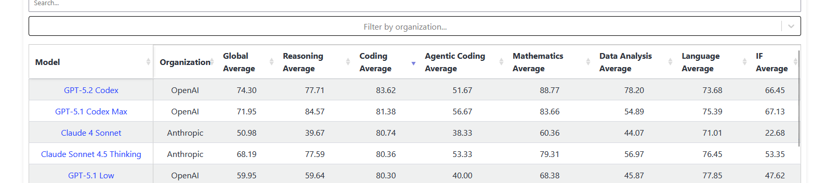

For coding, best model is GPT-5.2 Codex

This is for Benchmarking

How do we evaluate by our code?
We can write code in Python, which is very easy but Python code is very slow. But AI will help you convert into Rust code, which is very fast. We do entire development in Python, everytime we do that, we convert into Rust. We need to select the best model for this use-case. We have 4 models: HuggingFace, OpenAI, Anthropic, Google. Now we want to evaluate.
What should be the evaluation steps?
1. Write Python code
2. Run this code
3. Example: count prime numbers up to 1 million. It takes a lot of time in Python say 4.5 seconds
4. Convert Python code into Rust.
5. I will ask each of the 4 models to convert Python code into Rust
6. 4 different models will give us 4 different Rust codes.
7. Run Rust code from each model and calculate time maybe 0.5 seconds
8. How fast Rust code is running is one metric.
9. Second metric is, how correct the output code is?
10. How much time it takes to generate the Rust code?
11. What if we can ask some other LLM to be a judge?
12. Pass the code output(s) into some other LLM to evaluate the model
13. To run Rust code, install Rust compiler as well
14. Will check if the CUDA is running
15.

27:00

