Added a new Tool to MCPServer because OpenNutrition MCPServer tool failed in MCPClient

npx @modelcontextprotocol/inspector java --enable-native-access=ALL-UNNAMED -jar target/MCPServer-0.0.1-SNAPSHOT.jar

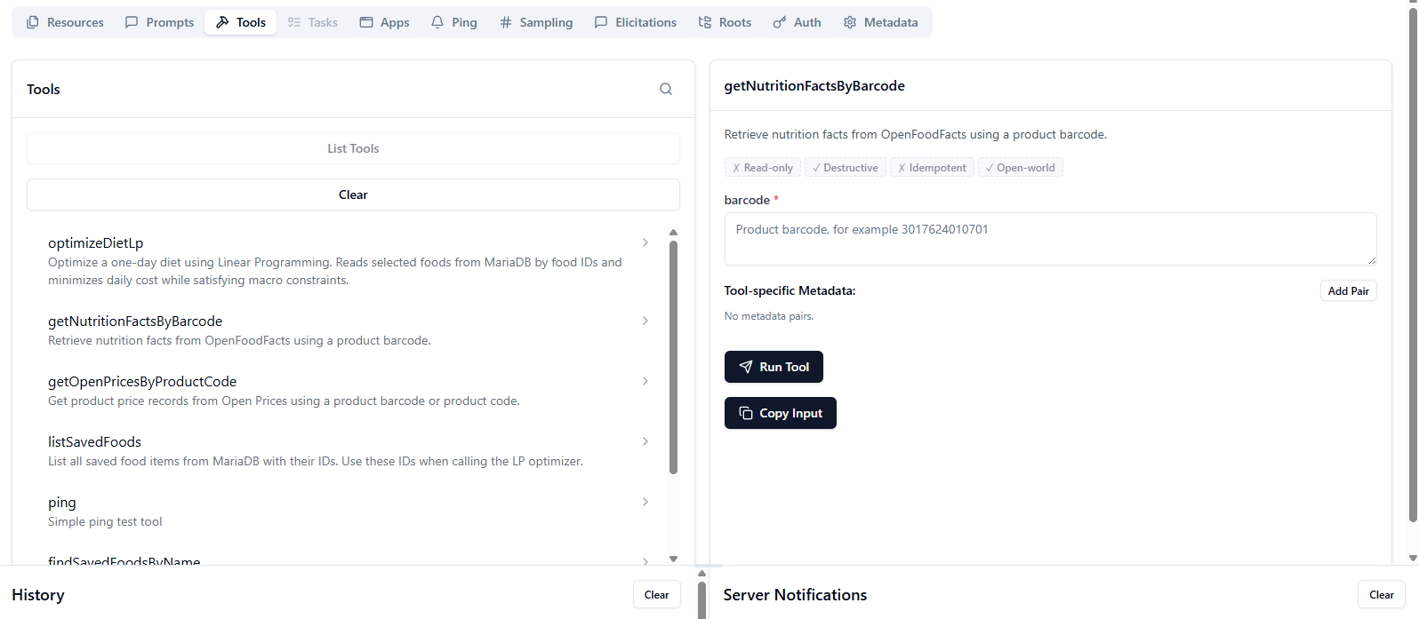

{
"barcode": "3017624010701"
}

{
"barcode": "3017624010701",
"productName": "Nutella",
"brand": "Ferrero",
"caloriesPer100g": 539,
"proteinPer100g": 6.3,
"carbsPer100g": 57.5,
"fatPer100g": 30.9,
"fiberPer100g": null,
"sugarsPer100g": 56.3,
"saltPer100g": 0.1075,
"nutriScore": "e",
"imageUrl": "https://images.openfoodfacts.org/images/products/301/762/401/0701/front_en.100.400.jpg",
"source": "OpenFoodFacts"
}

