Demo and UI
Setup WSL first and it was run on WSL environment

uv run dashboard.py

http://127.0.0.1:7860/

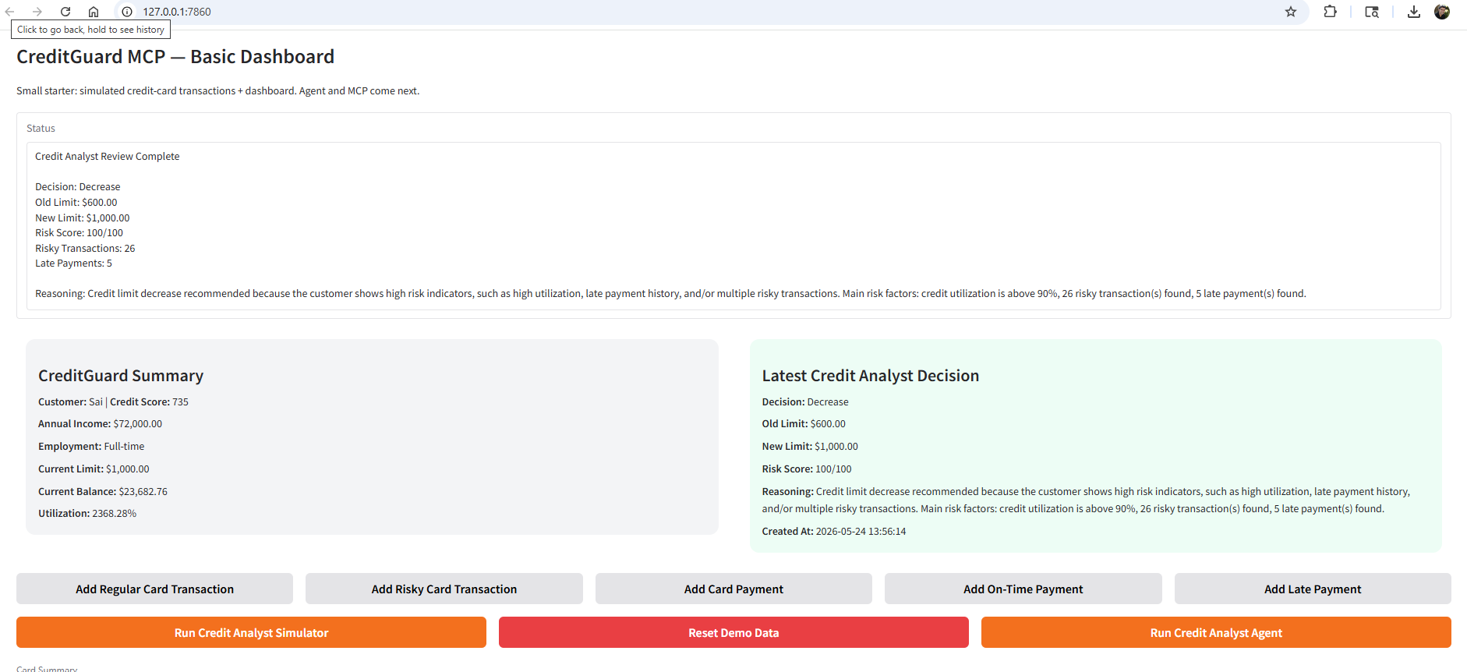
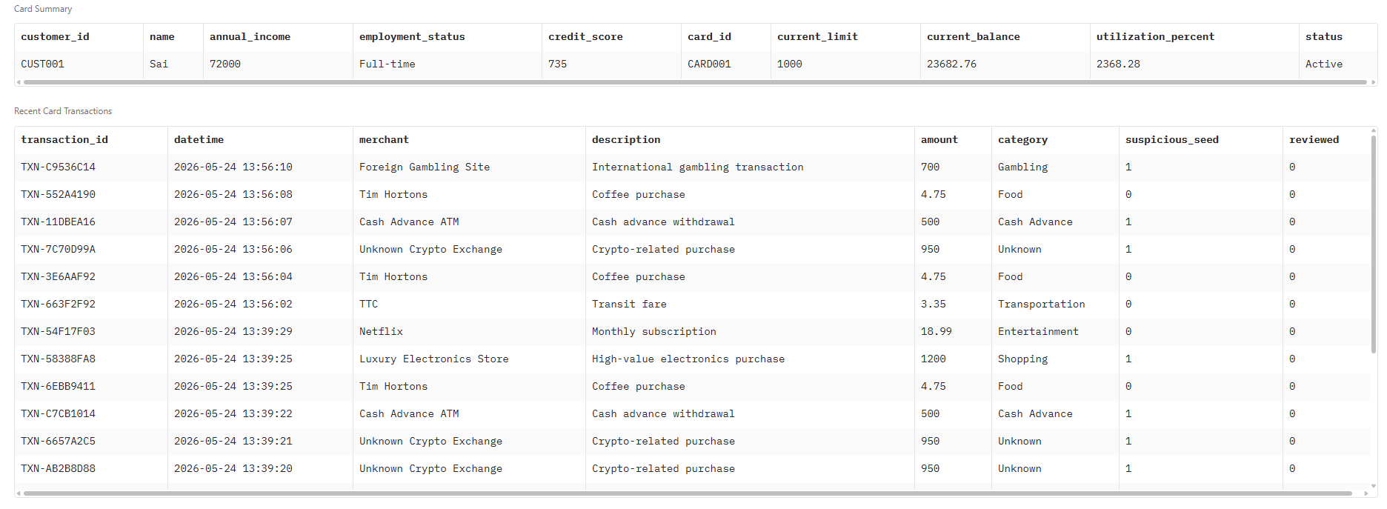

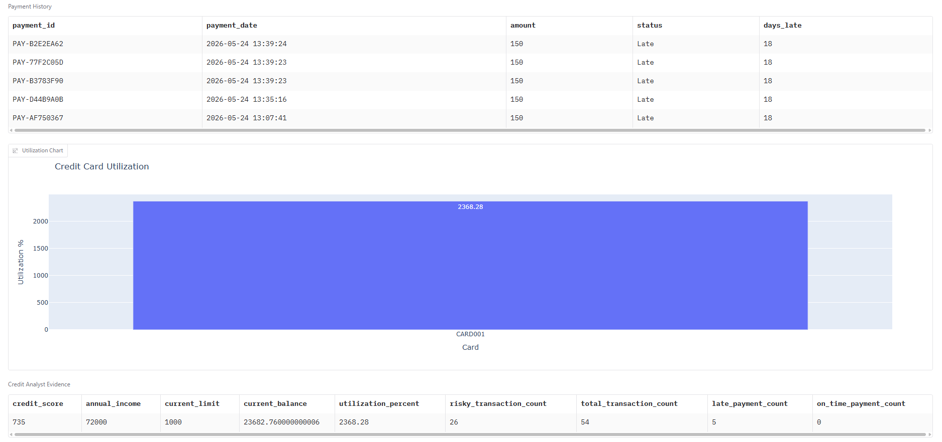
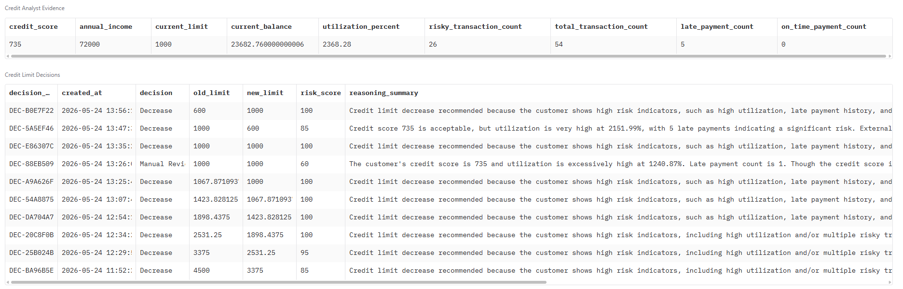
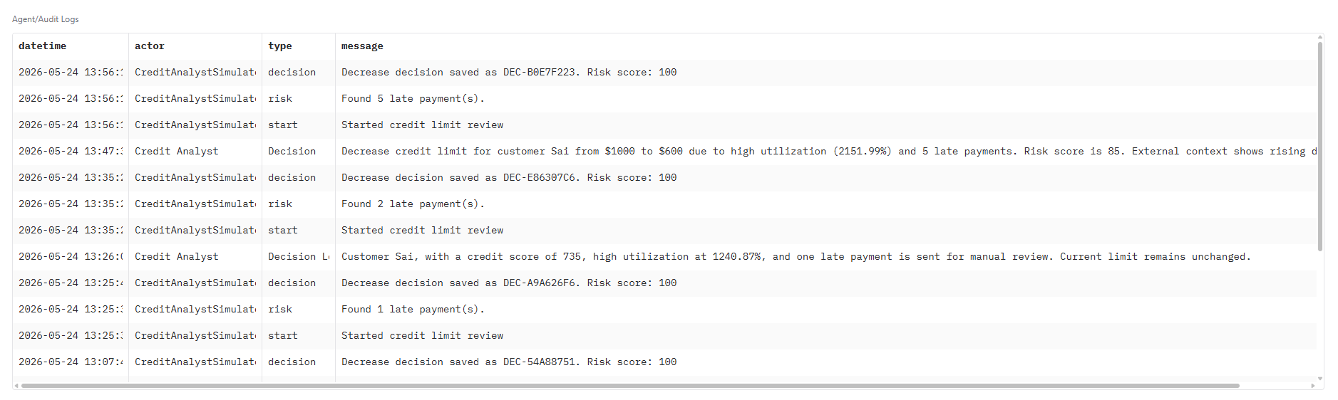

Manual rule-based decisions
Run Credit Analyst Simulator
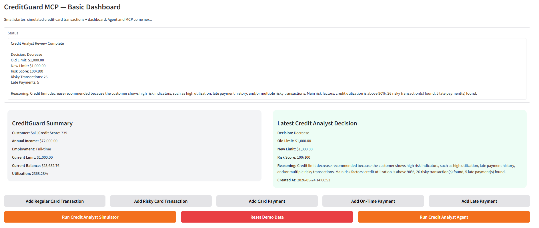

Run Credit Analyst Agent
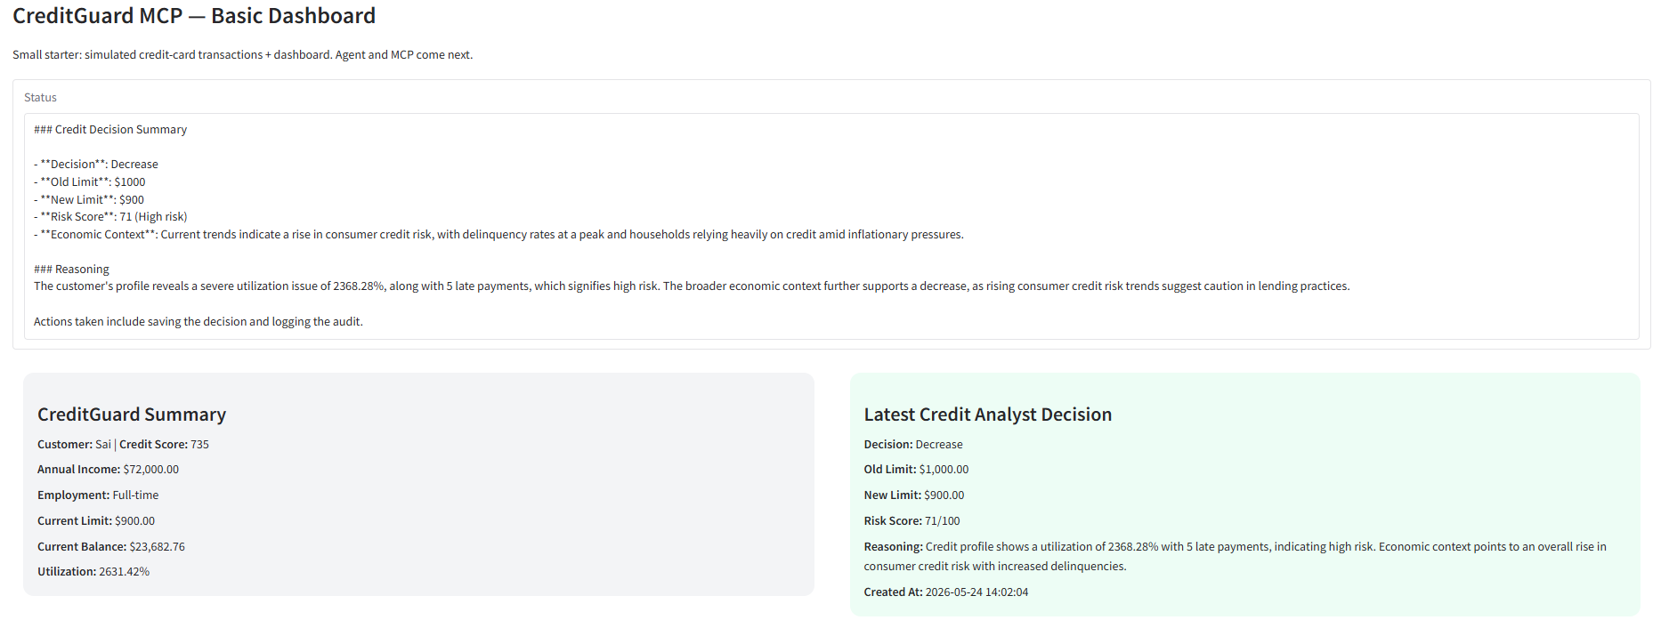

Reset Demo Data and retry

