WSL setup to run MCP Servers locally

We need to install Linux Windows SubSystem (WSL) that allows you to run Linux OS on your PC and running Cursor/VSCode connected to that.

You have to be in Linux Home directory or in the Home directory of the PC. The stuff you want to work on should be in Linux Home directory.

Two ways to do it:
Type WSL or Ubuntu.
If you type Ubuntu, you go straight into Linux Home directory

Open Powershell
wsl --install -d Ubuntu
Create a default Unix user account: xxxxxxxxxx
Password: xxxxxxxxxxxxxxxxxx

wsl -d Ubuntu
cd ~

curl -LsSf https://astral.sh/uv/install.sh | sh
exit
wsl -d Ubuntu to return to Linux
cd ~
mkdir projects
cd projects
git clone <Your_Repo>
uv sync

wsl --list –verbose

from a new Terminal
PS C:\Users\saito\source\repos\AIAgenticEngg> wsl --list --verbose
NAME STATE VERSION
* Ubuntu Running 2

If you have more than one, you might need to do this to make sure that Ubuntu is your default one: wsl --setdefault Ubuntu

Open VSCode
Ctrl+Shift+P and search for Remote-WSL: New Window

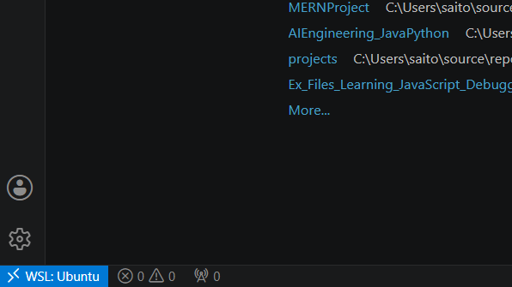

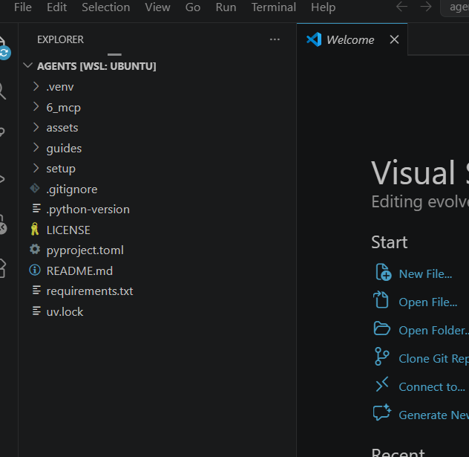

it should show
saito@SaiNov23Comp:~/AIAgenticEngg/projects/agents$ which node
which npx
/usr/bin/node
/usr/bin/npx

