Multi-tool calling

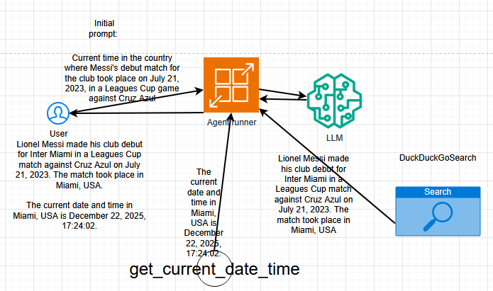

User sends query to chat function() then it gets forwarded to LLM. LLM sends tool call for “country where Messi’s debut match….”, then it executes DuckDuckGoSearchRun, gets response back. Chat function() sends “Current time…” request to get_current_date_time() function. Finally it invokes LLM and gets response for the user.

