RAG – Retrieval Augmented Generation
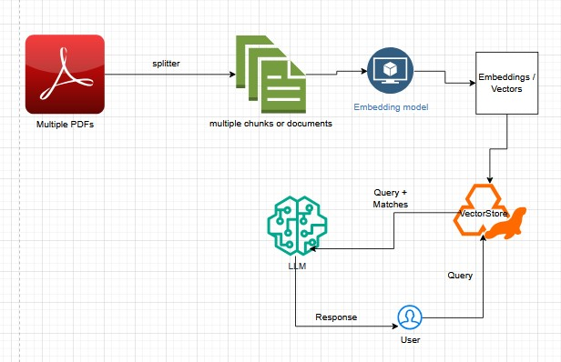

Say you are building a chatbot for your e-commerce website. In this scenario, when you ask for order status, how will AI model have access to your database where you have customer_name, order#, order_status. There should be some way to share your information with LLM. We don’t want to share everything with LLM. That’s where RAG comes into picture. We need the entire structure shown above for processing natural language processing from user chats. Right thats why, instead of sending entire data to LLM, we send only matches. Take the entire information, break down into smaller chunks, from small chunks we get vectors, store vectors in the vector store. From user query, using similarity search, we filter out only relevant documents then we provide to LLM as context. Then LLM will respond to the user.
Go to the project folder, then uv init, uv venv, uv add langchain_chroma

