MariaDB Setup

we need to add Dependency
Since it is MySQL-based we need to add JDBC dependencies as well

<dependency>
<groupId>org.springframework.boot</groupId>
<artifactId>spring-boot-starter-jdbc</artifactId>
</dependency>

<dependency>
<groupId>org.springframework.ai</groupId>
<artifactId>spring-ai-starter-vector-store-mariadb</artifactId>
</dependency>

<dependency>
<groupId>org.mariadb.jdbc</groupId>
<artifactId>mariadb-java-client</artifactId>
<scope>runtime</scope>
</dependency>

Download
https://mariadb.org/download/

MariaDB Server
Download the latest version

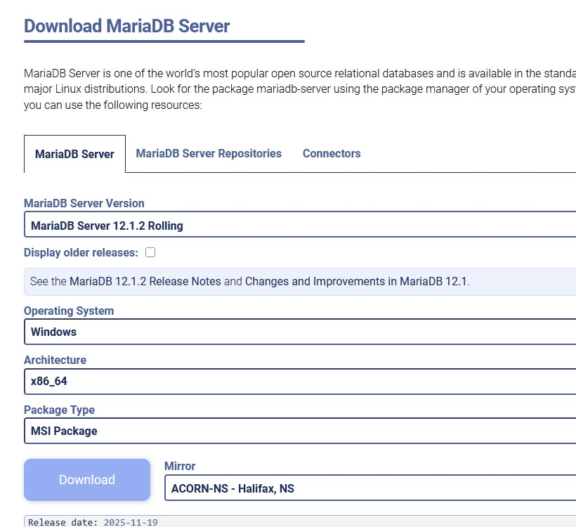

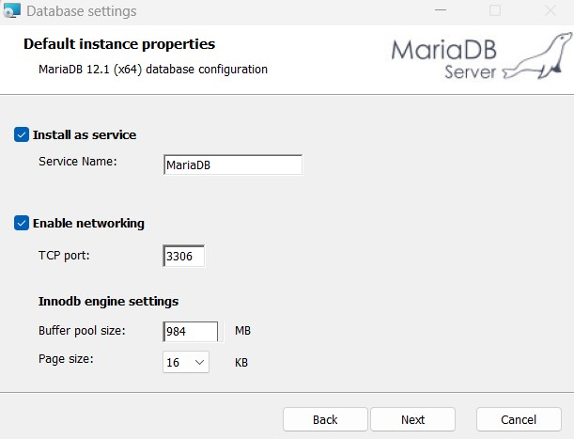

Look for MySQL client
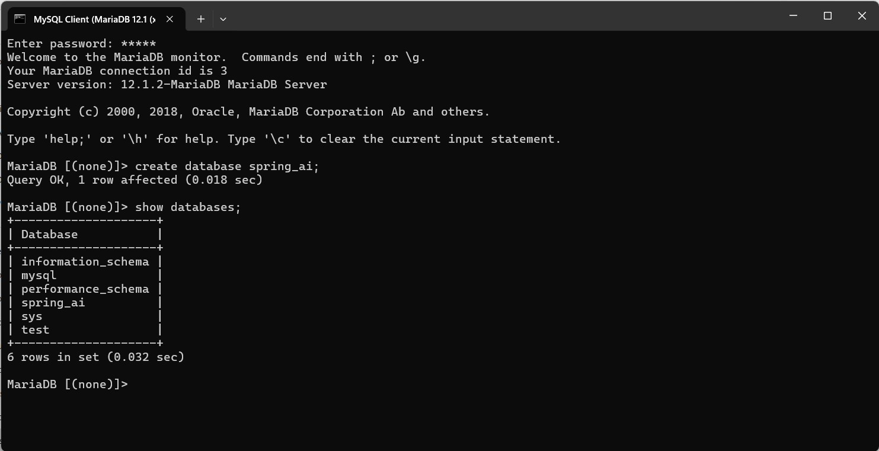

Open MySQL Client MariaDB

Add schema.sql into the init folder inside resources folder
CREATE TABLE IF NOT EXISTS vector_store (
id TEXT PRIMARY KEY,
content TEXT,
metadata JSONB,
embedding VECTOR(1536))
);

CREATE INDEX IF NOT EXISTS vector_store_embedding_idx ON vector_store USING HNSW (embedding vector_cosine_ops);

select * from vector_store;

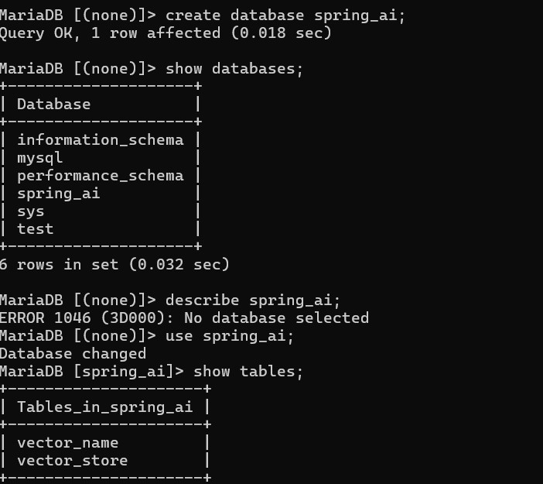

MariaDB [spring_ai]> select id, content, metadata, VEC_ToText(embedding) AS embedding_text from vector_store; ---> this will actually give the embedding

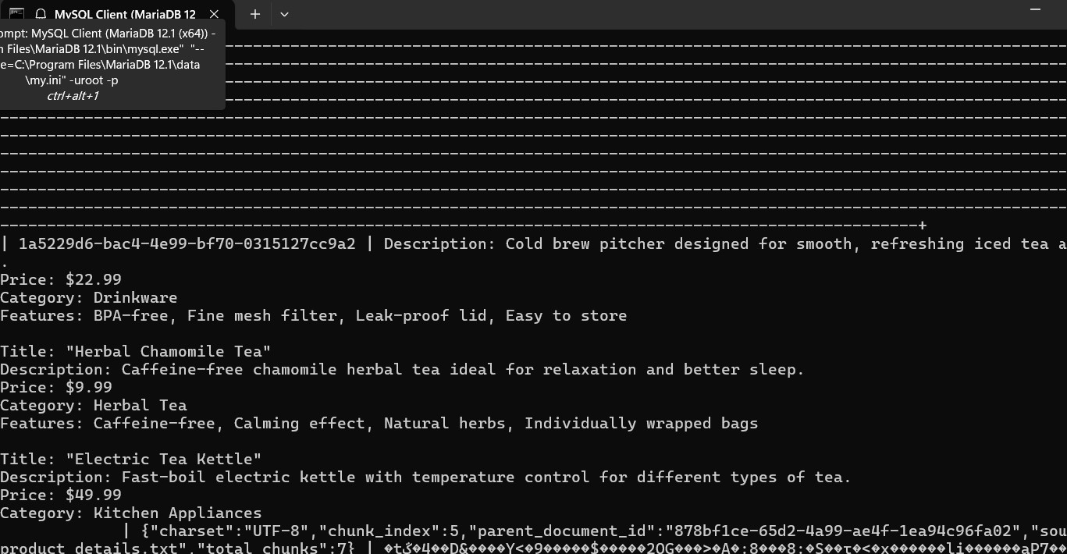
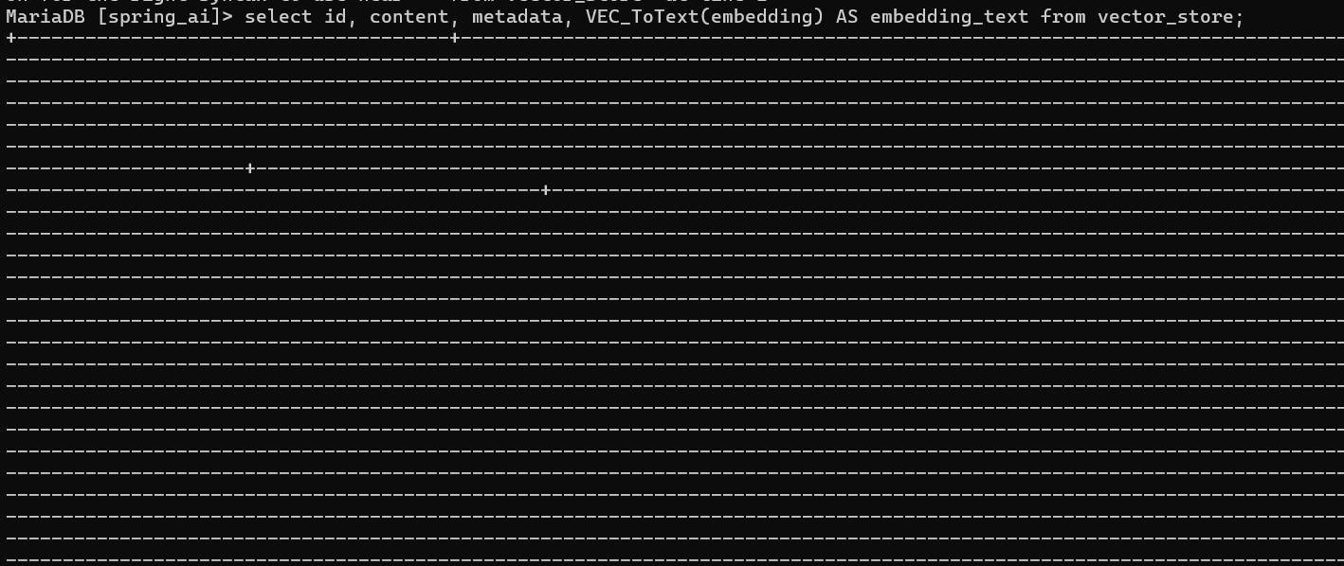
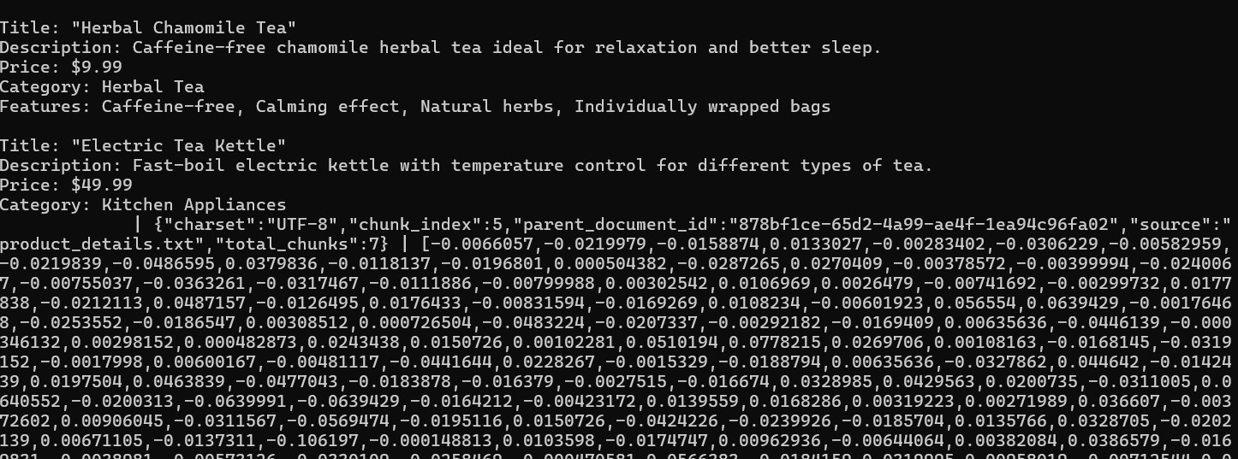
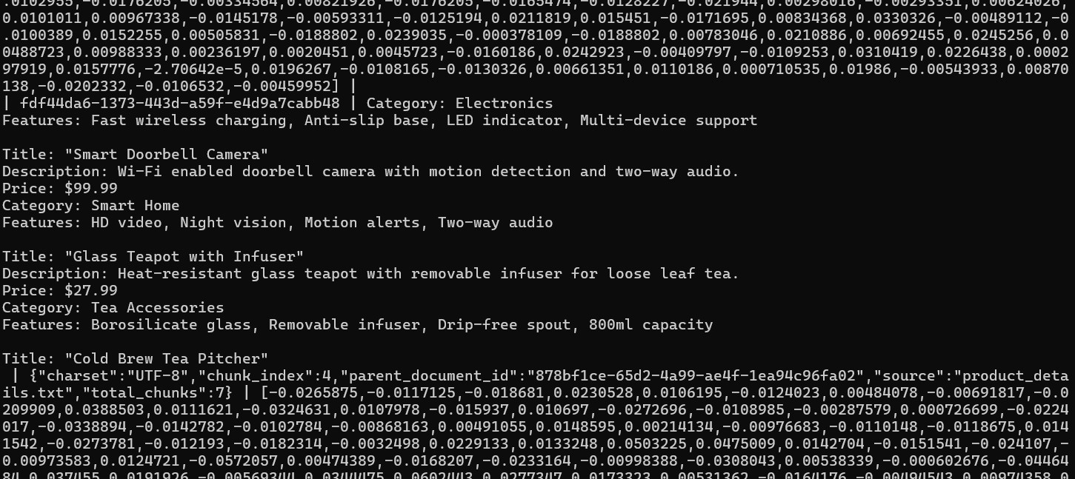

You can also use beekeeper studio

i ran the same query in HeidiSQL: select id, content, metadata, VEC_ToText(embedding) AS embedding_text from vector_store; ---> this will actually give the embedding

