LangGraph Conditional Edge:

In a Graph, we have multiple workflows: Sequential, Parallel and Conditional
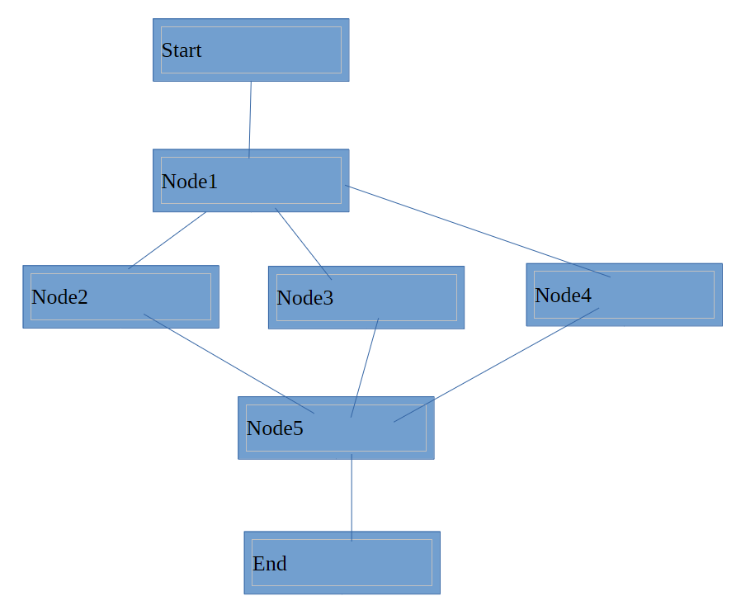

Difference between Parallel and Conditional workflow:
After Node1, in Parallel workflow we execute all Node2, 3, and 4. In Conditional, you are not going to execute all nodes, instead, we are going to select one of the three Nodes or options. Based on output from Node1 from AI, it will decide whether we should execute Node2, 3 or 5. In programming, we do it with the help of If-else. If you are executing Node2, then Node3 and 4 are not executed.
Instead of saying add_edge(start, N1), we will say addConditionalEdge(N1, router). In conditional edge, we will create a function called as ‘router’, based on the decision from router you will either go to N2, N3, N4. In a conditional edge, we add two things, Node and router. How do we create that router?

For this, we want to decide the category of the user
BMI < 18.5 => Underweight
18.5 <= BMI < 25 => Normal weight
25 <= BMI < 30 => Overweight
BMI >= 30 => Obese
Dotted lines are conditional edges. ‘find_category’ is the router.

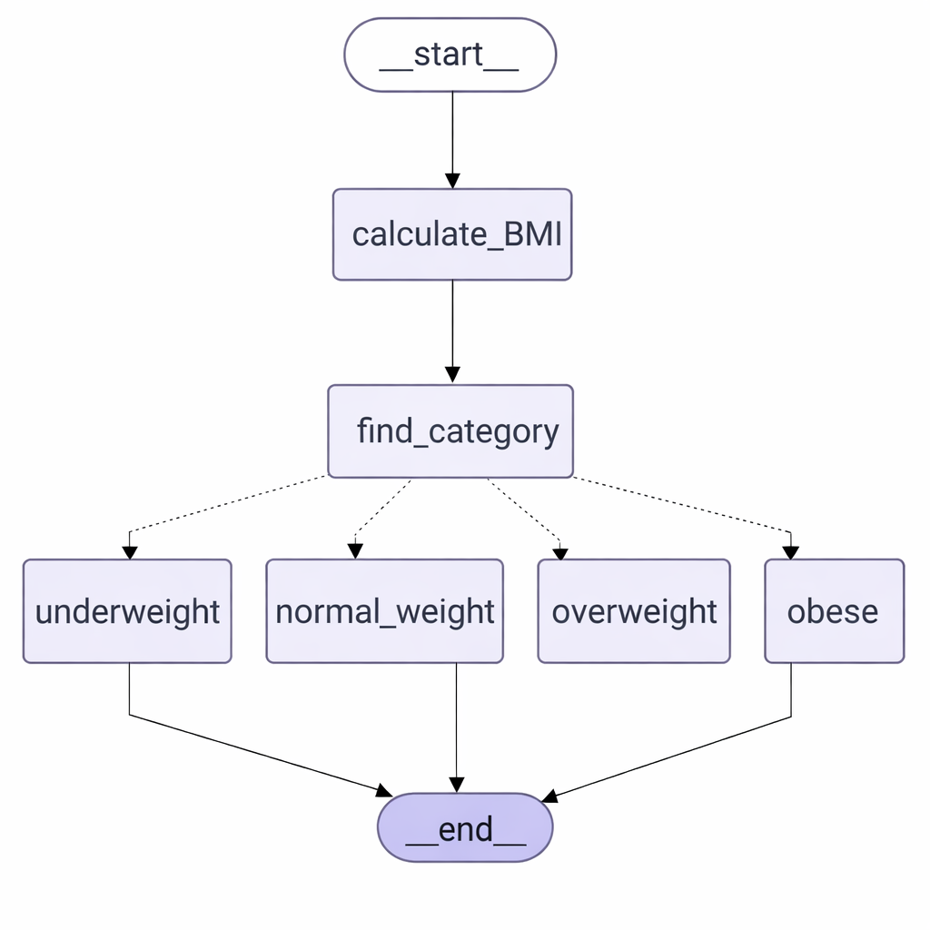
It can be used in credit card operations also, in creditcards, we get different kinds of cards, how much reward points per transaction we get depends upon type of credit card.

Old way would be:
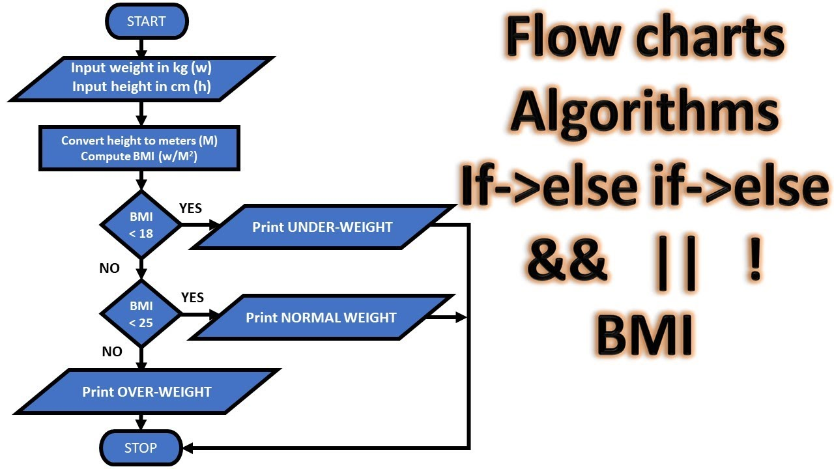

bmi_conditional.py
{'weight': 50.0, 'height': 170.0, 'bmi_value': 17.3, 'bmi_category': 'Underweight', 'bmi_explanation': "A BMI below 18.5 is categorized as underweight. This can be due to factors like nutrition, metabolism, genetics, or underlying health conditions. It's important to ensure adequate nutrition and consult a healthcare provider if necessary.", 'response': "BMI: 17.3 - UNDERWEIGHT\n Status: Underweight\n Recommendation: 1. **Increase Caloric Intake:** Focus on eating more calories than your body burns. Aim to have frequent meals and snacks throughout the day. \n - Include energy-dense foods like nuts, seeds, avocado, and olive oil in your diet.\n - Consider incorporating smoothies or shakes made with full-fat milk or yogurt.\n\n2. **Nutrient-Dense Foods:** Ensure that the extra calories come from nutritious sources to improve overall health and support muscle gain.\n - Choose whole grains, lean proteins, fruits, vegetables, and healthy fats.\n\n3. **Protein-Rich Diet:** Proteins are essential for growth and muscle development. \n - Incorporate lean meats, poultry, fish, eggs, beans, tofu, and dairy products into your meals.\n\n4. **Strength Training:** Engage in regular strength or resistance training exercises to build muscle mass, which can help increase weight in a healthy way.\n - Consult with a fitness trainer if needed to develop a safe and effective workout plan.\n\n5. **Limit Cardio:** While cardiovascular exercise is important for health, limiting excessive amounts may be beneficial if you're trying to gain weight.\n - Focus more on strength building exercises instead.\n\n6. **Monitor Your Progress:** Keep track of your weight gain journey by weighing yourself regularly and recording your progress. \n - Adjust your diet and exercise routine as needed if you aren’t seeing desired results over time.\n\n7. **Stay Hydrated:** Drink plenty of fluids throughout the day, but avoid filling up on water or other low-calorie drinks before meals, which may reduce appetite.\n\n8. **Consult a Healthcare Professional:** For personalized advice and to rule out any underlying health issues that might be contributing to being underweight, seek guidance from a doctor or registered dietitian.\n\n9. **Ensure Proper Sleep:** Adequate rest is essential for recovery and muscle growth. Aim for 7-9 hours of quality sleep each night.\n\nRemember, gaining weight can be just as challenging as losing weight, so it's important to be patient with yourself and focus on gradual, healthy weight gain.\n "}

