AI Agents

Year 2025 was the year of AI Agents. Even in IDEs like VSCode or IntelliJ Idea, you can see AI Agents that can write code for you or execute projects for you. AI Agents are there for Google Ads that can run Ad campaign. Entire idea behind AI Agents is to achieve a particular goal.
An AI Agent is an AI system that works toward a goal, not just a one-time answer.
For AI Agent, first we will do in Langchain then SpringAI. The reason we are not starting with SpringAI is because we don’t have a separate concept called as AI Agents in SpringAI. Whatever we can achieve with Langchain can be achieved with the ChatClient (with other tools combined) in SpringAI. Both Langchain or SpringAI is ultimately reaching that one point and that’s the goal.

See thats where we need AI Agents, say if you ask ChatGPT to give code for Spring Security or Login button, it will give you code, you can simply paste it but somewhere you are involved. But lets say you want to automate the process, you can ask VSCode in your IDE to create a page with Login button. It will understand your project structure, it will look at your code files then existing designs then it will automatically create a new page based on your existing designs. That means it is doing a lot of things automatically without your intervention. AI Agents can achieve a goal and it can do that with two things: 1. LLMs, 2. Tools. Why we need these two things? Because we have something called as ReAct (Reasoning and Acting). Acting can be done with the help of tools like to save something in database, create a file, do a Google search. So if you combine LLMs with tools, it will give you power to create AI Agent. ReAct is a design pattern to achieve AI Agent and it is one-way of doing it. There are other design patterns as well. If you go to ChatGPT and look into the thinking mode, you can see what ChatGPT is thinking, How the model is working and it will give you the response. If LLM can do external thoughts and if you combine with tools, we get the Agents.

In our previous example multi-tools.py, we used ‘while’ loop to achieve the same end goal. We are going to achieve the same end goal without that ‘while’ loop with AI Agents
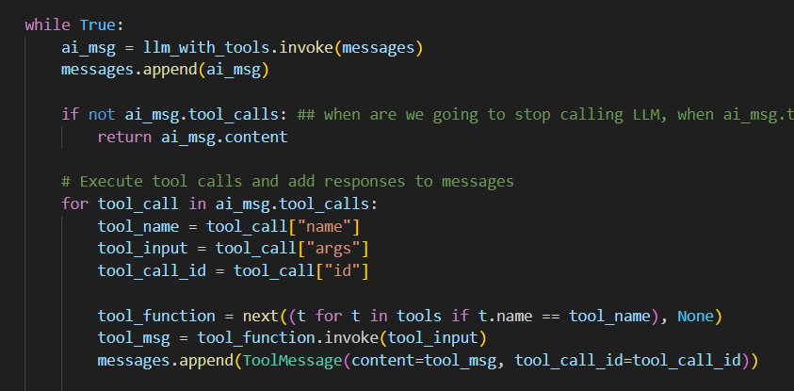

Why we need the ‘while’ loop?
If LLM knows the answer it is going to give you. What if LLM doesn’t know the answer (say the question is about recent news, your product data or current time) but needs the use of tools to give you the answer. However you inform about the availability of tools, so if LLM doesn’t know the answer and it can execute tools that host machine has, to give you the answer. If the message coming back from LLM has a tool calling, [“if not ai_msg.tool_calls:”], you are going to call it. But how many times? It depends on when the LLM is ready to give you the answer, until then tool calling is going to happen. That means, as long as, LLM is going to say “tool call”, “tool call”, you are going to execute the ‘for’ loop. If there is no further tool_calls, we are going to return ai_msg.content. What if it can be done by AI Agents? Entire ‘while’ loop can be taken care by the AI Agents with the help of ReAct design pattern.
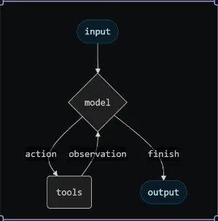

In this image, request goes to the model (currently we have the ‘while’ loop to handle the input), if you don’t want to handle request by yourself. If model cannot give you an answer, if we provide the tools, it will make a tool call (action), tool responds back to model (observation). If model thinks tool response is ok, it will call it done. Model first figures out the country then looks for the current time. Once it is ok with the observations, it will give you the final response (output). Thats how ReAct works, Reasoning and Acting. Before AI Agent does anything, it creates a plan. Plan is very important, without a proper plan, you will not know which tool to call. Sometimes, plan might change in between based on tools response. Say if you want to plan a trip, you can ask LLM to plan a trip for you based on your liking, budget, means of travel. What if you automate everything start to end? Will you trust AI Agents for everything? Answer is no. it might book a hotel that’s not safe or book an expensive flight etc. So we want human in loop. That means it will ask you can I book this flight? Only if you say ‘yes’ it will book that flight for you. So the loop is Thought => Action => Observation and it goes in a loop.

Query: “Current time in the country where Messi visited in Dec 2025”
Available tools:
- get_current_date_time(): Get current date and time
- duckduckgo_search: Search the web information

Thought: I need to find out which country Messi visited in December 2025
Action: duckduckgo_search
Action Input: “Messi visit in Dec 2025”
Observation: Messi visited India in December 2025 for G.O.A.T India tour

Second thought
Thought: Now I need to get the current time in India
Action: get_current_date_time()
Action Input: {}
Observation: 2026-01-05 14:30:45

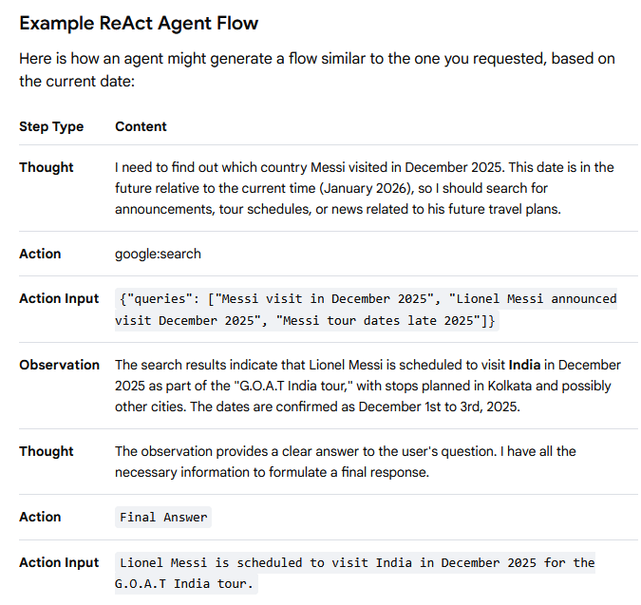

if you don’t want to write this ‘while’ loop code, you will need to create a “ReAct” Agent

if you want to execute an Agent, thats where we need “Agent Executor”
An Agent Executor is the core component in AI systems (like those in LangChain) that manages an agent's workflow, iteratively calling a Large Language Model (LLM) and tools to achieve a goal, essentially acting as the "brain" that plans, executes, observes, and repeats until a final answer is reached. It takes user input, feeds it to the agent, executes chosen actions (like using a search tool or calculator), and processes the results in a loop, managing the entire process from intent to concrete action.
- it manages the entire ReAct loop
- sends messages to the Agent
- Executes tools based on Agent’s decisions
- collects results and feeds them back to the Agent
- controls the loop until Agent says “Final Answer”
The Agent + AgentExecutor flow, commonly implemented in frameworks like LangChain, involves the agent dynamically selecting and using tools to achieve a goal.
Here are the seven steps describing this workflow:

User Input: The process begins when a user provides an initial request, prompt, or goal to the agent.
Thought/Reasoning: The agent (a large language model) receives the request and, based on its internal logic and access to tool definitions, determines the necessary steps to fulfill the request. This often involves an internal reasoning process, generating a plan or "thought".
Tool Selection: The agent decides which specific tool or tools are needed from its available set to execute the current step in its plan.
Action Formulation: The agent formulates a specific action call, including the name of the selected tool and any required input parameters (arguments) extracted from the user's request or its current thought process.
Action Execution (Executor Role): The AgentExecutor intercepts the action call, runs the selected tool with the specified inputs, and captures the tool's output (e.g., search results, a file operation result, or an API response).
Observation/Result: The output of the executed action is returned to the agent, providing an "observation" of the outcome.
Iteration or Final Answer: The agent evaluates the observation.
If the goal is not yet met, it iterates back to Step 2 (Thought/Reasoning) to decide the next action based on the new information.
If the goal is met, the agent generates a final, comprehensive answer for the user, concluding the flow.

For the Agent, we need to add create_react_agent() function

https://docs.langchain.com/oss/python/langchain/quickstart

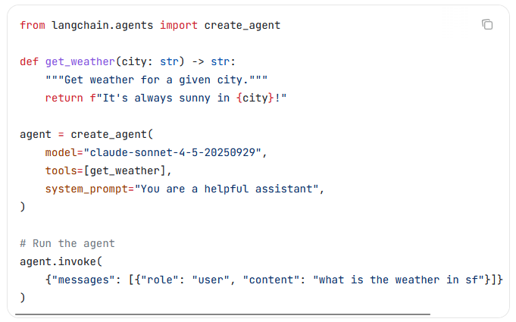

We are creating an agent with the help of create_agent(), behind the scenes, it uses Langraph. Since we are not familiar with Langraph, we are going to start with create_react_agent() function.

from langchain_classic.agents import create_react_agent
from langchain_core.prompts import PromptTemplate → we can specify ReAct prompts.

You can get prompt template from the hub:
https://smith.langchain.com/hub/hwchase17/react

Use this or the other:
Answer the following questions as best you can. You have access to the following tools:
{tools}
Use the following format:
Question: the input question you must answer
Thought: you should always think about what to do
Action: the action to take, should be one of [{tool_names}]
Action Input: the input to the action
Observation: the result of the action
... (this Thought/Action/Action Input/Observation can repeat N times)
Thought: I now know the final answer
Final Answer: the final answer to the original input question
Begin!
Question: {input}
Thought:{agent_scratchpad}

OR

# Create a LangSmith API in Settings > API Keys
# Make sure API key env var is set:
# import os; os.environ["LANGSMITH_API_KEY"] = "<your-api-key>"
from langsmith import Client
client = Client()
prompt = client.pull_prompt("hwchase17/react")

Agent_multi_tool.py output
> Entering new AgentExecutor chain...
To answer the question about the current time in the country where Lionel Messi visited in December 2025, I first need to find out which country Messi visited at that time.

Action: duckduckgo_search
Action Input: "Messi visit December 2025 country"
2 weeks ago - Lionel Messi's G.O.A.T. India Tour 2025 is a high-profile promotional and fan engagement tour by Argentine footballer Lionel Messi across India during December 2025. As a celebration of Messi's status among the greatest football players of all time, the tour included public appearances, exhibition matches, community events, and cultural engagements in several major Indian cities. This is Messi's first visit to India since 2011. October 2, 2025 - ... Lionel Messi will return to India this December as part of the GOAT Tour 2025 , with the football legend confirming the trip in an official statement on Thursday. “It is such an honour for me to make this trip. 2 weeks ago - Lionel Messi will arrive in India on Saturday for the GOAT India Tour 2025, which will take the football legend to Kolkata, Hyderabad, Mumbai and New Delhi over three days. The Lionel Messi GOAT India Tour opens on December 13 in Kolkata and ... 3 weeks ago - 17, 2025 ... Lionel Messi’s three-day ‘GOAT Tour’ to India — marred by chaotic scenes inside a stadium and the tour’s promoter being arrested and detained — has come to an end. Messi arrived in India on December 13 to thousands of fans lining the streets to catch a glimpse of who many believe is the greatest footballer of all time, hence the tour being called ‘GOAT’, an acronym of greatest of all time. ... And after visits to Kolkata, Hyderabad, Mumbai and ending his trip in New Delhi, the country’s capital, the Argentine World Cup winner, who was joined by Luis Suarez and Rodrigo De Paul, two of his Inter Miami team-mates, certainly left his mark. 3 weeks ago - Messi shared that it is always an honour to play in a country that has so much passion for football and wrote that he looks forward to meeting the new generation of Indian fans. ... This will be Messi’s second trip to India and it promises to be more than just football. His tour is packed with concerts, charity events and meet-and-greet sessions with some of India’s biggest names. Messi’s India journey will begin in Kolkata on December 13, 2025...Messi visited India in December 2025 during his G.O.A.T. India Tour. Now, to find out the current time in India, I will get the current date and time.

Action: get_current_date_time
Action Input: None2026-01-06 15:49:31The current date and time I have access to is January 6, 2026, 15:49:31. To determine the current time in India, I need to consider the time zone difference. India is in the Indian Standard Time (IST) zone, which is UTC+5:30.

Since there is no information given about which timezone this current date and time is in, I will assume it is in UTC (Coordinated Universal Time) for calculation purposes:

- UTC time: 2026-01-06 15:49:31
- IST is UTC+5:30, so we add 5 hours 30 minutes to the UTC time.

Therefore, the current time in India would be:

- IST time: 2026-01-06 21:19:31

Final Answer: The current time in India is 2026-01-06 21:19:31 IST.

> Finished chain.
The current time in India is 2026-01-06 21:19:31 IST.
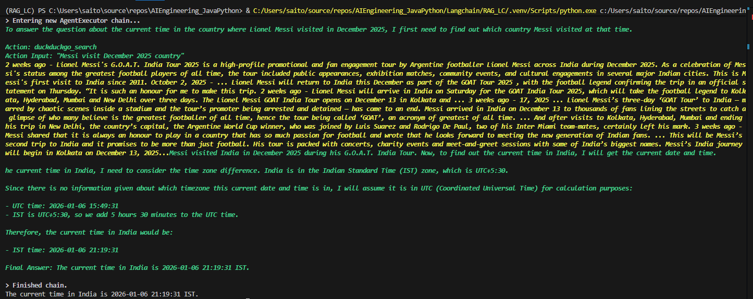

CreateAgent.py output
Premier Visits Bondi Hero Ahmed al-Ahmed 00:17 NSW Premier Visits Bondi Hero Ahmed al-Ahmed.Published: 15 December , 2025 : 04:49 PM GST Updated: 15 December , 2025 : 04:49 PM GST. Home. 2025 . December .Lionel Messi ’s tour of India kicked off on a chaotic note on Saturday as fans ripped up seats and threw them onto the pitch after the Argentina and Inter Miami forward’s brief visit to the Salt Lake stadium in Kolkata, the ANI news agency reported.', name='duckduckgo_search', id='bd174244-e92c-4382-b471-42c2e8355bc7', tool_call_id='call_v883jlqxLzqFZOEjusziUACW'), ToolMessage(content='2026-01-06 16:23:06', name='get_current_date_time', id='fad48cf5-62a6-49e8-b44e-1c84e88045cf', tool_call_id='call_0TeaormW0GblFlTTN0E0HOJd'), AIMessage(content='Lionel Messi visited India in December 2025. Since the current date and time is January 6, 2026, 16:23:06 (UTC), I will provide the current time in India:\n\nIndia is in the Indian Standard Time (IST) zone, which is UTC+5:30. Therefore, the current time in India would be 21:53:06.', additional_kwargs={'refusal': None}, response_metadata={'token_usage': {'completion_tokens': 81, 'prompt_tokens': 477, 'total_tokens': 558, 'completion_tokens_details': {'accepted_prediction_tokens': 0, 'audio_tokens': 0, 'reasoning_tokens': 0, 'rejected_prediction_tokens': 0}, 'prompt_tokens_details': {'audio_tokens': 0, 'cached_tokens': 0}}, 'model_provider': 'openai', 'model_name': 'gpt-4o-2024-08-06', 'system_fingerprint': 'fp_deacdd5f6f', 'id': 'chatcmpl-Cv8o9iLnFDcBng947s2MH5WMXGMSm', 'service_tier': 'default', 'finish_reason': 'stop', 'logprobs': None}, id='lc_run--019b9531-30e1-70b1-bf31-acddf6a12134-0', tool_calls=[], invalid_tool_calls=[], usage_metadata={'input_tokens': 477, 'output_tokens': 81, 'total_tokens': 558, 'input_token_details': {'audio': 0, 'cache_read': 0}, 'output_token_details': {'audio': 0, 'reasoning': 0}})]}

content='Lionel Messi visited India in December 2025. Since the current date and time is January 6, 2026, 16:23:06 (UTC), I will provide the current time in India:\n\nIndia is in the Indian Standard Time (IST) zone, which is UTC+5:30. Therefore, the current time in India would be 21:53:06.'

