Deployment

go to https://huggingface.co/

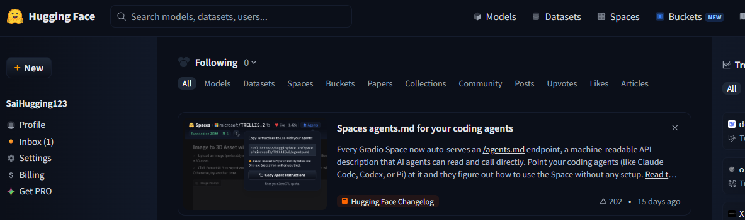
Create a Write token in HuggingFace

Create HF_TOKEN in the .env file

uv tool install 'huggingface_hub[cli]'

hf auth login --token hf_xxxxxxxxxxxxxxxxxxx

hf auth whoami

uv run gradio deploy

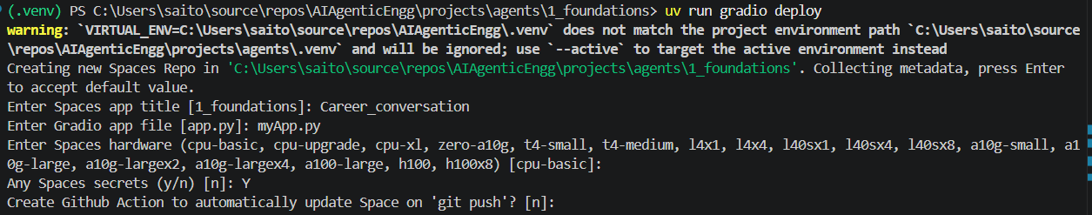
Title: Career_conversation
Gradio app file: myApp.py
cpu-basic
Any Spaces secrets: Y
Enter GoogleAPI key
GitHub actions: N

Space available at https://huggingface.co/spaces/SaiHugging123/Career_conversation

If you didn’t pass-in Google API key then go to Settings · SaiHugging123/Career_conversation

Go to Variables section

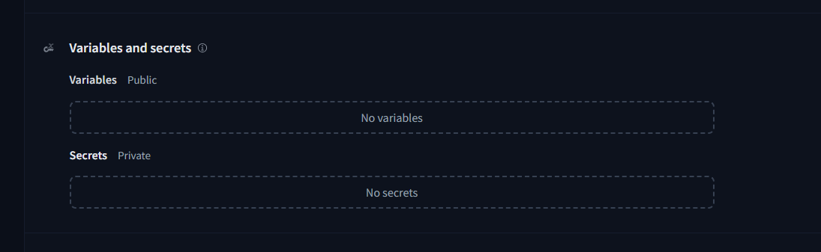
Set OPENAI_API_KEY as Dummy
Set GOOGLE_API_KEY

re run
uv run gradio deploy

Career_conversation - a Hugging Face Space by SaiHugging123

