NutriPlannerAI setup

Go to nutriplannerai-frontend folder

npm run dev

Initial UI

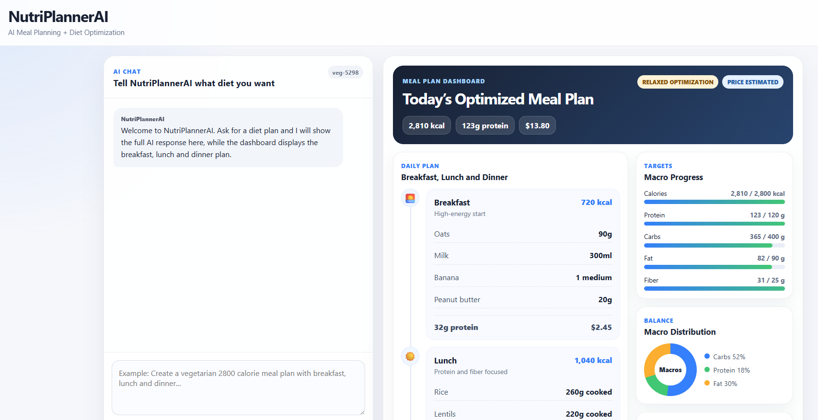
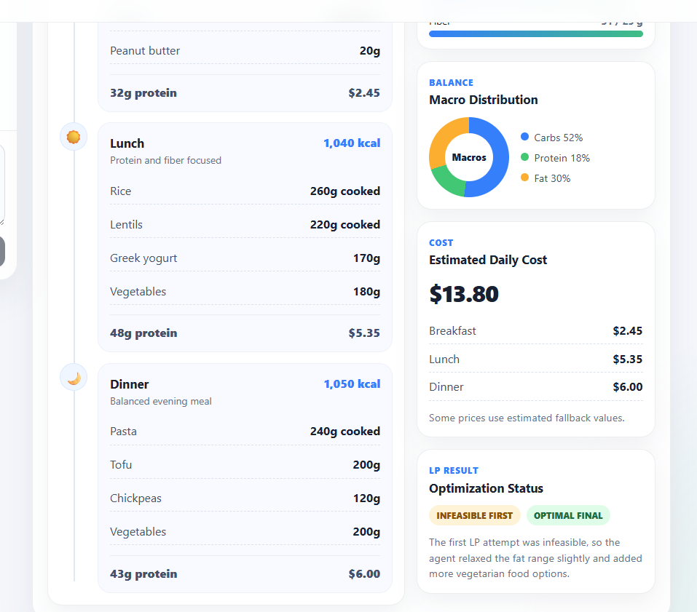
I tried this prompt:
Create a vegetarian 2800 calorie meal plan with at least 120g protein. Use affordable foods, get nutrition from OpenFoodFacts, estimate prices if needed, run optimization, and give me breakfast, lunch, dinner, daily totals, and tools used.

Conversation ID: veg-5298

I created a vegetarian meal plan that meets your calorie and protein requirements, with a focus on affordability. The total calories are slightly below the target, but the protein goals are achieved. Here's the breakdown:

**Breakfast:**
- Quaker Large Flake Oats: 150g
- Whole Milk 3.25%: 250g
- Banana: 200g
- Peanut Butter: 100g

**Lunch:**
- Tofu: 109g
- Lentils: 291g

**Dinner:**
- Paneer: 100g
- Cottage Cheese: 100g

**Daily Totals:**
- Calories: 2650 kcal
- Protein: 134.7 g
- Carbs: 250 g
- Fat: 100 g
- Fiber: 36.98 g
- Estimated cost: $6.30

**Tools Used:**
- NutriOpt optimization tool for calculating the meal plan.
- Saved food items for nutritional data and pricing.

This meal plan provides a good balance of macronutrients, while keeping the overall cost reasonable. If you'd like to make adjustments or need help with anything else, feel free to ask!

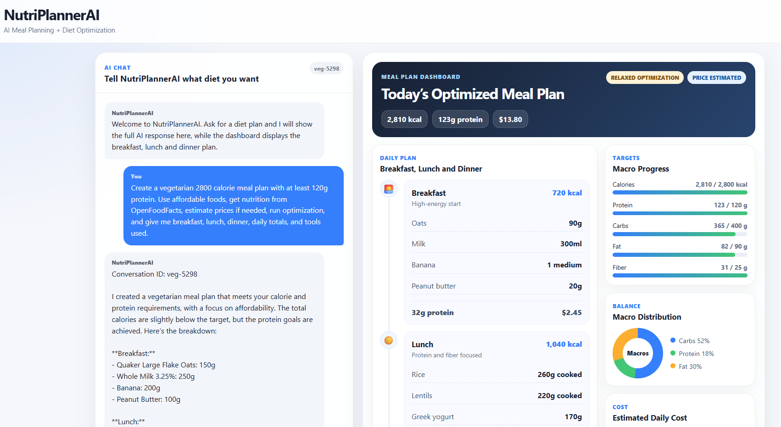

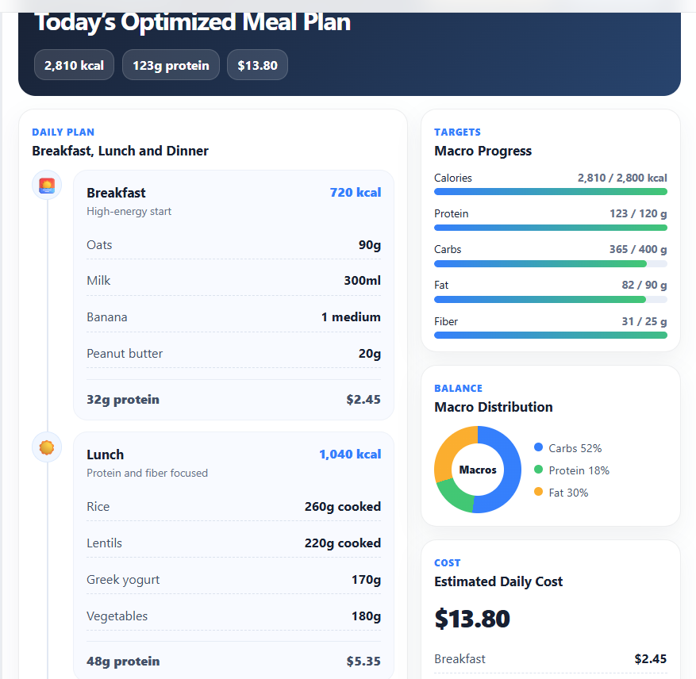

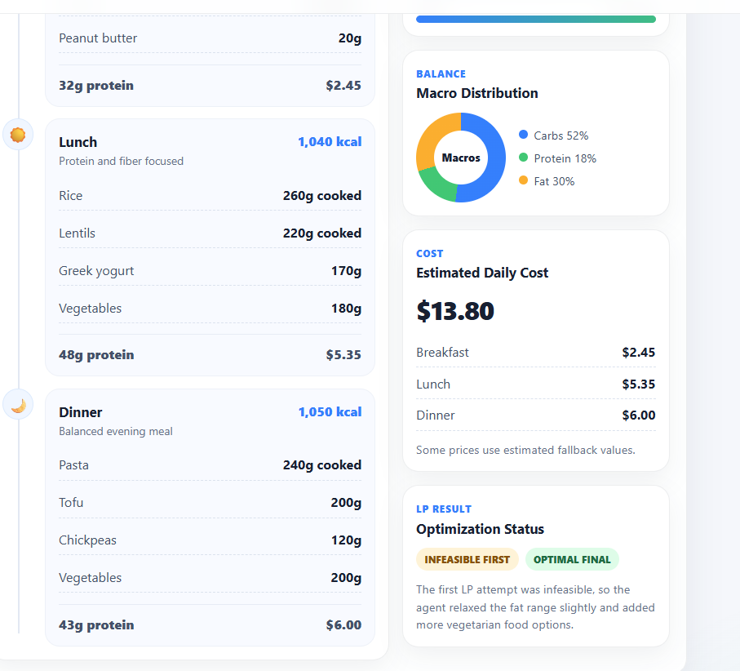

MariaDB

