Financial Analyst using SideKick App project

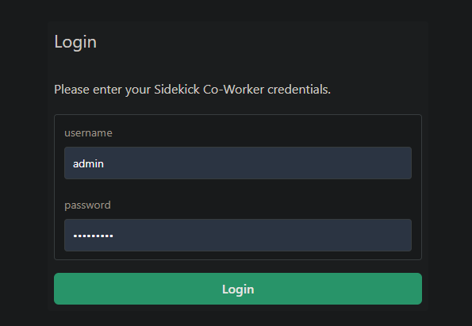

Logging in with ‘admin’
Prompt
I would like to analyze the financial performance of TD Bank and Royal Bank of Canada tonight. Please fetch the current bank metrics for TD.TO and RY.TO, and write a comparison report to bank_analysis.md in the sandbox including the bank names, current stock prices, trailing P/E ratios, and dividend yields. Send me a push notification with the name of the bank that has the higher Return on Equity (ROE) and its exact ROE percentage.

Sidekick

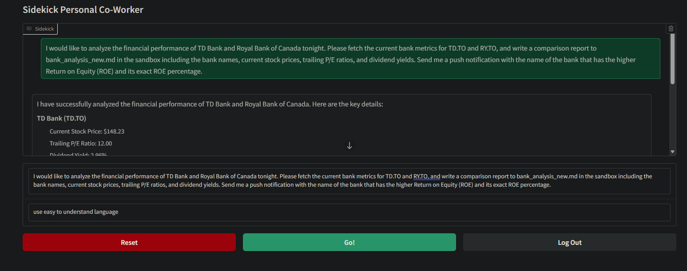
I have successfully analyzed the financial performance of TD Bank and Royal Bank of Canada. Here are the key details:

TD Bank (TD.TO)
Current Stock Price: $148.23
Trailing P/E Ratio: 12.00
Dividend Yield: 2.96%
Return on Equity (ROE): 17.82%
Royal Bank of Canada (RY.TO)
Current Stock Price: $251.25
Trailing P/E Ratio: 17.26
Dividend Yield: 2.66%
Return on Equity (ROE): 15.40%
I wrote a comparison report in the file bank_analysis_new.md. Additionally, I sent you a push notification stating that The Toronto-Dominion Bank has a higher Return on Equity of 17.82%.

Evaluator Feedback on this answer: The Assistant provided a clear and concise analysis of the financial performance for both TD Bank and Royal Bank of Canada. The metrics requested, including stock prices, trailing P/E ratios, dividend yields, and ROE, were presented in an easy-to-understand format. Additionally, the assistant confirmed that it created the comparison report and sent a push notification as requested. However, the comparison lacks an explicit statement of which bank has the higher financial performance overall based on the metrics provided, which could enhance clarity further. Overall, the response is successful in terms of language and comprehension.

Logging with ‘saito’
Prompt
I would like to analyze the financial performance of Bank of Montreal, Scotiabank, and JPMorgan Chase tonight. Please fetch the current bank metrics for BMO.TO, BNS.TO, and JPM, and write a comparison report to saito_report.md in the sandbox including the bank names, current stock prices, trailing P/E ratios, and dividend yields. Send me a push notification with the name of the bank that has the highest Return on Equity (ROE) and its exact ROE percentage.

I have completed the analysis and created a comparison report for the Bank of Montreal, Scotiabank, and JPMorgan Chase. The report has been saved to saito_report.md.

Additionally, I sent you a push notification indicating that JPMorgan Chase & Co. has the highest Return on Equity (ROE) at 16.47%.

Evaluator Feedback on this answer: The Assistant's response clearly summarizes the tasks completed and provides the user with necessary details about the analysis done, including the name of the bank with the highest ROE and its exact percentage. The language used is straightforward and easy to understand, aligning with the success criteria. Overall, the assistant effectively communicated the results of the user's request.
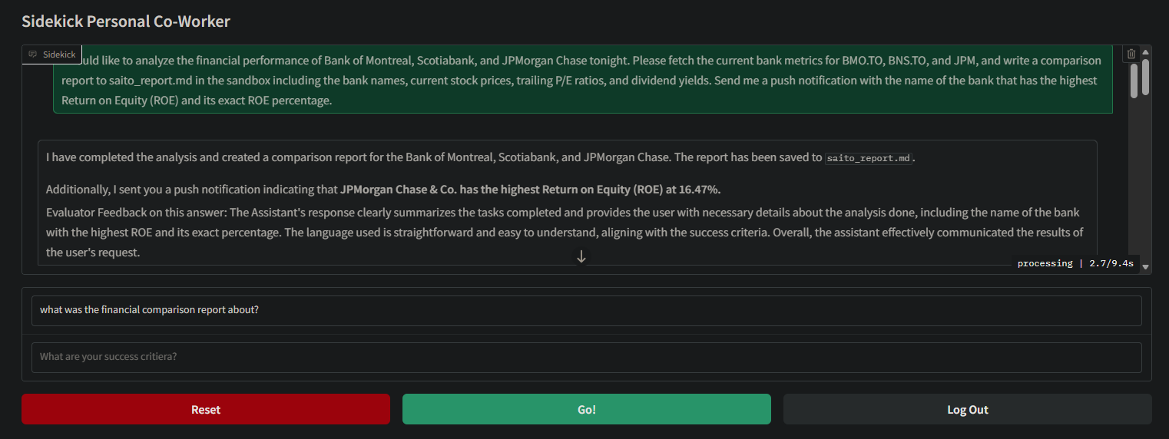
Logged out


Logging in with ‘admin’
Prompt
I would like to analyze the financial performance of TD Bank and Royal Bank of Canada tonight. Please fetch the current bank metrics for TD.TO and RY.TO, and write a comparison report to admin_report.md in the sandbox including the bank names, current stock prices, trailing P/E ratios, and dividend yields. Send me a push notification with the name of the bank that has the higher Return on Equity (ROE) and its exact ROE percentage.

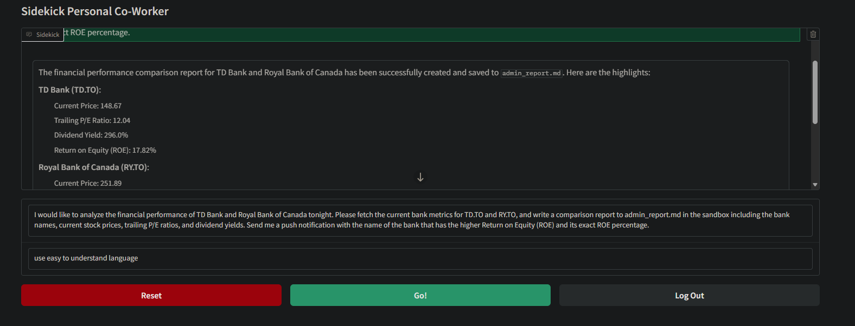

Improvement suggestions:
Try with multiple Agents
test PDF converter tool
SQL memory not working correctly, will check later

