(.venv) PS C:\Users\saito\source\repos\AIAgenticEngg\projects\agents\3_crew> crewai create crew Multi_Currency_Wallet
Creating folder multi_currency_wallet...
Cache expired or not found. Fetching provider data from the web...
Downloading [####################################] 1427090/71404
Select a provider to set up:
1. openai
2. anthropic
3. gemini
4. nvidia_nim
5. groq
6. huggingface
7. ollama
8. watson
9. bedrock
10. azure
11. cerebras
12. sambanova
13. other
q. Quit
Enter the number of your choice or 'q' to quit: 1
Select a model to use for Openai:
1. gpt-4
2. gpt-4.1
3. gpt-4.1-mini-2025-04-14
4. gpt-4.1-nano-2025-04-14
5. gpt-4o
6. gpt-4o-mini
7. o1-mini
8. o1-preview
q. Quit
Enter the number of your choice or 'q' to quit: 6
Enter your OPENAI API key (press Enter to skip): sk-proj-xxxxxxxxxxxxxxxxxxxxxxxxxxxxxxxx
API keys and model saved to .env file
Selected model: gpt-4o-mini
- Created multi_currency_wallet\.gitignore
- Created multi_currency_wallet\pyproject.toml
- Created multi_currency_wallet\README.md
- Created multi_currency_wallet\knowledge\user_preference.txt
- Created multi_currency_wallet\src\multi_currency_wallet\__init__.py
- Created multi_currency_wallet\src\multi_currency_wallet\main.py
- Created multi_currency_wallet\src\multi_currency_wallet\crew.py
- Created multi_currency_wallet\src\multi_currency_wallet\tools\custom_tool.py
- Created multi_currency_wallet\src\multi_currency_wallet\tools\__init__.py
- Created multi_currency_wallet\src\multi_currency_wallet\config\agents.yaml
- Created multi_currency_wallet\src\multi_currency_wallet\config\tasks.yaml
Crew Multi_Currency_Wallet created successfully!

crewai run
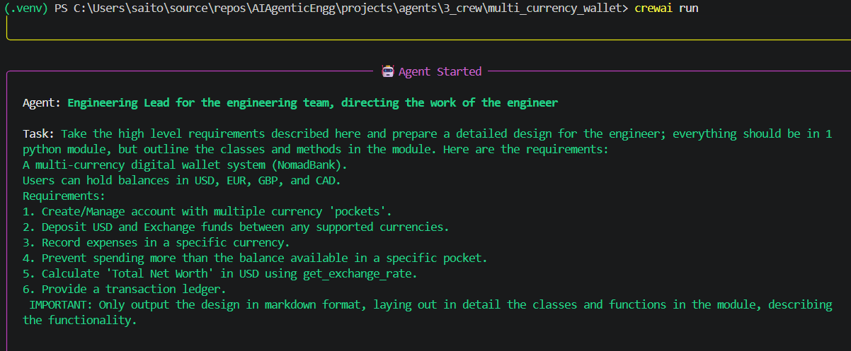
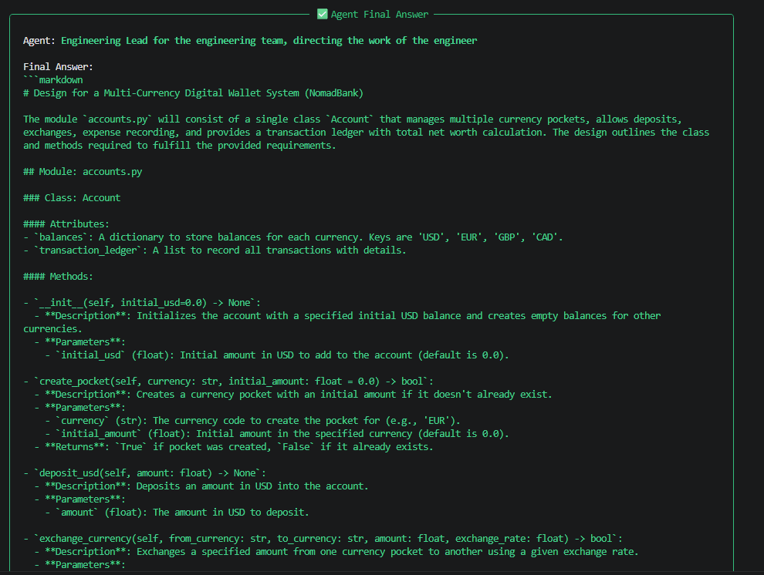

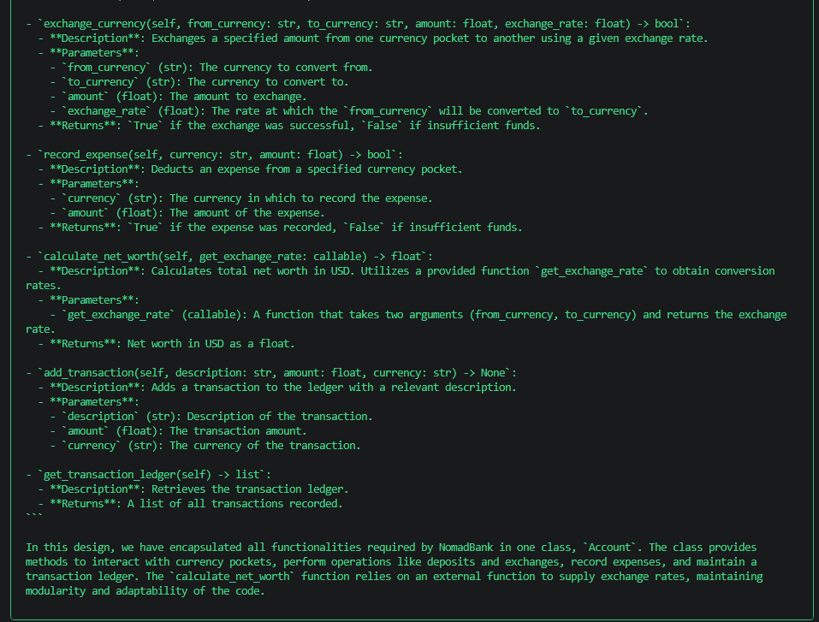

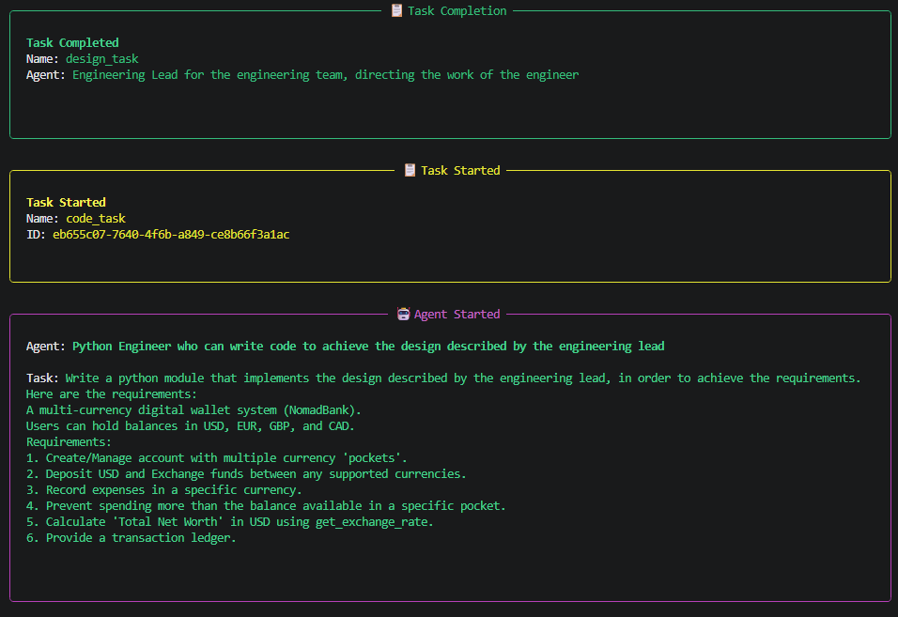
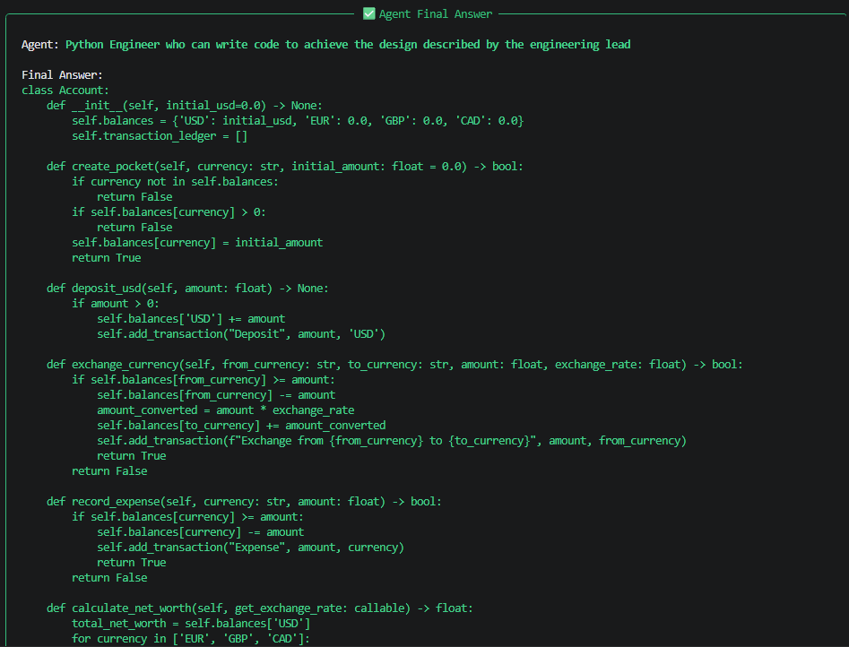
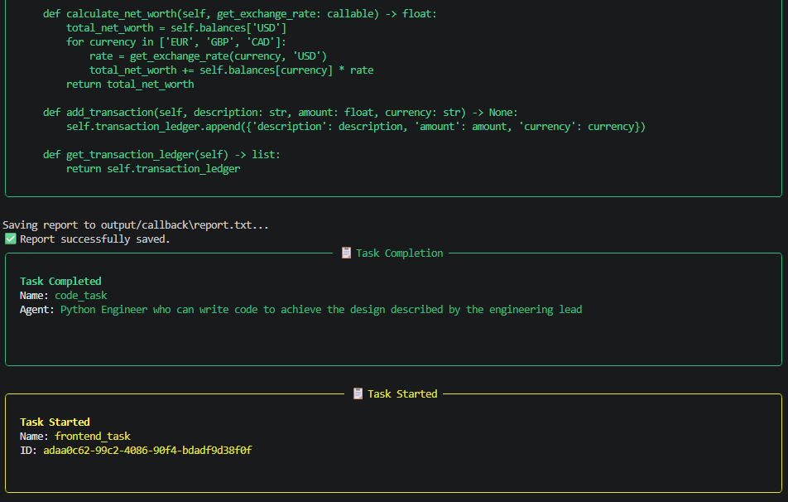
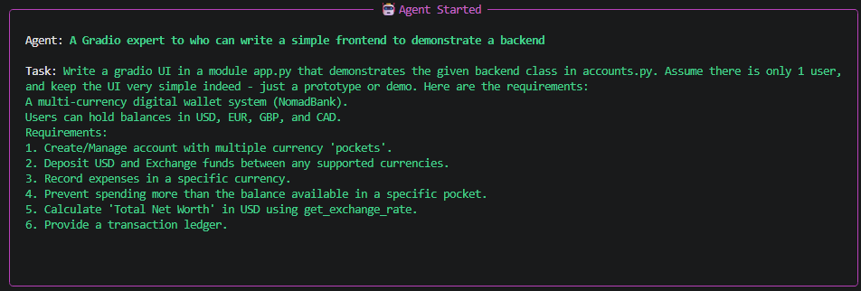
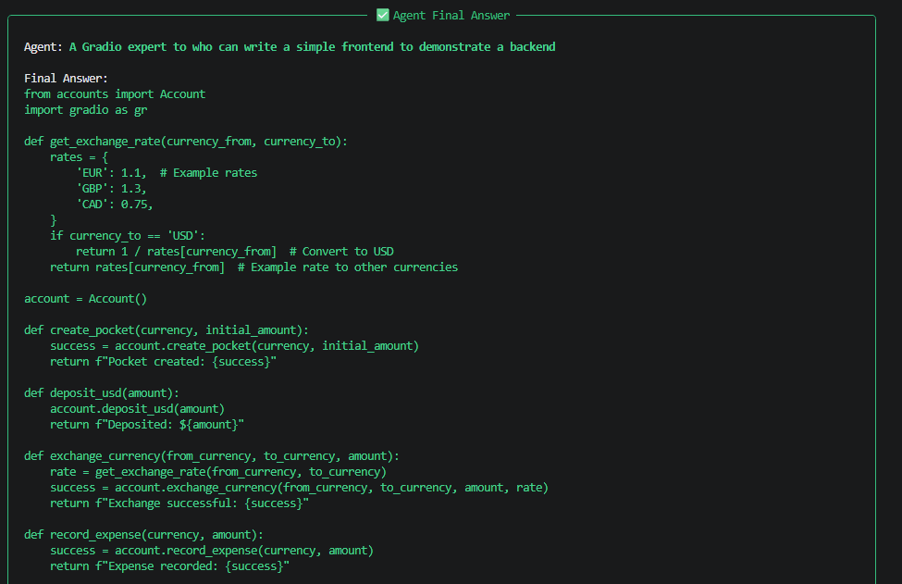
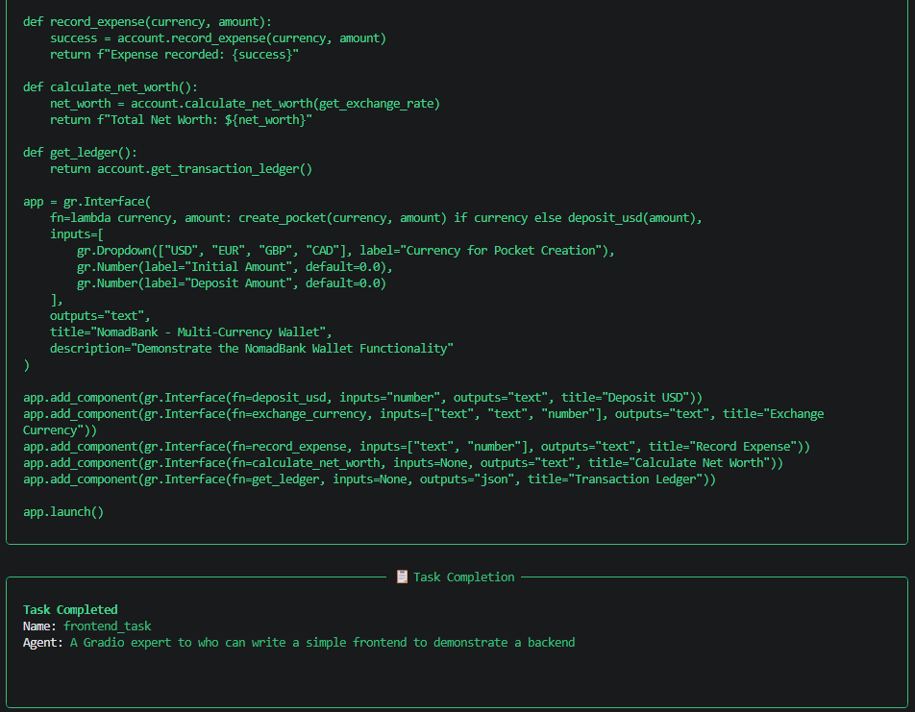
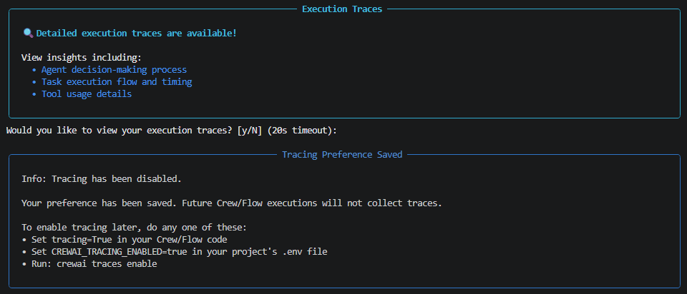

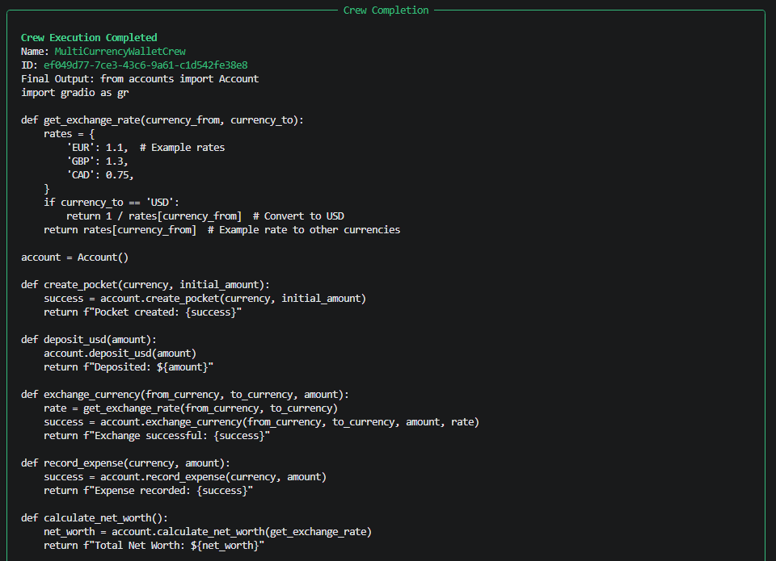
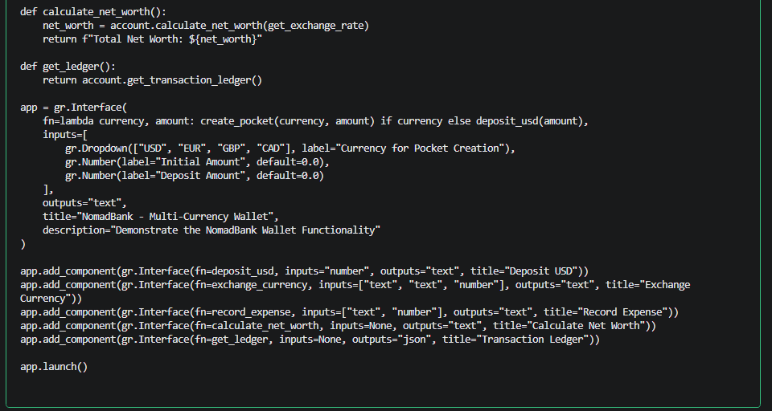
uv run app.py
Gradio: http://127.0.0.1:7860/

NomadBank Multi-Currency Wallet

UI

