MCPServer Inspection

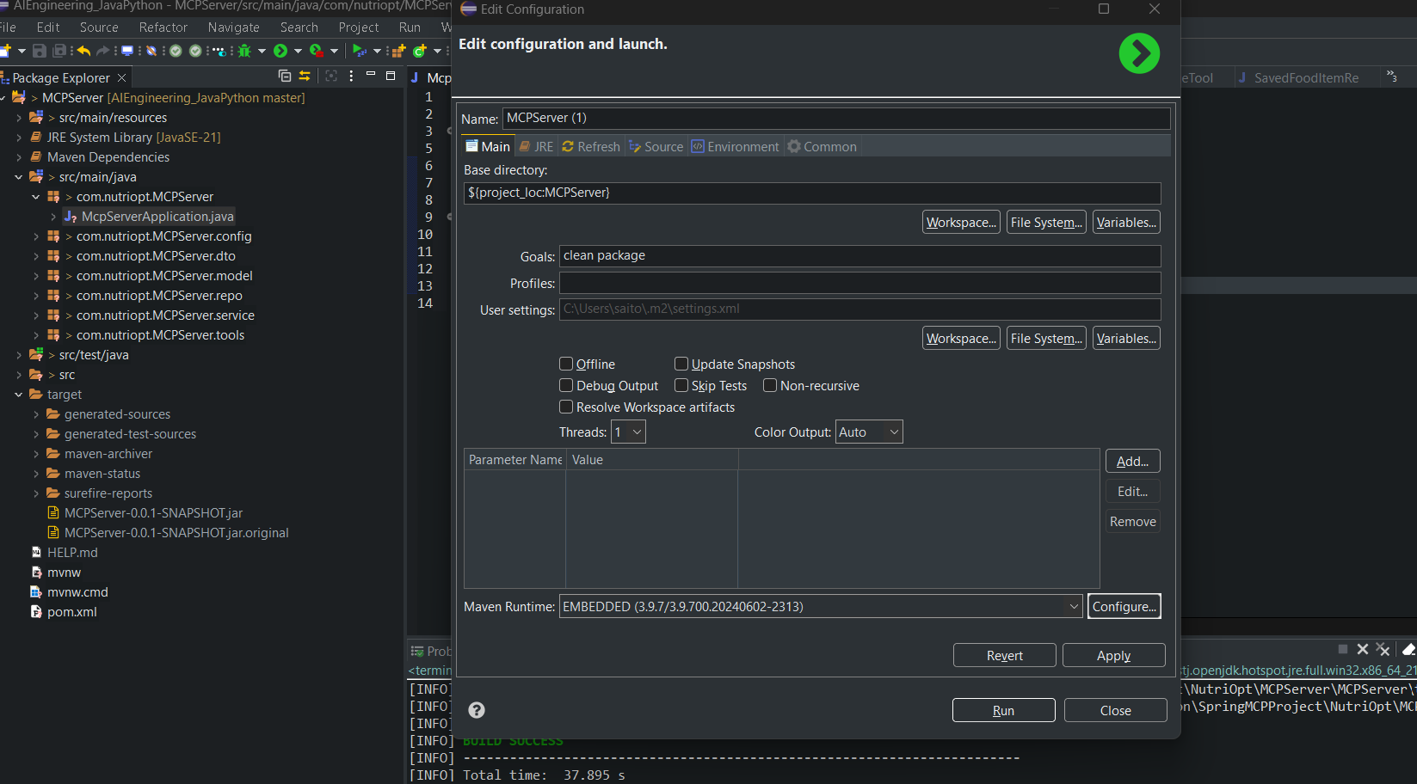

right-click main file and select Maven build
enter “clean package”
Look for “target/MCPServer-0.0.1-SNAPSHOT.jar”
Run “npx @modelcontextprotocol/inspector java -jar target\MCPServer-0.0.1-SNAPSHOT.jar”

Open http://localhost:6274/?MCP_PROXY_AUTH_TOKEN=a3d5532d36bdb32c8bccab9215e86d27551a9ff5dfef594b516c77f16da7bfef#tools

Click Connect
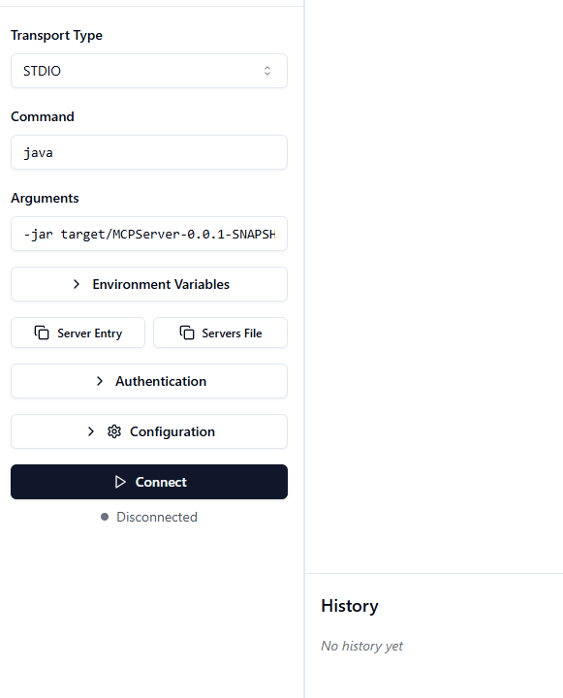

Testing fresh-mcp-ping tool

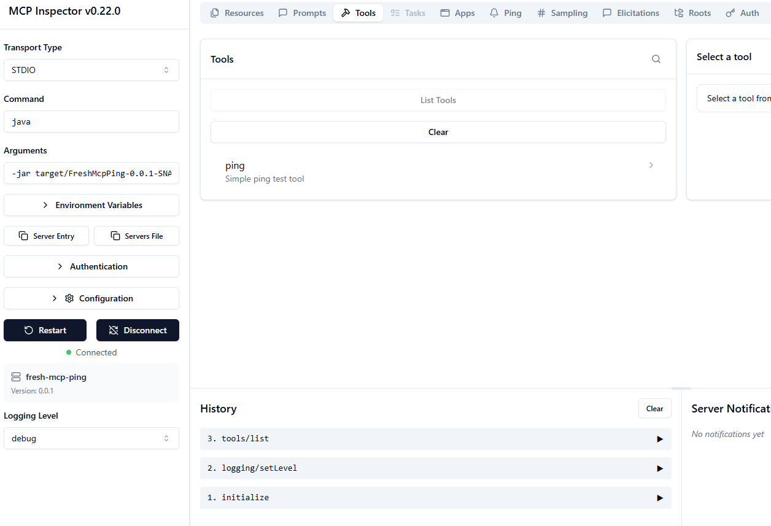

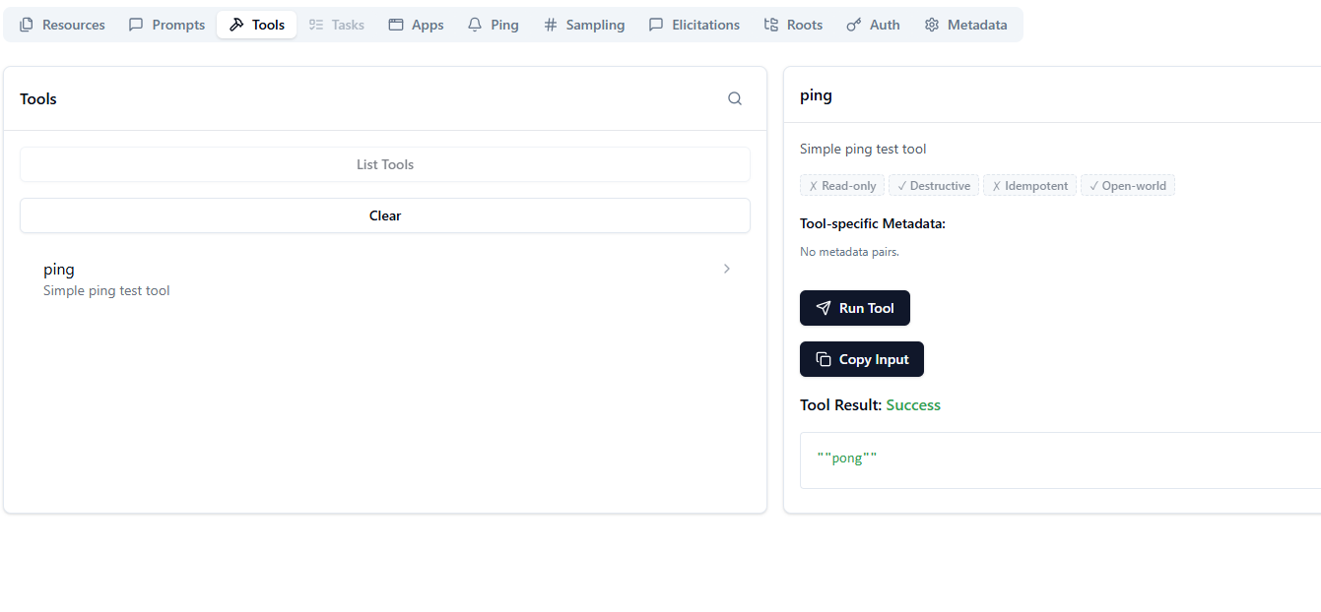
Now testing nutriopt-mcp-server with Ping tool, it works

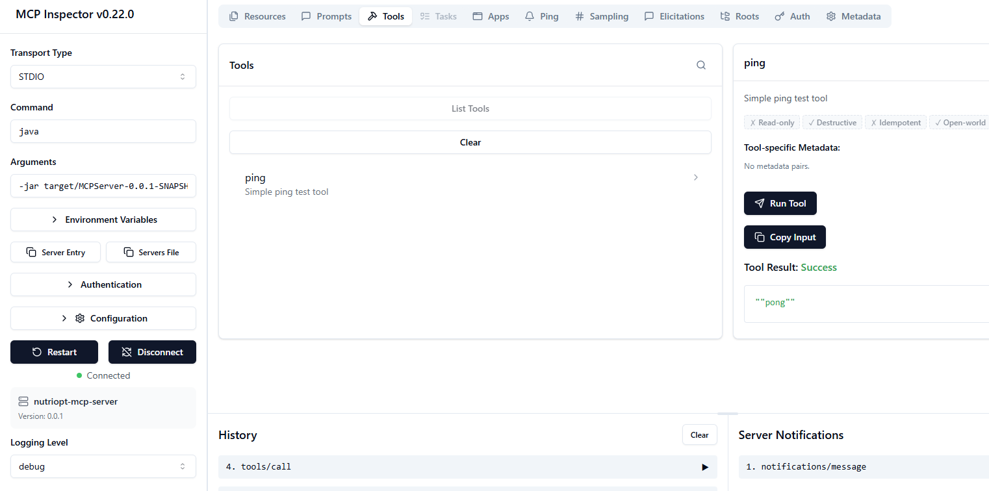

OpenPrices tool works

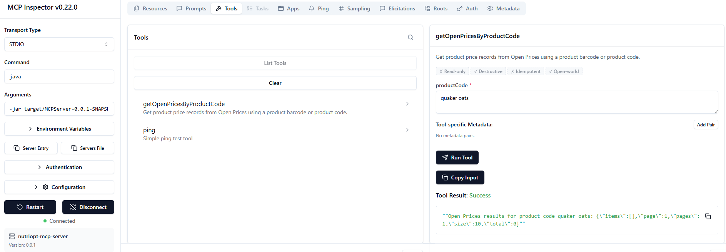

FoodStorageTool working

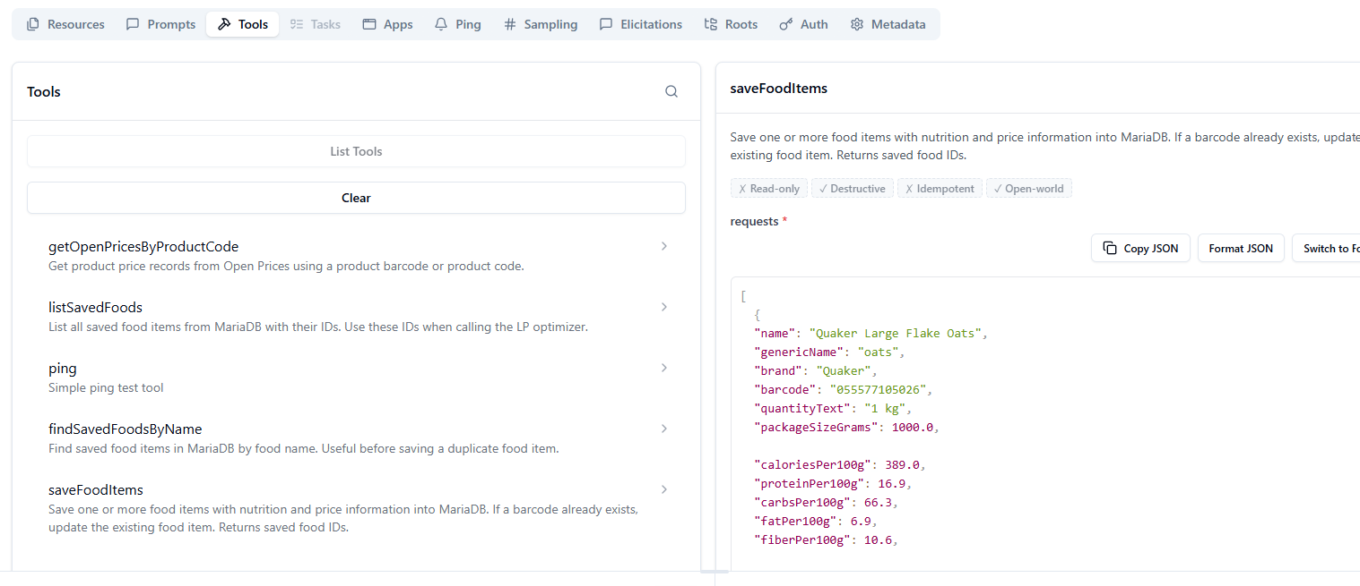
[
{
"name": "Quaker Large Flake Oats",
"genericName": "oats",
"brand": "Quaker",
"barcode": "055577105026",
"quantityText": "1 kg",
"packageSizeGrams": 1000,
"caloriesPer100g": 389,
"proteinPer100g": 16.9,
"carbsPer100g": 66.3,
"fatPer100g": 6.9,
"fiberPer100g": 10.6,
"latestPrice": 4.99,
"currency": "CAD",
"costPer100g": 0.499,
"priceSource": "manual_fallback",
"priceDate": "2026-06-08",
"minGrams": 30,
"maxGrams": 120
}
]

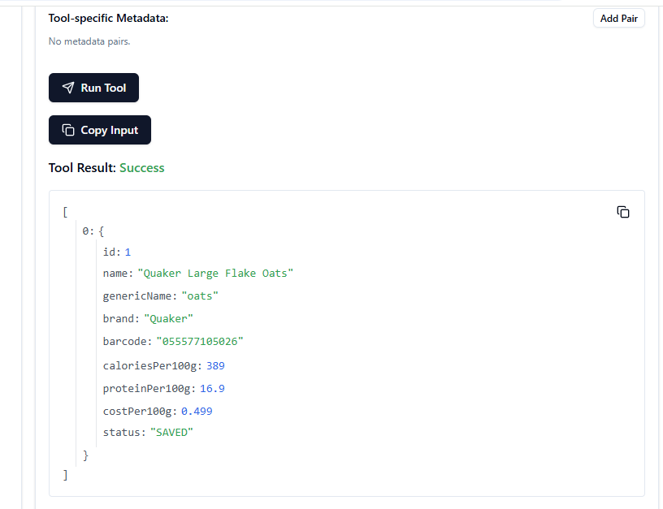

Now it shows LpOptimizerTool also

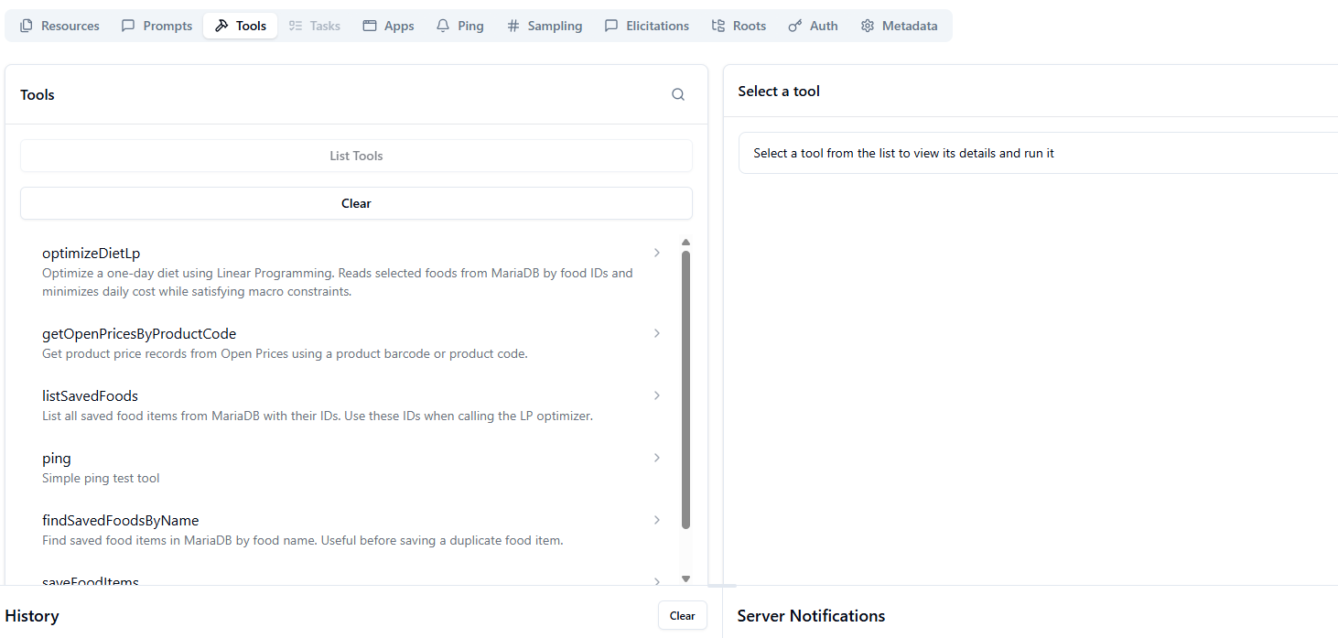
[
{
"name": "Quaker Large Flake Oats",
"genericName": "oats",
"brand": "Quaker",
"barcode": "055577105026",
"quantityText": "1 kg",
"packageSizeGrams": 1000.0,
"caloriesPer100g": 389.0,
"proteinPer100g": 16.9,
"carbsPer100g": 66.3,
"fatPer100g": 6.9,
"fiberPer100g": 10.6,
"latestPrice": 4.99,
"currency": "CAD",
"costPer100g": 0.499,
"priceSource": "manual_test",
"priceDate": "2026-06-08",
"minGrams": 30.0,
"maxGrams": 150.0
},
{
"name": "Whole Milk 3.25%",
"genericName": "milk",
"brand": "Neilson",
"barcode": "064420001234",
"quantityText": "4 L",
"packageSizeGrams": 4000.0,
"caloriesPer100g": 61.0,
"proteinPer100g": 3.2,
"carbsPer100g": 4.8,
"fatPer100g": 3.3,
"fiberPer100g": 0.0,
"latestPrice": 6.49,
"currency": "CAD",
"costPer100g": 0.162,
"priceSource": "manual_test",
"priceDate": "2026-06-08",
"minGrams": 200.0,
"maxGrams": 700.0
},
{
"name": "Large Eggs",
"genericName": "eggs",
"brand": "No Name",
"barcode": "060383000111",
"quantityText": "12 eggs",
"packageSizeGrams": 600.0,
"caloriesPer100g": 143.0,
"proteinPer100g": 12.6,
"carbsPer100g": 0.7,
"fatPer100g": 9.5,
"fiberPer100g": 0.0,
"latestPrice": 3.99,
"currency": "CAD",
"costPer100g": 0.665,
"priceSource": "manual_test",
"priceDate": "2026-06-08",
"minGrams": 50.0,
"maxGrams": 200.0
},
{
"name": "Chicken Breast",
"genericName": "chicken breast",
"brand": "Generic",
"barcode": "000000000101",
"quantityText": "1 kg",
"packageSizeGrams": 1000.0,
"caloriesPer100g": 165.0,
"proteinPer100g": 31.0,
"carbsPer100g": 0.0,
"fatPer100g": 3.6,
"fiberPer100g": 0.0,
"latestPrice": 12.00,
"currency": "CAD",
"costPer100g": 1.2,
"priceSource": "manual_test",
"priceDate": "2026-06-08",
"minGrams": 100.0,
"maxGrams": 350.0
},
{
"name": "White Rice Cooked",
"genericName": "rice",
"brand": "Generic",
"barcode": "000000000102",
"quantityText": "cooked",
"packageSizeGrams": 1000.0,
"caloriesPer100g": 130.0,
"proteinPer100g": 2.7,
"carbsPer100g": 28.0,
"fatPer100g": 0.3,
"fiberPer100g": 0.4,
"latestPrice": 2.50,
"currency": "CAD",
"costPer100g": 0.25,
"priceSource": "manual_test",
"priceDate": "2026-06-08",
"minGrams": 100.0,
"maxGrams": 500.0
},
{
"name": "Banana",
"genericName": "banana",
"brand": "Generic",
"barcode": "000000000103",
"quantityText": "1 kg",
"packageSizeGrams": 1000.0,
"caloriesPer100g": 89.0,
"proteinPer100g": 1.1,
"carbsPer100g": 22.8,
"fatPer100g": 0.3,
"fiberPer100g": 2.6,
"latestPrice": 1.69,
"currency": "CAD",
"costPer100g": 0.169,
"priceSource": "manual_test",
"priceDate": "2026-06-08",
"minGrams": 100.0,
"maxGrams": 300.0
},
{
"name": "Peanut Butter",
"genericName": "peanut butter",
"brand": "Kraft",
"barcode": "068100091234",
"quantityText": "1 kg",
"packageSizeGrams": 1000.0,
"caloriesPer100g": 588.0,
"proteinPer100g": 25.0,
"carbsPer100g": 20.0,
"fatPer100g": 50.0,
"fiberPer100g": 6.0,
"latestPrice": 5.99,
"currency": "CAD",
"costPer100g": 0.599,
"priceSource": "manual_test",
"priceDate": "2026-06-08",
"minGrams": 10.0,
"maxGrams": 60.0
},
{
"name": "Frozen Mixed Vegetables",
"genericName": "mixed vegetables",
"brand": "No Name",
"barcode": "060383001234",
"quantityText": "750 g",
"packageSizeGrams": 750.0,
"caloriesPer100g": 65.0,
"proteinPer100g": 3.0,
"carbsPer100g": 12.0,
"fatPer100g": 0.5,
"fiberPer100g": 4.0,
"latestPrice": 2.99,
"currency": "CAD",
"costPer100g": 0.399,
"priceSource": "manual_test",
"priceDate": "2026-06-08",
"minGrams": 100.0,
"maxGrams": 400.0
}
]

Response

[
{
"id": 1,
"name": "Quaker Large Flake Oats",
"genericName": "oats",
"brand": "Quaker",
"barcode": "055577105026",
"caloriesPer100g": 389,
"proteinPer100g": 16.9,
"costPer100g": 0.499,
"status": "UPDATED"
},
{
"id": 2,
"name": "Whole Milk 3.25%",
"genericName": "milk",
"brand": "Neilson",
"barcode": "064420001234",
"caloriesPer100g": 61,
"proteinPer100g": 3.2,
"costPer100g": 0.162,
"status": "SAVED"
},
{
"id": 3,
"name": "Large Eggs",
"genericName": "eggs",
"brand": "No Name",
"barcode": "060383000111",
"caloriesPer100g": 143,
"proteinPer100g": 12.6,
"costPer100g": 0.665,
"status": "SAVED"
},
{
"id": 4,
"name": "Chicken Breast",
"genericName": "chicken breast",
"brand": "Generic",
"barcode": "000000000101",
"caloriesPer100g": 165,
"proteinPer100g": 31,
"costPer100g": 1.2,
"status": "SAVED"
},
{
"id": 5,
"name": "White Rice Cooked",
"genericName": "rice",
"brand": "Generic",
"barcode": "000000000102",
"caloriesPer100g": 130,
"proteinPer100g": 2.7,
"costPer100g": 0.25,
"status": "SAVED"
},
{
"id": 6,
"name": "Banana",
"genericName": "banana",
"brand": "Generic",
"barcode": "000000000103",
"caloriesPer100g": 89,
"proteinPer100g": 1.1,
"costPer100g": 0.169,
"status": "SAVED"
},
{
"id": 7,
"name": "Peanut Butter",
"genericName": "peanut butter",
"brand": "Kraft",
"barcode": "068100091234",
"caloriesPer100g": 588,
"proteinPer100g": 25,
"costPer100g": 0.599,
"status": "SAVED"
},
{
"id": 8,
"name": "Frozen Mixed Vegetables",
"genericName": "mixed vegetables",
"brand": "No Name",
"barcode": "060383001234",
"caloriesPer100g": 65,
"proteinPer100g": 3,
"costPer100g": 0.399,
"status": "SAVED"
}
]

Saved into MariaDB
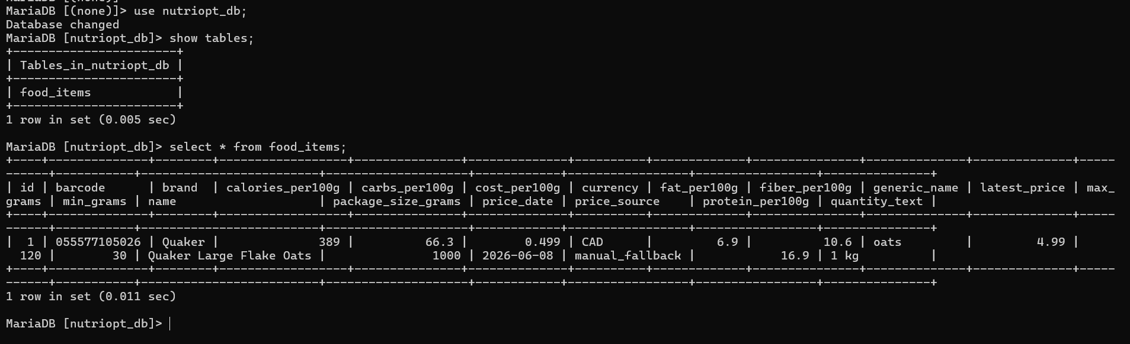

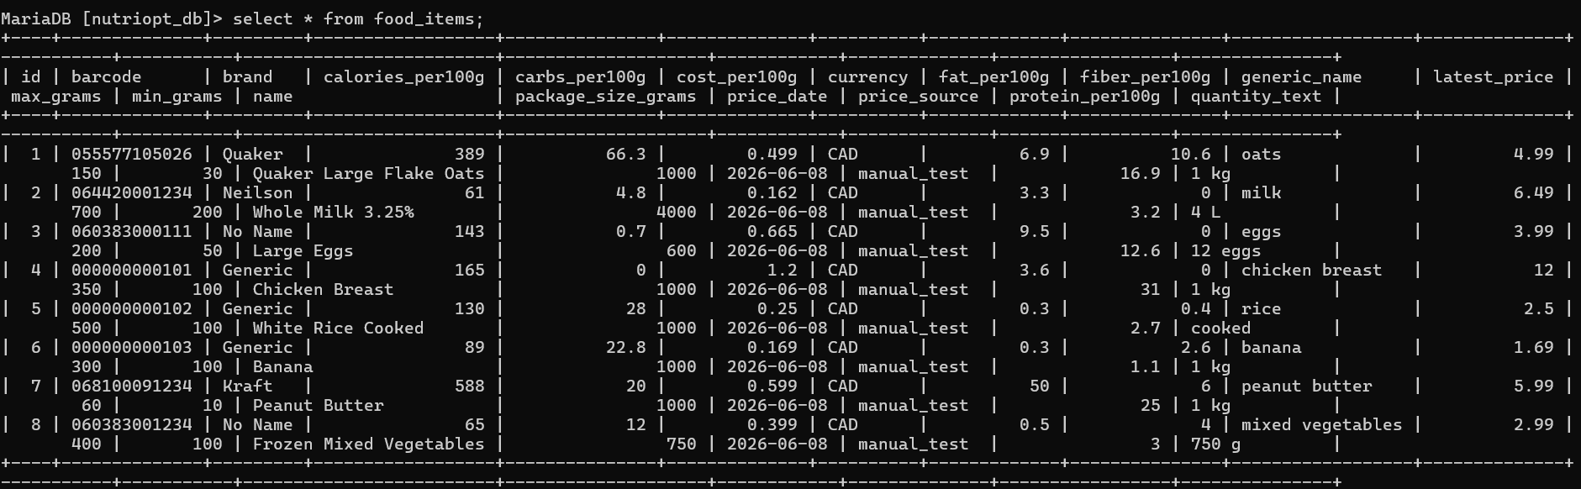
optimizeDietLp Payload

{
"foodIds": [1, 2, 3, 4, 5, 6, 7, 8],
"targets": {
"budgetMax": 20.0,
"caloriesMax": 3000.0,
"caloriesMin": 2000.0,
"carbsMax": 450.0,
"carbsMin": 180.0,
"fatMax": 130.0,
"fatMin": 40.0,
"fiberMin": 15.0,
"proteinMin": 100.0
}
}

optimizeDietLp

{
"foodIds": [
1,
2,
3,
4,
5,
6,
7,
8
],
"targets": {
"budgetMax": 20,
"caloriesMax": 3000,
"caloriesMin": 2000,
"carbsMax": 450,
"carbsMin": 180,
"fatMax": 130,
"fatMin": 40,
"fiberMin": 15,
"proteinMin": 100
}
}

{
"foodIds": [
1,
2,
3,
4,
5,
6,
7,
8
],
"targets": {
"budgetMax": 20,
"caloriesMax": 3000,
"caloriesMin": 2000,
"carbsMax": 450,
"carbsMin": 180,
"fatMax": 130,
"fatMin": 40,
"fiberMin": 15,
"proteinMin": 100
}
}

Response

{
"status": "OPTIMAL",
"totalCalories": 2000,
"totalProtein": 100,
"totalCarbs": 273.19,
"totalFat": 58.03,
"totalFiber": 27.76,
"totalCost": 4.6,
"items": [
{
"foodId": 1,
"food": "Quaker Large Flake Oats",
"quantity": 150,
"unit": "g/ml"
},
{
"foodId": 2,
"food": "Whole Milk 3.25%",
"quantity": 220.8,
"unit": "g/ml"
},
{
"foodId": 3,
"food": "Large Eggs",
"quantity": 50,
"unit": "g/ml"
},
{
"foodId": 4,
"food": "Chicken Breast",
"quantity": 100,
"unit": "g/ml"
},
{
"foodId": 5,
"food": "White Rice Cooked",
"quantity": 414.24,
"unit": "g/ml"
},
{
"foodId": 6,
"food": "Banana",
"quantity": 100,
"unit": "g/ml"
},
{
"foodId": 7,
"food": "Peanut Butter",
"quantity": 60,
"unit": "g/ml"
},
{
"foodId": 8,
"food": "Frozen Mixed Vegetables",
"quantity": 100,
"unit": "g/ml"
}
]
}

