API testing

Start SpringBoot application

POST: http://localhost:8080/api/rca/search

Body => raw
{
"question": "Why are payments failing?"
}

{
"question": "Why are payments failing?",
"answer": "Retrieved 2 evidence records from Pinecone",
"evidence": [
"ID: trace-TRACE-10046\nScore: 0.1906171292066574\nTrace ID: TRACE-10046\nTransaction ID: TXN-790\nServices: account-service,auth-service,notification-service,payment-service\nError Codes: BALANCE_CHECK_FAILED,DB_CONNECTION_ERROR,DB_POOL_EXHAUSTED\nEnvironment: simulated-prod\n\nEvidence:\nEvidence logs for traceId TRACE-10046 and transactionId TXN-790.\nThe following logs show the request flow in timestamp order:\n\n2026-06-22T10:17:29Z | service=auth-service | level=INFO | eventType=APPLICATION_LOG | errorCode=NONE | latencyMs=105 | message=Token validation successful\n2026-06-22T10:17:30Z | service=account-service | level=ERROR | eventType=APPLICATION_ERROR | errorCode=DB_CONNECTION_ERROR | latencyMs=5100 | message=Account balance lookup failed because database connection timed out\n2026-06-22T10:17:31Z | service=payment-service | level=ERROR | eventType=APPLICATION_ERROR | errorCode=BALANCE_CHECK_FAILED | latencyMs=5200 | message=Payment failed because account balance could not be verified\n2026-06-22T10:17:32Z | service=account-service | level=ERROR | eventType=DATABASE_ERROR | errorCode=DB_POOL_EXHAUSTED | latencyMs=5000 | message=Connection pool exhausted while connecting to account database\n2026-06-22T10:17:33Z | service=notification-service | level=WARN | eventType=APPLICATION_LOG | errorCode=NONE | latencyMs=80 | message=Payment failure notification queued for customer\n",
"ID: trace-TRACE-10045\nScore: 0.13343356549739838\nTrace ID: TRACE-10045\nTransaction ID: TXN-789\nServices: account-service,auth-service,fraud-service,payment-service\nError Codes: FRAUD_TIMEOUT,POD_RESTARTED,SERVICE_UNHEALTHY\nEnvironment: simulated-prod\n\nEvidence:\nEvidence logs for traceId TRACE-10045 and transactionId TXN-789.\nThe following logs show the request flow in timestamp order:\n\n2026-06-22T10:15:29Z | service=auth-service | level=INFO | eventType=APPLICATION_LOG | errorCode=NONE | latencyMs=120 | message=Token validation successful\n2026-06-22T10:15:30Z | service=account-service | level=INFO | eventType=APPLICATION_LOG | errorCode=NONE | latencyMs=210 | message=Account balance check successful\n2026-06-22T10:15:31Z | service=payment-service | level=ERROR | eventType=APPLICATION_ERROR | errorCode=FRAUD_TIMEOUT | latencyMs=4300 | message=Payment failed due to fraud-service timeout\n2026-06-22T10:15:33Z | service=fraud-service | level=ERROR | eventType=READINESS_PROBE_FAILED | errorCode=SERVICE_UNHEALTHY | latencyMs=4200 | message=Readiness probe failed: /health returned 503\n2026-06-22T10:15:34Z | service=fraud-service | level=WARN | eventType=POD_RESTARTED | errorCode=POD_RESTARTED | latencyMs=0 | message=fraud-service pod restarted after repeated health check failures\n"
]
}

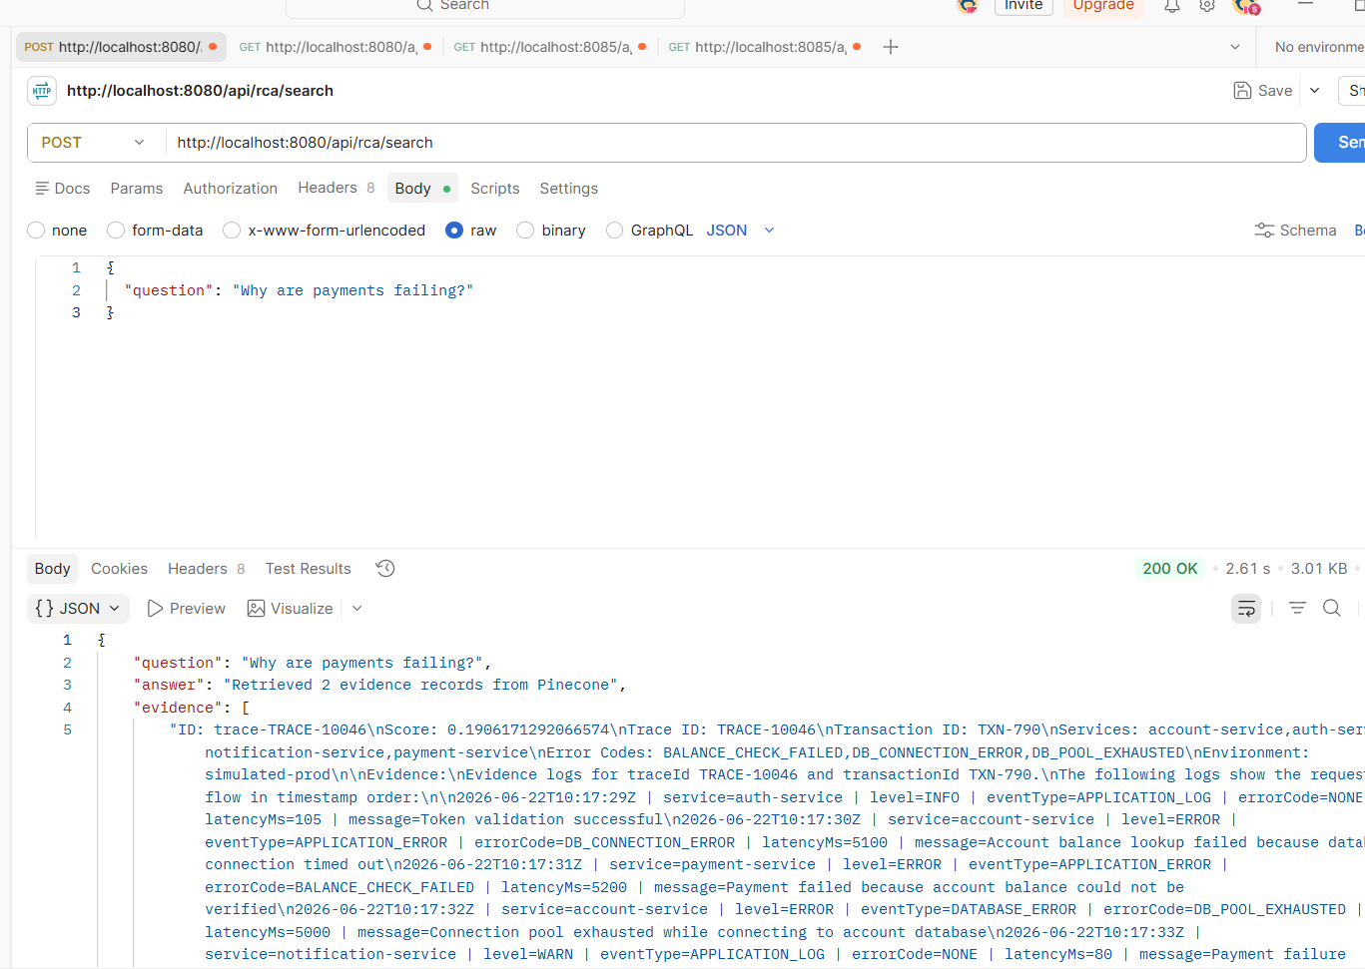

POST http://localhost:8080/api/rca/analyze

Body => raw
{
"question": "Why are payments failing?"
}

{
"question": "Why are payments failing?",
"answer": "1. **Root Cause** \n The primary cause of the payment failures is a combination of database connection issues in the account-service and timeout errors with the fraud-service. Specifically, the account-service encountered a database connection timeout and an exhausted connection pool, while the fraud-service was unhealthy and timed out during payment processing.\n\n2. **Symptom** \n Payments are failing for users, resulting in error messages indicating that account balance verification could not be completed and that there were issues with fraud detection.\n\n3. **Impacted Service** \n The impacted service is the payment-service, which relies on both the account-service for balance verification and the fraud-service for fraud checks.\n\n4. **Evidence** \n - For Transaction ID TXN-790 (TRACE-10046): \n - 2026-06-22T10:17:30Z | account-service | ERROR | DB_CONNECTION_ERROR | Account balance lookup failed because database connection timed out. \n - 2026-06-22T10:17:31Z | payment-service | ERROR | BALANCE_CHECK_FAILED | Payment failed because account balance could not be verified. \n - 2026-06-22T10:17:32Z | account-service | ERROR | DB_POOL_EXHAUSTED | Connection pool exhausted while connecting to account database. \n - For Transaction ID TXN-789 (TRACE-10045): \n - 2026-06-22T10:15:31Z | payment-service | ERROR | FRAUD_TIMEOUT | Payment failed due to fraud-service timeout. \n - 2026-06-22T10:15:34Z | fraud-service | ERROR | SERVICE_UNHEALTHY | Readiness probe failed: /health returned 503. \n\n5. **Suggested Fix** \n - Investigate and resolve the database connection issues in the account-service, including increasing the connection pool size to prevent exhaustion and ensuring database availability.\n - Check the health and performance of the fraud-service to ensure it can respond in a timely manner and avoid timeouts during payment processing. Consider scaling the service if it's under heavy load or has insufficient resources.\n - Monitor the services closely after fixes are applied to ensure payment processing stabilizes.",
"evidence": [
"ID: trace-TRACE-10046\nScore: 0.1906171292066574\nTrace ID: TRACE-10046\nTransaction ID: TXN-790\nServices: account-service,auth-service,notification-service,payment-service\nError Codes: BALANCE_CHECK_FAILED,DB_CONNECTION_ERROR,DB_POOL_EXHAUSTED\nEnvironment: simulated-prod\n\nEvidence:\nEvidence logs for traceId TRACE-10046 and transactionId TXN-790.\nThe following logs show the request flow in timestamp order:\n\n2026-06-22T10:17:29Z | service=auth-service | level=INFO | eventType=APPLICATION_LOG | errorCode=NONE | latencyMs=105 | message=Token validation successful\n2026-06-22T10:17:30Z | service=account-service | level=ERROR | eventType=APPLICATION_ERROR | errorCode=DB_CONNECTION_ERROR | latencyMs=5100 | message=Account balance lookup failed because database connection timed out\n2026-06-22T10:17:31Z | service=payment-service | level=ERROR | eventType=APPLICATION_ERROR | errorCode=BALANCE_CHECK_FAILED | latencyMs=5200 | message=Payment failed because account balance could not be verified\n2026-06-22T10:17:32Z | service=account-service | level=ERROR | eventType=DATABASE_ERROR | errorCode=DB_POOL_EXHAUSTED | latencyMs=5000 | message=Connection pool exhausted while connecting to account database\n2026-06-22T10:17:33Z | service=notification-service | level=WARN | eventType=APPLICATION_LOG | errorCode=NONE | latencyMs=80 | message=Payment failure notification queued for customer\n",
"ID: trace-TRACE-10045\nScore: 0.13343356549739838\nTrace ID: TRACE-10045\nTransaction ID: TXN-789\nServices: account-service,auth-service,fraud-service,payment-service\nError Codes: FRAUD_TIMEOUT,POD_RESTARTED,SERVICE_UNHEALTHY\nEnvironment: simulated-prod\n\nEvidence:\nEvidence logs for traceId TRACE-10045 and transactionId TXN-789.\nThe following logs show the request flow in timestamp order:\n\n2026-06-22T10:15:29Z | service=auth-service | level=INFO | eventType=APPLICATION_LOG | errorCode=NONE | latencyMs=120 | message=Token validation successful\n2026-06-22T10:15:30Z | service=account-service | level=INFO | eventType=APPLICATION_LOG | errorCode=NONE | latencyMs=210 | message=Account balance check successful\n2026-06-22T10:15:31Z | service=payment-service | level=ERROR | eventType=APPLICATION_ERROR | errorCode=FRAUD_TIMEOUT | latencyMs=4300 | message=Payment failed due to fraud-service timeout\n2026-06-22T10:15:33Z | service=fraud-service | level=ERROR | eventType=READINESS_PROBE_FAILED | errorCode=SERVICE_UNHEALTHY | latencyMs=4200 | message=Readiness probe failed: /health returned 503\n2026-06-22T10:15:34Z | service=fraud-service | level=WARN | eventType=POD_RESTARTED | errorCode=POD_RESTARTED | latencyMs=0 | message=fraud-service pod restarted after repeated health check failures\n"
]
}

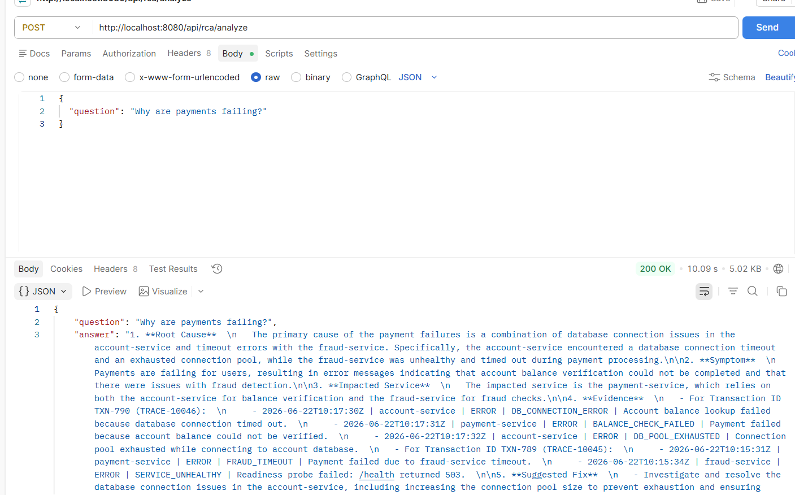

POST http://localhost:8080/api/rca/analyze
Body => JSON
{
"question": "Why did TRACE-10045 fail?"
}

{
"question": "Why did TRACE-10045 fail?"
}

{
"question": "Why did TRACE-10045 fail?",
"rootCause": "The fraud-service timed out due to being unhealthy and restarted.",
"symptom": "Payment failed due to fraud-service timeout.",
"impactedService": "payment-service",
"evidence": [
"2026-06-22T10:15:31Z | service=payment-service | level=ERROR | eventType=APPLICATION_ERROR | errorCode=FRAUD_TIMEOUT | latencyMs=4300 | message=Payment failed due to fraud-service timeout",
"2026-06-22T10:15:33Z | service=fraud-service | level=ERROR | eventType=READINESS_PROBE_FAILED | errorCode=SERVICE_UNHEALTHY | latencyMs=4200 | message=Readiness probe failed: /health returned 503",
"2026-06-22T10:15:34Z | service=fraud-service | level=WARN | eventType=POD_RESTARTED | errorCode=POD_RESTARTED | latencyMs=0 | message=fraud-service pod restarted after repeated health check failures"
],
"suggestedFix": [
"Investigate the health of the fraud-service to prevent timeouts.",
"Monitor and optimize the readiness probe settings for the fraud-service."
],
"retrievedEvidence": [
"ID: trace-TRACE-10046\nScore: 0.20818598568439484\nTrace ID: TRACE-10046\nTransaction ID: TXN-790\nServices: account-service,auth-service,notification-service,payment-service\nError Codes: BALANCE_CHECK_FAILED,DB_CONNECTION_ERROR,DB_POOL_EXHAUSTED\nEnvironment: simulated-prod\n\nEvidence:\nEvidence logs for traceId TRACE-10046 and transactionId TXN-790.\nThe following logs show the request flow in timestamp order:\n\n2026-06-22T10:17:29Z | service=auth-service | level=INFO | eventType=APPLICATION_LOG | errorCode=NONE | latencyMs=105 | message=Token validation successful\n2026-06-22T10:17:30Z | service=account-service | level=ERROR | eventType=APPLICATION_ERROR | errorCode=DB_CONNECTION_ERROR | latencyMs=5100 | message=Account balance lookup failed because database connection timed out\n2026-06-22T10:17:31Z | service=payment-service | level=ERROR | eventType=APPLICATION_ERROR | errorCode=BALANCE_CHECK_FAILED | latencyMs=5200 | message=Payment failed because account balance could not be verified\n2026-06-22T10:17:32Z | service=account-service | level=ERROR | eventType=DATABASE_ERROR | errorCode=DB_POOL_EXHAUSTED | latencyMs=5000 | message=Connection pool exhausted while connecting to account database\n2026-06-22T10:17:33Z | service=notification-service | level=WARN | eventType=APPLICATION_LOG | errorCode=NONE | latencyMs=80 | message=Payment failure notification queued for customer\n",
"ID: trace-TRACE-10045\nScore: 0.19158847630023956\nTrace ID: TRACE-10045\nTransaction ID: TXN-789\nServices: account-service,auth-service,fraud-service,payment-service\nError Codes: FRAUD_TIMEOUT,POD_RESTARTED,SERVICE_UNHEALTHY\nEnvironment: simulated-prod\n\nEvidence:\nEvidence logs for traceId TRACE-10045 and transactionId TXN-789.\nThe following logs show the request flow in timestamp order:\n\n2026-06-22T10:15:29Z | service=auth-service | level=INFO | eventType=APPLICATION_LOG | errorCode=NONE | latencyMs=120 | message=Token validation successful\n2026-06-22T10:15:30Z | service=account-service | level=INFO | eventType=APPLICATION_LOG | errorCode=NONE | latencyMs=210 | message=Account balance check successful\n2026-06-22T10:15:31Z | service=payment-service | level=ERROR | eventType=APPLICATION_ERROR | errorCode=FRAUD_TIMEOUT | latencyMs=4300 | message=Payment failed due to fraud-service timeout\n2026-06-22T10:15:33Z | service=fraud-service | level=ERROR | eventType=READINESS_PROBE_FAILED | errorCode=SERVICE_UNHEALTHY | latencyMs=4200 | message=Readiness probe failed: /health returned 503\n2026-06-22T10:15:34Z | service=fraud-service | level=WARN | eventType=POD_RESTARTED | errorCode=POD_RESTARTED | latencyMs=0 | message=fraud-service pod restarted after repeated health check failures\n"
]
}

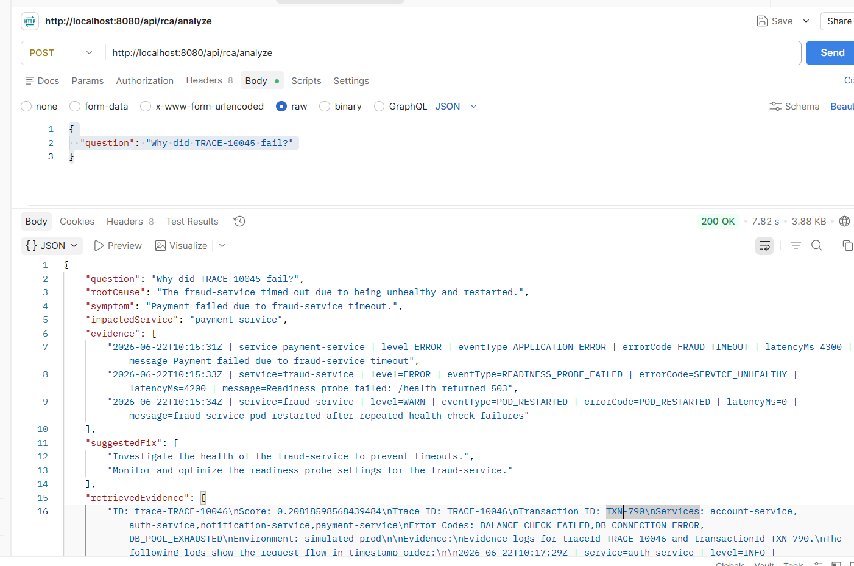

GET http://localhost:8080/api/dashboard/overview

{
"errorsByService": [
{
"service": "payment-service",
"errors": 2
},
{
"service": "fraud-service",
"errors": 2
},
{
"service": "account-service",
"errors": 2
}
],
"errorTrend": [
{
"time": "10:15:31",
"errors": 1
},
{
"time": "10:15:33",
"errors": 1
},
{
"time": "10:15:34",
"errors": 1
},
{
"time": "10:17:30",
"errors": 1
},
{
"time": "10:17:31",
"errors": 1
},
{
"time": "10:17:32",
"errors": 1
}
],
"errorCodes": [
{
"errorCode": "FRAUD_TIMEOUT",
"count": 1
},
{
"errorCode": "SERVICE_UNHEALTHY",
"count": 1
},
{
"errorCode": "POD_RESTARTED",
"count": 1
},
{
"errorCode": "DB_CONNECTION_ERROR",
"count": 1
},
{
"errorCode": "BALANCE_CHECK_FAILED",
"count": 1
},
{
"errorCode": "DB_POOL_EXHAUSTED",
"count": 1
}
],
"traces": [
{
"traceId": "TRACE-10045",
"transactionId": "TXN-789",
"services": "payment-service, fraud-service",
"errorCodes": "FRAUD_TIMEOUT, SERVICE_UNHEALTHY, POD_RESTARTED",
"severity": "High"
},
{
"traceId": "TRACE-10046",
"transactionId": "TXN-790",
"services": "account-service, payment-service",
"errorCodes": "DB_CONNECTION_ERROR, BALANCE_CHECK_FAILED, DB_POOL_EXHAUSTED",
"severity": "High"
}
]
}

