Banking Microservices RCA
AI ProductionSupport Agent

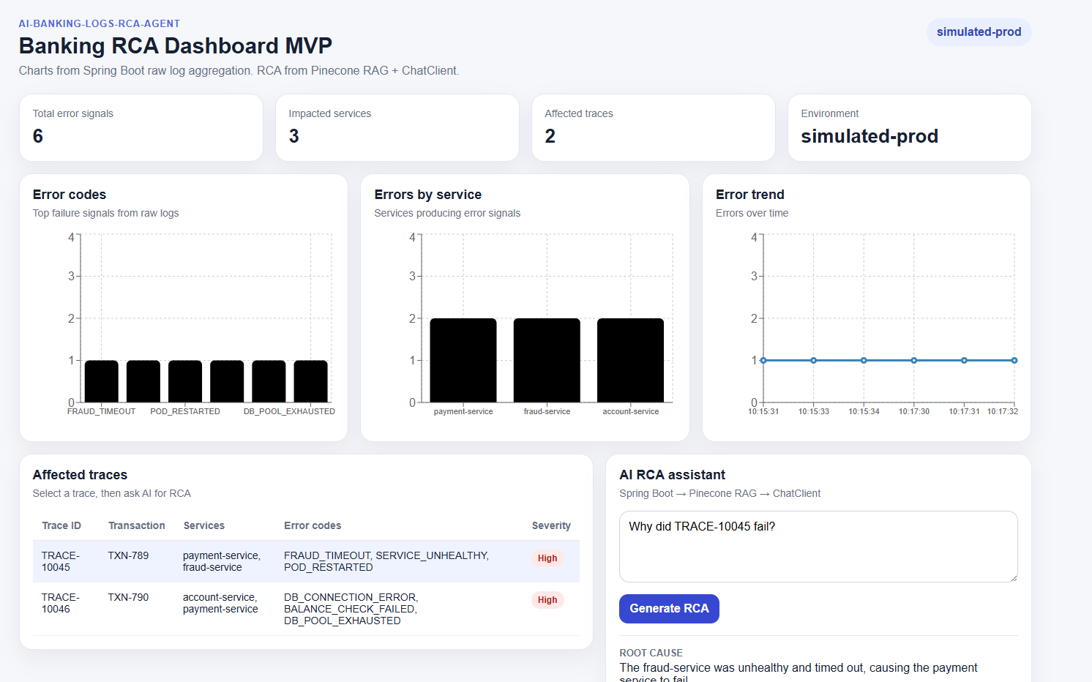

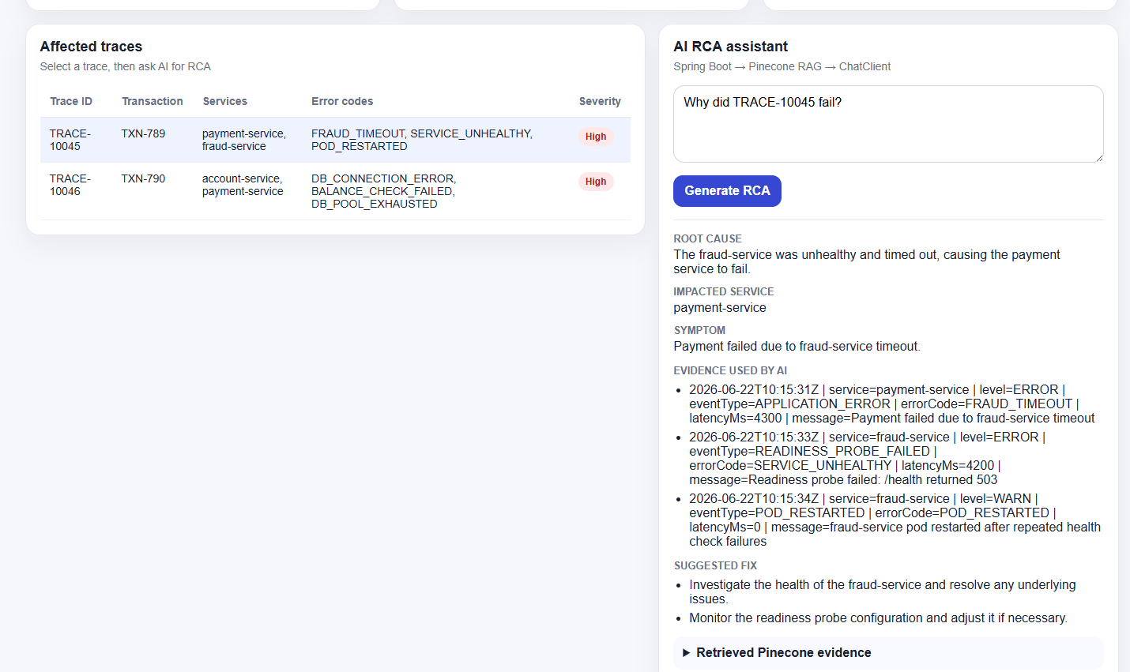

Steps to run

Start watch_raw_logs_to_cloudwatch.py

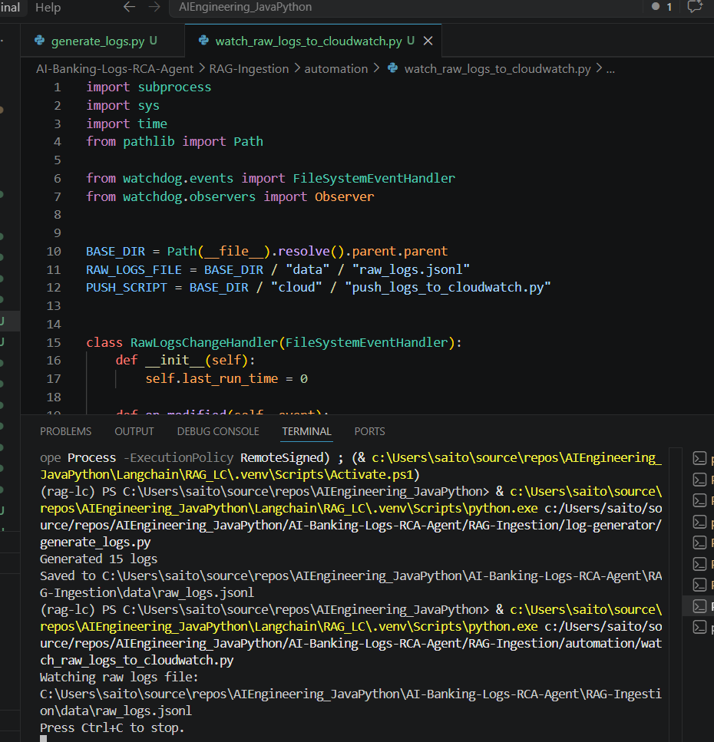
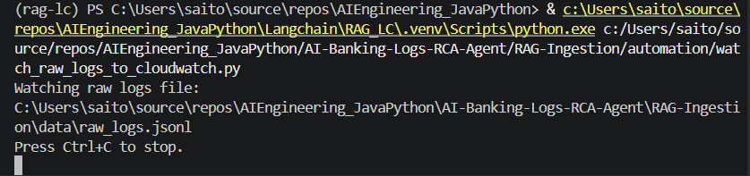

Start Frontend

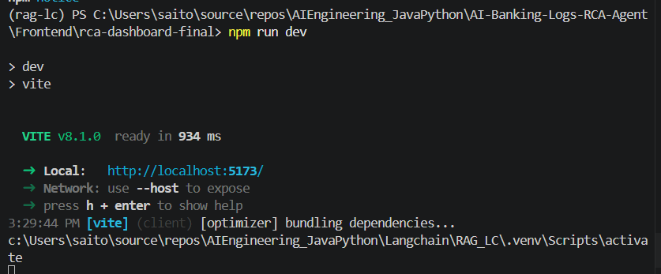

npm run dev

Run generate_logs.py

Start Java Backend

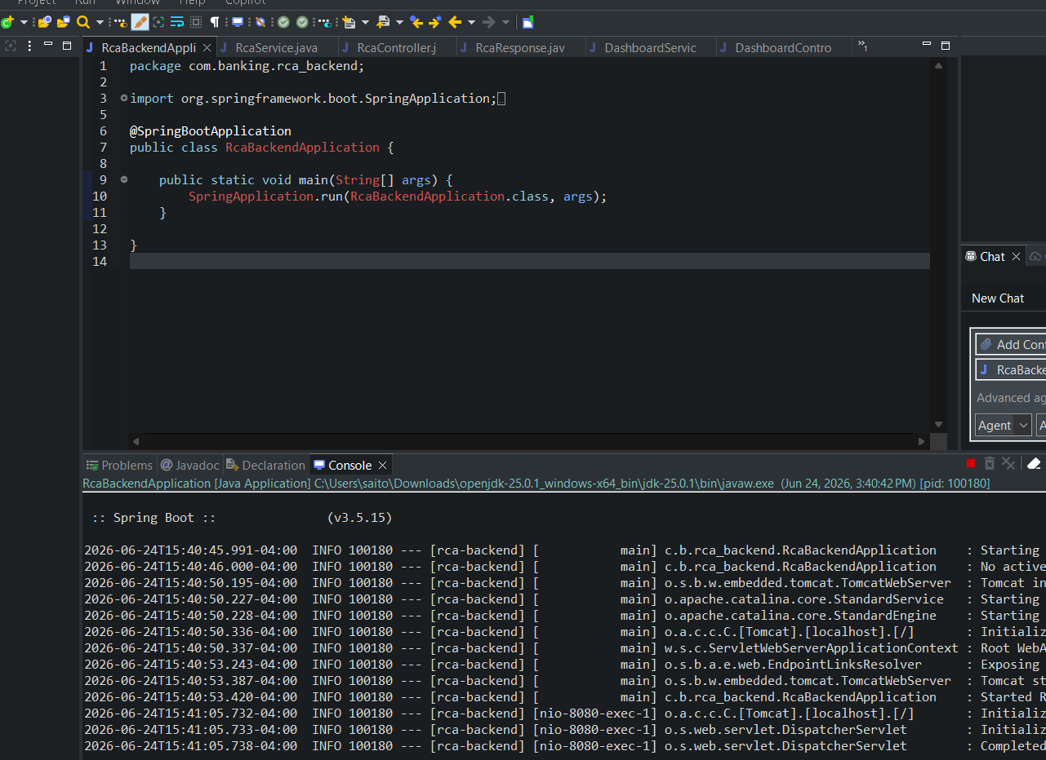

I run Python generate_logs

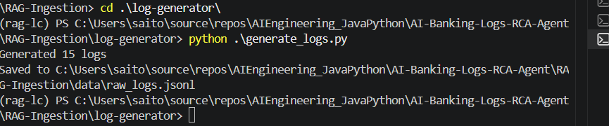

(rag-lc) PS C:\Users\saito\source\repos\AIEngineering_JavaPython\AI-Banking-Logs-RCA-Agent\RAG-Ingestion\log-generator> python .\generate_logs.py
Generated 15 logs

raw_logs.jsonl is updated

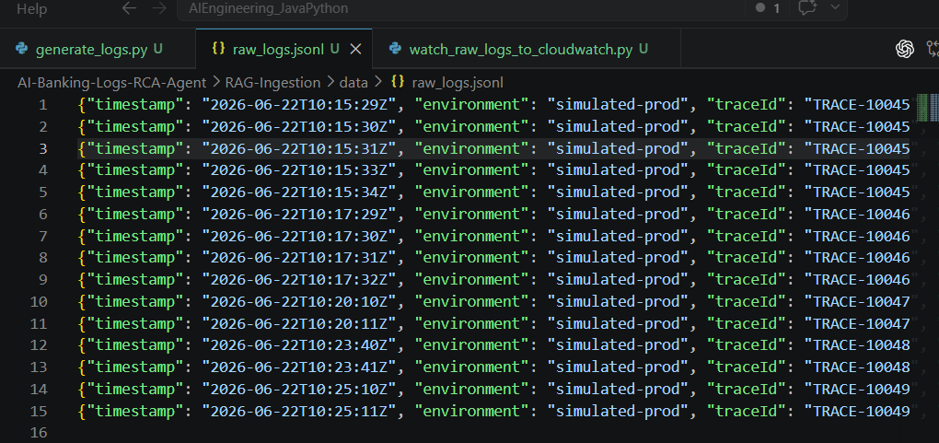

I go to Pinecone

https://app.pinecone.io/organizations/-OvrIsA_yJ8jfTYVBkou/projects/c3748f4f-3842-4b5d-8e41-ec634f41c7ae/indexes/banking-logs-rca/browser

I see everything in the “simulated-prod” Namespace

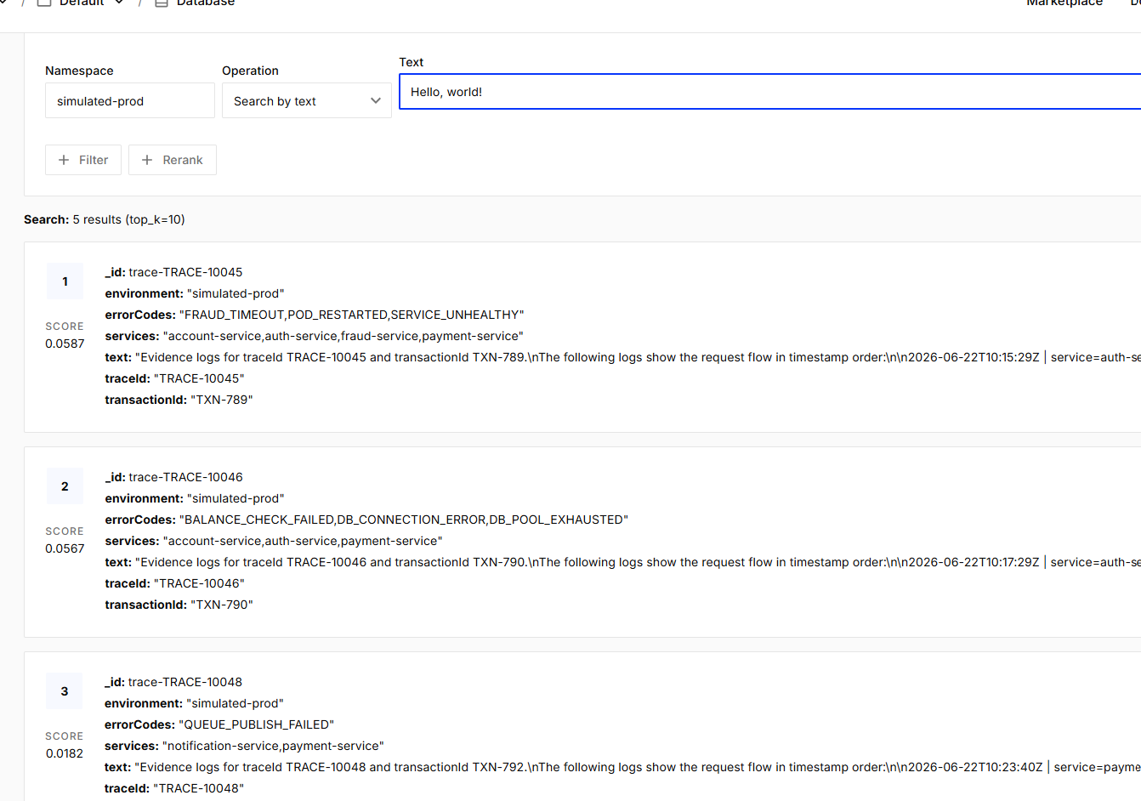

Next go to AWS CloudWatch => Log management => /banking/similated-prod => local-log-generator

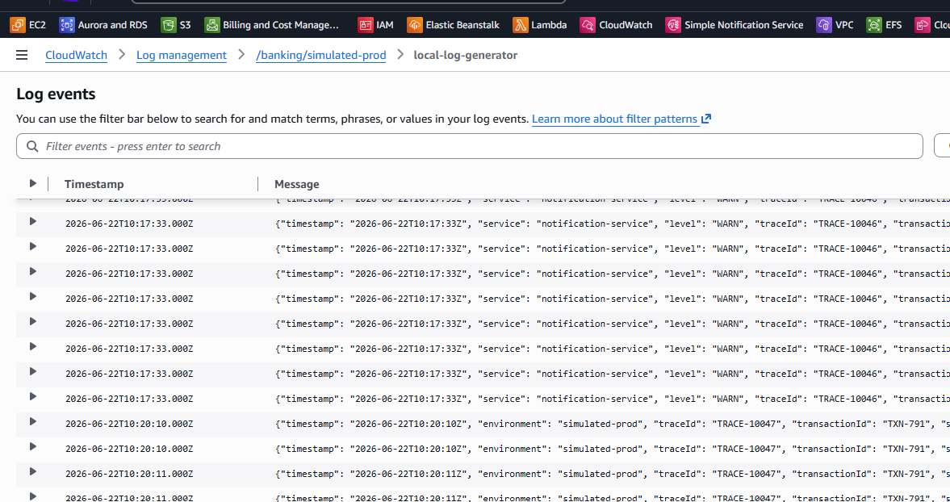

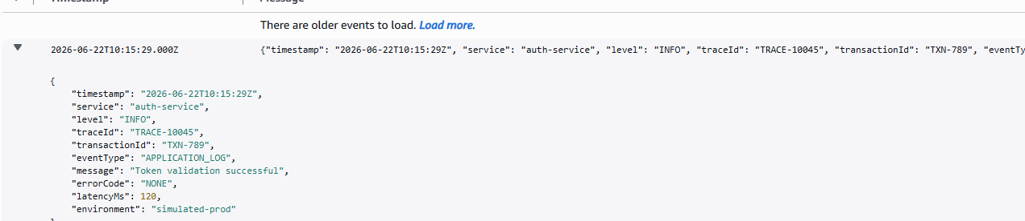

Raw logs are uploaded into CloudWatch then Lambda applies Chunking and groups raw_logs into groups by TraceID.

CloudWatch raw logs
→ Lambda receives batch
→ parses each JSON log line
→ groups logs by traceId
→ creates 1 evidence document per traceId
→ upserts that document to Pinecone

You can go to Log management => aws/lambda/banking-ingestion-lambda and pick the latest log

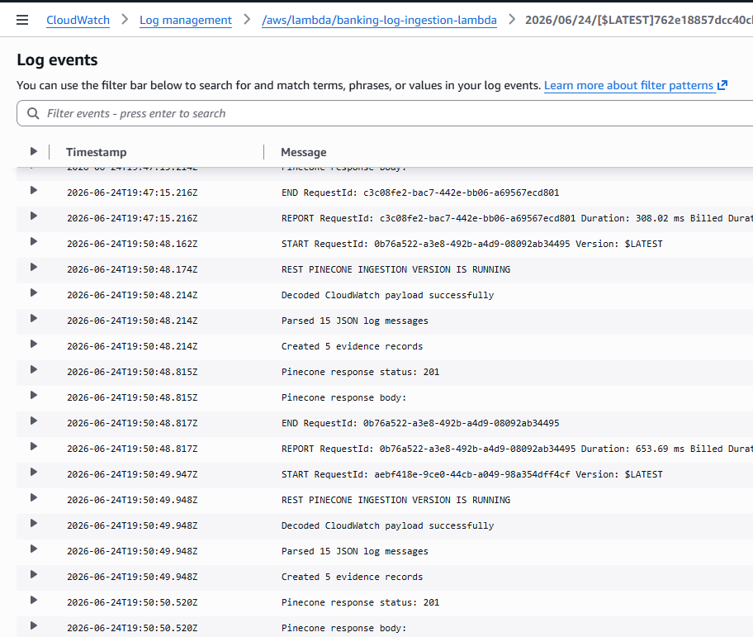

Lambda chunks all raw data by TraceID into Evidence record by TraceIDs

Now we go to Frontend: http://localhost:5173/

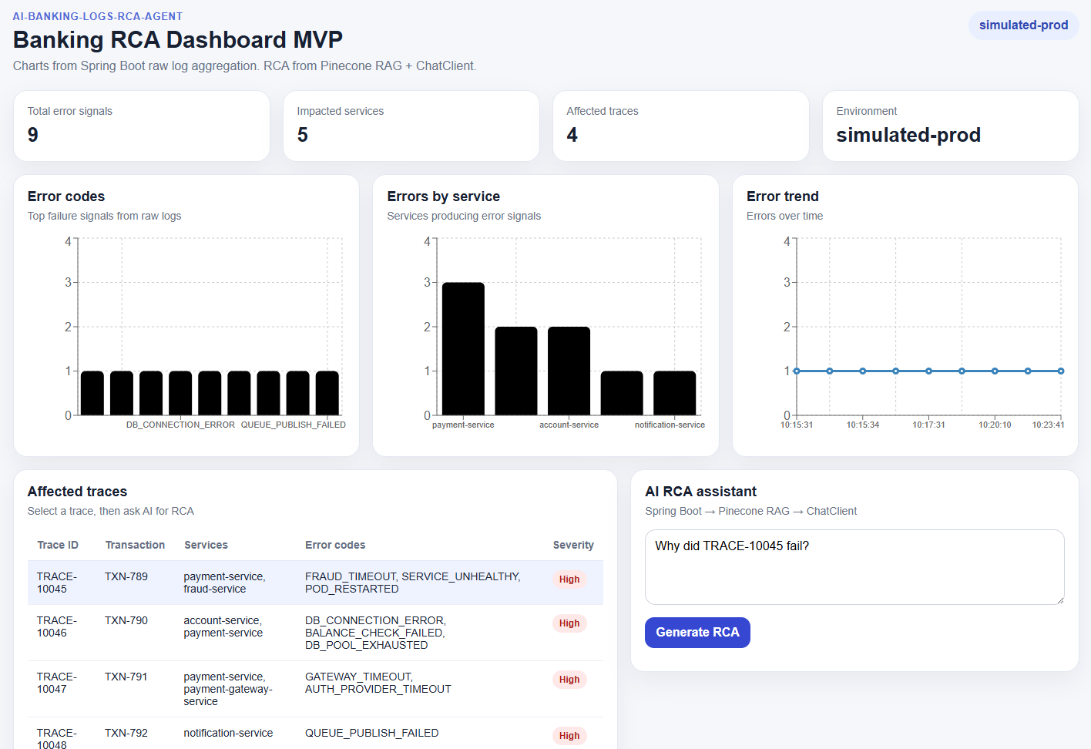

Prompt
The dashboard shows repeated payment-service errors. Is payment-service the real root cause, or are upstream dependencies causing the failures?

Root cause
Upstream dependencies (specifically payment-gateway-service and fraud-service) are causing the failures.

Impacted service
payment-service

Symptom
Payment authorization and payment processing errors in the payment-service.

Evidence used by AI
Payment authorization failed because payment-gateway-service timed out (GATEWAY_TIMEOUT)
Payment failed due to fraud-service timeout (FRAUD_TIMEOUT)
Suggested fix
Investigate and resolve timeout issues with payment-gateway-service.
Address the health and readiness of the fraud-service to prevent service unavailability.
Retrieved Pinecone evidence
[
"ID: trace-TRACE-10047\nScore: 0.3562491834163666\nTrace ID: TRACE-10047\nTransaction ID: TXN-791\nServices: payment-gateway-service,payment-service\nError Codes: AUTH_PROVIDER_TIMEOUT,GATEWAY_TIMEOUT\nEnvironment: simulated-prod\n\nEvidence:\nEvidence logs for traceId TRACE-10047 and transactionId TXN-791.\nThe following logs show the request flow in timestamp order:\n\n2026-06-22T10:20:10Z | service=payment-service | level=ERROR | eventType=APPLICATION_ERROR | errorCode=GATEWAY_TIMEOUT | latencyMs=6200 | message=Payment authorization failed because payment-gateway-service timed out\n2026-06-22T10:20:11Z | service=payment-gateway-service | level=ERROR | eventType=DOWNSTREAM_TIMEOUT | errorCode=AUTH_PROVIDER_TIMEOUT | latencyMs=6100 | message=External authorization provider did not respond within timeout\n",
"ID: trace-TRACE-10045\nScore: 0.32967695593833923\nTrace ID: TRACE-10045\nTransaction ID: TXN-789\nServices: account-service,auth-service,fraud-service,payment-service\nError Codes: FRAUD_TIMEOUT,POD_RESTARTED,SERVICE_UNHEALTHY\nEnvironment: simulated-prod\n\nEvidence:\nEvidence logs for traceId TRACE-10045 and transactionId TXN-789.\nThe following logs show the request flow in timestamp order:\n\n2026-06-22T10:15:29Z | service=auth-service | level=INFO | eventType=APPLICATION_LOG | errorCode=NONE | latencyMs=120 | message=Token validation successful\n2026-06-22T10:15:30Z | service=account-service | level=INFO | eventType=APPLICATION_LOG | errorCode=NONE | latencyMs=210 | message=Account balance check successful\n2026-06-22T10:15:31Z | service=payment-service | level=ERROR | eventType=APPLICATION_ERROR | errorCode=FRAUD_TIMEOUT | latencyMs=4300 | message=Payment failed due to fraud-service timeout\n2026-06-22T10:15:33Z | service=fraud-service | level=ERROR | eventType=READINESS_PROBE_FAILED | errorCode=SERVICE_UNHEALTHY | latencyMs=4200 | message=Readiness probe failed: /health returned 503\n2026-06-22T10:15:34Z | service=fraud-service | level=WARN | eventType=POD_RESTARTED | errorCode=POD_RESTARTED | latencyMs=0 | message=fraud-service pod restarted after repeated health check failures\n"
]
10:15:31

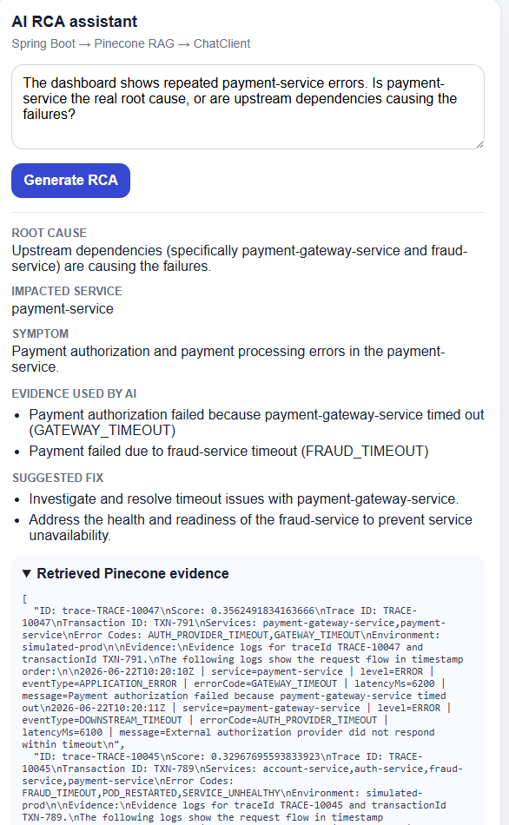

Prompt
why trace-TRACE-10047 fail?

Root cause
Database connection issues leading to account balance verification failure.

Impacted service
payment-service

Symptom
Payment failed because account balance could not be verified.

Evidence used by AI
Account balance lookup failed because database connection timed out.
Payment failed because account balance could not be verified.
Connection pool exhausted while connecting to account database.
Suggested fix
Investigate and resolve the database connection timeout issue.
Increase the database connection pool size to prevent exhaustion.

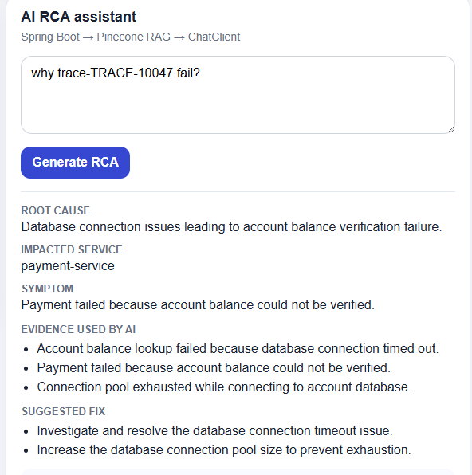

.env in Python
OPENAI_API_KEY=your_openai_api_key
PINECONE_API_KEY=*************************
PINECONE_INDEX_NAME=**********************
PINECONE_NAMESPACE=simulated-prod

AWS_ACCESS_KEY_ID=****************
AWS_SECRET_ACCESS_KEY=******************************
AWS_REGION=ca-central-1

.env in Java
OPENAI_API_KEY=************************
PINECONE_API_KEY=&**********************************
PINECONE_INDEX_HOST=********************************
PINECONE_NAMESPACE=simulated-prod

Environment variables in Lambda

