Pinecone setup + test

Go to Pinecone website => start for free

https://www.pinecone.io/

Create API key, Index

To test in local and manually

Run
generate_logs.py
create_evidence_chunk.py
ingest_to_pinecone.py

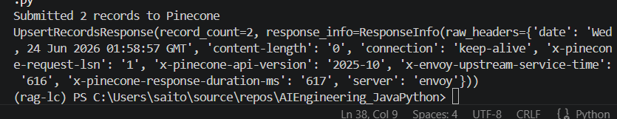

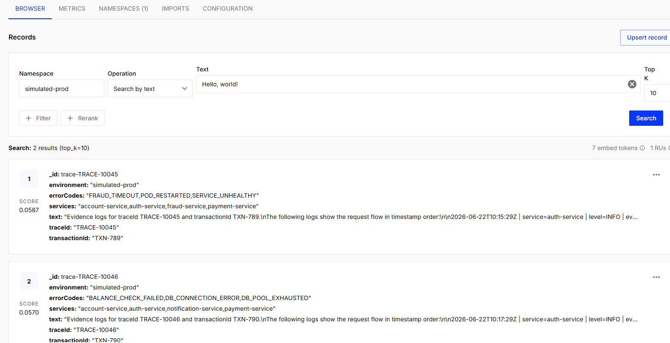

(rag-lc) PS C:\Users\saito\source\repos\AIEngineering_JavaPython\AI-Banking-Logs-RCA-Agent\search> python .\test_search.py

Question:
Why are payments failing?

Pinecone Search Results:

---------------------------
Score: None
ID: None
Trace ID: TRACE-10046
Transaction ID: TXN-790
Services: account-service,auth-service,notification-service,payment-service
Error Codes: BALANCE_CHECK_FAILED,DB_CONNECTION_ERROR,DB_POOL_EXHAUSTED
Environment: simulated-prod

Evidence Text:
Evidence logs for traceId TRACE-10046 and transactionId TXN-790.
The following logs show the request flow in timestamp order:

2026-06-22T10:17:29Z | service=auth-service | level=INFO | eventType=APPLICATION_LOG | errorCode=NONE | latencyMs=105 | message=Token validation successful
2026-06-22T10:17:30Z | service=account-service | level=ERROR | eventType=APPLICATION_ERROR | errorCode=DB_CONNECTION_ERROR | latencyMs=5100 | message=Account balance lookup failed because database connection timed out
2026-06-22T10:17:31Z | service=payment-service | level=ERROR | eventType=APPLICATION_ERROR | errorCode=BALANCE_CHECK_FAILED | latencyMs=5200 | message=Payment failed because account balance could not be verified
2026-06-22T10:17:32Z | service=account-service | level=ERROR | eventType=DATABASE_ERROR | errorCode=DB_POOL_EXHAUSTED | latencyMs=5000 | message=Connection pool exhausted while connecting to account database
2026-06-22T10:17:33Z | service=notification-service | level=WARN | eventType=APPLICATION_LOG | errorCode=NONE | latencyMs=80 | message=Payment failure notification queued for customer

---------------------------
Score: None
ID: None
Trace ID: TRACE-10045
Transaction ID: TXN-789
Services: account-service,auth-service,fraud-service,payment-service
Error Codes: FRAUD_TIMEOUT,POD_RESTARTED,SERVICE_UNHEALTHY
Environment: simulated-prod

Evidence Text:
Evidence logs for traceId TRACE-10045 and transactionId TXN-789.
The following logs show the request flow in timestamp order:

2026-06-22T10:15:29Z | service=auth-service | level=INFO | eventType=APPLICATION_LOG | errorCode=NONE | latencyMs=120 | message=Token validation successful
2026-06-22T10:15:30Z | service=account-service | level=INFO | eventType=APPLICATION_LOG | errorCode=NONE | latencyMs=210 | message=Account balance check successful
2026-06-22T10:15:31Z | service=payment-service | level=ERROR | eventType=APPLICATION_ERROR | errorCode=FRAUD_TIMEOUT | latencyMs=4300 | message=Payment failed due to fraud-service timeout
2026-06-22T10:15:33Z | service=fraud-service | level=ERROR | eventType=READINESS_PROBE_FAILED | errorCode=SERVICE_UNHEALTHY | latencyMs=4200 | message=Readiness probe failed: /health returned 503
2026-06-22T10:15:34Z | service=fraud-service | level=WARN | eventType=POD_RESTARTED | errorCode=POD_RESTARTED | latencyMs=0 | message=fraud-service pod restarted after repeated health check failures

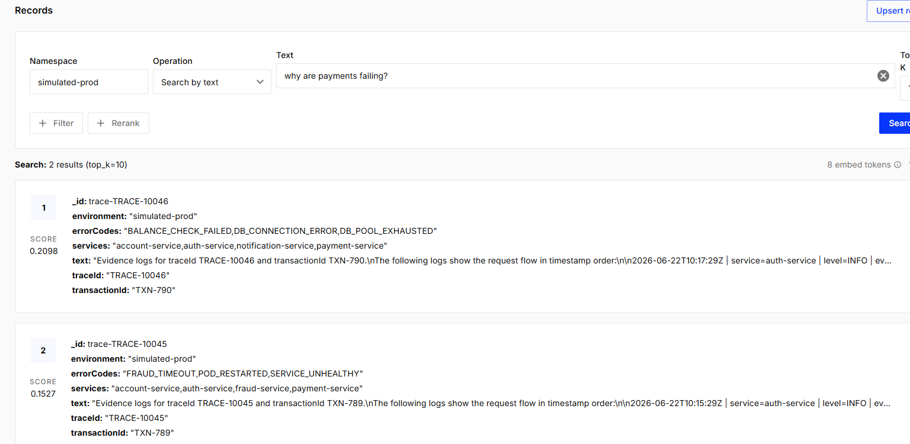

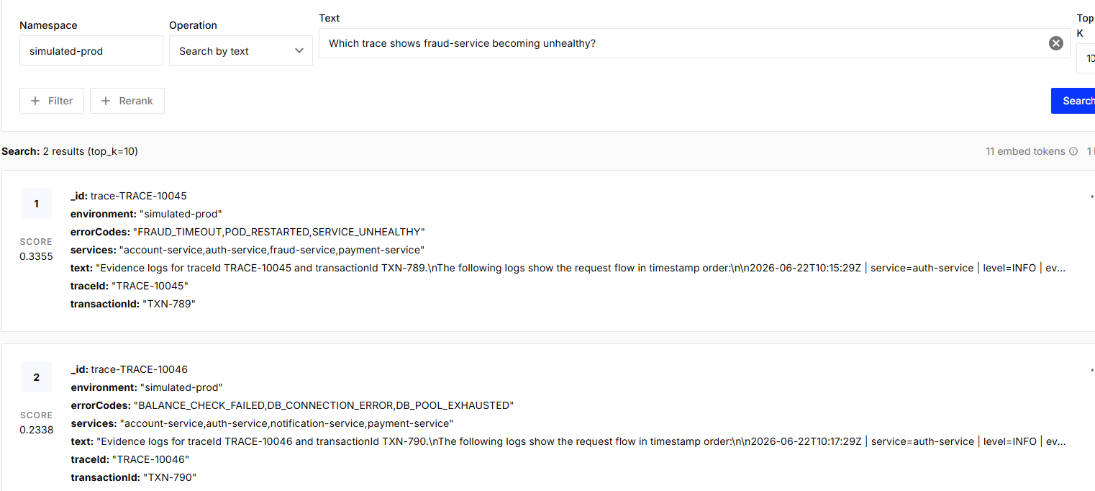

Automating with AWS

Ran python cloud/push_logs_to_cloudwatch.py

Go to AWS CloudWatch

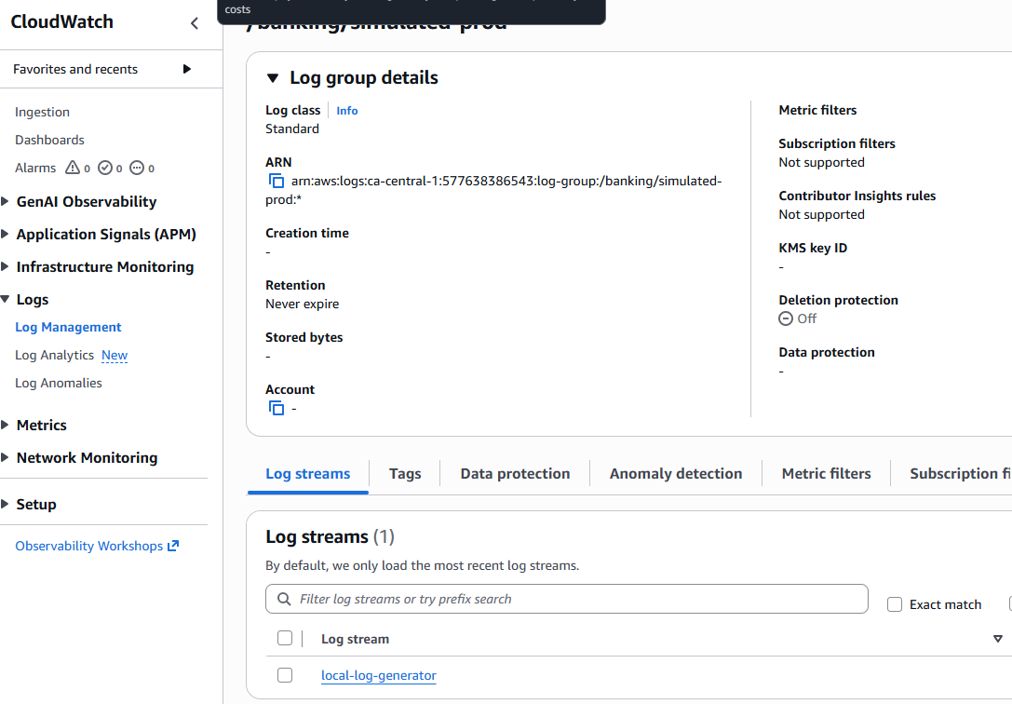

We can see all the logs

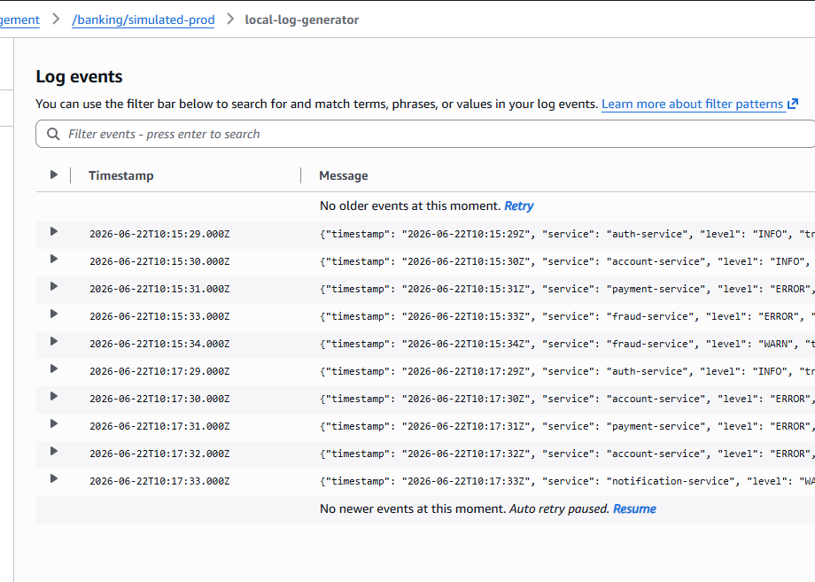

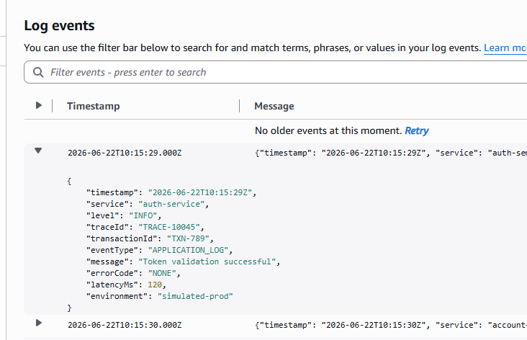

Next Create Lambda function

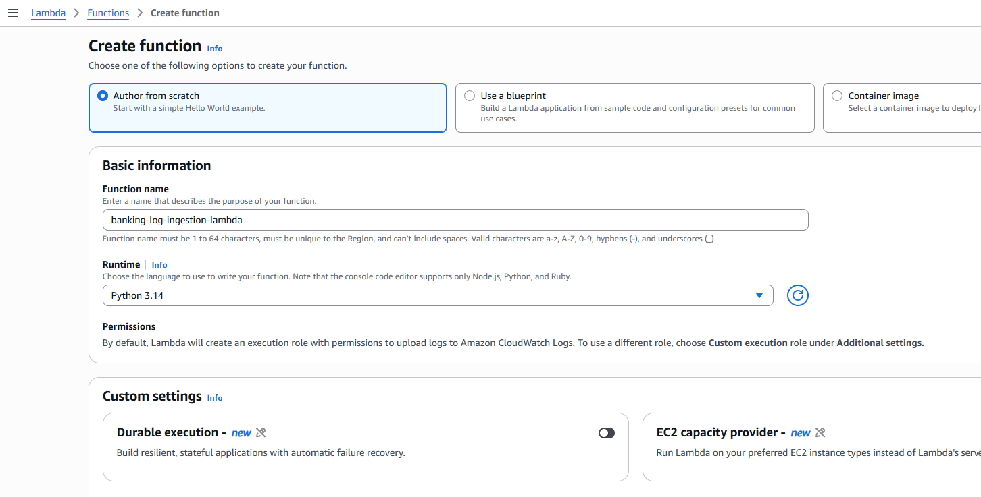

Copy paste the lambda_function.py

Click Deploy

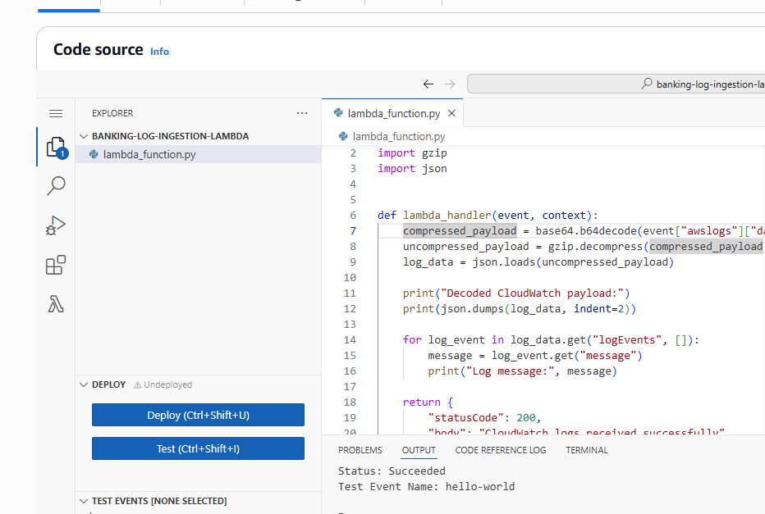

After deploying, go back to CloudWatch

Go to Subscription filters of /banking/simulated-prod

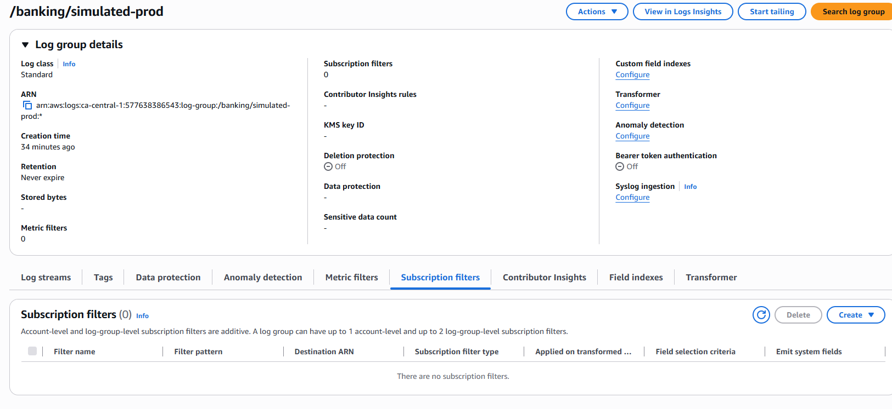

Create Lambda Subscription filter

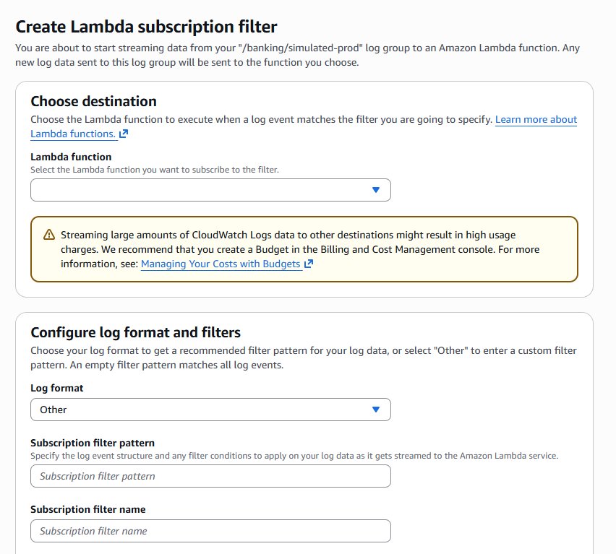
A subscription filter is the automatic bridge between CloudWatch Logs and Lambda.

Subscription filter name: banking-logs-to-lambda

Click Start streaming

New log arrives in /banking/simulated-prod
↓
Subscription filter checks it
↓
If it matches the filter pattern
↓
CloudWatch sends it to Lambda
↓
Lambda runs automatically
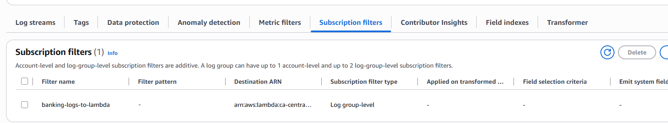

Re-run push_logs_to_cloudwatch.py

Go to banking-log-ingestion-lambda

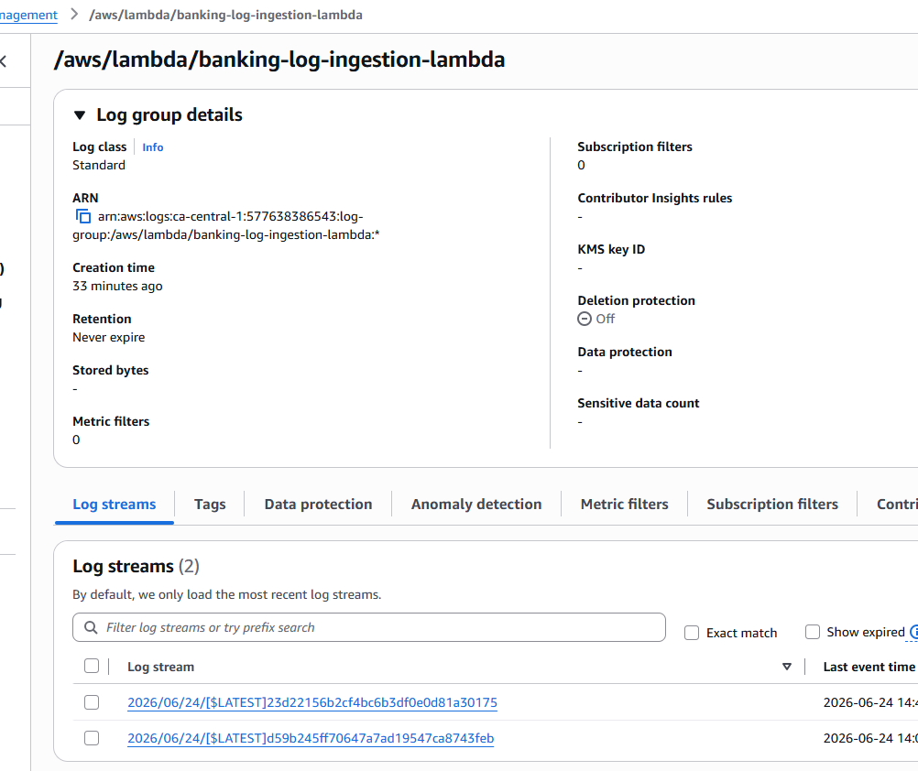

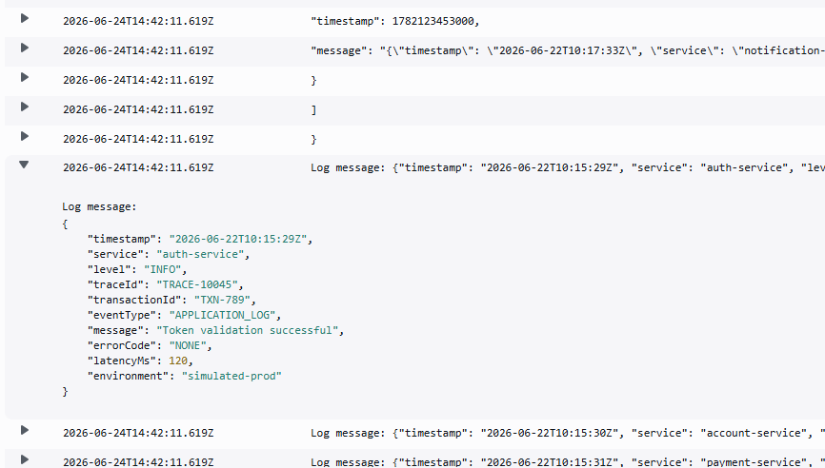

Local script → CloudWatch Logs → Subscription Filter → Lambda ✅

Add Pinecone environment variables to Lambda
Lambda → banking-log-ingestion-lambda → Configuration → Environment variables

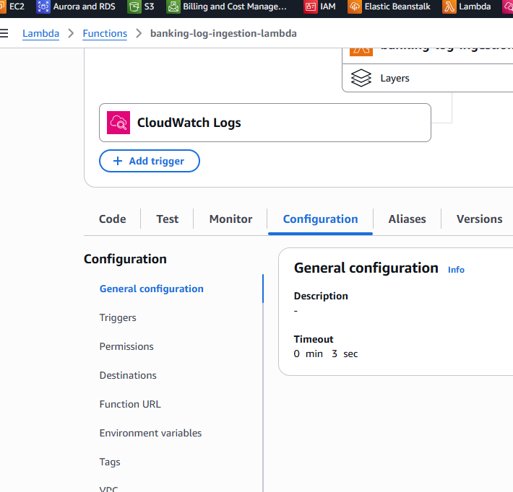

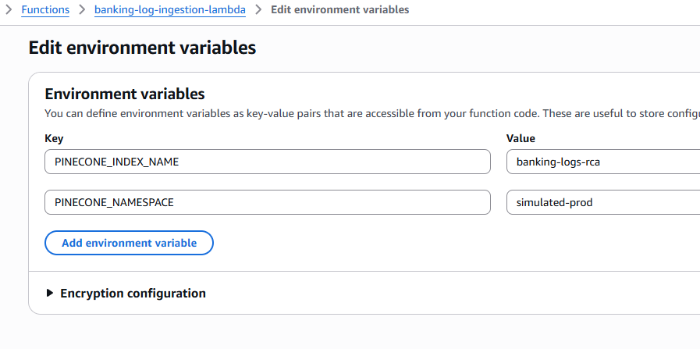

Go to vscode

mkdir lambda_build
mkdir lambda_build\package

python -m pip install pinecone -t lambda_build\package

Add test lambda_function.py

cd lambda_build\package
Compress-Archive -Path * -DestinationPath ..\banking-log-ingestion-lambda.zip -Force
cd ..\..

python cloud/push_logs_to_cloudwatch.py

I upload the new zip file into Lambda

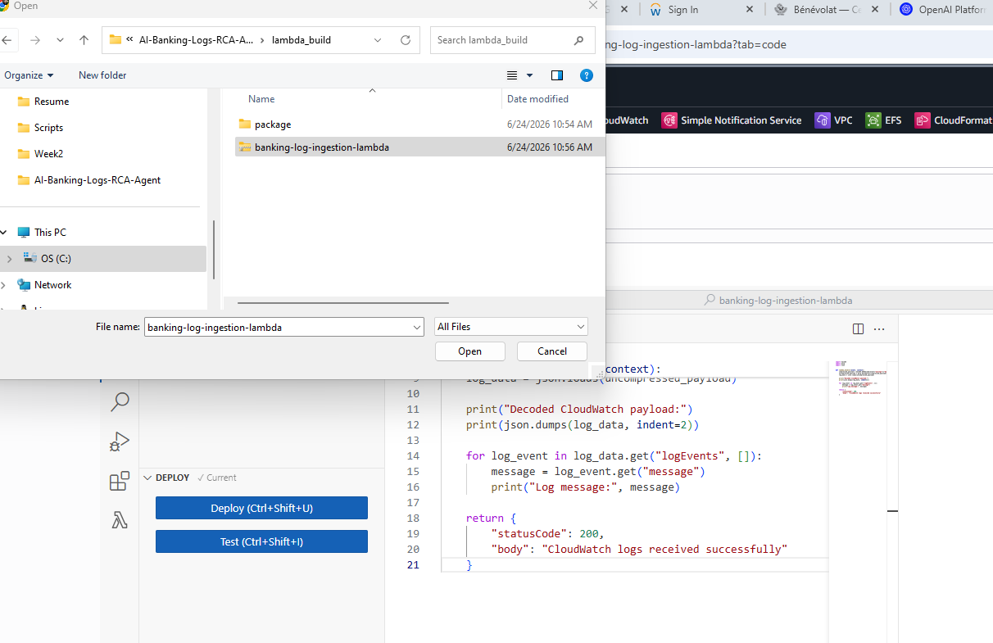

Now I retry with deploy_lambda_zip.py

python cloud/deploy_lambda_zip.py

Make sure you have following Environment variables in Lambda

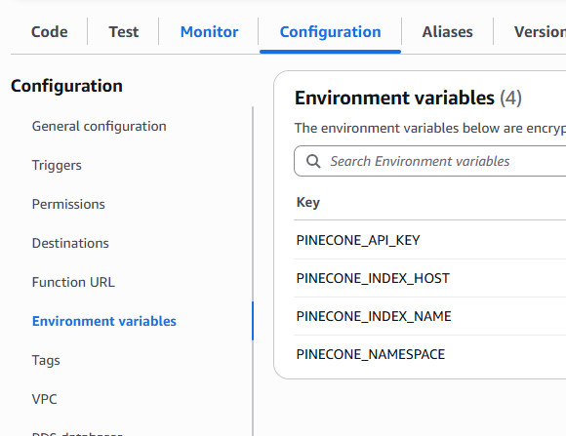

Re-run push_logs_to_cloudwatch.py

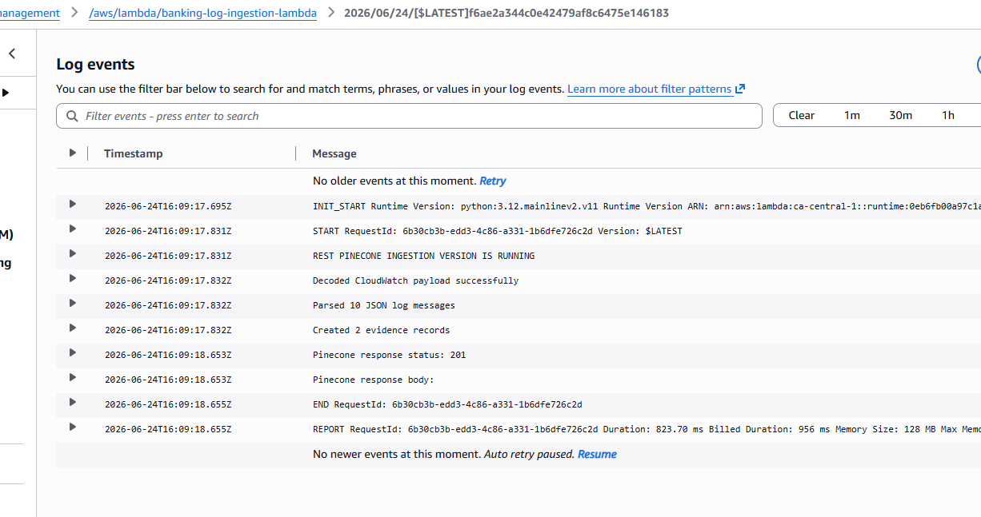

Local raw_logs.jsonl
→ CloudWatch Logs
→ Subscription Filter
→ Lambda
→ Pinecone REST upsert
✅

