Angular Project Structure

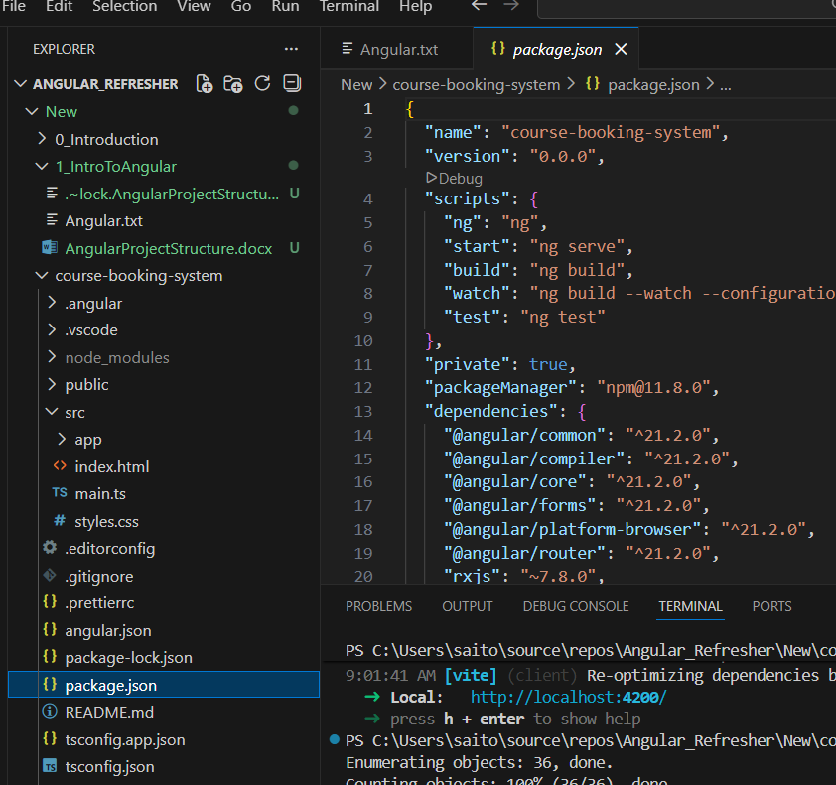

Lets start with top-level first: package.json. Heart of project dependencies
Lists all packages the app needs like Angular, TypeScript, Various libraries. They are downloaded into the node_modules folder
node_modules folder has a long list of files lot more than the package.json file. Thats because of the dependencies of the dependencies

Next is angular.json file
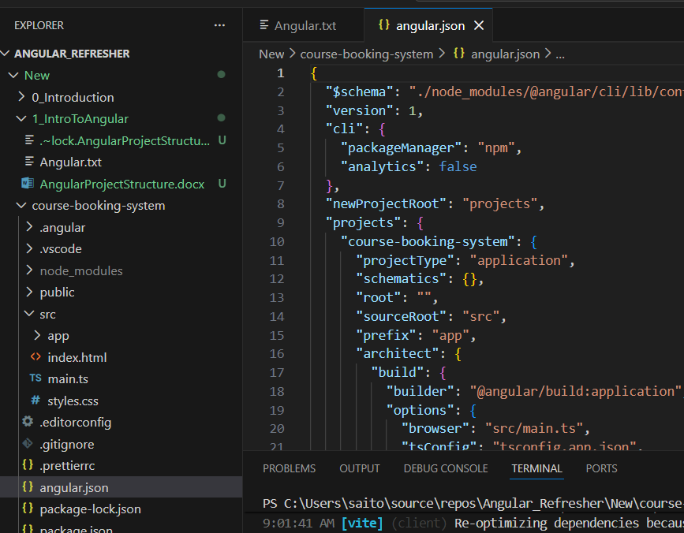
angular.json => it has the CLI configuration, how our project is built, tested and includes settings for different environments and build options

tsconfig.json

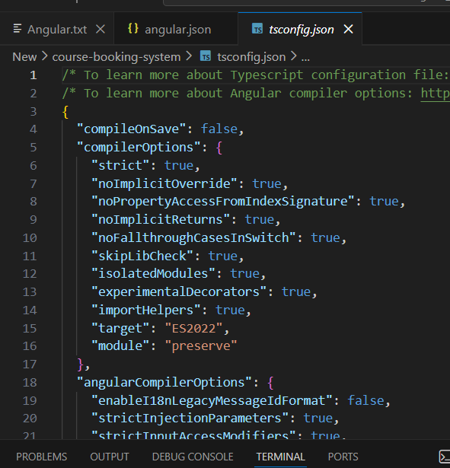

tsconfig.json => TypeScript configuration file, it sets rules for TypeScript compilation, supports code consistency. Helps with consistency and catching errors early on.

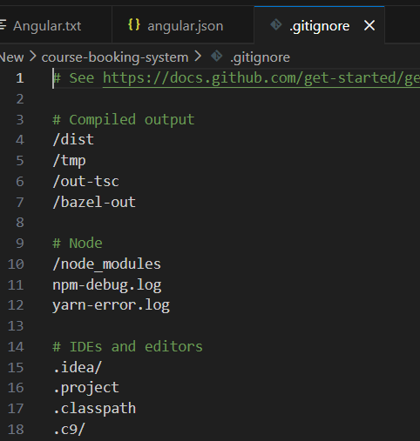

.gitignore file tells Git which folders and files to ignore. It prevents unnecessary files like huge node_modules folder or sensitive files containing environment secrets from being tracked in a version control.

/src/ folder where the magic happens. The application code lives here.
main.ts

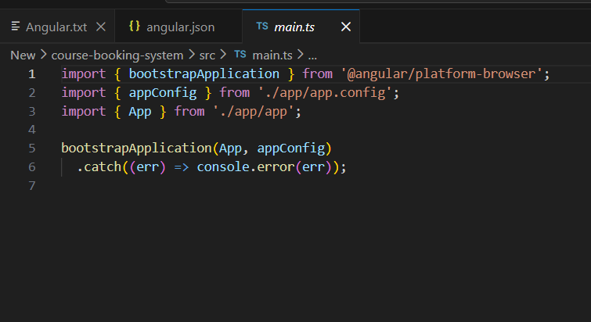

This is the entry point for our application. It bootstraps the Angular app, essentially kicking off the whole process.

index.html

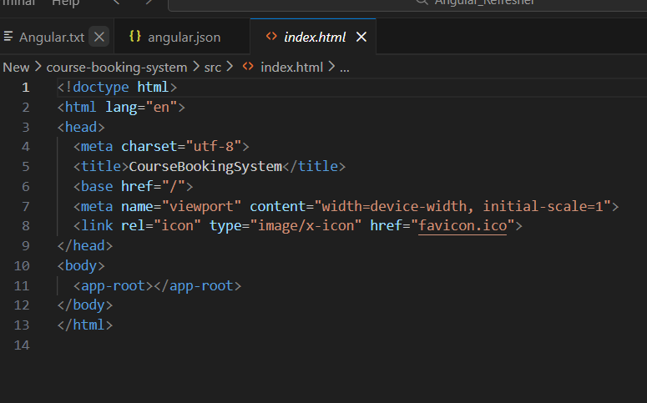
index.html is the main html file that Angular injects our App into. This determines what we will see on the page. Then styles.css, this file contains global styles for our app, affecting look and feel across all components. It’s where we can setup color screens, typography, and overall design aesthetics.
Asset components: they are in the ‘app’ folder. That’s where we have the application components, services, and other core functionality resides

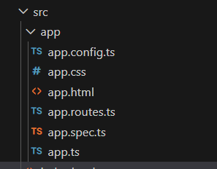

app component is in app.ts
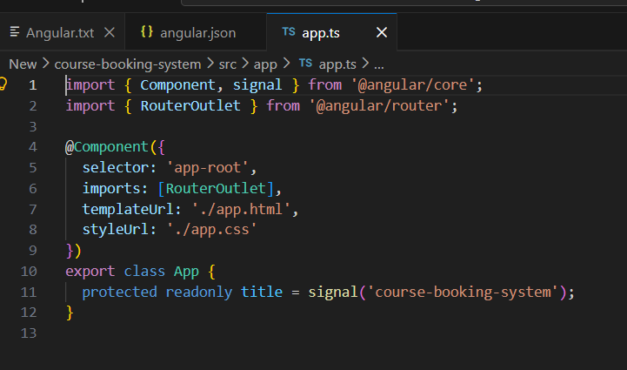
it consists of a TypeScript file, HTML, a CSS file and a test file. This file defines the root component of our application. This is the first component that loads and serves as the parent for all other components.

We can see this component is injected into index.html <app-root></app-root>

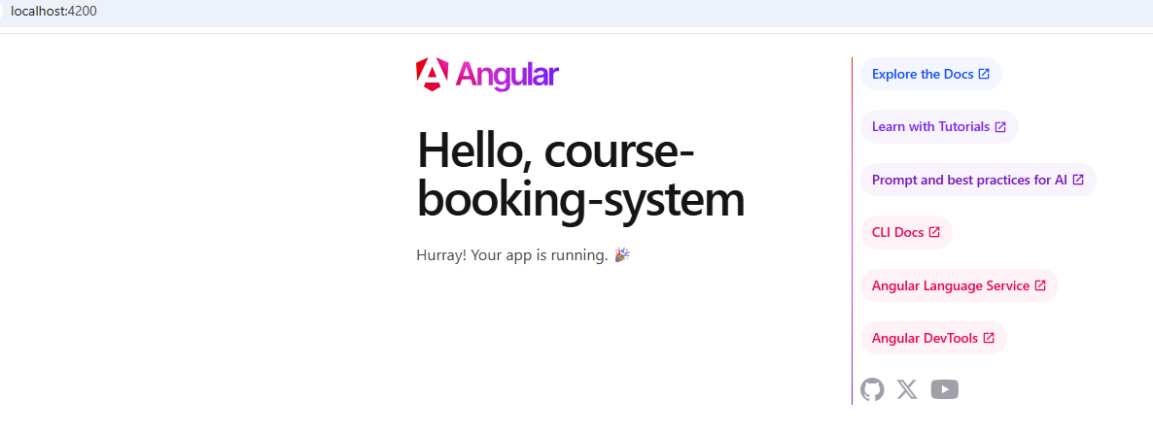

app.routes.ts defines main navigation within our app. It defines how users move between different components and views

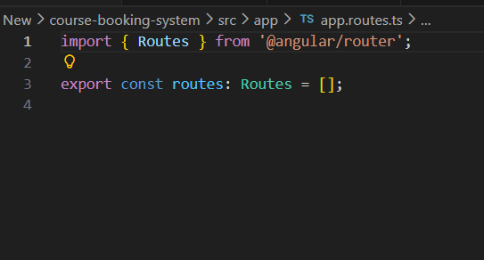

‘public’ folder is the folder for aesthetics assets like images or other files that don’t require processing by Angular. Good for storing assets
