**AWS RDS ---> Relational Databases**

Database -> data will be stored permanently

Relational database means, data will be stored in the form of rows and columns (in the form of tables)

Example: ID, name, image,

Non-cloud database

1. Purchase database server license
2. Install DB server software
3. Security responsibility is on your head
4. Good support for Networking
5. Backup database

Major cloud providers ---> they are providing the database on cloud so no Security concerns, no Networking issues, no Backup issues

We are only going to buy the database services from the cloud providers

Database: It is a software, which is used to store data permanently

We have many database management softwares ---> Oracle, MySQL, Postgres, SQLServer

Every application will use database to store and manage data. Relational databases store data in table format (rows and columns)

Limitations to have on prem database:

Security concerns, Network issues, Backup issues, Administration issues

To overcome on prem database maintenance challenges, we can use Cloud database service

AWS RDS service provides cloud database facility

---> RDS stands for Relational Database Service in AWS cloud, which can be used to create and manage relational database

---> RDS is a fully managed service in AWS cloud and works based on pay-as you go model

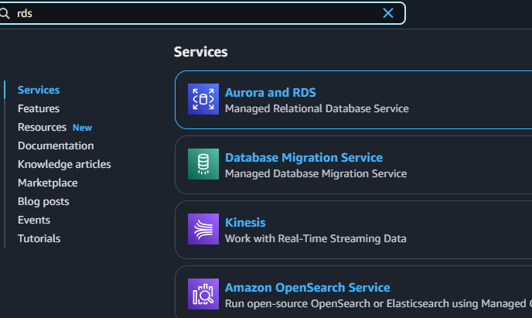

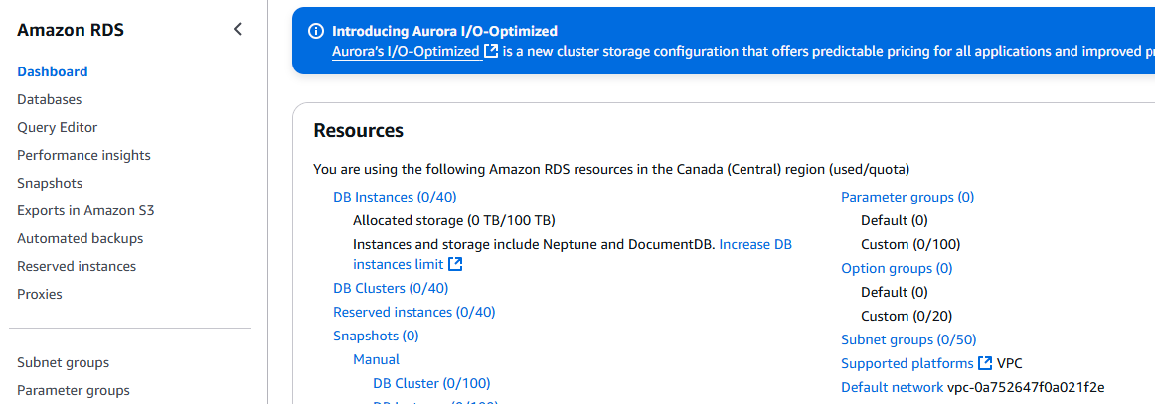

Create database

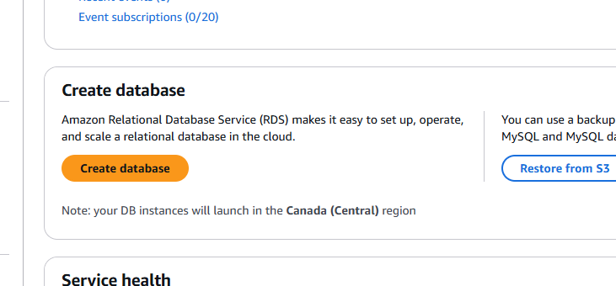

Standard create and MySQL, then free tier, rest default

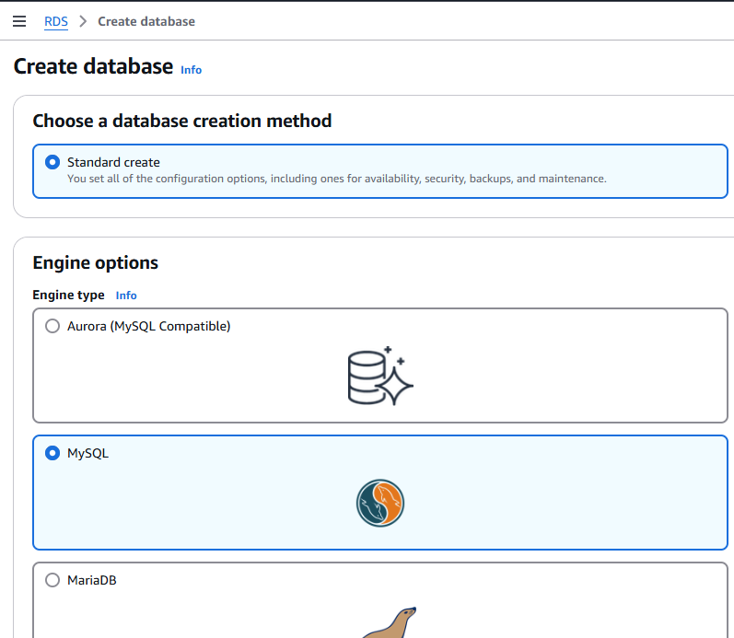

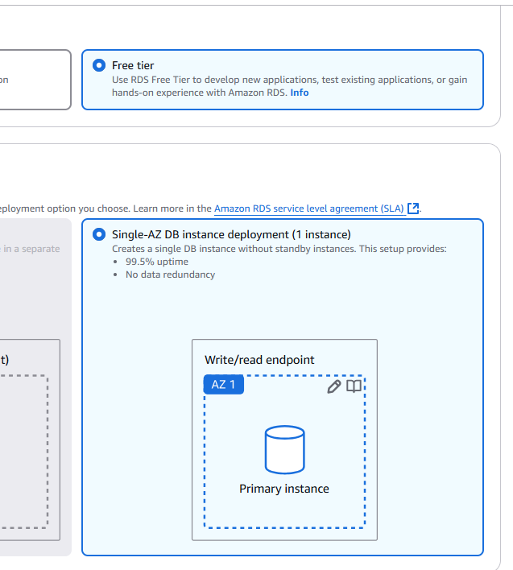

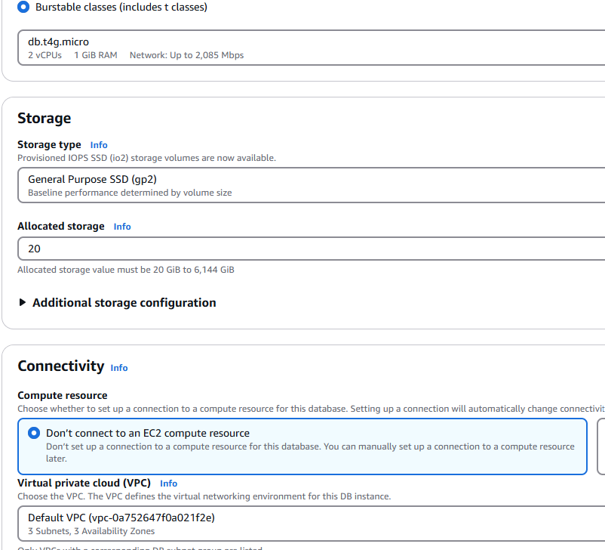

Public access: Yes, we can also connect to MySQL DB from desktop workbench

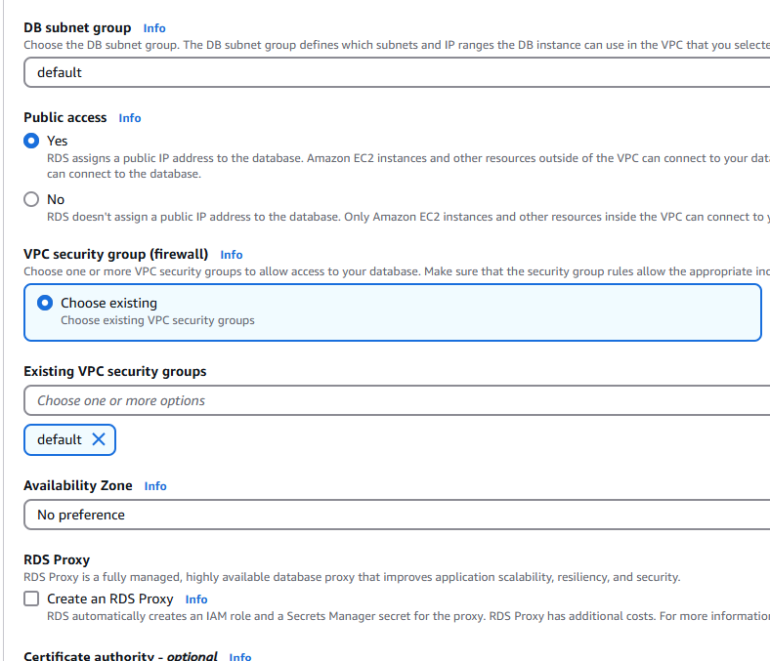

We add MySQL/Aurora to the inbound rules

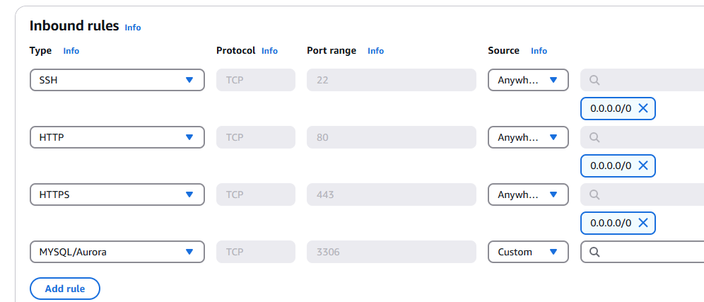

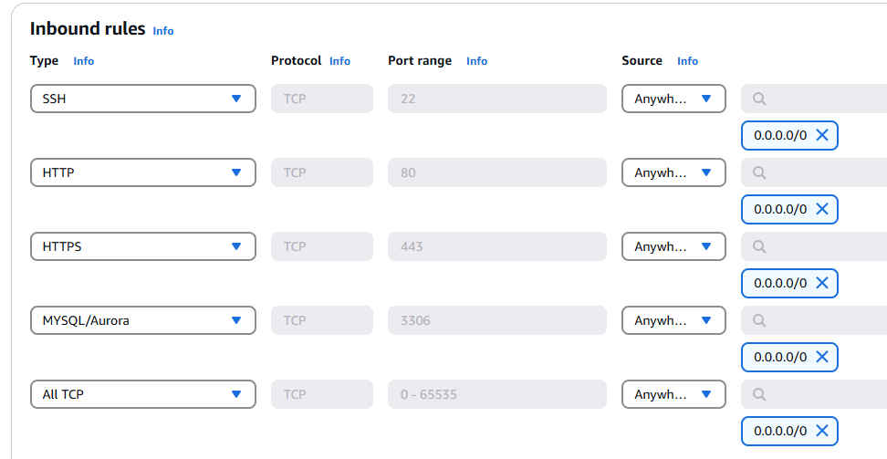

Add Security group

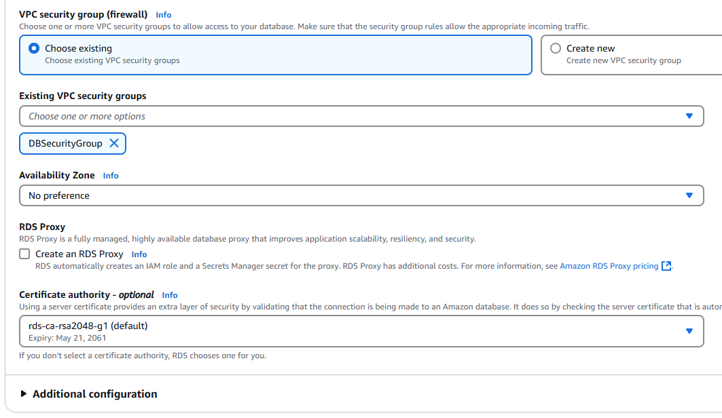

Add Initial database name no other changes

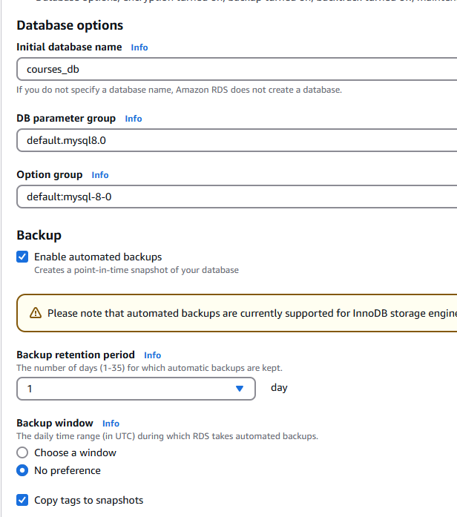

Create Database

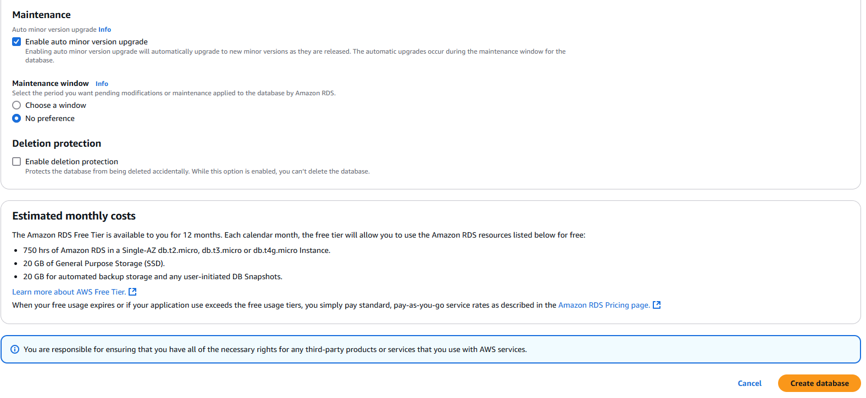

Practical RDS tasks:

Create MySQL DB server using RDS

Standard create

MySQL option

Version of MySQL default

Templates (Free tier)

Setting --> Enter DB instance identifier, Set Master user name - admin, self-managed, enter password

Storage - default

Connectivity - default options

Public access - Yes

Security group (Add MySQL in security group)

Note: Enable MySQL :: 3306 port number in Security group InBound rules

Additional configuration ---> Database options (enter initial database name)

Backup ----> based on your need we can edit

Click Create database

Note: After practice, delete RDS instance to avoid billing

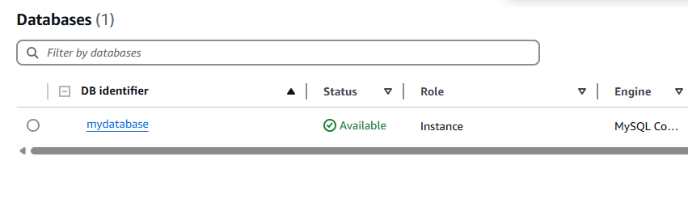

Click connection details

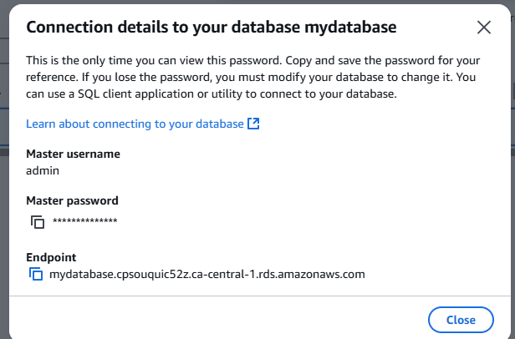

Go to MySQL workbench ---> click + button

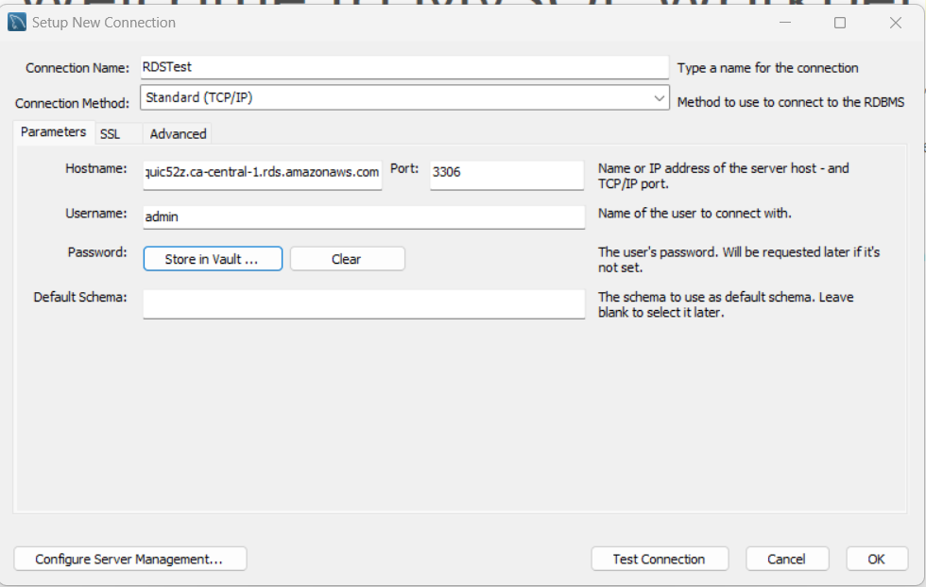

Click Test Connection

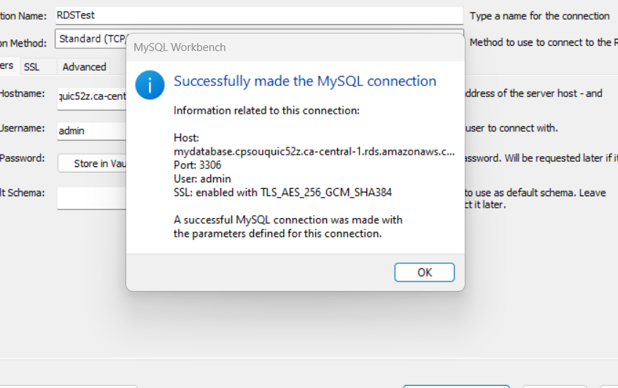

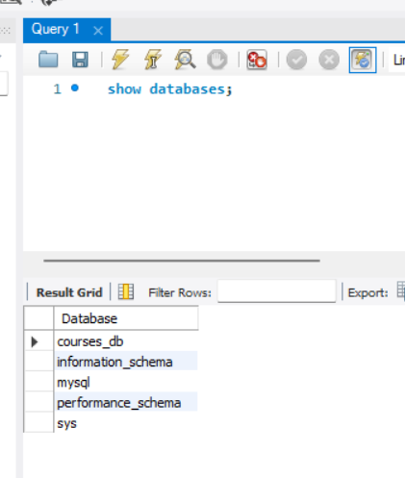

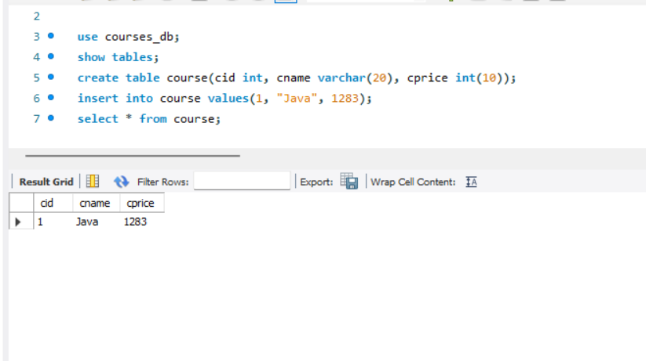

Whenever we create RDS database, the backup will be created in the S3 bucket

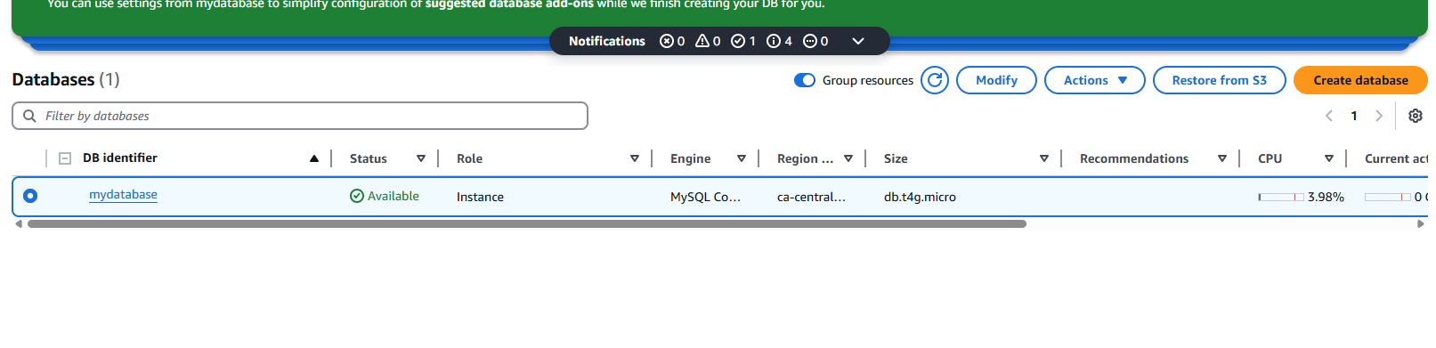

that’s why it shows “Restore from S3”. Automatically backup is created in S3. Snapshot means backup of database