AWS S3: Simple Storage Service || Scalable storage in cloud (Store and retrieve any amount of data from anywhere)

What is S3? ---> Unlimited storage

Why we need S3?

Advantages of S3

Working with S3

Real-time use-cases

-------------------------------------------

Simple Storage Service ---> Unlimieted Storage ---> it stores data in the form of Object Based Storage (file)

Examples of files: txt, pdf, word, excel, audio, video, png,……

In Storage we have multiple options:

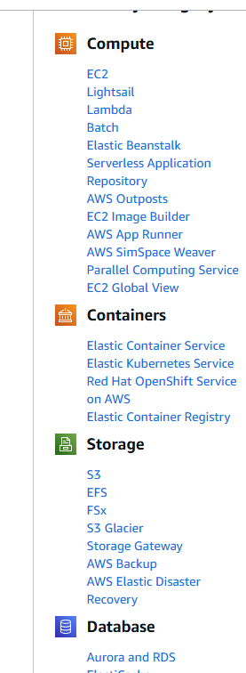

---> S3 will maintain buckets and in one bucket we can store multiple objects ---> (Object means file)

Select ACLs enabled

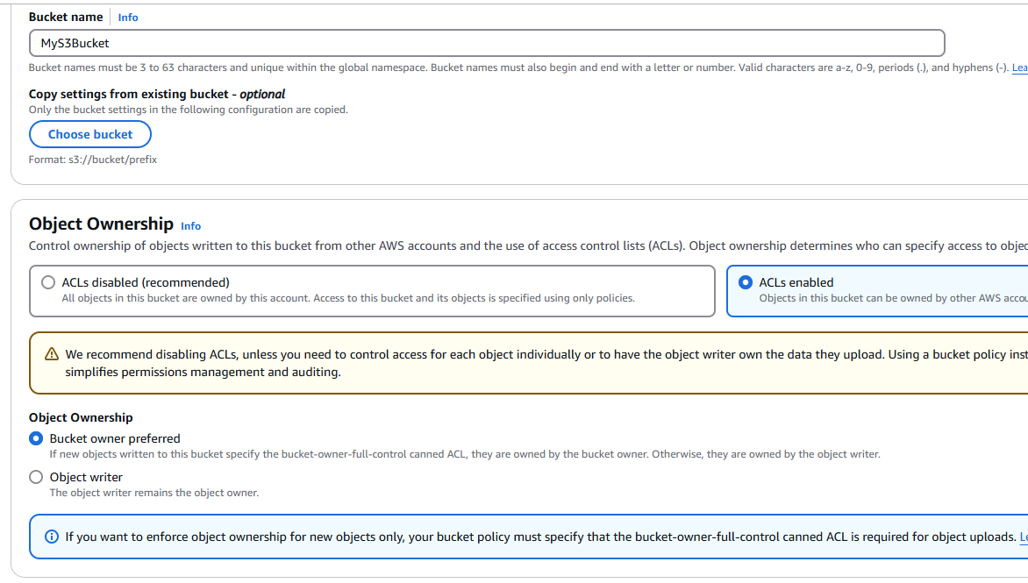

If you want everyone to access bucket:

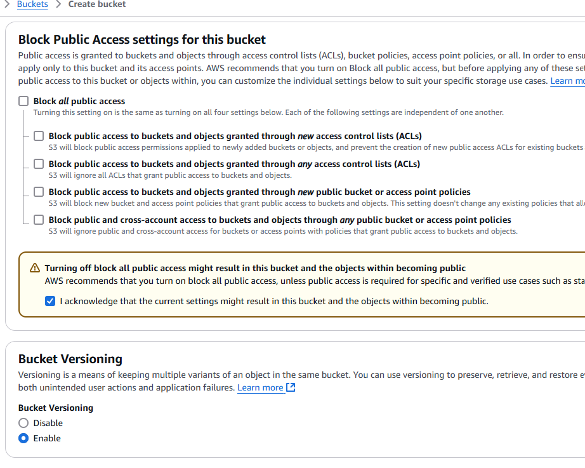

Enable Bucket Versioning, all others default

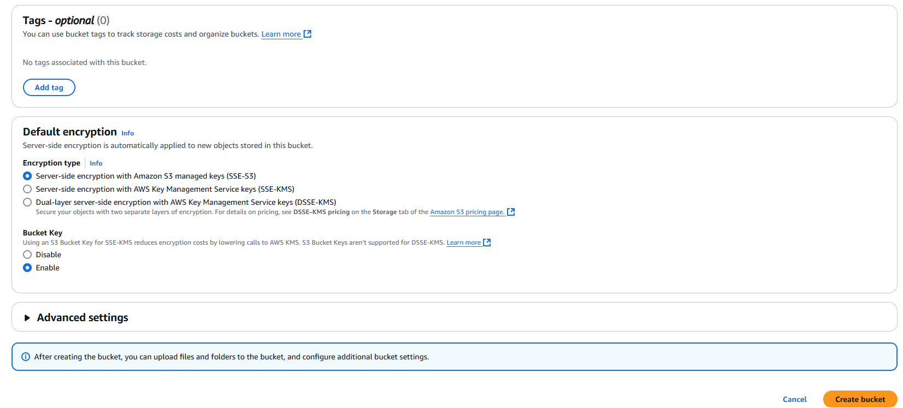

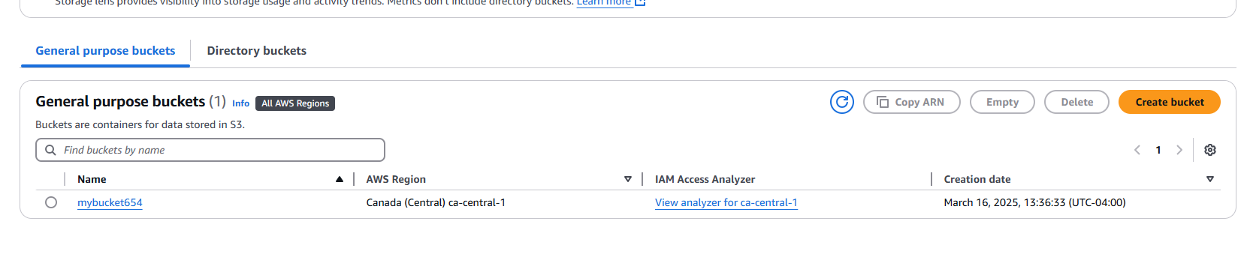

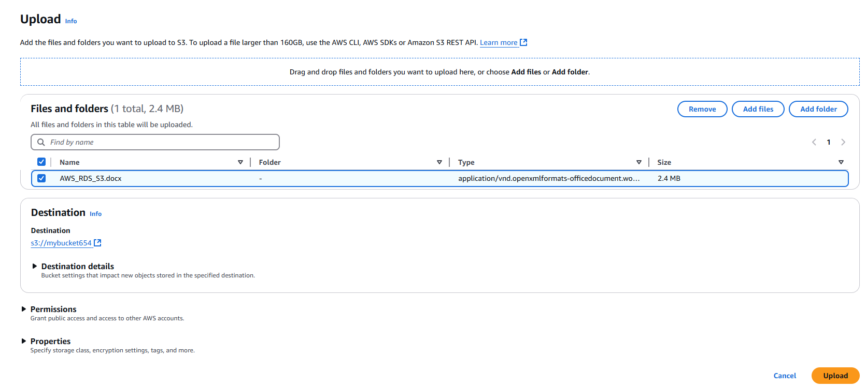

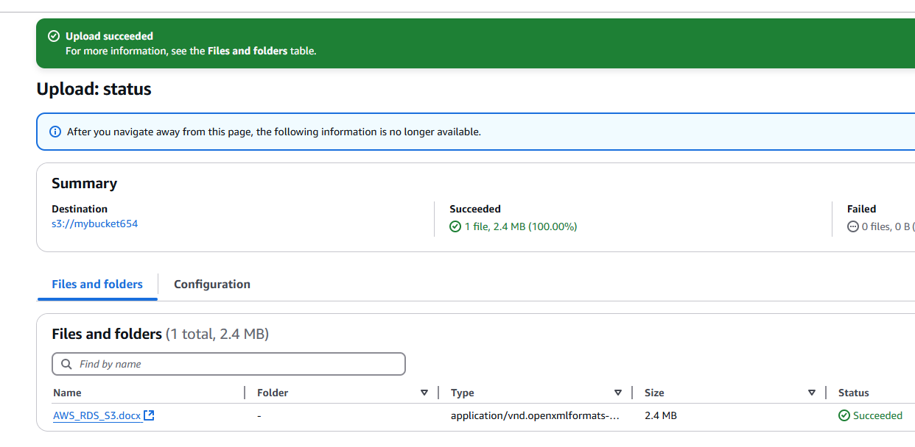

Click on filename first then Permissions

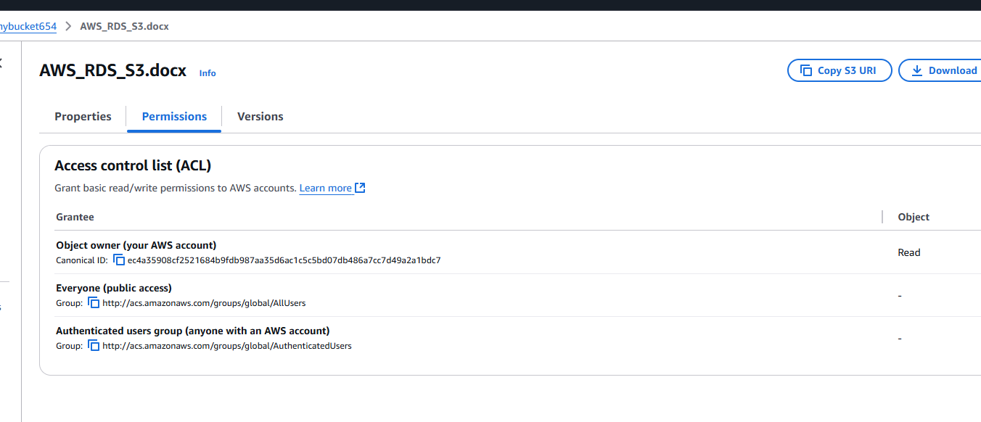

Access Control List (ACL)

Edit give only Read access to public

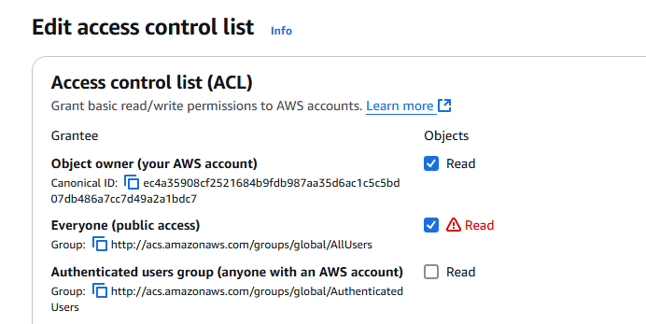

Go back to Bucket and Copy URL

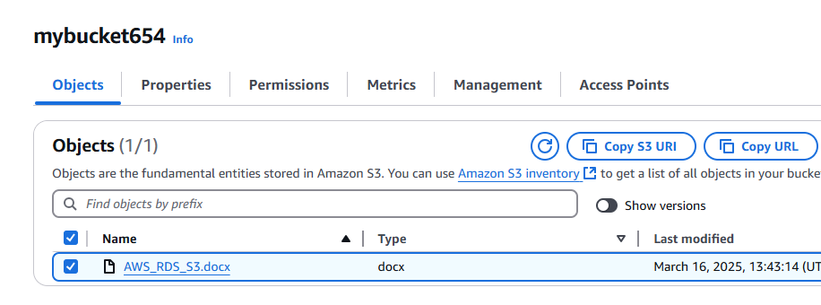

Now this URL should be accessible from anywhere

Delete immediately after creating service

For Billing, go to Billing and Cost management

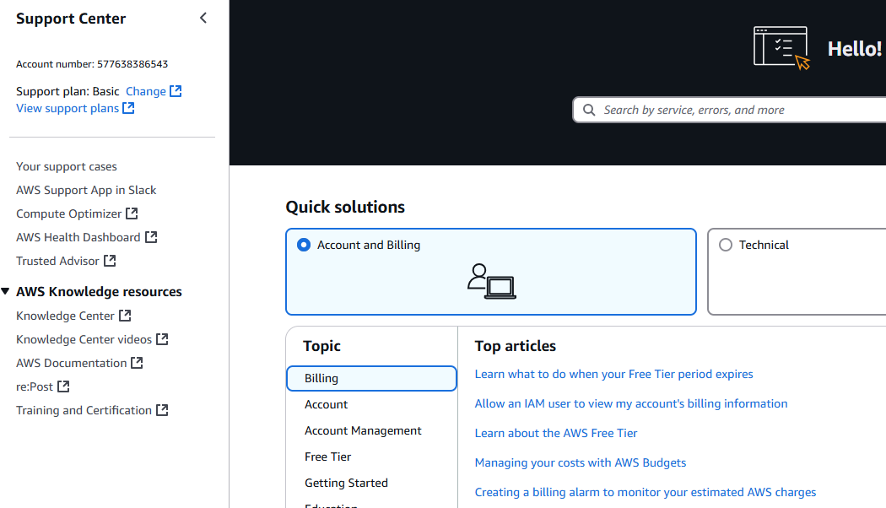

Go to Create case --> Account and Billing

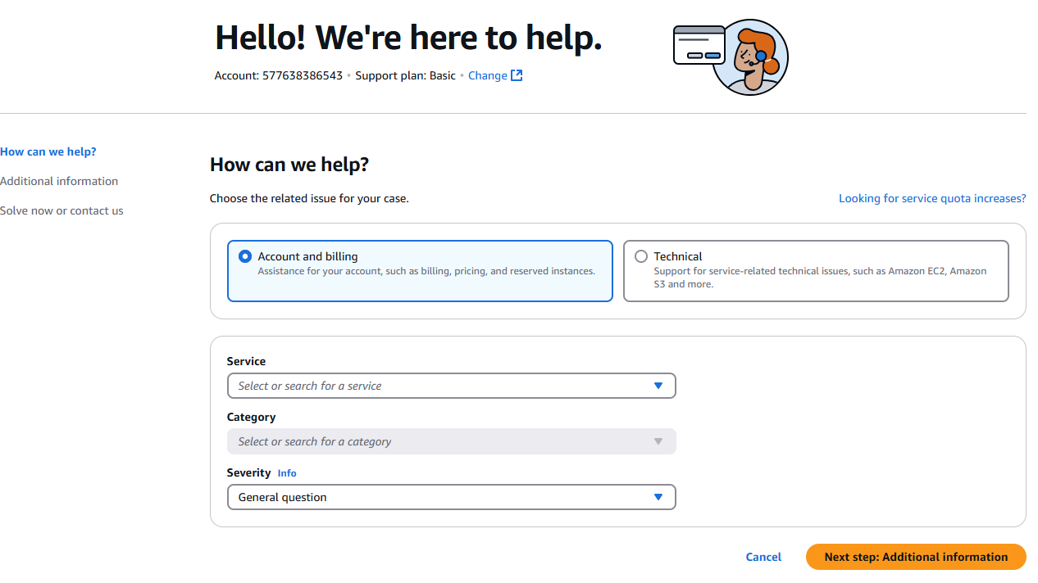

Select ‘Billing’ and ‘Consolidated Billing’

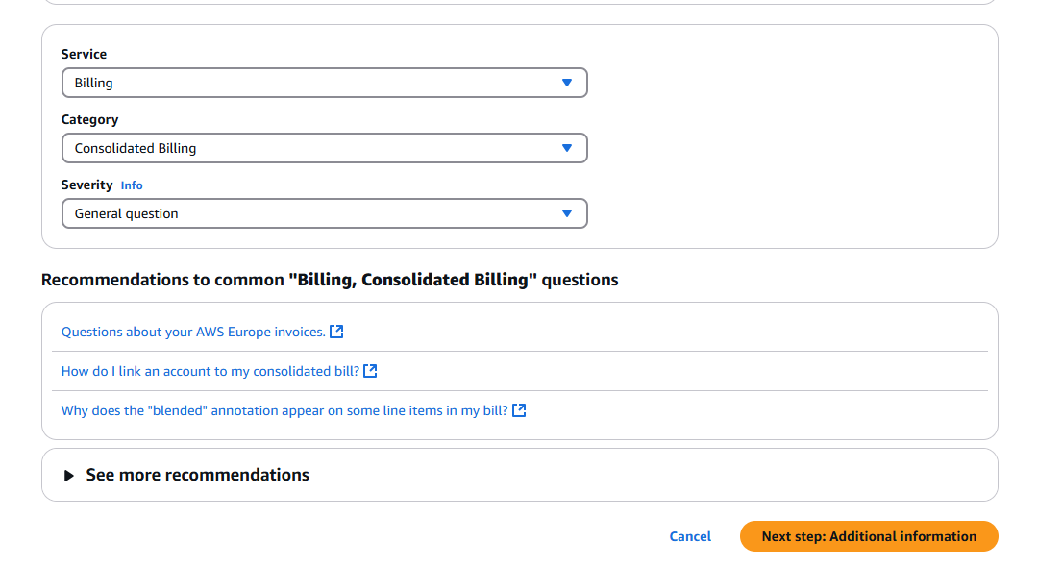

Click Next step

