**AWS S3 Part II**

S3 ----> Simple Storage Service part 2 || Identity and Access Managemet (IAM)

S3 is a scalable storage service in AWS cloud, which supports unlimited storage and works on Object based storage (files like audio, video, image, txt file etc)

We create buckets to store data and every bucket should have unique name

By default, all the buckets and objects are private however, we can make them public as well

Advantages ---> unlimited storage, scalability, availability, security, backup ---> all taken care by AWS only

AWS S3

Web App

Database (RDS)

Web App stores data in the form of rows and columns in RDS. However, we have the option of storing data in S3 also but works based on objects not limited to data type or file extensions

---> Based on needs, we can create multiple buckets in S3

---> S3 is a global service where in buckets are regional, we could specify multiple regions also, but mostly regional specific only

Static Website Hosting using S3:

So far, we have used only VMs to host static website using httpd

Can we host website without VMs? About Static and Dynamic website we discussed earlier

For example, before we login into Udemy or any website it is a static website because everyone has the same data. After we login it changes

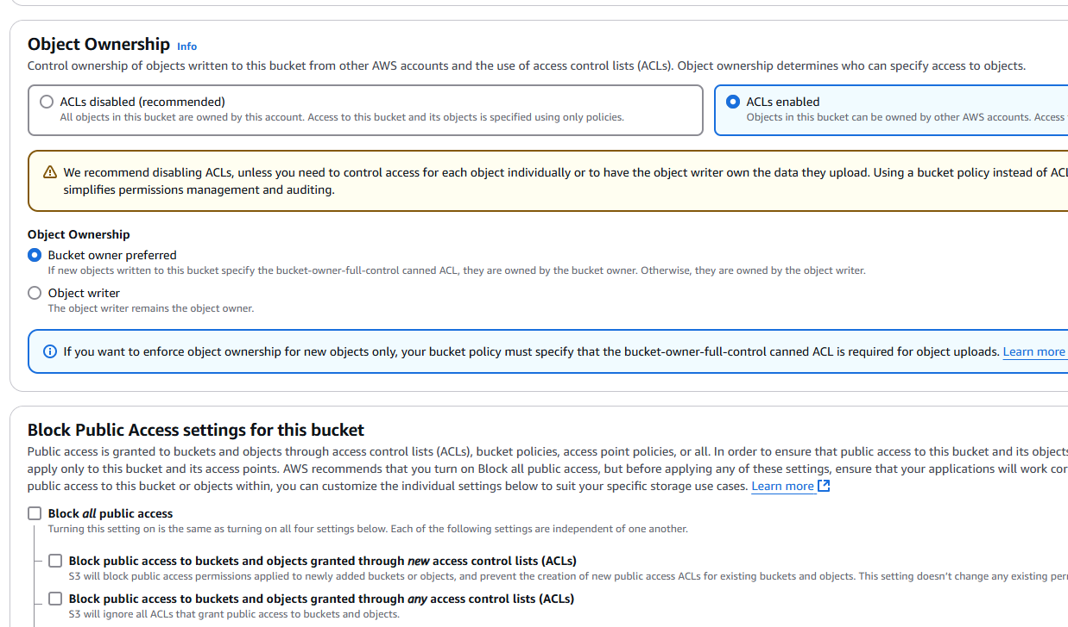

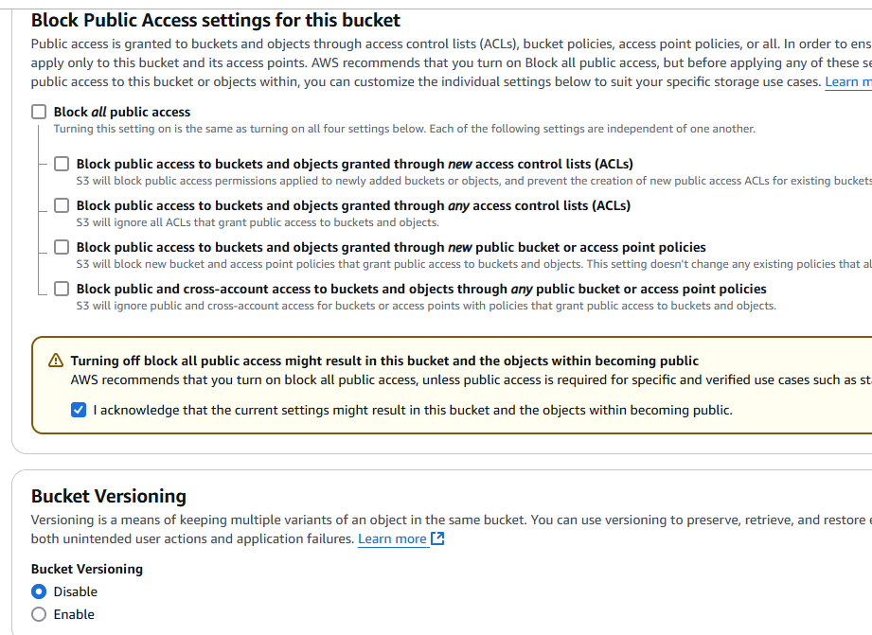

Create bucket ---> Properties ---> S3 static website hosting

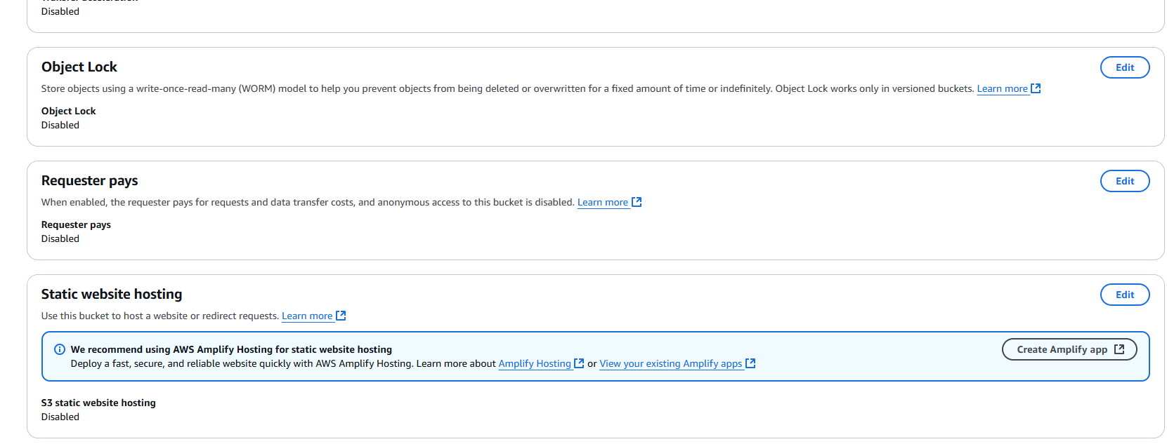

Click Edit

Make it ‘Enable’

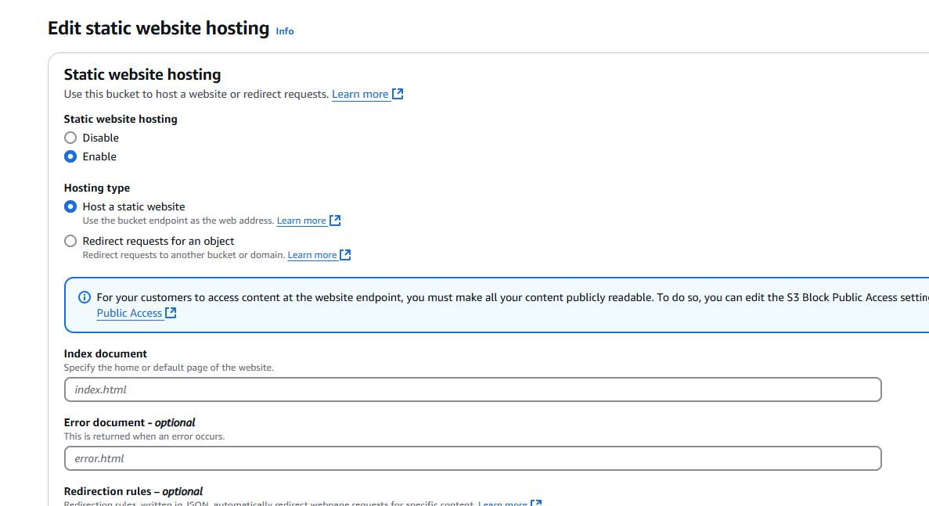

I create two html files and I upload into S3

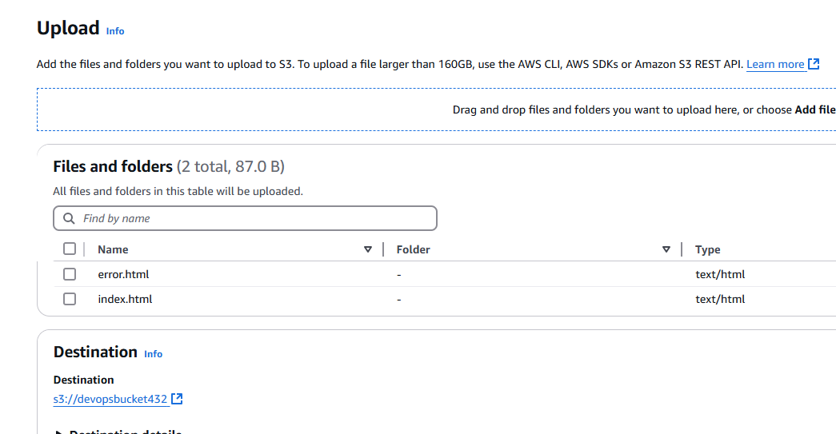

After uploading files, edit Static Website Hosting

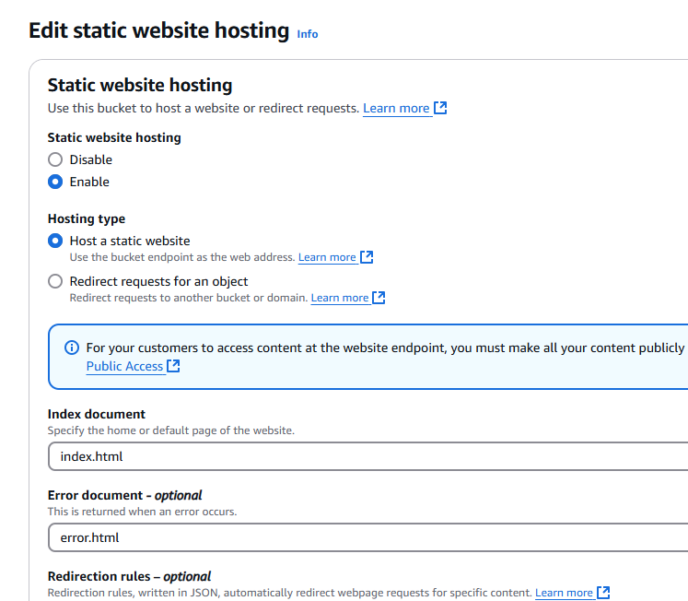

Go to Permissions ---> Access Control List (ACL) --> this doesn’t work

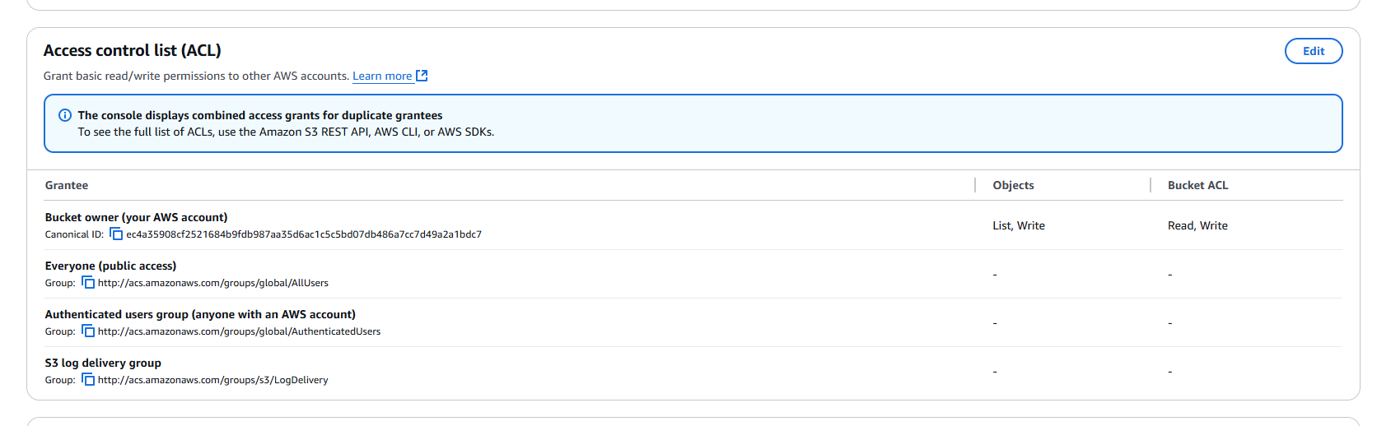

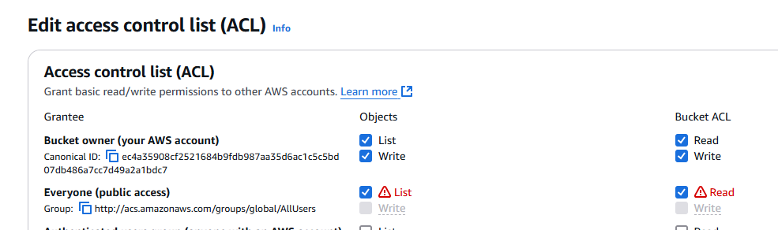

**IMPORTANT**

Before you click Upload, add files then go to Permissions

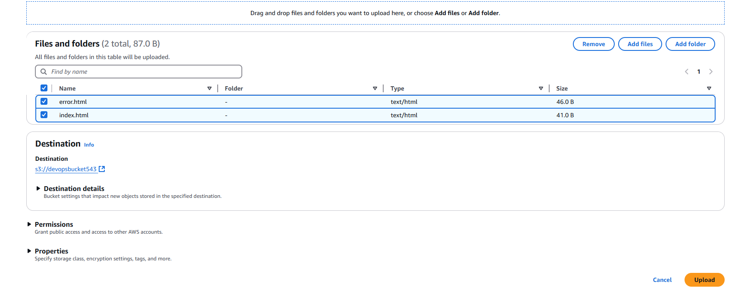

Select Grant public-read access

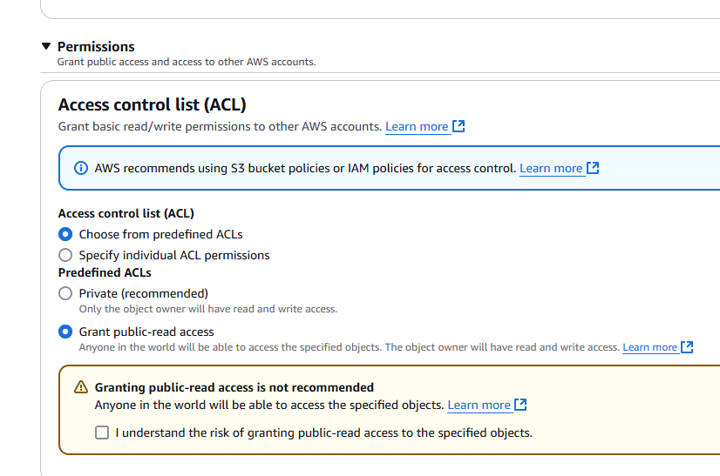

Then Click Upload

Now go to Static Website Hosting

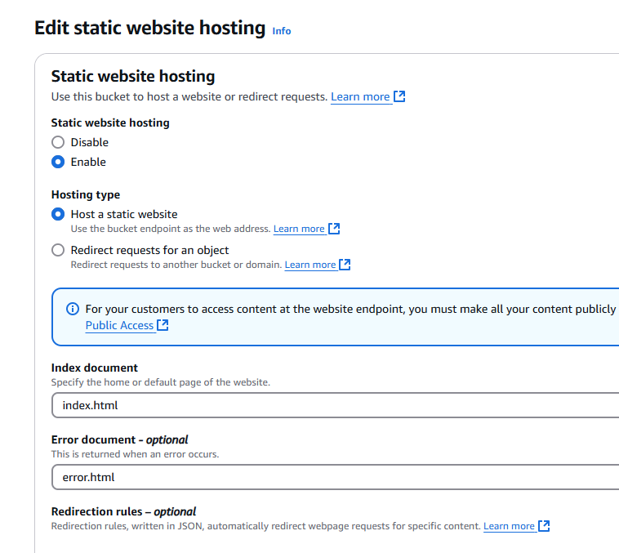

Click Save changes

Scroll down after making changes to see Bucket website endpoint

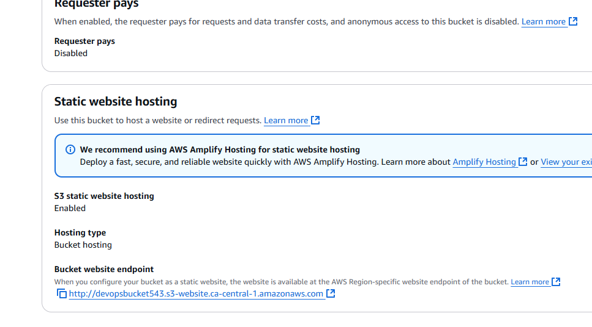

Click that link:

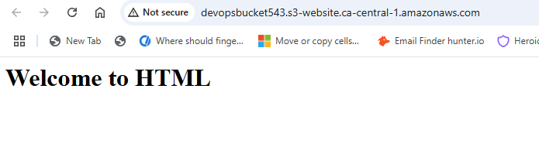

Can we host a Static website on Amazon without creating any VMs? Answer is Yes

Delete all buckets and empty contents

There is something called as 1. Versioning, 2. Locking, 3. Transfer Acceleration, 4. Storage classes in S3

Create new S3 bucket ---> upload alien.txt

While uploading Grant public-read access

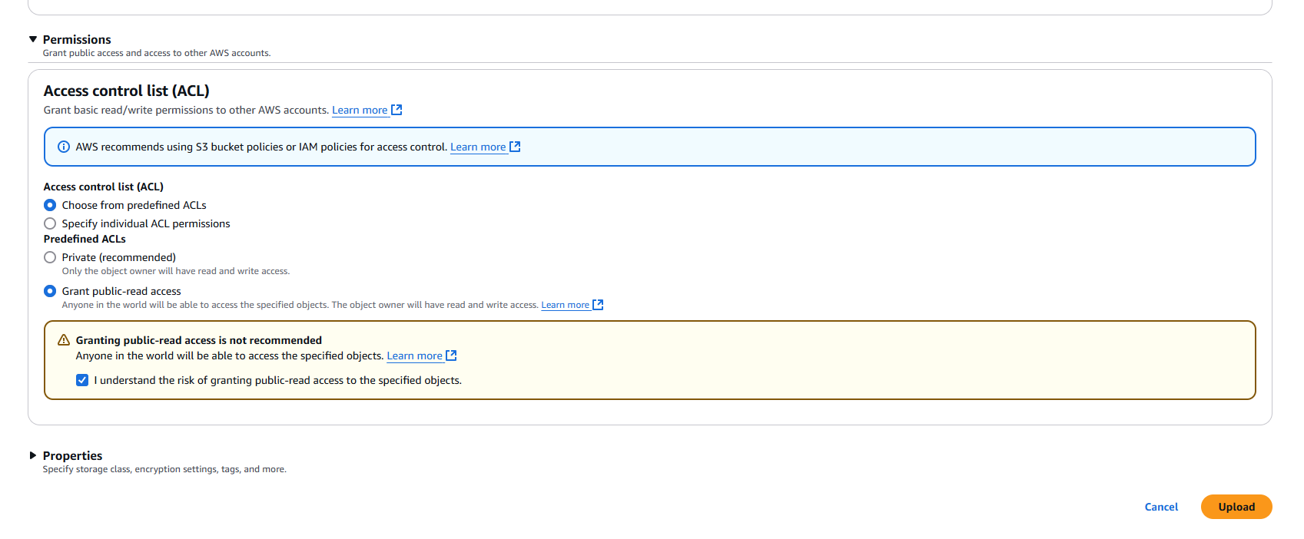

File is uploaded

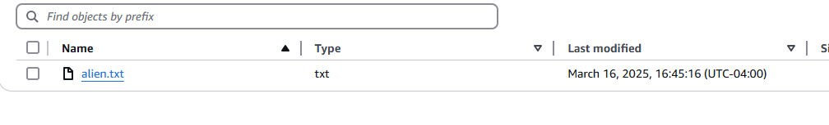

Mar 16 2025, 16:45:16

Again Upload --> Add file ---> go to the same folder and select alien.txt

I open alien.txt then I make changes in that file



I again upload ---> Mar 16, 2025 16:48:00

Currently it is only replacing the existing file

The solution is Versioning, if you don’t want anyone to modify or replace then we go with Locking

If you want to upload huge file very fast, then go for ‘Transfer Acceleration’

If you want to frequently access or download files from S3 unlimited storage, then go for ‘Storage classes’. Based on the access frequency, we can decide which storage class to use

Again I try to upload the same file --> go to Properties ---> Storage class

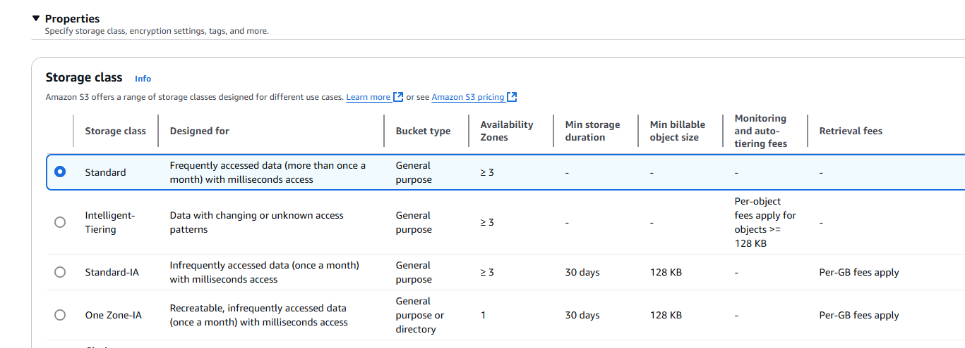

99.999 security, availability, backup guarantee is there

Click bucket name ---> Properties ---> Bucket versioning

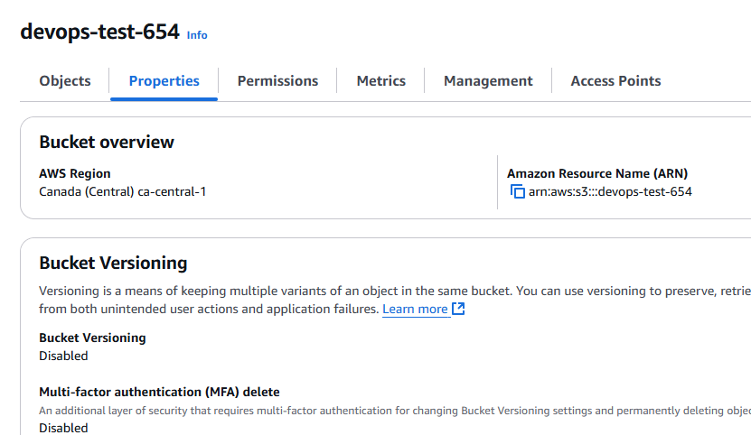

Edit then Enable

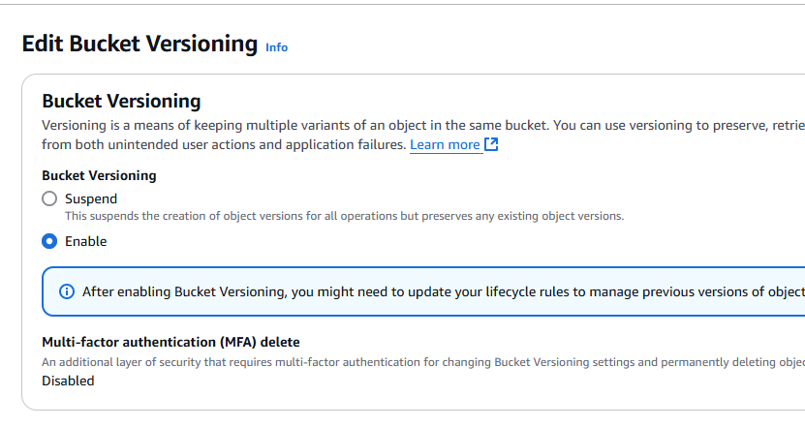

I click the file then Versions

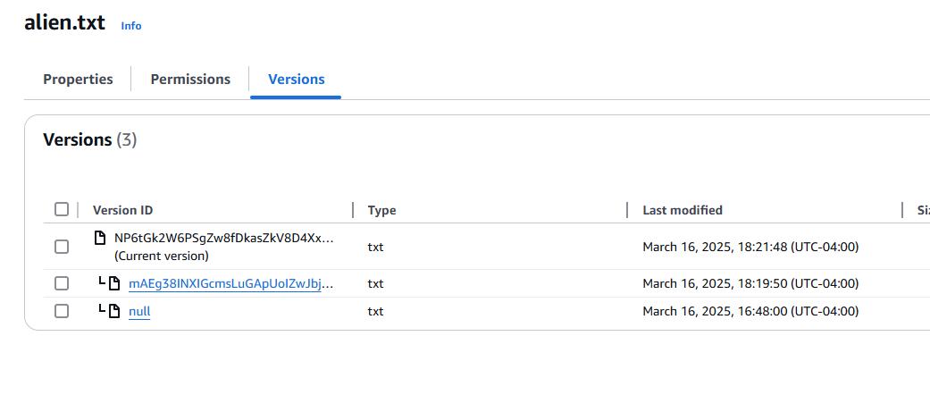

Click on ‘Show versions’

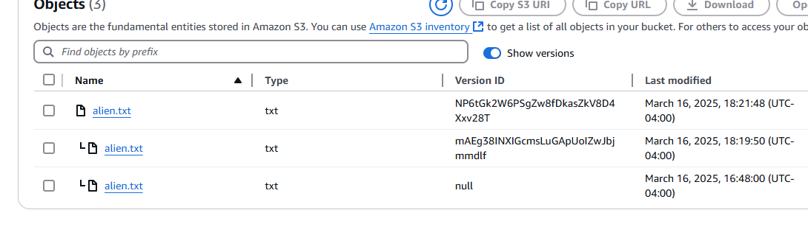

Versioning: It is used to maintain multipl variants of the same file. By default, Versioning is disabled for S3 bucket. However, we can enable in properties ---> Bucket versioning--enable

Since by default Versioning is disabled whenever we add new same file again in bucket, it will replace or overwrite the old one and if you don’t want to replace old objects with new objects from bucket, then go with Versioning

Note: Once Versioning is enabled then we cannot disable but we can suspend it

S3 Storage classes:

Used to specify how frequently you can/you want to access the objects from S3

We have multiple Storage classes in S3

Write Once Read Many times ---> Object locking

Same in the Bucket Properties we see

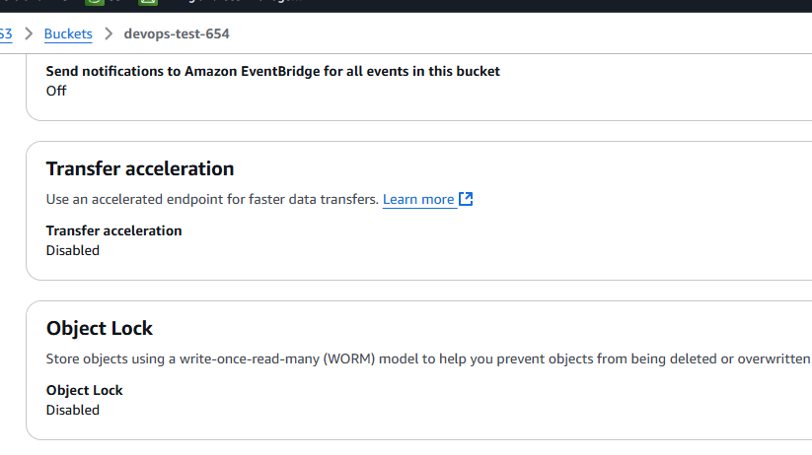

Transfer Acceleration:

Speed up data transfer process in S3 bucket

Amazon S3 Transfer Acceleration is a bucket-level feature that enables fast, easy, and secure transfers of files over long distances between your client and an S3 bucket. Transfer Acceleration is designed to optimize transfer speeds from across the world into S3 bucket

Look into Multi-region access point