Static website hosting => userdata

Loadbalancer, Monolith, Microservices

Website: Collection of web pages (html pages)

Static website (gives same response to every user) and Dynamic website (gives response based on user activity)

Webserver -> used to host/run our website

For Static websites we have httpd, apache2

For Dynamic websites: tomcat, IIS

Hosting website using httpd:

[ec2-user@ip-172-31-13-80 ~]$ sudo systemctl start httpd



[ec2-user@ip-172-31-13-80 ~]$ cd /var/www/html

[ec2-user@ip-172-31-13-80 html]$ sudo vi index.html



sudo yum update -y

sudo yum install httpd

sudo systemctl start httpd

Note: Enable HTTP: 80 in security group inbound rules

Access our website using EC2 VM public IP

To modify the content we can navigate:

cd /var/www/html

sudo vi index.html

Access again our website using EC2 instance public IP

User-data in EC2 VM:

--> used to execute script while launching machine

--> user data will execute only once

Create a new EC2 VM with below user data

#! /bin/bash

sudo su

yum install httpd -y

cd /var/www/html

echo "<html><h1>Script from EC2 User data</h1></html>" > index.html

systemctl start httpd

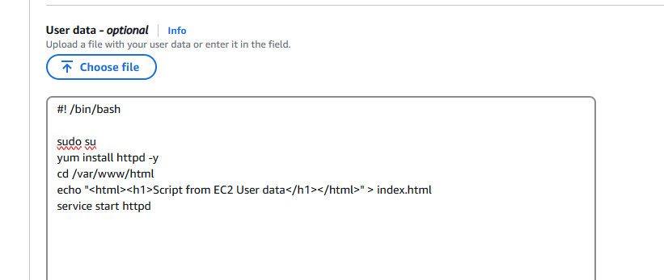



Disadvantages of having one server for our application:

One server must handle all the incoming requests

High burden on server, which might result in delay in responses

Can lead to server crash (single point of failure)

All these problems will lead to business loss

Deploying same application into multiple servers

App is now deployed in say 3 servers

How can we divert the traffic to multiple servers?

Load balancer: All requests to application will be diverted to multiple servers (Round robin)

Application will run on multiple servers

-> load will be distributed

-> Fast performance

-> High availability

Load balancer: it is used to distribute incoming load / requests to multiple servers in round robin technique

There are different types of Load balancers in AWS:

1. Application load balancer (http & https)
2. Network load balancer
3. Gateway load balancer

Classic Load Balancer (outdated / old gen)

Practical task on Load balancer:

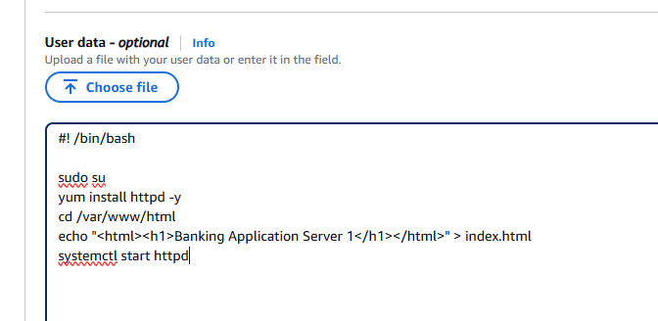





Target group: List of servers running our application

These two servers together is called as a Target group

Create two VMs and deploy Baning Application

Add these instances to one target group -> List of servers running our application

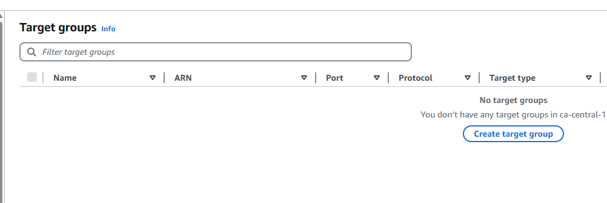

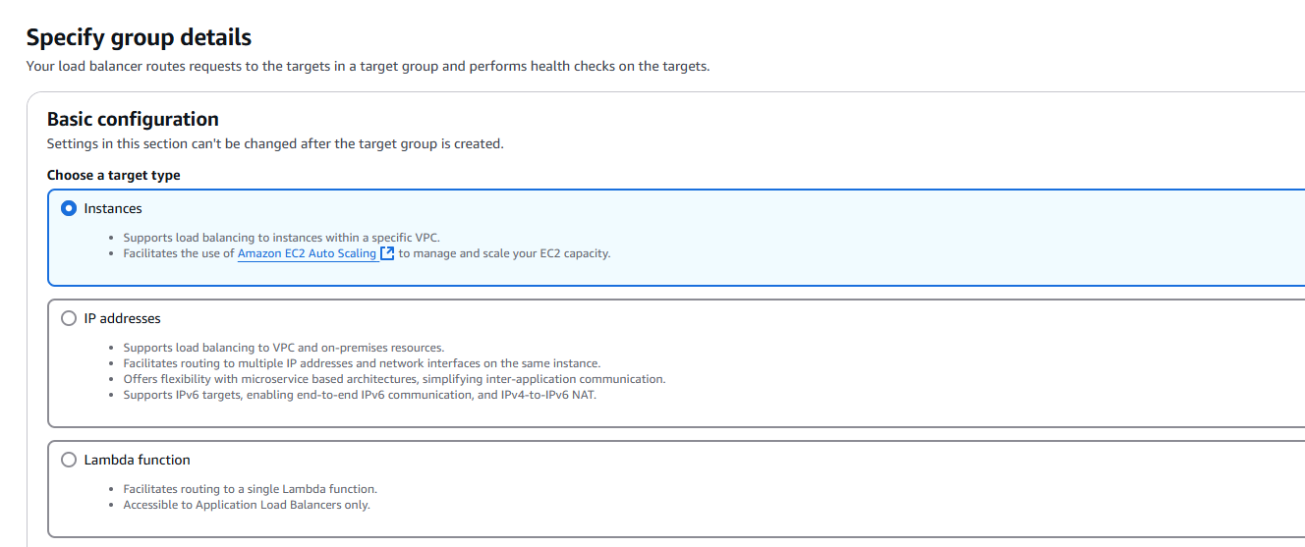

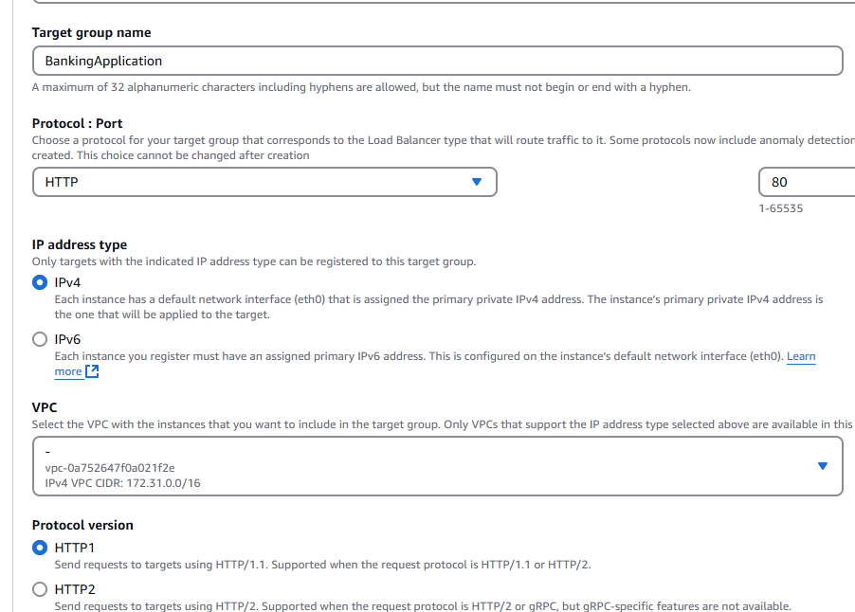

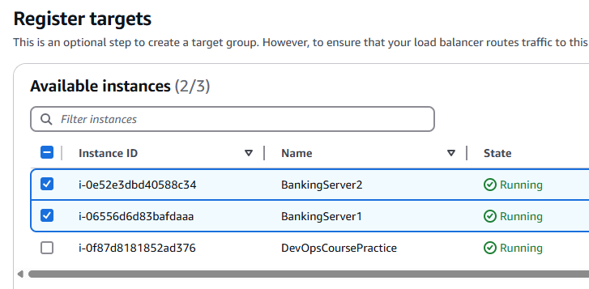

Click ->Include as pending below -> Create Target Group

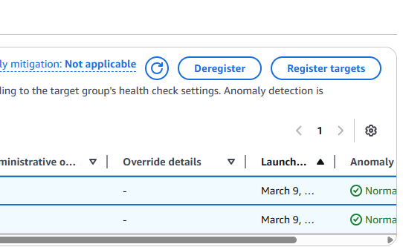

Register Targets

Go to Load Balancers

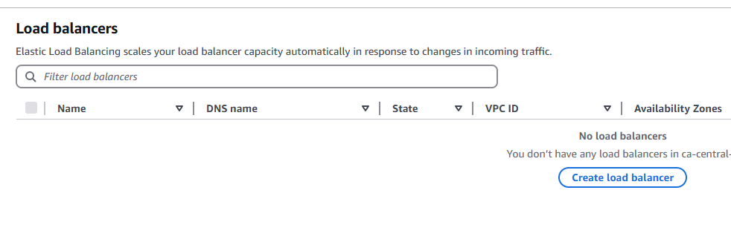

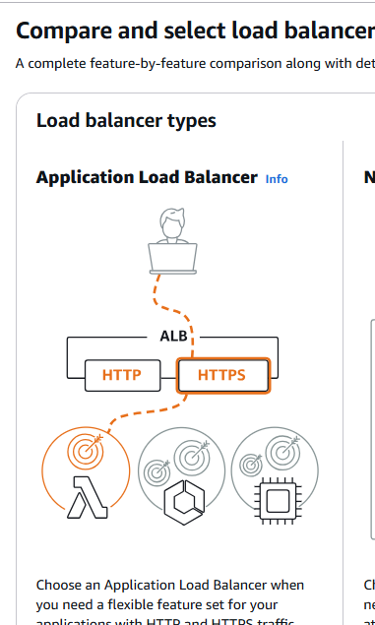

Create Application Load Balancer

Internet facing and leave other options as it is

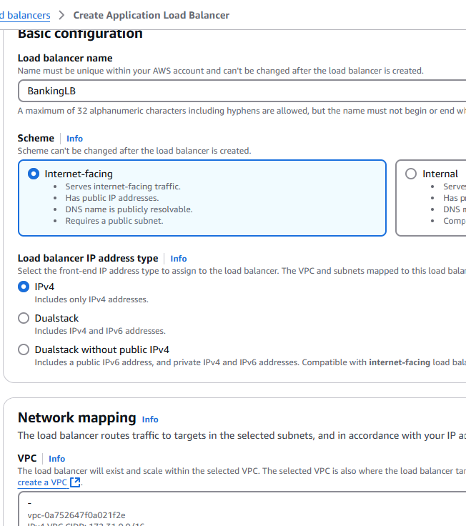

Select Availability Zones

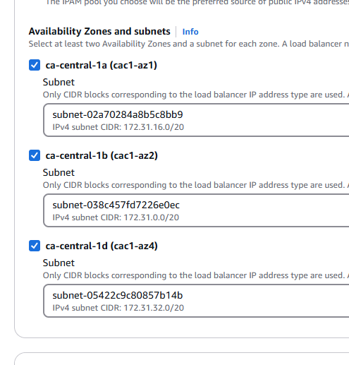

Select Security Groups, Target Group

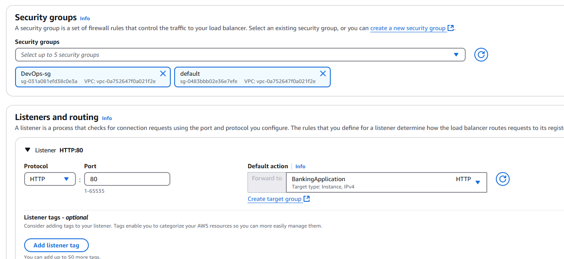

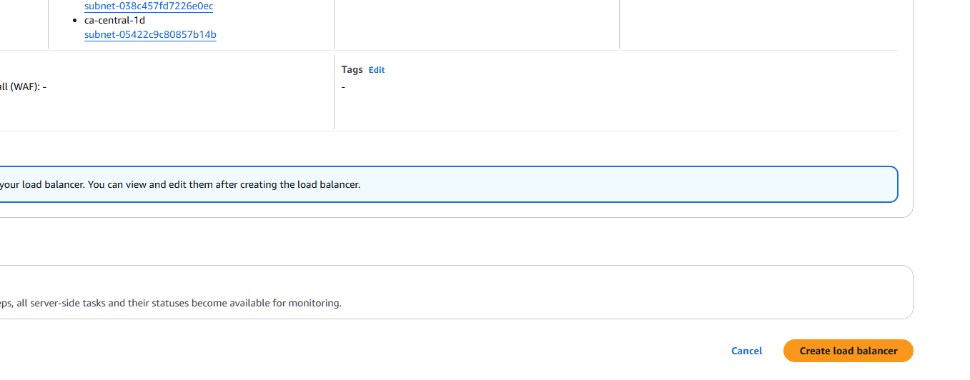

Scroll down then Create Load Balancer

It gives public DNS

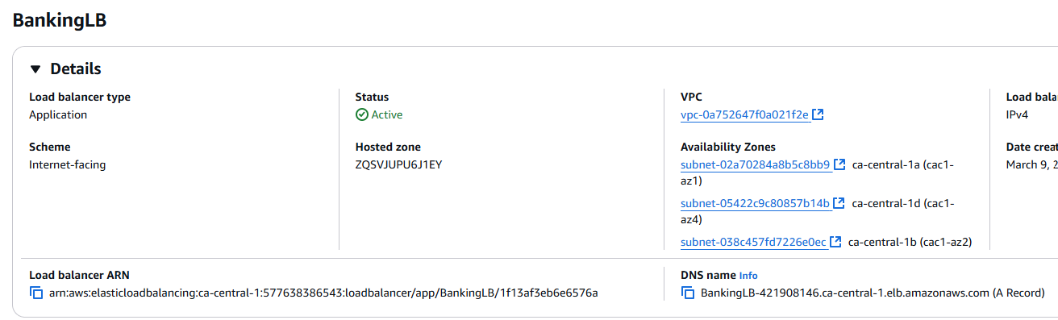

DNS



When we refresh the page:  


If you decide to add a new Server say Server 3, we add to the Target group that’s it Load balancer will be updated as well

Architectural design patterns:

Monolithic Vs Microservices

Monolithic -> developing all functionalities in single application

Deploying one application into multiple servers, it is Monolithic

For Monolithic app usually we need one target group

For Microservices: dividing functionalities into multiple APIs . One application is divided into micro applications.

BookingApplication -> features like hotels, flights, car rentals everything in one application. This is monolithic

(Monolithic) App -> UI <- end user -> UI -> Hotels App, Car rentals App, Flights App (Microservices)

So many requests are coming to Application -> we have a Load balancer in between. In Target group, we have 3 applications -> this is Monolithic

In Microservices, I have 3 car rental applications deployed on multiple servers, 3 hotel applications deployed on multiple servers, 3 flight applications deployed on multiple servers

HotelsApp

HotelsApp

HotelsApp

FlightsApp

FlightsApp

FlightsApp

Hotels Target Group

Flight Target Group

So it is challenging for Load balancer. that’s why we need to configure “Routing”

#! /bin/bash

sudo su

yum install httpd -y

cd /var/www/html

echo "<html><h1>Flights Service 1</h1></html>" > index.html

systemctl start httpd

#! /bin/bash

sudo su

yum install httpd -y

cd /var/www/html

echo "<html><h1>Flights Service 2</h1></html>" > index.html

systemctl start httpd

#! /bin/bash

sudo su

yum install httpd -y

cd /var/www/html

echo "<html><h1>Hotels Service 1</h1></html>" > index.html

systemctl start httpd

#! /bin/bash

sudo su

yum install httpd -y

cd /var/www/html

echo "<html><h1>Hotels Service 2</h1></html>" > index.html

systemctl start httpd

We create 2 servers for each service then we register into Target groups

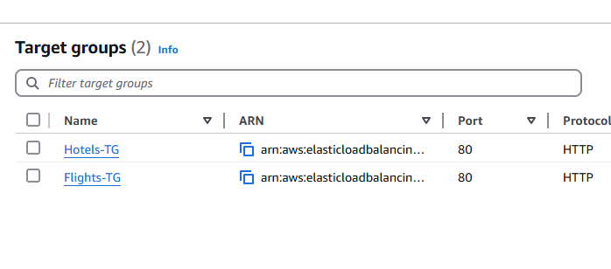

For a normal HTTP application, Application Load Balancer is recommended

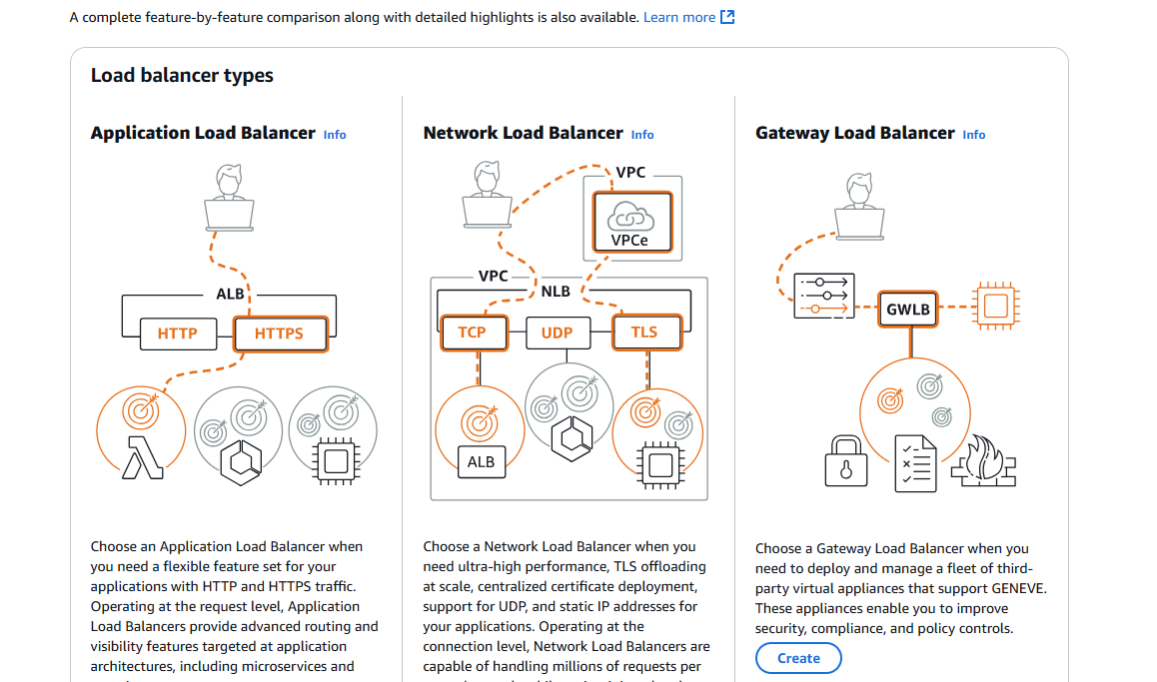

First I add only Flights-TG  
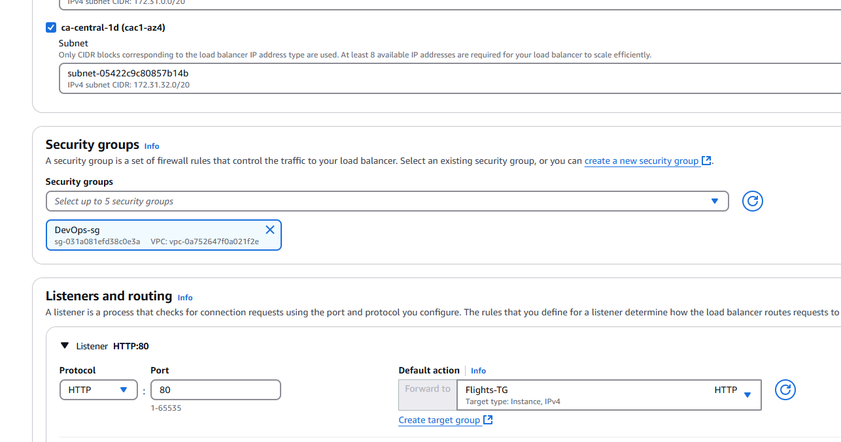

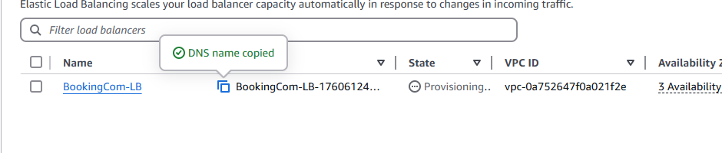





Click on Add Listener

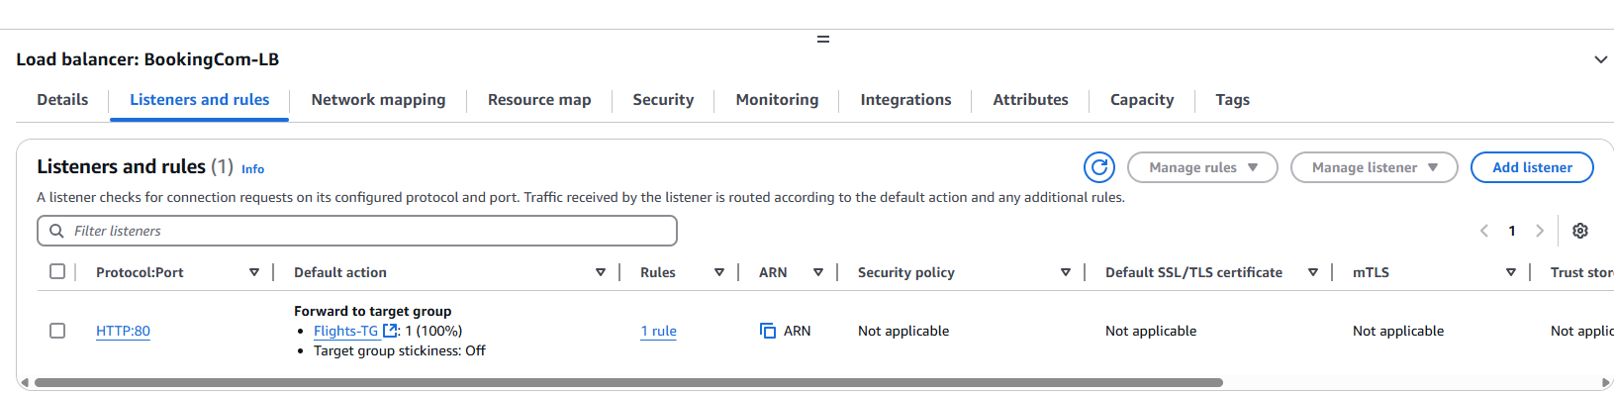

Hotels added

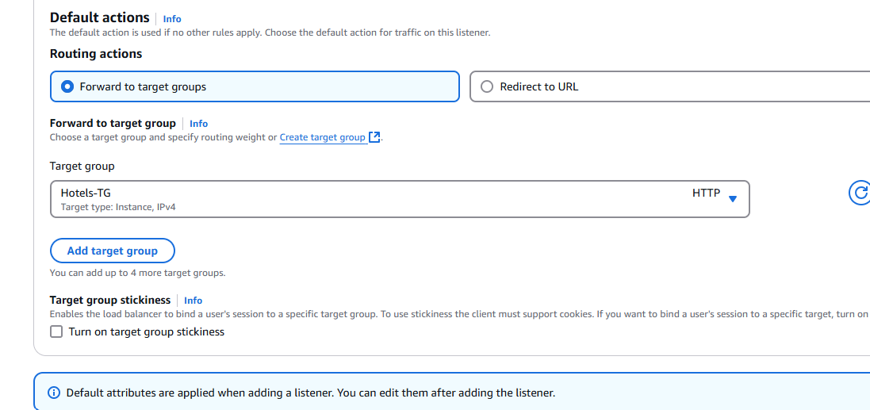

Two listeners

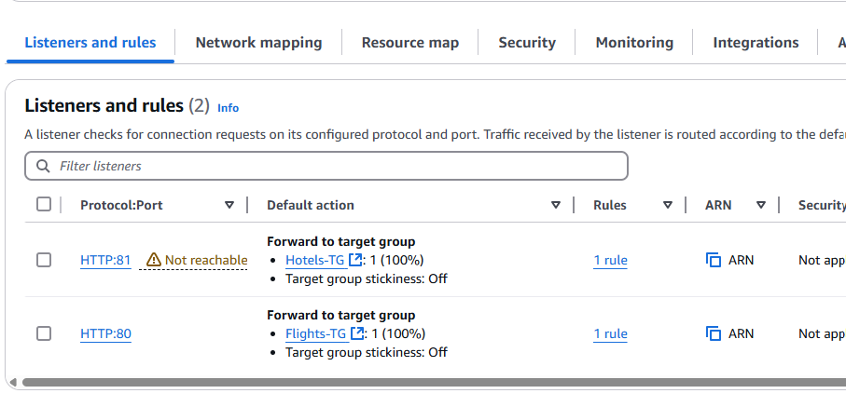

81 is not reachable so we are going to edit the existing listener

Edit existing target group and add new Target group

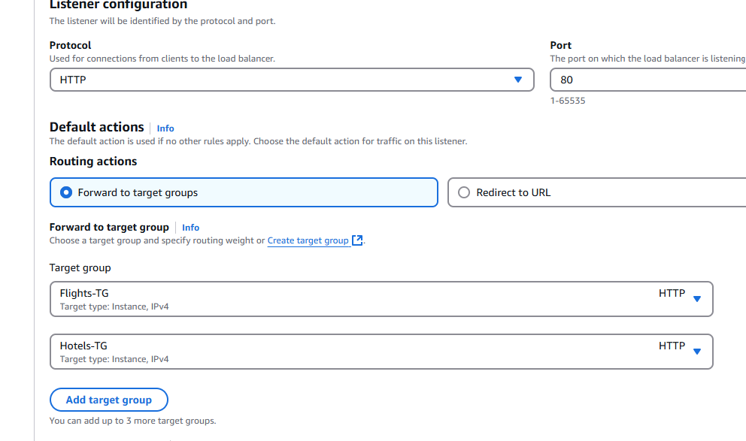

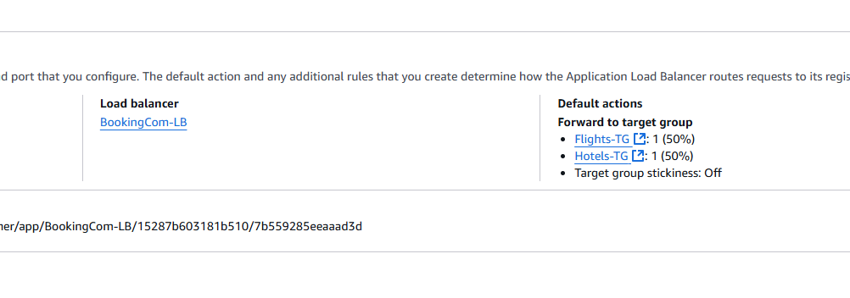

It shows both Hotel and Flight services but we don’t want this random decision

Add rule

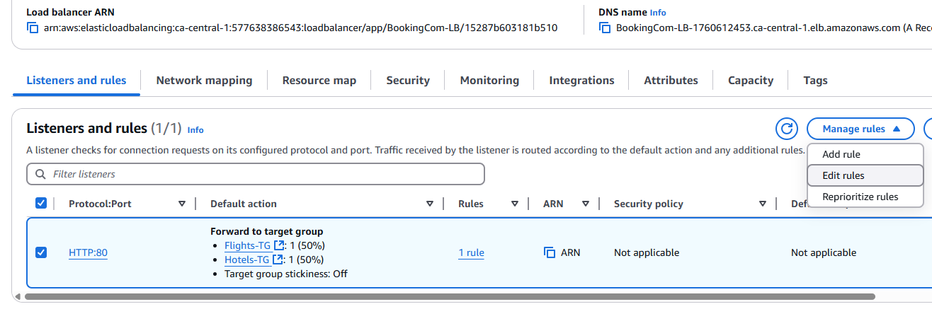

Select Query String

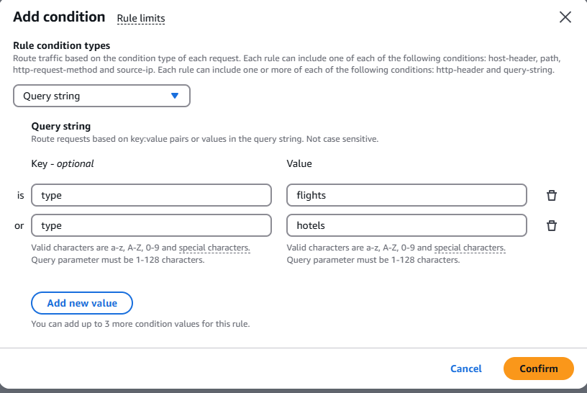

We have edited the Query String

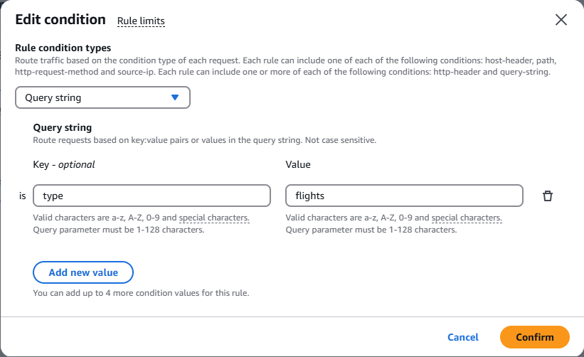

Set Priority to 1

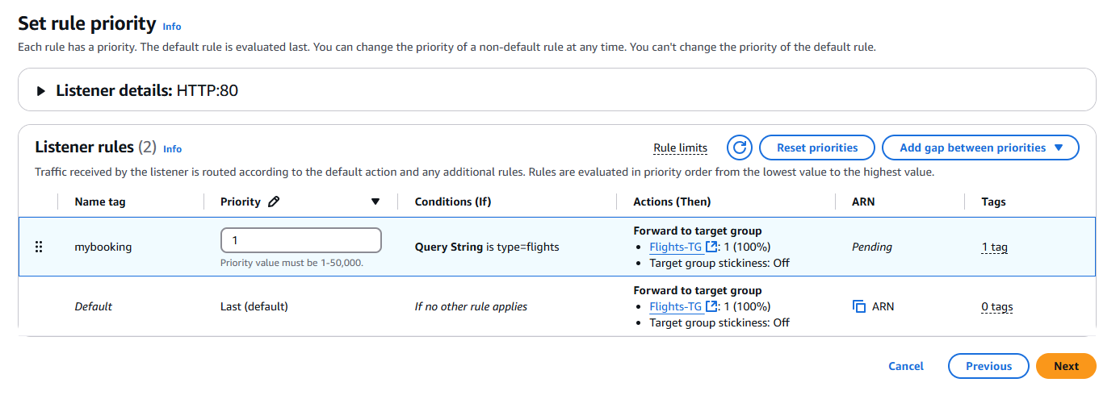

Listener rules created

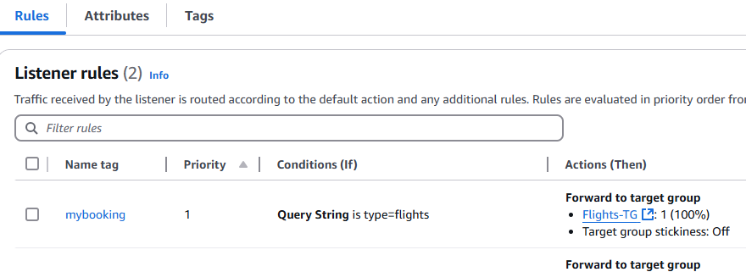

When I pass the Query parameter I get only Flights in this case

http://bookingcom-lb-1760612453.ca-central-1.elb.amazonaws.com/?type=flights



Again add the rule

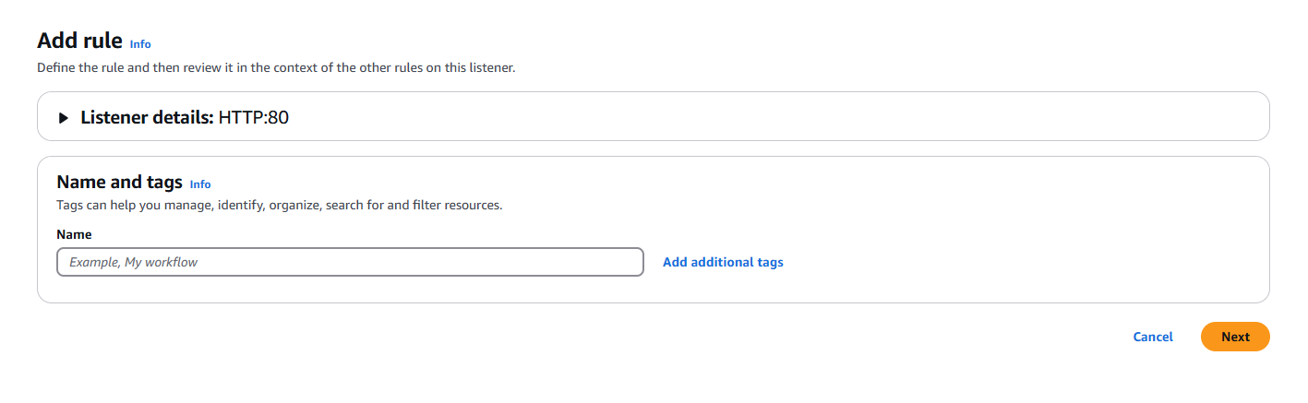

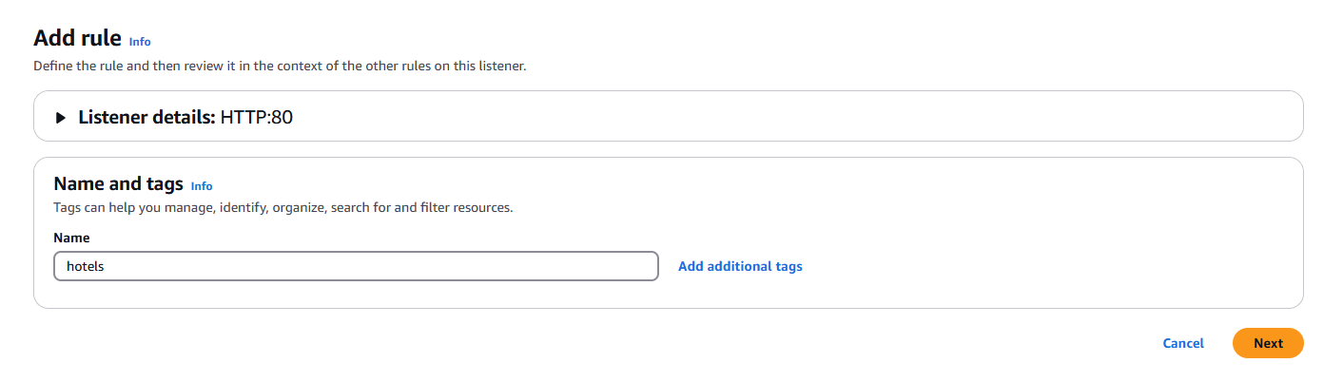

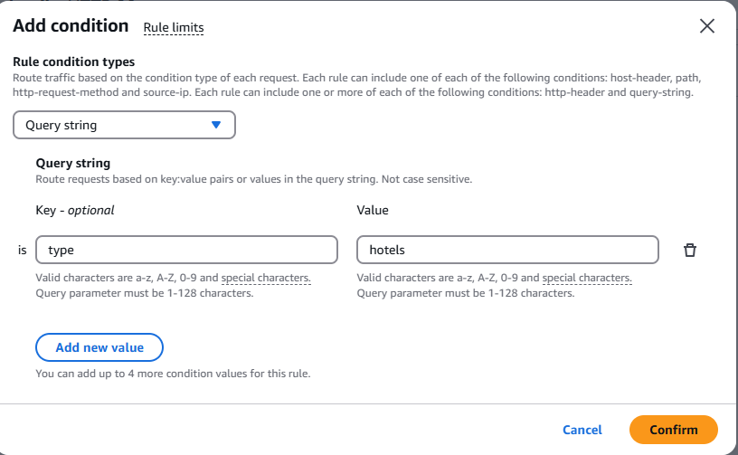

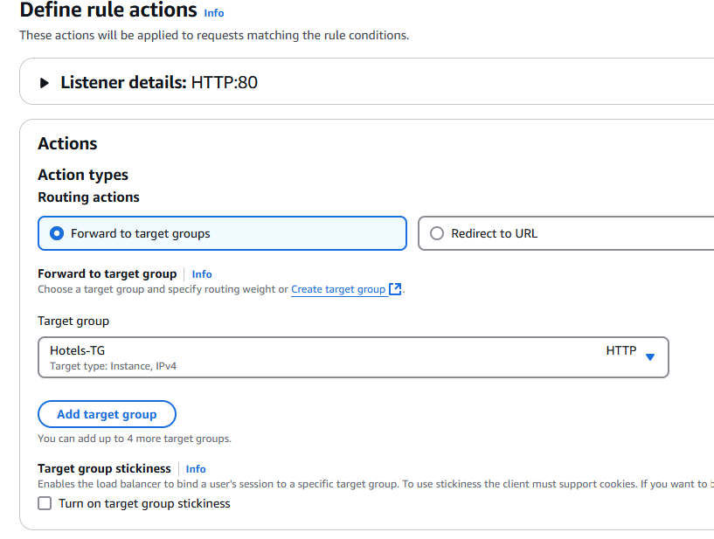

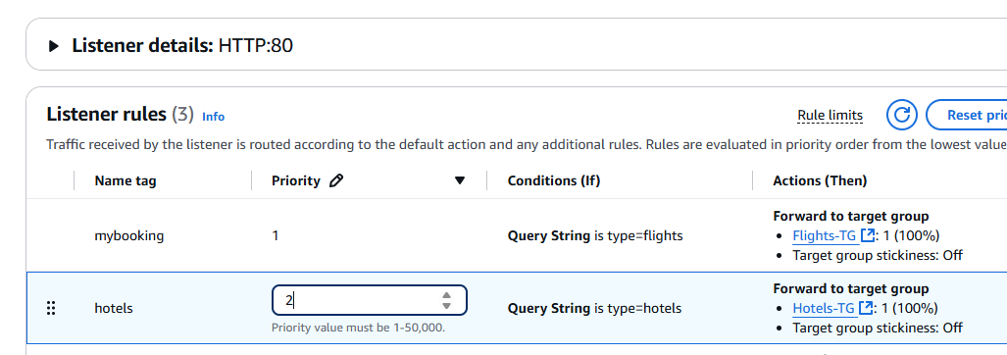

We see two rules

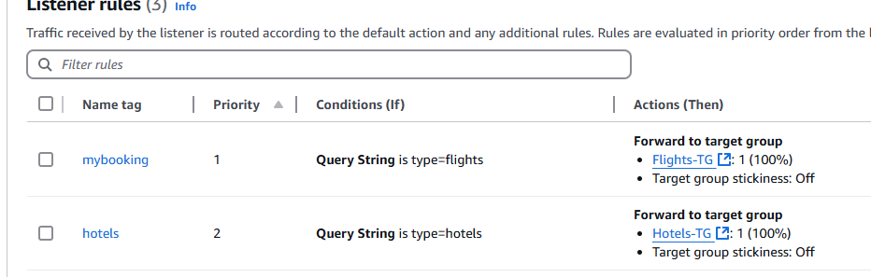

Now we are getting only Hotels Service

http://bookingcom-lb-1760612453.ca-central-1.elb.amazonaws.com/?type=hotels





In what situation, we may have to create multiple target groups?

Microservices

Types of Load Balancers:

Application Load Balancers (ALB)

Network Load Balancers (NLB)

Gateway Load Balancers (GLB)

OSI model: Open Systems Interconnections

It contains 7 layers, it will represent how request will transfer from Client to Server

Client -----------------------------------------> Server

<------------------------------------------

During this communication, there are 7 layers and they are called as OSI layers

Layer 7: Application layer (Application Load Balancer)

Layer 6: Presentation layer

Layer 5: Session layer

Layer 4: Transport layer (Network Load Balancer)

Layer 3: Network layer

Layer 2: Data link layer

Layer 1: Physical layer

Client’request first goes to Application layer (At this point, Application Load Balancer intercepts the request, then it determines where it has to go Hostname, entire path: like Flights or Hotels etc) -> Presentation layer -> Session layer -> Transport layer (say if it is a high performance application where we don’t want to decide which Target group to go to etc, something like Gaming application where decision-making is not important then Network Load Balancer comes into picture) -> Network layer -> Data link layer -> Physical layer -> Server (App)

Decision-making -> Application Load Balancer

Non-decision-making something like Gaming then we go with Network Load Balancer

Application Load Balancer:

Operates at 7 (Application layer of OSI model)

It is desined to route HTTP and HTTPS traffic based on content (path-based routing & host-based routing with the help of HTTP headers)

Ideal for modern web applications, Microservices and (Container based application)

Request per minute -> maybe 10k / min -> lets say we have 3 servers currently

Say 100,000 RPM -> then we need 30 servers to manage 100,000 requests

If requests increase to 200,000 then we need to increase the servers accordingly

Auto-scaling concept is there to handle variations in servers based on RPM

Auto-scaling -> Fault tolerance (if some instance is unhealthy, it will automatically launch to replace it), Cost management, Availability