Terraform

<https://www.terraform.io/>

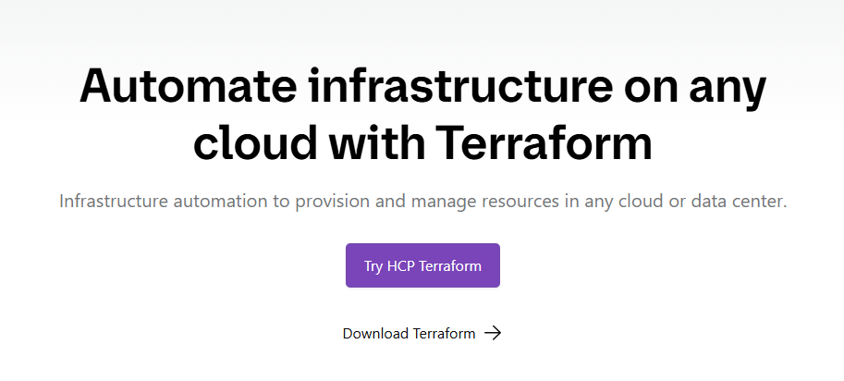

On Linux run this command, Terraform will be installed

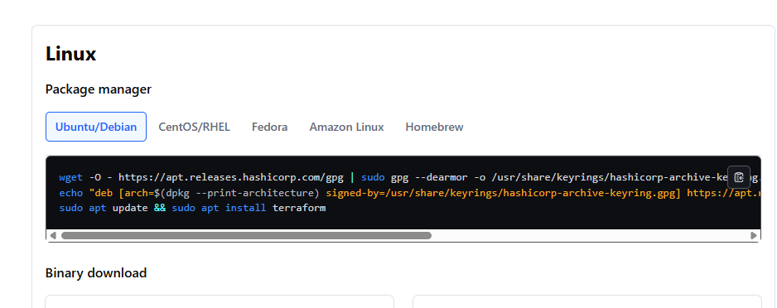

wget -O - https://apt.releases.hashicorp.com/gpg | sudo gpg --dearmor -o /usr/share/keyrings/hashicorp-archive-keyring.gpg

echo "deb [arch=$(dpkg --print-architecture) signed-by=/usr/share/keyrings/hashicorp-archive-keyring.gpg] https://apt.releases.hashicorp.com $(lsb_release -cs) main" | sudo tee /etc/apt/sources.list.d/hashicorp.list

sudo apt update && sudo apt install terraform