Ansible part 3

Setup --> Control node --> Managed nodes

Playbook is just a yaml file

Start all nodes in AWS

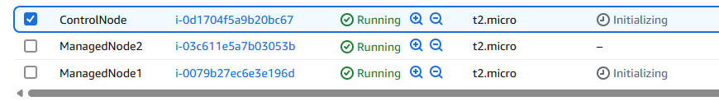

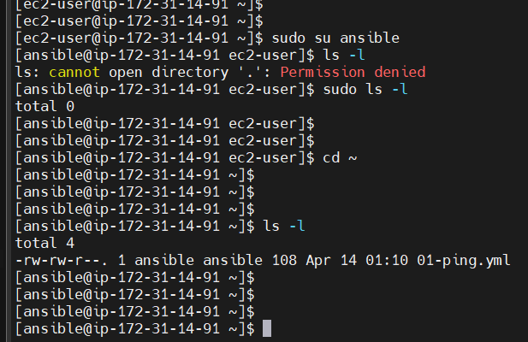

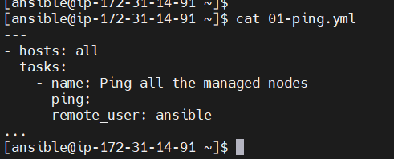

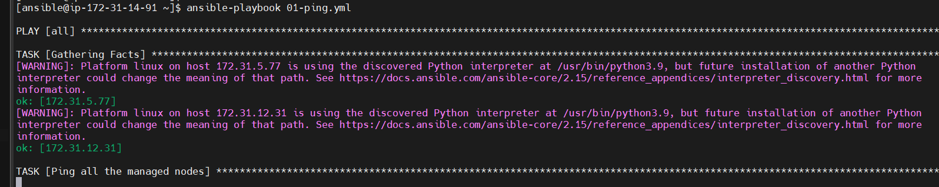

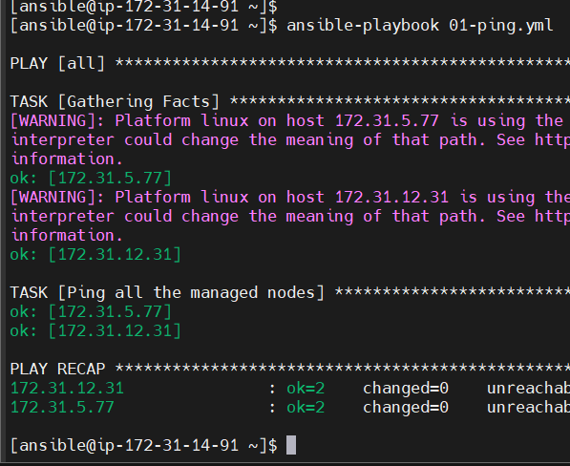

More verbose -vv

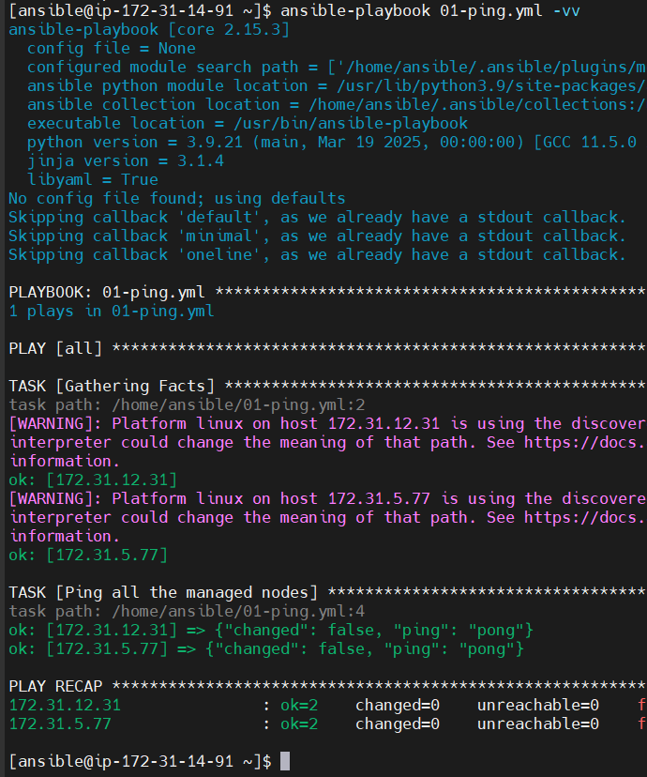

-vvv more verbose ansible report

ansible user already created

ansible directory created

1. We had switched to user ansible: sudo su ansible
2. Get into ansible directory: cd ~ or cd ../ansible
3. Present working directory: pwd ---> /home/ansible
4. [ansible@ip-172-31-14-91 ~]$ vi 01-ping.yml
5. ---
6. - hosts: all
7. tasks:
8. - name: Ping all the managed nodes
9. ping:
10. remote_user: ansible
11. ...
12. ansible-playbook 01-ping.yml
13. To get more info about the playbook execution or internal info about the playbook --> Verbosity
14. ansible-playbook 01-ping.yml -vv --> more verbosity or more detailed output
15. To check playbook syntax
16. ansible-playbook 01-ping.yml --syntax-check
17. Inventory file will have the information about the machines we are managing
18. 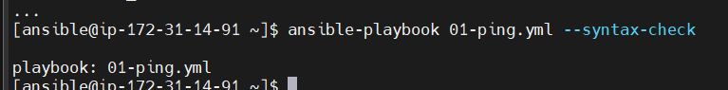
19. To check which hosts will be affected by a Playbook:
20. [ansible@ip-172-31-14-91 ~]$ ansible-playbook 01-ping.yml --list-hosts
21. playbook: 01-ping.yml
22. play #1 (all): all TAGS: []
23. pattern: ['all']
24. hosts (2):
25. 172.31.5.77
26. 172.31.12.31
27. 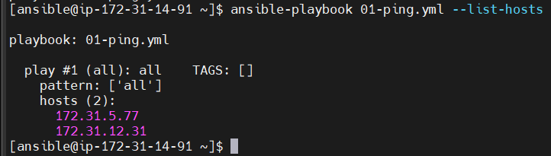
28. Execute one step at a time and confirm each task before running with yes, no or continue
29. [ansible@ip-172-31-14-91 ~]$ ansible-playbook 01-ping.yml --step
30. 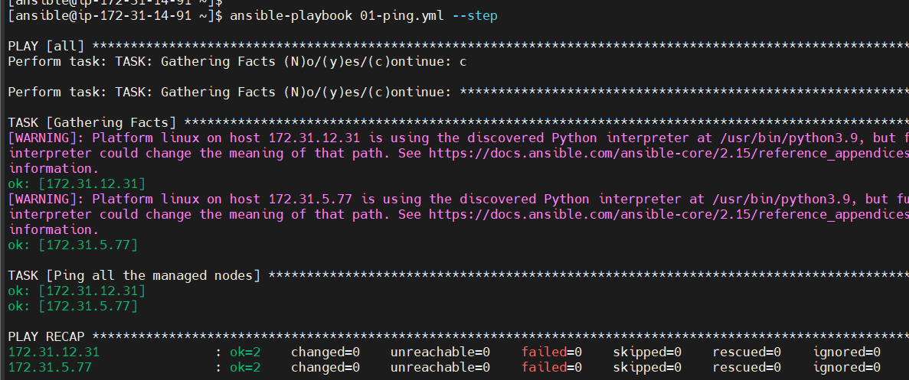
31. For dryrun
32. 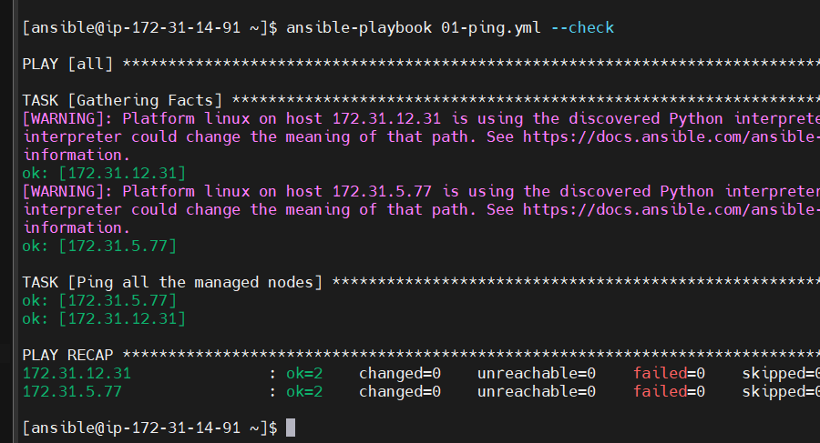

Inventory file

Managed node1

Playbook

Managed node2

Control node

Managed node3

I want to create file in each of the Managed nodes using Ansible

Log into Managed Node1

[ec2-user@ip-172-31-5-77 ~]$ sudo su ansible

[ansible@ip-172-31-5-77 ec2-user]$

[ansible@ip-172-31-5-77 ec2-user]$

[ansible@ip-172-31-5-77 ec2-user]$

[ansible@ip-172-31-5-77 ec2-user]$ cd ~

Go to Control node:

[ansible@ip-172-31-14-91 ~]$ vi 02-create-file.yml

[ansible@ip-172-31-14-91 ~]$ cat 02-create-file.yml

---

- hosts: all

tasks:

- name: Create file in all the managed nodes

file:

path: /home/ansible/fromControlNode.txt

state: touch

...

[ansible@ip-172-31-14-91 ~]$ ansible-playbook 02-create-file.yml --syntax

playbook: 02-create-file.yml

[ansible@ip-172-31-14-91 ~]$ ansible-playbook 02-create-file.yml

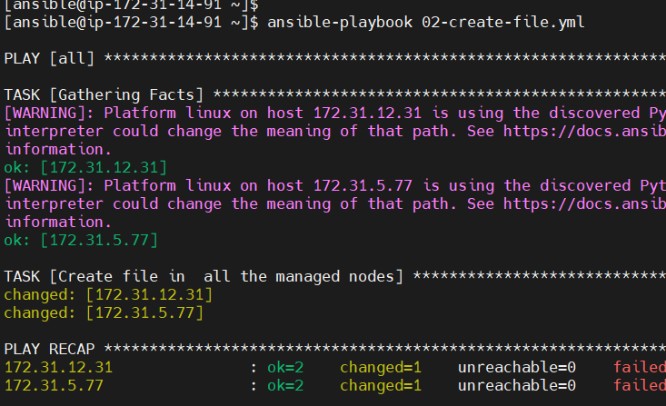

Go to Managed Node 1:

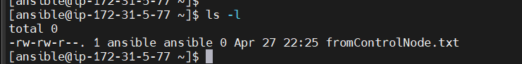

The file ‘fromControlNode.txt is created’

Second Managed node:

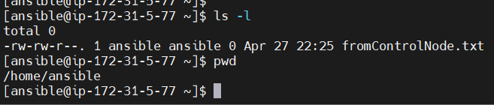

Same file is created

Back to ControlNode:

Modify yml file lightly to create another file in managed nodes

Managed Node1:

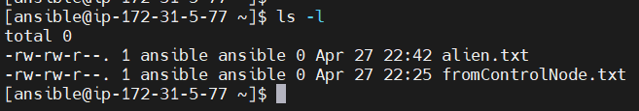

Steps we followed so far:

Create files in Managed Nodes using Ansible from Control Node

Create a new yml playbook file in Control Node

vi 02-create-file.yml

[ansible@ip-172-31-14-91 ~]$ cat 02-create-file.yml

---

- hosts: all

tasks:

- name: Create file in all the managed nodes

file:

path: /home/ansible/alien.txt

state: touch

...

ansible-playbook 02-create-file.yml

Later get connected to managed nodes and check if files are created

Task 3: Install git in client (Managed nodes) ---> Assignment to install Maven

[ansible@ip-172-31-14-91 ~]$ vi 03-install-git.yml

become: true gives admin privilleges

---

- hosts: all

become: true

tasks:

- name: Install Git in all the managed nodes

yum:

name: git

state: latest

...

[ansible@ip-172-31-14-91 ~]$ ansible-playbook 03-install-git.yml --syntax-check

playbook: 03-install-git.yml

[ansible@ip-172-31-14-91 ~]$ ansible-playbook 03-install-git.yml

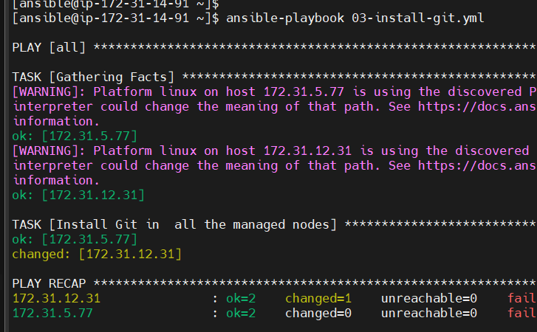

Go to Managed Node 1:

[ansible@ip-172-31-5-77 ~]$ git -v

git version 2.47.1

Git is installed successfully

Same in Managed node 2:



Go back to ControlNode:

[ansible@ip-172-31-14-91 ~]$ cat /etc/ansible/hosts

[webservers]

172.31.5.77

[dbservers]

172.31.12.31

We have created two groups: webservers and dbservers group

[ansible@ip-172-31-14-91 ~]$ vi 04-website-hosting.yml

[ansible@ip-172-31-14-91 ~]$

[ansible@ip-172-31-14-91 ~]$

[ansible@ip-172-31-14-91 ~]$ cat 04-website-hosting.yml

---

- hosts: webservers

become: true

tasks:

- name: Install httpd package in only Managed node1

yum:

name: httpd

state: latest

- name: Copy index.html file

copy:

src: index.html

dest: /var/www/html/index.html

- name: Start httpd server

service: Start httpd server

name: httpd

state: started

...

In the ControlNode:

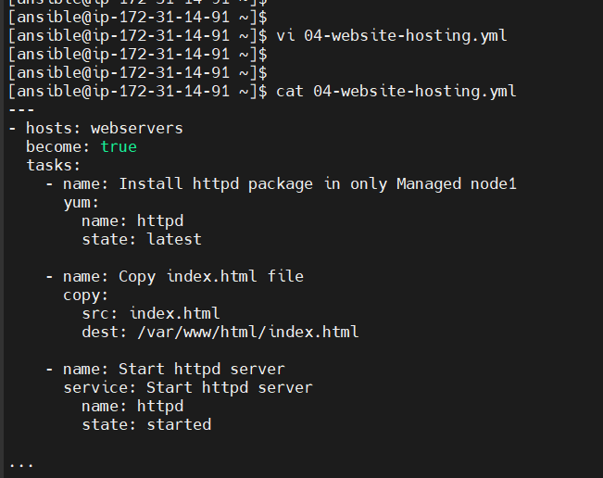

In the ControlNode, create one file called as ‘index.html’ file

[ansible@ip-172-31-14-91 ~]$ vi index.html

[ansible@ip-172-31-14-91 ~]$ cat index.html

<h1> DevOps Course Ansible </h1>>

[ansible@ip-172-31-14-91 ~]$ ansible-playbook 04-website-hosting.yml --syntax-check

playbook: 04-website-hosting.yml

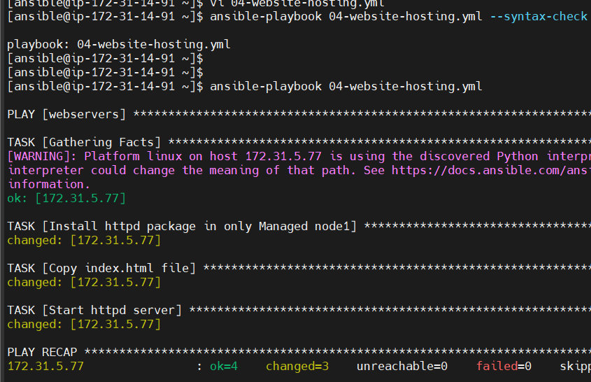

Copy public IP of Managed host 1

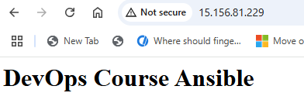

Steps we followed so far for webhosting

vi 04-website-hosting.yml

[ansible@ip-172-31-14-91 ~]$ cat 04-website-hosting.yml

---

- hosts: webservers

become: true

tasks:

- name: Install httpd package in only Managed node1

yum:

name: httpd

state: latest

- name: Copy index.html file

copy:

src: index.html

dest: /var/www/html/index.html

- name: Start httpd server

service:

name: httpd

state: started

...

[ansible@ip-172-31-14-91 ~]$ ansible-playbook 04-website-hosting.yml --list-hosts

playbook: 04-website-hosting.yml

play #1 (webservers): webservers TAGS: []

pattern: ['webservers']

hosts (1):

172.31.5.77

[ansible@ip-172-31-14-91 ~]$ ansible-playbook 04-website-hosting.yml --syntax-check

playbook: 04-website-hosting.yml

[ansible@ip-172-31-14-91 ~]$ ansible-playbook 04-website-hosting.yml

Use Public IP of webservers group machine and check if website is up and running

I run the same file again from ControlNode

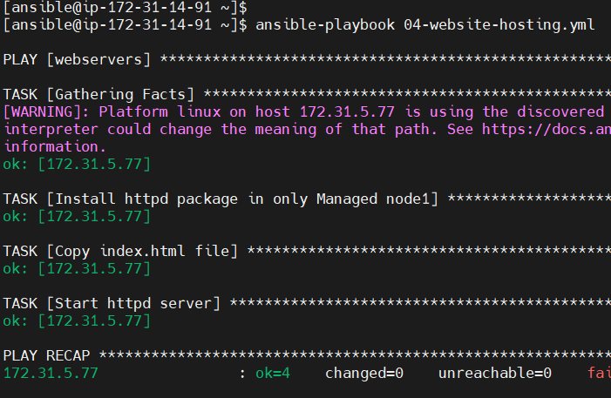

Note: Changed=0 that means no change

Now if I make changes to the same file, then changed=1 because it’s treated as a new file

Variables:

Used to store data / information

id: 1

name: Rohan

We can use the concept of variables in Ansible in 4 different ways:

Runtime variables

Playbook variables

Group variables

Host variables

Runtime variables: while I execute the particular playbook yml file, I will be passing the values

Playbook variables: In the Playbook itself I will be creating the variables

Group variables: we create variables at Group levels. Inside Inventory file, we have information about Managed nodes and Groups. Group variables we create the Inventory level. Same goes with the Host variable

Host variable: Created in the Inventory level, in one Group, possibility of having multiple machines

1. Runtime variable: We can pass variable value at Runtime.

[ansible@ip-172-31-14-91 ~]$ vi 05-website-hosting-variable.yml

[ansible@ip-172-31-14-91 ~]$ cat 05-website-hosting-variable.yml

---

- hosts: webservers

become: true

tasks:

- name: Install httpd package in only Managed node1

yum:

name: "{{package_name}}"

state: latest

- name: Copy index.html file

copy:

src: index.html

dest: /var/www/html/index.html

- name: "{{package_name}}"

service:

name: httpd

state: started

...

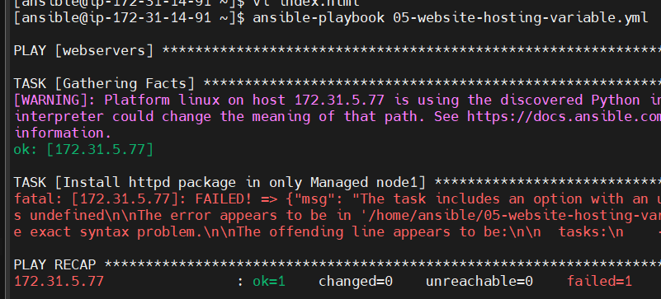

Add [ansible@ip-172-31-14-91 ~]$ ansible-playbook 05-website-hosting-variable.yml --extra-vars package_name=httpd

--extra-vars package_name=httpd

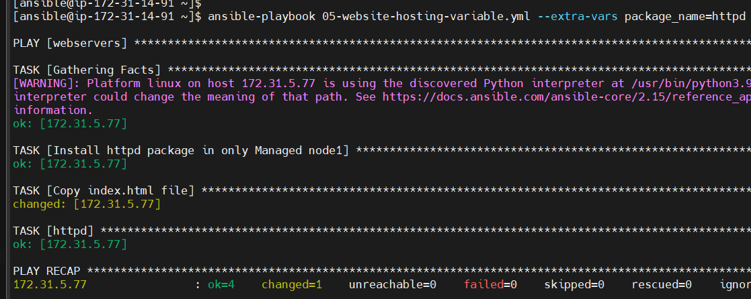

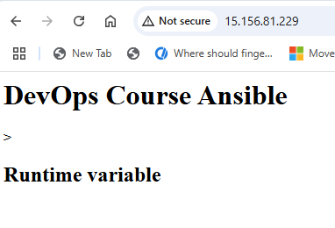

1. Playbook variable ---> Declare and use the variables within playbook

[ansible@ip-172-31-14-91 ~]$ vi 06-playbook-variables.yml

[ansible@ip-172-31-14-91 ~]$ cat 06-playbook-variables.yml

---

- hosts: webservers

become: true

vars:

package_name: httpd webserver

tasks:

- name: Install httpd package in only Managed node1

yum:

name: "{{package_name}}"

state: latest

- name: Copy index.html file

copy:

src: index.html

dest: /var/www/html/index.html

- name: "{{package_name}}"

service:

name: httpd

state: started

...

[ansible@ip-172-31-14-91 ~]$ vi 06-playbook-variables.yml

[ansible@ip-172-31-14-91 ~]$ cat 06-playbook-variables.yml

---

- hosts: webservers

become: true

vars:

package_name: httpd webserver

tasks:

- name: Install "{{package_name}}" in only Managed node1

yum:

name: httpd

state: latest

- name: Copy index.html file

copy:

src: index.html

dest: /var/www/html/index.html

- name: "{{package_name}}"

service:

name: httpd

state: started

...

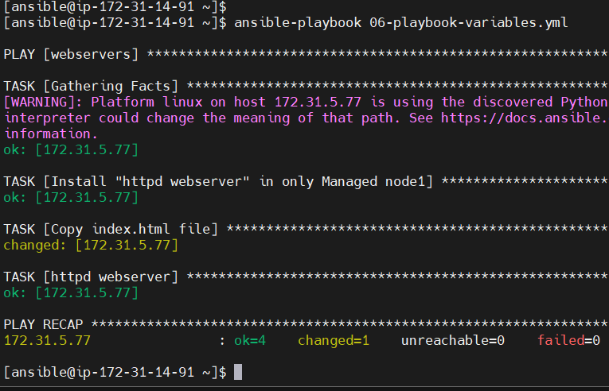

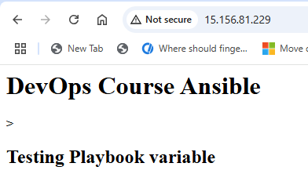

Assignment: Write Ansible playbook to install Java in webserver group and MySQL in dbserver group