Ansible 3_part1:

Group variable:

Group variable file should be created at host inventory location.

Where is the host inventory? /etc/ansible/hosts

mkdir /etc/ansible/hosts/group_vars

sudo vi /etc/ansible/hosts/group_vars/webservers.yml

package_name: java

sudo vi /etc/ansible/hosts/group_vars/dbservers.yml

package_name: mysql

Host vars: server/machine specific variables --> for every machine/host if you want specific variable then we can go with host variables

mkdir /etc/ansible/host_vars

---> Create a file with hostname or ip

sudo vi /etc/ansible/hosts/host_vars/hostname.yml --> sudo vi /etc/ansible/hosts/host_vars/<ip_address>.yml

Handlers and Tags:

For example, when you execute ansible-playbook 04-website-hosting.yml

Tasks are executed in the sequential order

Lets say we have 3 tasks, out of them, I want to execute only a particular task or I don’t want to install some tasks in the yml file. Concept of Tags comes into picture

I want my third task to be executed only if my second task is completed, then Concept of Handler comes into picture

In Playbook, all the tasks by default will be executed in sequential order, using Handlers, we can execute tasks based on other tasks status. If second task status is changed, only then the third task is executed. It will notify the tasks to execute and we use ‘notify’ keyword to inform Handler to execute.

Using Tag, we can map task to a tagname and we can execute particular task and we can skip certain tasks also. Both can be done.

‘Notify’ means, httpd service will be restarted only if there are any changes in the yml file

[ec2-user@ip-172-31-14-91 ~]$ vi 07-handlers.yml

[ec2-user@ip-172-31-14-91 ~]$ cat 07-handlers.yml

---

- hosts: webservers

become: true

vars:

package_name: httpd

tasks:

- name: Install "{{package_name}}" in only Managed node1

yum:

name: "{{package_name}}"

state: latest

tags:

- install

- name: Copy index.html file

copy:

src: index.html

dest: /var/www/html/index.html

tags:

- copy

notify:

starting httpd

- name: Starting "{{package_name}}" package

service:

name: "{{package_name}}"

state: started

...

We have two tags: copy and install --> using tags we can skip and run a specific task

[ec2-user@ip-172-31-14-91 ~]$ ansible-playbook 07-handlers.yml --syntax-check

playbook: 07-handlers.yml

[ec2-user@ip-172-31-14-91 ~]$ ansible-playbook 07-handlers.yml --list-tags

playbook: 07-handlers.yml

play #1 (webservers): webservers TAGS: []

TASK TAGS: [copy, install]

Only “copy” I want to execute

[ec2-user@ip-172-31-14-91 ~]$ ansible-playbook 07-handlers.yml --tags "copy"

Both “copy” and “install” I want to execute

[ec2-user@ip-172-31-14-91 ~]$ ansible-playbook 07-handlers.yml --tags "copy, install"

[ec2-user@ip-172-31-14-91 ~]$ ansible-playbook 07-handlers.yml --skip-tags “install, copy”

Ansible Vault:

To secure our playbooks, we go with the concept of Ansible Vault --> we encrypt and decrypt using this concepts

ansible-vault encrypt 07-handlers.yml

[ansible@ip-172-31-14-91 ~]$ sudo ansible-vault encrypt 07-handlers.yml

New Vault password:

Confirm New Vault password:

Encryption successful

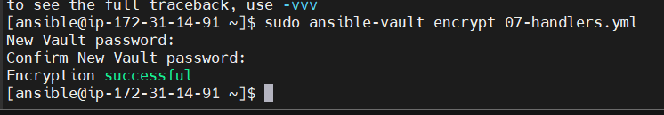

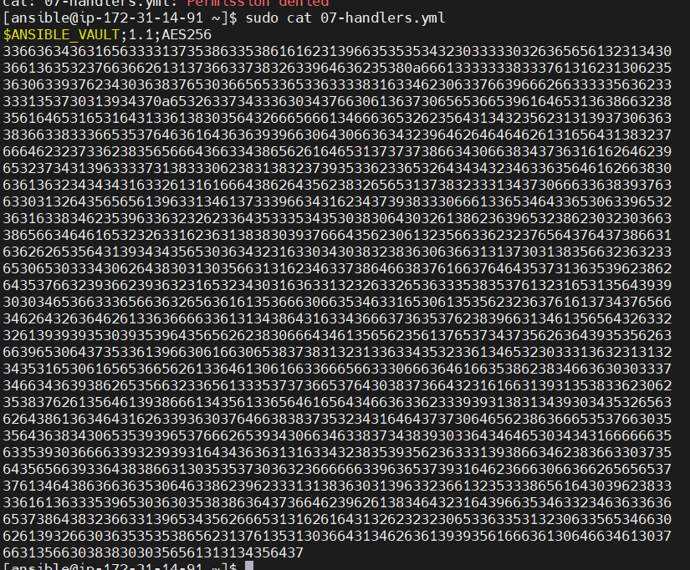

Without decrypt, we cannot see the code

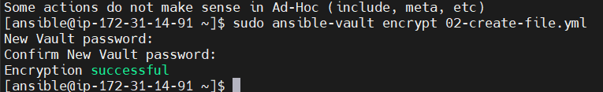

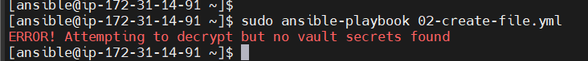

--ask-vault-pass

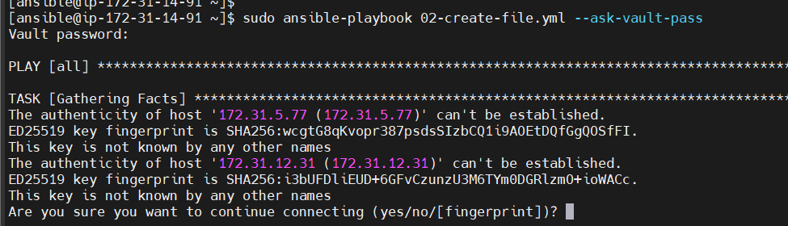

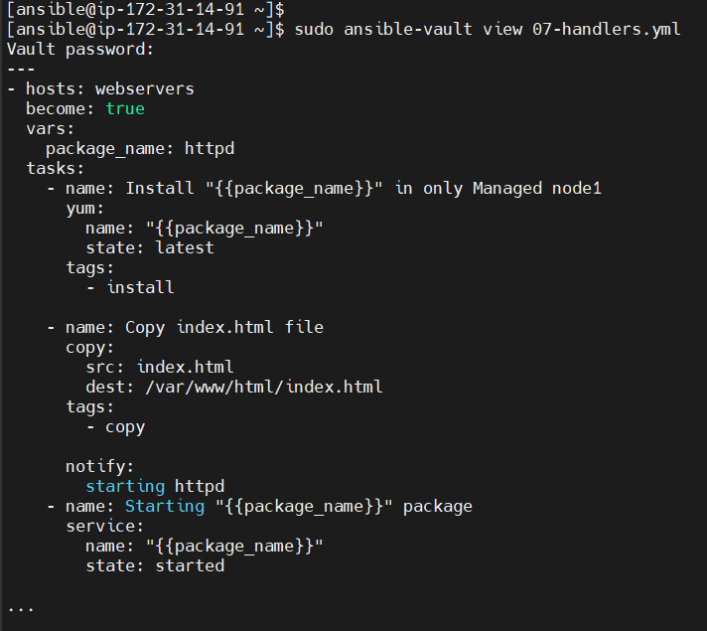

[ansible@ip-172-31-14-91 ~]$ sudo ansible-vault edit 07-handlers.yml

Now we can edit

---

- hosts: webservers

become: true

vars:

package_name: httpd

tasks:

- name: Install "{{package_name}}" in only Managed node1

yum:

name: "{{package_name}}"

state: latest

tags:

- install

- name: Copy index.html file

copy:

src: index.html

dest: /var/www/html/index.html

tags:

- copy

notify:

starting httpd

- name: Starting "{{package_name}}" package

service:

name: "{{package_name}}"

state: started

…

Decryption :

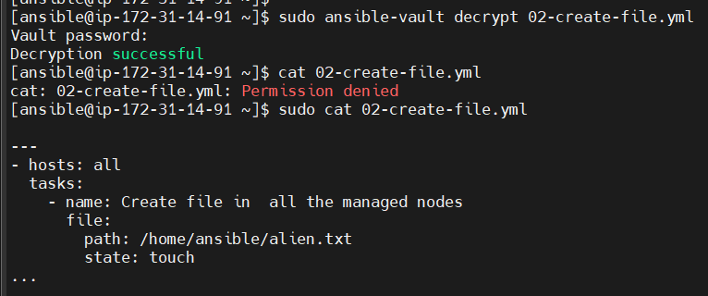

ansible-vault encrypt <playbook.yml> ---> to encrypt yml file

ansible-vault decrypt <playbook.yml> ---> to decrypt yml file

ansible-vault edit <playbook.yml> ---> to edit yml file

ansible-vault view <playbook.yml> ---> to view yml file