Ansible 4:

Ansible roles: --> Webservers, Apache Tomcat

If you want to divide tasks from one playbook into smaller chunks or if you want to organize playbook better then we need Ansible roles. Tasks, Handlers all separate

Multiple yaml files

Tasks

Install httpd

Copy file

Handler

Start service

Multiple yaml files

File

Multiple yaml files

Handler

When I breakdown one playbook into multiple chunks, then there is less ambiguity and issues. This is all possible with the concept of Ansible Roles

Whenever there are more tasks or more functionalities in our playbook, it becomes difficult to manage and maintain. Here Ansible Roles, come into picture, allow us to breakdown complex playbook into smaller chuncks that could be co-ordinated by a central entry point. To create Roles in Ansible, we have a concept called as “Ansible Galaxy”.

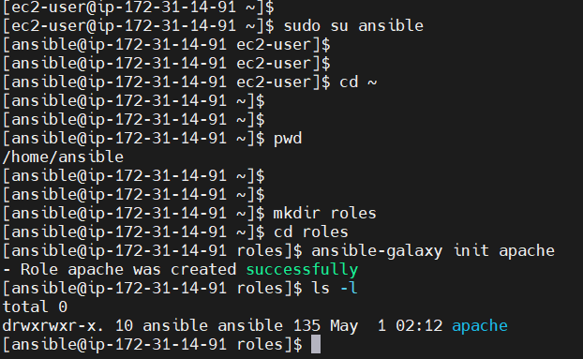

Practicals with Ansible roles:

sudo su ansible

cd ~

pwd ---> /home/ansible

mkdir roles

cd roles

ansible-galaxy init apache ---> apache role is created

(install tree)

tree apache

cd apache

vi tasks/main.yml

---

# tasks file for apache

- name: Install httpd in only Managed node1

yum:

name: httpd

state: present

- name: Copy index.html file

copy:

src: index.html

dest: /var/www/html/index.html

notify:

- restart apache

…

vi files/index.html

<h1> Ansible Role Learning </h1>

vi handlers/main.yml

---

# handlers file for apache

- name: restart apache

service:

name: httpd

state: restarted

...

vi runsetup

---

- hosts: webservers

become: true

roles:

- apache

...

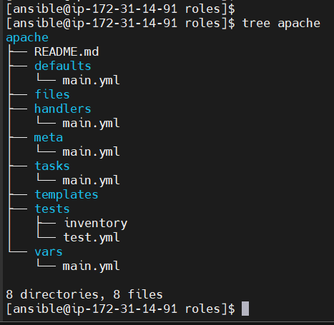

One playbook is divided into three parts

[ansible@ip-172-31-14-91 roles]$ cd apache/

[ansible@ip-172-31-14-91 apache]$ vi tasks/main.yml

[ansible@ip-172-31-14-91 apache]$

[ansible@ip-172-31-14-91 apache]$

[ansible@ip-172-31-14-91 apache]$ cat tasks/main.yml

---

# tasks file for apache

- name: Install httpd in only Managed node1

yum:

name: httpd

state: present

- name: Copy index.html file

copy:

src: index.html

dest: /var/www/html/index.html

notify:

- restart apache

…

Step 2:

[ansible@ip-172-31-14-91 apache]$ vi files/index.html

[ansible@ip-172-31-14-91 apache]$ cat files/index.html

<h1> Ansible Role Learning </h1>

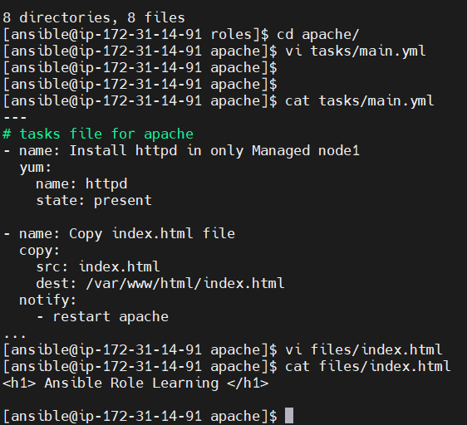

[ansible@ip-172-31-14-91 apache]$ cat handlers/main.yml

---

# handlers file for apache

- name: restart apache

service:

name: httpd

state: restarted

...

[ansible@ip-172-31-14-91 apache]$ cd ..

[ansible@ip-172-31-14-91 roles]$ tree apache

apache

├── README.md

├── defaults

│   └── main.yml

├── files

│   └── index.html

├── handlers

│   └── main.yml

├── meta

│   └── main.yml

├── tasks

│   └── main.yml

├── templates

├── tests

│   ├── inventory

│   └── test.yml

└── vars

└── main.yml

8 directories, 9 files

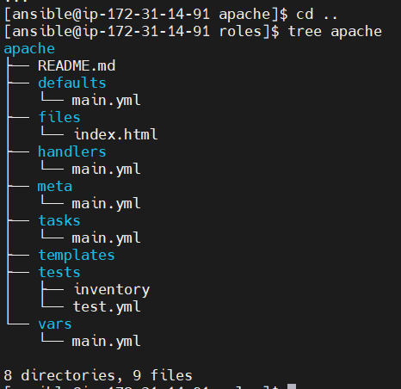

[ansible@ip-172-31-14-91 ~]$ vi runsetup

[ansible@ip-172-31-14-91 ~]$ cat runsetup

---

- hosts: webservers

become: true

roles:

- apache

...

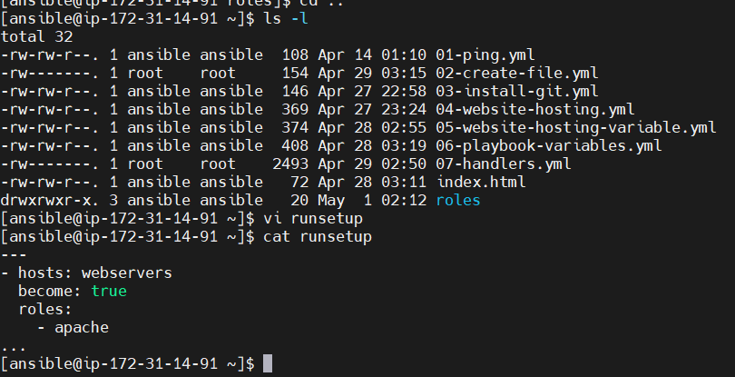

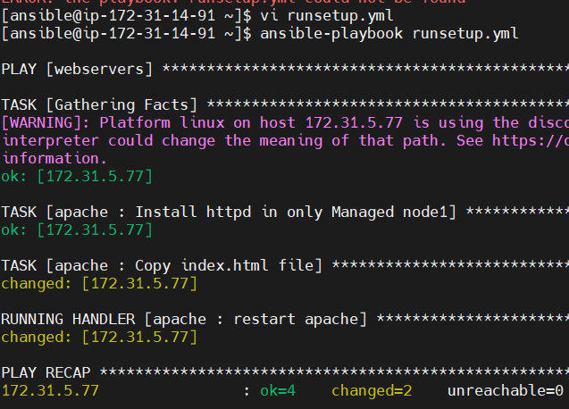

Ansible Tower:

**Ansible Tower** (now part of **Red Hat Ansible Automation Platform**) is a **web-based UI and REST API** that makes it easier to manage and scale Ansible across an enterprise.

Ansible Tower is a paid software managed by Red Hat which provides UI to create/schedule/manage/execute playbook

Webservers:

Web service over internet --->

Mobile, Browser, WebBrowser

App.war file

Server

App is packaged as a .war file. Keeping application file inside Server software is called as Deployment

Webservers --->

Server software is used to run our web applications and users across the globe with internet can access our web applications by sending requests to server

Users will use Client softare or web browsers to send requests to server

Server is responsible to handle requests and response

There are many server softwares in the market to run our web apps

Example: Tomcat, Glassfish, WebLogic, JBoss, IIS, Websphere

Is it compulsory to have a server software to run our application? The answer is Yes

Every web application must be present inside the Server software. To run our webapp server is mandatory

The process of executing web applications by using server is called as Deployment

Tomcat server:

It is free and open-source sofware, which is developed by Apache organization

Tomcat server is developed using Java language. Hence, to run Tomcat, Java also has to be installed

Tomcat supports multiple operating system

By default, Tomcat runs on 8080 port number (if needed we can change the port number of Tomcat)