Jenkins 1

Users and Roles and in Jenkins

Master-Slave architecture

Pipeline

User and Roles in Jenkins

There are multiple people (Dev team, Testing team, DevOps team, ) working on the same project. Do we want to give access to everyone working on the project the entire Jenkins dashboard? The access level will be different for different teams in Jenkins. that’s where we need User management in Jenkins. Generally in every project, multiple teams (Dev, DevOps, QA) could be there and for every team Jenkins access would be provided. Every team members will have their own user account to login into Jenkins and not every team member will have complete access to Jenkins. Certain teams such as Dev, QA team will have limited access to Jenkins because they are responsible just to run the job not to create, edit, or delete the jobs whereas Operations team will have more access to Jenkins as they are responsible to create, edit or delete jobs in Jenkins.

Creating Users and managing their permissions:

Start Jenkins-Server

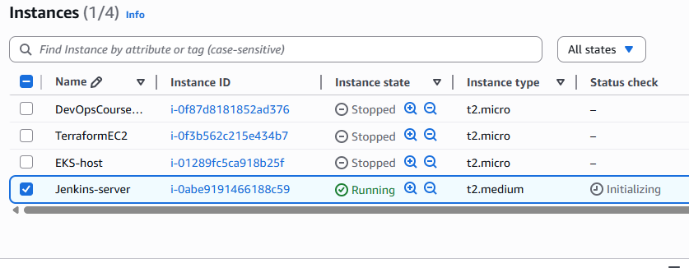

<http://16.52.83.212:8080/login?from=%2F>

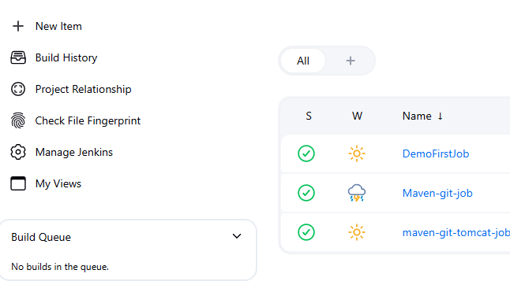

Manage Jenkins

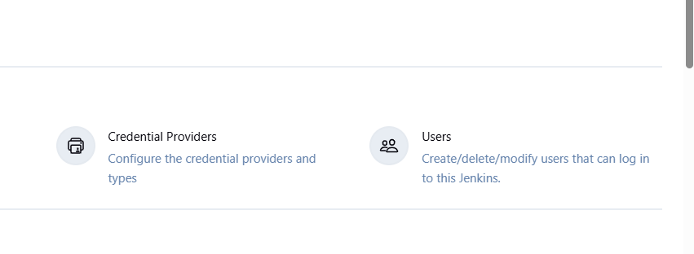

Users

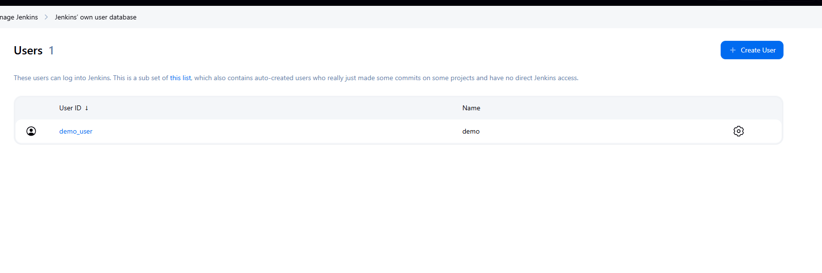

Create User

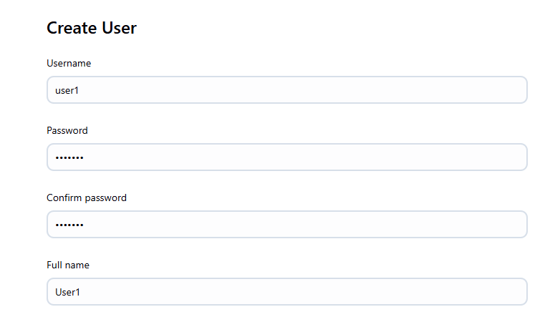

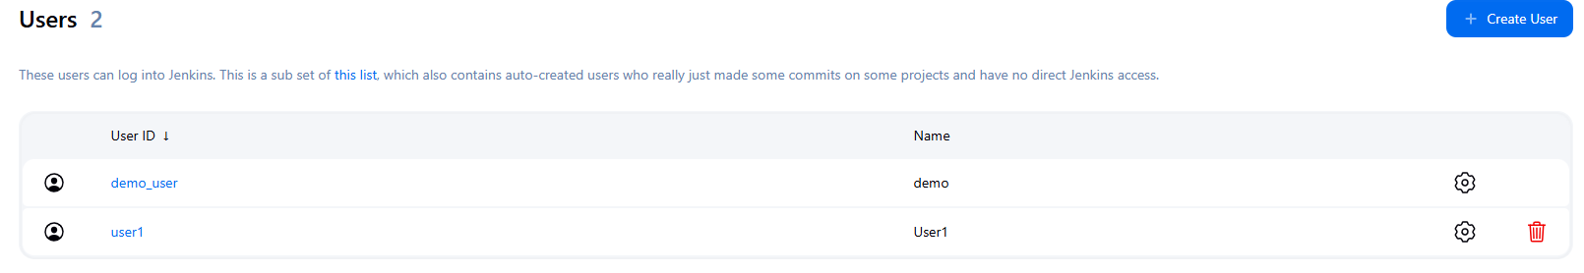

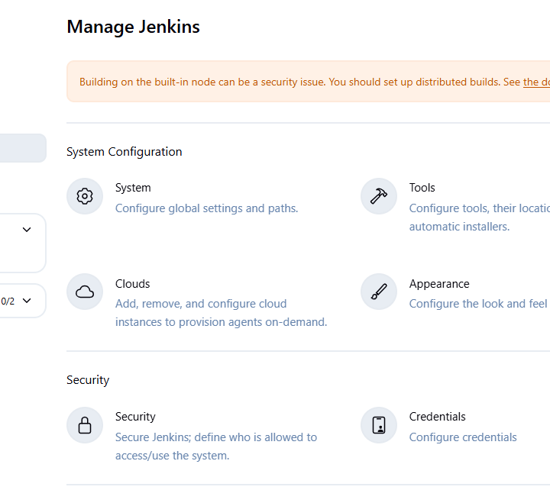

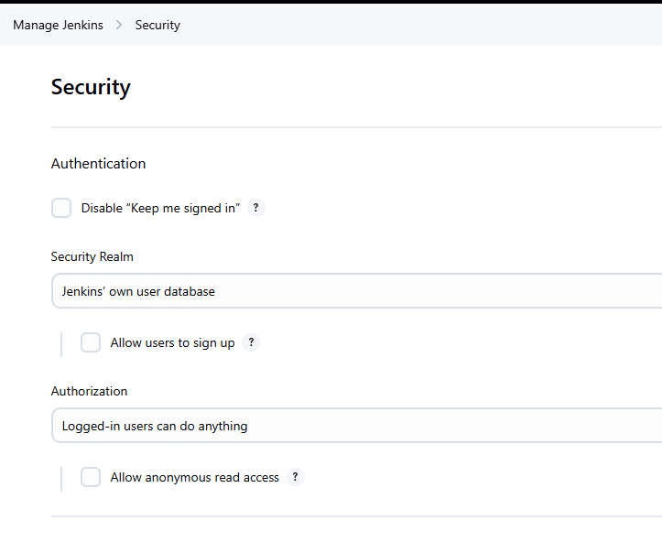

In Authorization select matrix-based security

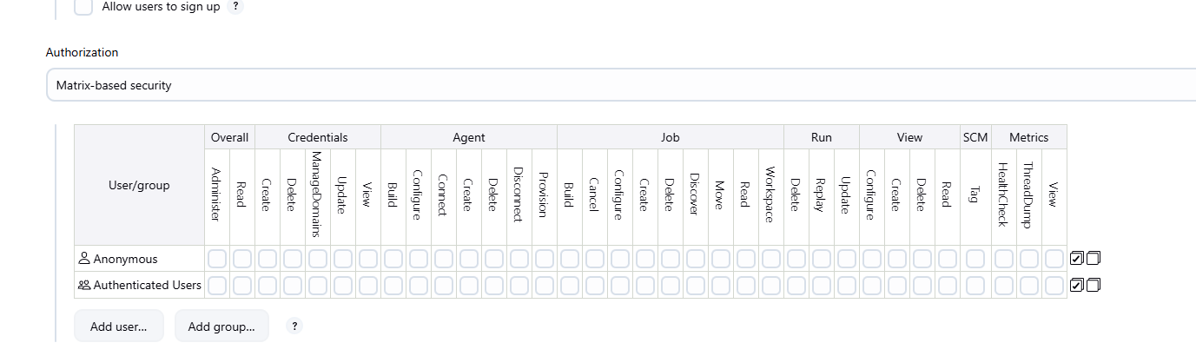

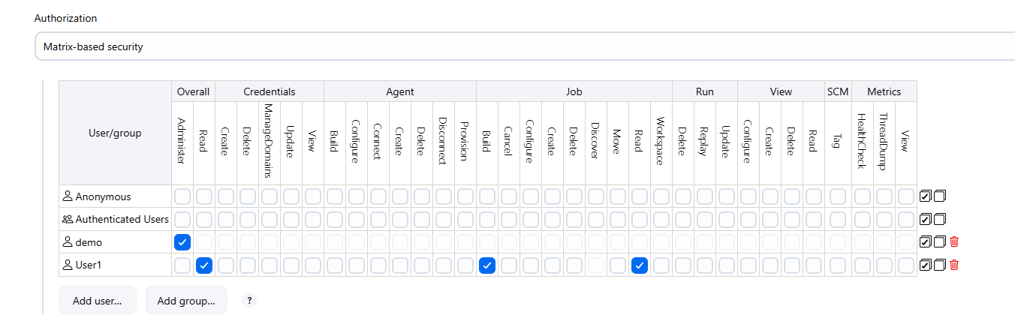

Apply then Save

Logout

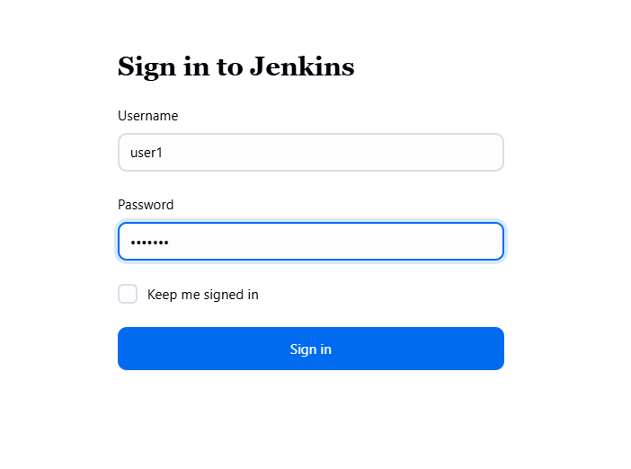

For example, user1 cannot have access to Configure

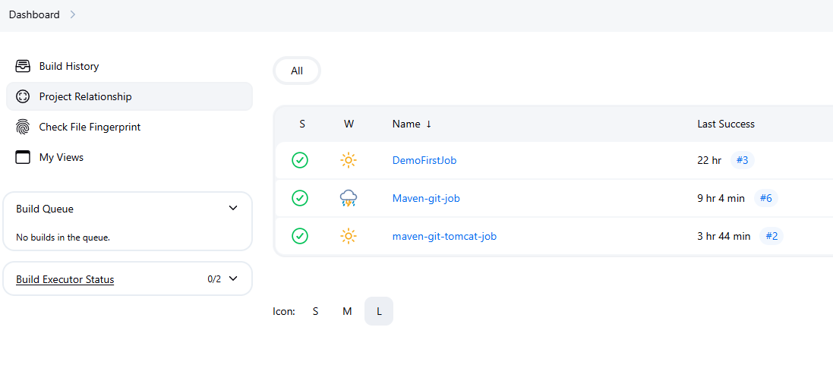

Say we have 200 users are there, and it is cumbersome to give role-based access to entire 200 users imagine. The solution is to create User-Roles, Developer-Role then we will assign to specific teams

Logout then login as admin user

Creating Users and managing their Permissions

--> Jenkins dashboard

Dashboard --> Manage Jenkins --> Configure Security --> Security Realm (Jenkins own user database) -> Authorization (Matrix base security) -> Add users (demo_user, user1) Add permission based on requirements. Enable API token stats --> Apply and Save

39:00