Kubernetes_4

eksctl create cluster --name my-eks-cluster --region ca-central-1 --node-type t2.medium --zones ca-central-1a,ca-central-1b

ubuntu@ip-172-31-9-165:~$ kubectl apply -f deployment.yml

deployment.apps/javawebdeployment created

ubuntu@ip-172-31-9-165:~$

ubuntu@ip-172-31-9-165:~$ kubectl get all

NAME READY STATUS RESTARTS AGE

pod/javawebdeployment-57988f5cd7-9g8tr 1/1 Running 0 21s

pod/javawebdeployment-57988f5cd7-p7cb7 1/1 Running 0 22s

NAME TYPE CLUSTER-IP EXTERNAL-IP PORT(S) AGE

service/kubernetes ClusterIP 10.100.0.1 <none> 443/TCP 8m11s

NAME READY UP-TO-DATE AVAILABLE AGE

deployment.apps/javawebdeployment 2/2 2 2 22s

NAME DESIRED CURRENT READY AGE

replicaset.apps/javawebdeployment-57988f5cd7 2 2 2 22s

ubuntu@ip-172-31-9-165:~$ kubectl scale deployment javawebdeployment --replicas 4

deployment.apps/javawebdeployment scaled

ubuntu@ip-172-31-9-165:~$ kubectl get pods

NAME READY STATUS RESTARTS AGE

javawebdeployment-57988f5cd7-9g8tr 1/1 Running 0 2m

javawebdeployment-57988f5cd7-g2th6 1/1 Running 0 5s

javawebdeployment-57988f5cd7-p7cb7 1/1 Running 0 2m1s

javawebdeployment-57988f5cd7-t6xpg 1/1 Running 0 5s

ubuntu@ip-172-31-9-165:~$

If you don’t explicitly specify service, the default service is ClusterIP

---

apiVersion: apps/v1

kind: Deployment

metadata:

name: javawebdeploy

spec:

replicas: 2

strategy:

type: RollingUpdate

selector:

matchLabels:

app: javawebapp

template:

metadata:

name: javawebpod

labels:

app: javawebapp

spec:

containers:

- name: javawebappcontainer

image: hacker123shiva/springbt-in-docker:latest

ports:

- containerPort: 8080

---

apiVersion: v1

kind: Service

metadata:

name: javawebappsvc

spec:

type: LoadBalancer

selector:

app: javawebapp

ports:

- port: 80

targetPort: 8080

…

ubuntu@ip-172-31-9-165:~$ cat dep-svc.yml

---

apiVersion: apps/v1

kind: Deployment

metadata:

name: javawebdeployment

spec:

replicas: 2

strategy:

type: RollingUpdate

selector:

matchLabels:

app: javawebapp

template:

metadata:

name: javawebpod

labels:

app: javawebapp

spec:

containers:

- name: javawebappcontainer

image: hacker123shiva/springbt-in-docker:latest

ports:

- containerPort: 8080

---

apiVersion: v1

kind: Service

metadata:

name: javawebappsvc

spec:

type: LoadBalancer

selector:

app: javawebapp

ports:

- port: 80

targetPort: 8080

...

ubuntu@ip-172-31-9-165:~$ kubectl apply -f dep-svc.yml

deployment.apps/javawebdeployment created

service/javawebappsvc created

ubuntu@ip-172-31-9-165:~$ kubectl get all

NAME READY STATUS RESTARTS AGE

pod/javawebdeployment-57988f5cd7-4mhbd 1/1 Running 0 70s

pod/javawebdeployment-57988f5cd7-wm8gz 1/1 Running 0 70s

NAME TYPE CLUSTER-IP EXTERNAL-IP PORT(S) AGE

service/javawebappsvc LoadBalancer 10.100.177.181 a2c8cab06e2fa4241aec665485af8c3c-58365812.ca-central-1.elb.amazonaws.com 80:31546/TCP 70s

service/kubernetes ClusterIP 10.100.0.1 <none> 443/TCP 7m48s

NAME READY UP-TO-DATE AVAILABLE AGE

deployment.apps/javawebdeployment 2/2 2 2 71s

NAME DESIRED CURRENT READY AGE

replicaset.apps/javawebdeployment-57988f5cd7 2 2 2 71s

Go to EC2 Loadbalancer

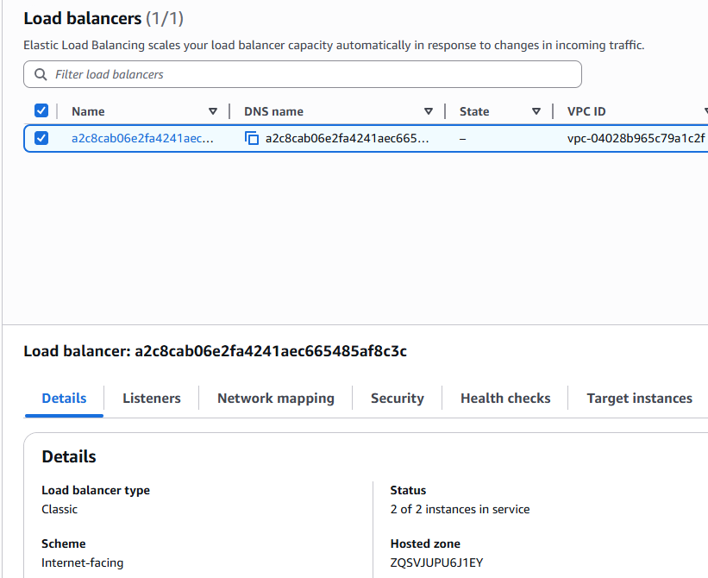

a2c8cab06e2fa4241aec665485af8c3c-58365812.ca-central-1.elb.amazonaws.com



ubuntu@ip-172-31-9-165:~$ kubectl delete all --all

pod "javawebdeployment-57988f5cd7-4mhbd" deleted

pod "javawebdeployment-57988f5cd7-wm8gz" deleted

service "javawebappsvc" deleted

service "kubernetes" deleted

deployment.apps "javawebdeployment" deleted

replicaset.apps "javawebdeployment-57988f5cd7" deleted

Autoscaling

Process of increasing or decreasing the infrastructure resources based on the demand

Autoscaling: Horizontal (increasing / decreasing infrastructure resources based on the demand) and Vertical scaling (increasing the capacity of the same single system / machine / pod)

HPA (Horizontal Pod Autoscaling) and VPA (Vertical Pod Autoscaling)

Why Autoscale in K8s?

High availability of application or better availability of application

Elasticity

Efficient resource utilization

Seamless load management

HPA (Horizontal Pod Autoscaling) --> used to scale up or scale down number of pod replicas based on observed metrics (CPU or memory utilization). we cannot simply add or remove resources, we got to check certain metrics before we hire someone

HPA needs metrics to adjust the pods

HPA observes all metrics --> based on the observation, it will add/delete pods, tracks multiple metrics

HPA will interact with Metric server to identify CPU/memory utilization of POD

Metric server is an application that collects metrics from objects, pods, nodes according to state of CPU and memory

ubuntu@ip-172-31-9-165:~$ kubectl top nodes

NAME CPU(cores) CPU(%) MEMORY(bytes) MEMORY(%)

ip-192-168-13-3.ca-central-1.compute.internal 39m 2% 629Mi 18%

ip-192-168-34-135.ca-central-1.compute.internal 24m 1% 550Mi 16%

Metrics server will not be present by default in Kubernetes server

Install metrics API

$ mkdir k8s-metrics-server

$ cd k8s-metrics-server

$ vi metrics-api-server.yaml

---

apiVersion: v1

kind: ServiceAccount

metadata:

labels:

k8s-app: metrics-server

name: metrics-server

namespace: metrics

…

ubuntu@ip-172-31-9-165:~$ cat metrics-api-server.yaml

---

apiVersion: v1

kind: ServiceAccount

metadata:

labels:

k8s-app: metrics-server

name: metrics-server

namespace: metrics

...

ubuntu@ip-172-31-9-165:~/k8s-metrics-server$ cat metrics-deployment.yaml

---

apiVersion: apps/v1

kind: Deployment

metadata:

name: metrics-server

namespace: kube-system

labels:

k8s-app: metrics-server

spec:

selector:

matchLabels:

k8s-app: metrics-server

app.kubernetes.io/instance: metrics-server

app.kubernetes.io/name: metrics-server

strategy:

rollingUpdate:

maxUnavailable: 0

template:

metadata:

labels:

k8s-app: metrics-server

app.kubernetes.io/instance: metrics-server

app.kubernetes.io/name: metrics-server

spec:

serviceAccountName: metrics-server

nodeSelector:

kubernetes.io/os: linux

priorityClassName: system-cluster-critical

containers:

- name: metrics-server

image: k8s.gcr.io/metrics-server/metrics-server:v0.5.0

imagePullPolicy: IfNotPresent

args:

- --cert-dir=/tmp

- --secure-port=443

- --kubelet-preferred-address-types=InternalIP,ExternalIP,Hostname

- --kubelet-use-node-status-port

- --metric-resolution=15s

- --kubelet-insecure-tls

ports:

- containerPort: 443

name: https

protocol: TCP

livenessProbe:

failureThreshold: 3

httpGet:

path: /livez

port: https

scheme: HTTPS

periodSeconds: 10

readinessProbe:

failureThreshold: 3

httpGet:

path: /readyz

port: https

scheme: HTTPS

initialDelaySeconds: 20

periodSeconds: 10

resources:

requests:

cpu: 100m

memory: 200Mi

securityContext:

readOnlyRootFilesystem: true

runAsNonRoot: true

runAsUser: 1000

volumeMounts:

- mountPath: /tmp

name: tmp-dir

volumes:

- name: tmp-dir

emptyDir: {}

...

ubuntu@ip-172-31-9-165:~/k8s-metrics-server$ cat metrics-rbac.yaml

---

apiVersion: v1

kind: ServiceAccount

metadata:

name: metrics-server

namespace: kube-system

---

apiVersion: rbac.authorization.k8s.io/v1

kind: ClusterRole

metadata:

name: system:aggregated-metrics-reader

rules:

- apiGroups: ["metrics.k8s.io"]

resources: ["pods", "nodes"]

verbs: ["get", "list", "watch"]

---

apiVersion: rbac.authorization.k8s.io/v1

kind: ClusterRole

metadata:

name: system:metrics-server

rules:

- apiGroups: [""]

resources:

- pods

- nodes

- nodes/stats

- namespaces

- configmaps

- services

verbs: ["get", "list", "watch"]

---

apiVersion: rbac.authorization.k8s.io/v1

kind: ClusterRoleBinding

metadata:

name: metrics-server:system:auth-delegator

roleRef:

apiGroup: rbac.authorization.k8s.io

kind: ClusterRole

name: system:auth-delegator

subjects:

- kind: ServiceAccount

name: metrics-server

namespace: kube-system

---

apiVersion: rbac.authorization.k8s.io/v1

kind: ClusterRoleBinding

metadata:

name: system:metrics-server

roleRef:

apiGroup: rbac.authorization.k8s.io

kind: ClusterRole

name: system:metrics-server

subjects:

- kind: ServiceAccount

name: metrics-server

namespace: kube-system

...

ubuntu@ip-172-31-9-165:~/k8s-metrics-server$ cat metrics-server-service.yaml

---

apiVersion: v1

kind: Service

metadata:

name: metrics-server

namespace: kube-system

labels:

k8s-app: metrics-server

spec:

selector:

k8s-app: metrics-server

ports:

- port: 443

targetPort: https

protocol: TCP

name: https

type: ClusterIP

...

ubuntu@ip-172-31-9-165:~/k8s-metrics-server$ cat metrics-serviceaccount.yaml

---

apiVersion: apiregistration.k8s.io/v1

kind: APIService

metadata:

name: v1beta1.metrics.k8s.io

labels:

k8s-app: metrics-server

spec:

group: metrics.k8s.io

version: v1beta1

insecureSkipTLSVerify: true

groupPriorityMinimum: 100

versionPriority: 100

service:

name: metrics-server

namespace: kube-system

...

Create a metric system inside the namespace: kube-system

ubuntu@ip-172-31-9-165:~/k8s-metrics-server$ ls -l

total 20

-rw-rw-r-- 1 ubuntu ubuntu 138 May 25 18:42 metrics-api-server.yaml

-rw-rw-r-- 1 ubuntu ubuntu 923 May 25 18:44 metrics-deployment.yaml

-rw-rw-r-- 1 ubuntu ubuntu 1212 May 25 18:48 metrics-rbac.yaml

-rw-rw-r-- 1 ubuntu ubuntu 288 May 25 18:52 metrics-server-service.yaml

-rw-rw-r-- 1 ubuntu ubuntu 102 May 25 18:55 metrics-serviceaccount.yaml

Run or Execute the Yaml file

$ kubectl apply -f k8s-metrics-server (run directory only if all yml files inside the dir are correct)

Recommended approach: Run all yaml files individually

ubuntu@ip-172-31-9-165:~/k8s-metrics-server$ kubectl apply -f metrics-api-server.yaml

Warning: resource serviceaccounts/metrics-server is missing the kubectl.kubernetes.io/last-applied-configuration annotation which is required by kubectl apply. kubectl apply should only be used on resources created declaratively by either kubectl create --save-config or kubectl apply. The missing annotation will be patched automatically.

serviceaccount/metrics-server configured

kubectl apply -f metrics-deployment.yaml

deployment.apps/metrics-server created

ubuntu@ip-172-31-9-165:~/k8s-metrics-server$ kubectl apply -f metrics-rbac.yaml

serviceaccount/metrics-server configured

clusterrole.rbac.authorization.k8s.io/system:aggregated-metrics-reader created

Warning: resource clusterroles/system:metrics-server is missing the kubectl.kubernetes.io/last-applied-configuration annotation which is required by kubectl apply. kubectl apply should only be used on resources created declaratively by either kubectl create --save-config or kubectl apply. The missing annotation will be patched automatically.

clusterrole.rbac.authorization.k8s.io/system:metrics-server configured

Warning: resource clusterrolebindings/metrics-server:system:auth-delegator is missing the kubectl.kubernetes.io/last-applied-configuration annotation which is required by kubectl apply. kubectl apply should only be used on resources created declaratively by either kubectl create --save-config or kubectl apply. The missing annotation will be patched automatically.

clusterrolebinding.rbac.authorization.k8s.io/metrics-server:system:auth-delegator configured

Warning: resource clusterrolebindings/system:metrics-server is missing the kubectl.kubernetes.io/last-applied-configuration annotation which is required by kubectl apply. kubectl apply should only be used on resources created declaratively by either kubectl create --save-config or kubectl apply. The missing annotation will be patched automatically.

clusterrolebinding.rbac.authorization.k8s.io/system:metrics-server configured

ubuntu@ip-172-31-9-165:~/k8s-metrics-server$ kubectl apply -f metrics-server-service.yaml

Warning: resource services/metrics-server is missing the kubectl.kubernetes.io/last-applied-configuration annotation which is required by kubectl apply. kubectl apply should only be used on resources created declaratively by either kubectl create --save-config or kubectl apply. The missing annotation will be patched automatically.

service/metrics-server configured

ubuntu@ip-172-31-9-165:~/k8s-metrics-server$ kubectl apply -f metrics-serviceaccount.yaml

Warning: resource apiservices/v1beta1.metrics.k8s.io is missing the kubectl.kubernetes.io/last-applied-configuration annotation which is required by kubectl apply. kubectl apply should only be used on resources created declaratively by either kubectl create --save-config or kubectl apply. The missing annotation will be patched automatically.

apiservice.apiregistration.k8s.io/v1beta1.metrics.k8s.io configured

It will create metrics-server, service-account, role, role binding and all the stuff required

Check top nodes using metrics-server

ubuntu@ip-172-31-9-165:~$ eksctl create addon --name metrics-server --cluster my-eks-cluster --region ca-central-1 --force

ubuntu@ip-172-31-9-165:~$ kubectl get pods -n kube-system -l k8s-app=metrics-server

NAME READY STATUS RESTARTS AGE

metrics-server-79bb88c6fc-gv6mv 0/1 Running 0 11m

kubectl -n kube-system exec -it metrics-server-79bb88c6fc-gv6mv -- /bin/sh

curl -k https://<worker-node-ip>:10250/stats/summary

I will debug later

ubuntu@ip-172-31-9-165:~$ kubectl top nodes

error: Metrics API not available

<https://docs.aws.amazon.com/eks/latest/userguide/metrics-server.html>

This is working fine

kubectl apply -f <https://github.com/kubernetes-sigs/metrics-server/releases/latest/download/components.yaml>

kubectl get deployment metrics-server -n kube-system

kubectl top nodes

ubuntu@ip-172-31-9-165:~$ kubectl get deployment metrics-server -n kube-system

NAME READY UP-TO-DATE AVAILABLE AGE

metrics-server 1/1 1 1 84s

ubuntu@ip-172-31-9-165:~$ kubectl top nodes

NAME CPU(cores) CPU(%) MEMORY(bytes) MEMORY(%)

ip-192-168-13-3.ca-central-1.compute.internal 28m 1% 622Mi 18%

ip-192-168-34-135.ca-central-1.compute.internal 28m 1% 617Mi 18%

ubuntu@ip-172-31-9-165:~$ kubectl top pods

No resources found in default namespace.

Note: metrics-server will be installed under kube-system namespace

Deploy same application

ubuntu@ip-172-31-9-165:~$ cat hpa-demo-deployment.yaml

apiVersion: apps/v1

kind: Deployment

metadata:

name: hpa-demo-deployment

labels:

app: hpa-demo

spec:

replicas: 1

selector:

matchLabels:

app: hpa-demo

template:

metadata:

labels:

app: hpa-demo

spec:

containers:

- name: hpa-demo-container

image: k8s.gcr.io/hpa-example

ports:

- containerPort: 80

resources:

requests:

cpu: 100m

limits:

cpu: 500m

ubuntu@ip-172-31-9-165:~$ kubectl apply -f hpa-demo-deployment.yaml

deployment.apps/hpa-demo-deployment created

Create HPA service

ubuntu@ip-172-31-9-165:~$ cat hpa-demo-service.yaml

apiVersion: v1

kind: Service

metadata:

name: hpa-demo-service

labels:

run: hpa-demo

spec:

selector:

run: hpa-demo

ports:

- port: 80

targetPort: 80

ubuntu@ip-172-31-9-165:~$ kubectl apply -f hpa-demo-service.yaml

service/hpa-demo-service created

Create HPA

ubuntu@ip-172-31-9-165:~$ cat hpa-demo.yaml

apiVersion: autoscaling/v2

kind: HorizontalPodAutoscaler

metadata:

name: hpa-demo-hpa

namespace: default

spec:

scaleTargetRef:

apiVersion: apps/v1

kind: Deployment

name: hpa-demo-deployment

minReplicas: 1

maxReplicas: 5

metrics:

- type: Resource

resource:

name: cpu

target:

type: Utilization

averageUtilization: 50

ubuntu@ip-172-31-9-165:~$ kubectl apply -f hpa-demo.yaml

horizontalpodautoscaler.autoscaling/hpa-demo-hpa created

ubuntu@ip-172-31-9-165:~$ kubectl get deploy

NAME READY UP-TO-DATE AVAILABLE AGE

hpa-demo-deployment 1/1 1 1 25m

ubuntu@ip-172-31-9-165:~$ kubectl get svc

NAME TYPE CLUSTER-IP EXTERNAL-IP PORT(S) AGE

hpa-demo-service ClusterIP 10.100.42.151 <none> 80/TCP 18m

kubernetes ClusterIP 10.100.0.1 <none> 443/TCP 5h57m

ubuntu@ip-172-31-9-165:~$ kubectl get hpa

NAME REFERENCE TARGETS MINPODS MAXPODS REPLICAS AGE

hpa-demo-hpa Deployment/hpa-demo-deployment cpu: 1%/50% 1 5 1 8m39s

To demonstrate auto-scaling, I will increase load on this machine

kubectl run -i --tty load-generator --image=busybox --restart=Never -- /bin/sh -c “while sleep 0.01; do wget -q -o- <http://hpa-demo;> done”

kubectl run -i --tty load-generator --image=busybox --restart=Never -- /bin/sh -c "while sleep 0.01; do wget -q -O- http://hpa-demo-service; done"

ubuntu@ip-172-31-9-165:~$ kubectl get pods -l app=hpa-demo

NAME READY STATUS RESTARTS AGE

hpa-demo-deployment-7577d65cb7-ckp7c 1/1 Running 0 48m

Make sure

ubuntu@ip-172-31-9-165:~$ kubectl get endpoints hpa-demo-service

NAME ENDPOINTS AGE

hpa-demo-service 192.168.32.129:80 7s

ubuntu@ip-172-31-9-165:~$ kubectl run -i --tty load-generator --image=busybox --restart=Never -- /bin/sh -c "while sleep 0.01; do wget -q -O- http://hpa-demo-service; done"

If you don't see a command prompt, try pressing enter.

OK!OK!OK!OK!OK!OK!OK!OK!OK!OK!OK!OK!OK!OK!OK!OK!OK!OK!OK!OK!OK!OK!OK!OK!OK!OK!OK!OK!OK!OK!OK!OK!OK!OK!OK!OK!OK!

OK!OK!OK!OK!OK!OK!OK!OK!OK!OK!OK!OK!OK!OK!OK!OK!OK!

OK!OK!OK!OK!OK!OK!^Cpod default/load-generator terminated (Error)

Duplicate tabs

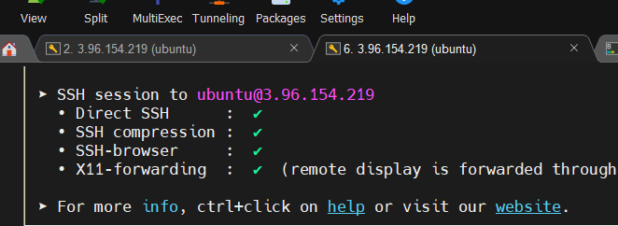

I run this in one window

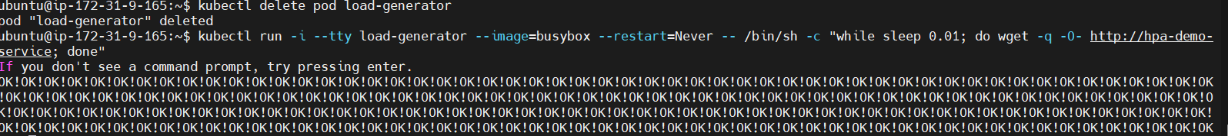

Second window I observe

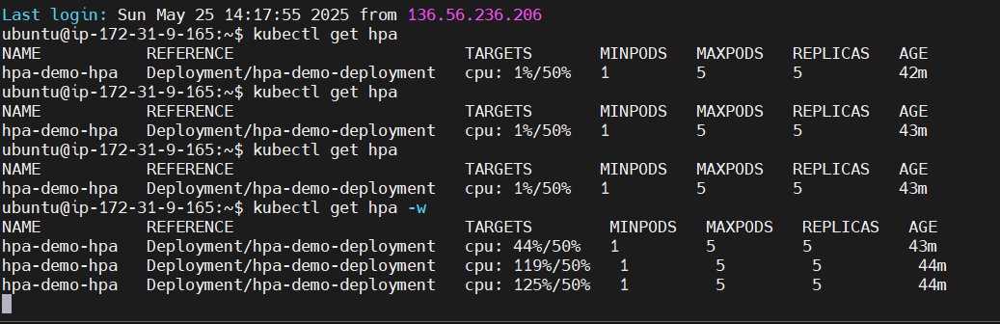

ubuntu@ip-172-31-9-165:~$ kubectl get hpa -w

NAME REFERENCE TARGETS MINPODS MAXPODS REPLICAS AGE

hpa-demo-hpa Deployment/hpa-demo-deployment cpu: 44%/50% 1 5 5 43m

hpa-demo-hpa Deployment/hpa-demo-deployment cpu: 119%/50% 1 5 5 44m

hpa-demo-hpa Deployment/hpa-demo-deployment cpu: 125%/50% 1 5 5 44m

As load increases, POD increases, reached max 5

ubuntu@ip-172-31-9-165:~$ kubectl get hpa -w

NAME REFERENCE TARGETS MINPODS MAXPODS REPLICAS AGE

hpa-demo-hpa Deployment/hpa-demo-deployment cpu: 44%/50% 1 5 5 43m

hpa-demo-hpa Deployment/hpa-demo-deployment cpu: 119%/50% 1 5 5 44m

hpa-demo-hpa Deployment/hpa-demo-deployment cpu: 125%/50% 1 5 5 44m

hpa-demo-hpa Deployment/hpa-demo-deployment cpu: 131%/50% 1 5 5 44m

I stopped the load balancer

ubuntu@ip-172-31-9-165:~$ kubectl get hpa -w

NAME REFERENCE TARGETS MINPODS MAXPODS REPLICAS AGE

hpa-demo-hpa Deployment/hpa-demo-deployment cpu: 44%/50% 1 5 5 43m

hpa-demo-hpa Deployment/hpa-demo-deployment cpu: 119%/50% 1 5 5 44m

hpa-demo-hpa Deployment/hpa-demo-deployment cpu: 125%/50% 1 5 5 44m

hpa-demo-hpa Deployment/hpa-demo-deployment cpu: 131%/50% 1 5 5 44m

hpa-demo-hpa Deployment/hpa-demo-deployment cpu: 123%/50% 1 5 5 45m

hpa-demo-hpa Deployment/hpa-demo-deployment cpu: 125%/50% 1 5 5 45m

hpa-demo-hpa Deployment/hpa-demo-deployment cpu: 53%/50% 1 5 5 45m

hpa-demo-hpa Deployment/hpa-demo-deployment cpu: 1%/50% 1 5 5 46m

Now the load has dropped

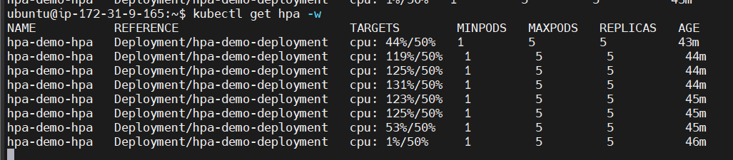

After sometime, replicas is scaled-down as well

ubuntu@ip-172-31-9-165:~$ kubectl get hpa

NAME REFERENCE TARGETS MINPODS MAXPODS REPLICAS AGE

hpa-demo-hpa Deployment/hpa-demo-deployment cpu: 1%/50% 1 5 1 52m



Container orchestration --> K8s introduction --> Advantages --> Architecture --> Architecture components --> K8s cluster setup --> K8s resources --> POD, Service (ClusterIP, NodePort & LoadBalancer) --> Namespace --> ReplicaSet --> Deployment --> Metrics-server --> HPA

Blue-Green deployment model -> strategy of application deployment

Assume that application is running on different PODs. We cannot access the Pods directly so we create a Service to expose them. Endusers are accessing our application through Service. Application is inside the Pods, and after 10 days there are major updates that we want to do. If my Endusers are using the same Pods, inside Pods, application will be there. If we are exposing the same old Pods, then Endusers are using only the same Old applications. Every application changes over time. I want to have new Pods, if new Pods need to work, then it is a Deployment process. Deployment takes time and there will be some downtime. If I delete my old pods and create new pods, by default application downtime will be there. What if you have some errors or issues in your latest Pods. Don’t you think it is a big business loss. That’s where the concept of Blue-Green deployment comes into picture. It is like an application-release model, it will help you to decrease the downtime. It will follow a strategy in a way that downtime will also be reduced and if there is new problem or issue with the new Pods, Endusers can rollback / go back to the Old Pods with minimal time. It will show you how to release your application with minimal downtime. It is decreasing the risks we face during application release

Pod2

Pod1

Pod4

Pod3

Service

Selector:

Color: Blue

End users

If I say Selector: Color: Blue, people are able to access it. Then I will create another deployment and I will label as Green. I have created new Pods and this is deployed recently. Now before I give access to Endusers to access the new Pods, I will expose only to our testing team with the Pre-Production Service. Pre-Prod service is accessing the application only for the testing purpose. Inside the new Service, I will give the Selector as Green. Even if there is issues after new pods are deployed, our Endusers are not getting affected. Our testing team is now ok with the new pods. Then I change Selector color of Blue to Green. This is not re-deployment, it is not taking much time. New pods are already created, up and running, so no downtime. Just trying to change the Service from Blue to Green it wont take much time. We could add a Router/Live service also that would re-direct Users to Blue or Green environment. If Green environment is stable then we rename as Blue then new Green environment will start.

Blue-Green deployment is an application release model, which decreases risk and minimizes downtime. It uses two production environments known as Blue and Green. Old version of the application is called as the Blue environment and new version is known as Green environment. Four Yaml files are required: Blue deployment, Green deployment, Live service, Pre-prod service

ubuntu@ip-172-31-9-165:~$ kubectl delete deployment metrics-server -n kube-system

deployment.apps "metrics-server" deleted

ubuntu@ip-172-31-9-165:~$ kubectl delete all --all

pod "hpa-demo-deployment-7577d65cb7-8tdh7" deleted

pod "load-generator" deleted

service "hpa-demo-service" deleted

service "kubernetes" deleted

deployment.apps "hpa-demo-deployment" deleted

horizontalpodautoscaler.autoscaling "hpa-demo-hpa" deleted

buntu@ip-172-31-9-165:~$ mkdir blue-green-model

ubuntu@ip-172-31-9-165:~$ cd blue-green-model/

ubuntu@ip-172-31-9-165:~/blue-green-model$ ls -l

total 0

ubuntu@ip-172-31-9-165:~/blue-green-model$ touch blue-deployment.yml

ubuntu@ip-172-31-9-165:~/blue-green-model$ touch live-service.yml

ubuntu@ip-172-31-9-165:~/blue-green-model$ touch green-deployment.yml

ubuntu@ip-172-31-9-165:~/blue-green-model$ touch pre-pod.yml

ubuntu@ip-172-31-9-165:~/blue-green-model$ cat blue-deployment.yml

---

apiVersion: apps/v1

kind: Deployment

metadata:

name: javawebbluedeploy

spec:

replicas: 2

strategy:

type: RollingUpdate

selector:

matchLabels:

app: java-web-app

version: v1

color: blue

template:

metadata:

labels:

app: java-web-app

version: v1

color: blue

spec:

containers:

- name: javawebappcontainer

image: hacker123shiva/springbt-in-docker:latest

imagePullPolicy: Always

ports:

- containerPort: 8080

...

ubuntu@ip-172-31-9-165:~/blue-green-model$ cat live-service.yml

---

apiVersion: v1

kind: Service

metadata:

name: javawebapplivesvc

spec:

type: LoadBalancer

selector:

app: java-web-app # Matches the app

color: blue # Sends traffic to the blue pods

ports:

- port: 80

targetPort: 8080

...

ubuntu@ip-172-31-9-165:~/blue-green-model$ kubectl apply -f blue-deployment.yml

deployment.apps/javawebbluedeploy created

ubuntu@ip-172-31-9-165:~/blue-green-model$ kubectl apply -f live-service.yml

service/javawebapplivesvc created

ubuntu@ip-172-31-9-165:~/blue-green-model$ kubectl get pods

NAME READY STATUS RESTARTS AGE

javawebbluedeploy-68fc6554d6-fftdv 1/1 Running 0 52s

javawebbluedeploy-68fc6554d6-sxgqg 1/1 Running 0 52s

ubuntu@ip-172-31-9-165:~/blue-green-model$ kubectl get svc

NAME TYPE CLUSTER-IP EXTERNAL-IP PORT(S) AGE

javawebapplivesvc LoadBalancer 10.100.87.253 ae0fc82729dfa40bd88bd26c491601b6-408506887.ca-central-1.elb.amazonaws.com 80:31359/TCP 60s

kubernetes ClusterIP 10.100.0.1 <none>

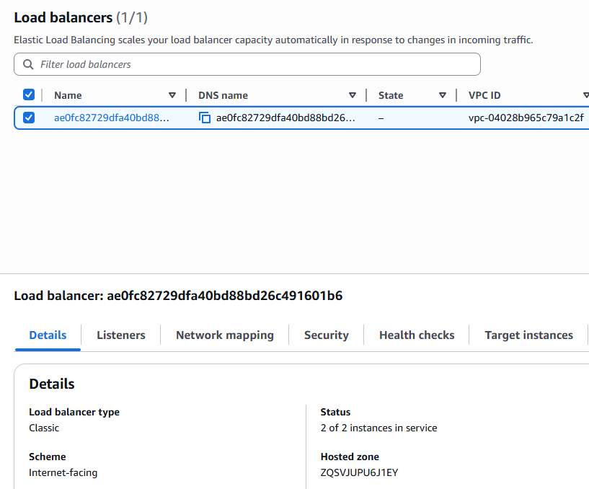

<http://ae0fc82729dfa40bd88bd26c491601b6-408506887.ca-central-1.elb.amazonaws.com/>

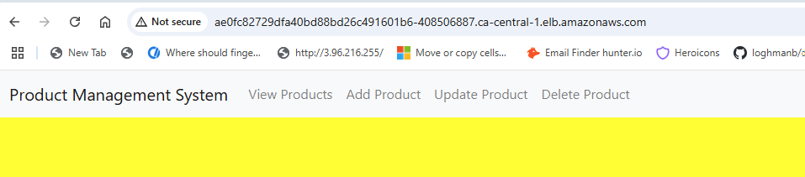

ubuntu@ip-172-31-9-165:~/blue-green-model$ cat green-deployment.yml

---

apiVersion: apps/v1

kind: Deployment

metadata:

name: javawebgreendeploy

spec:

replicas: 2

strategy:

type: RollingUpdate

selector:

matchLabels:

app: java-web-app

version: v2

color: green

template:

metadata:

labels:

app: java-web-app

version: v2

color: green

spec:

containers:

- name: javawebappcontainer

image: hacker123shiva/springbt-in-docker:latest

imagePullPolicy: Always

ports:

- containerPort: 8080

...

ubuntu@ip-172-31-9-165:~/blue-green-model$ cat pre-pod.yml

---

apiVersion: v1

kind: Service

metadata:

name: javaprepodsvc

spec:

type: NodePort

selector:

app: javawebapp

color: green

ports:

- port: 80

targetPort: 8080

protocol: TCP

nodePort: 31785 # Optional: remove this if you want auto-assign port

...

ubuntu@ip-172-31-9-165:~/blue-green-model$

ubuntu@ip-172-31-9-165:~/blue-green-model$ kubectl apply -f green-deployment.yml

deployment.apps/javawebgreendeploy created

ubuntu@ip-172-31-9-165:~/blue-green-model$ kubectl apply -f pre-pod.yml

service/javaprepodsvc created

ubuntu@ip-172-31-9-165:~/blue-green-model$ kubectl get pods

NAME READY STATUS RESTARTS AGE

javawebbluedeploy-68fc6554d6-fftdv 1/1 Running 0 14m

javawebbluedeploy-68fc6554d6-sxgqg 1/1 Running 0 14m

javawebgreendeploy-656f8cf5f4-cn7cb 1/1 Running 0 16s

javawebgreendeploy-656f8cf5f4-jblr5 1/1 Running 0 16s

ubuntu@ip-172-31-9-165:~/blue-green-model$ kubectl get svc

NAME TYPE CLUSTER-IP EXTERNAL-IP PORT(S) AGE

javaprepodsvc NodePort 10.100.227.153 <none> 80:31785/TCP 10s

javawebapplivesvc LoadBalancer 10.100.87.253 ae0fc82729dfa40bd88bd26c491601b6-408506887.ca-central-1.elb.amazonaws.com 80:31359/TCP 14m

kubernetes ClusterIP 10.100.0.1 <none> 443/TCP 28m

Still Blue pods are available for Endusers. Green pods are working in the background

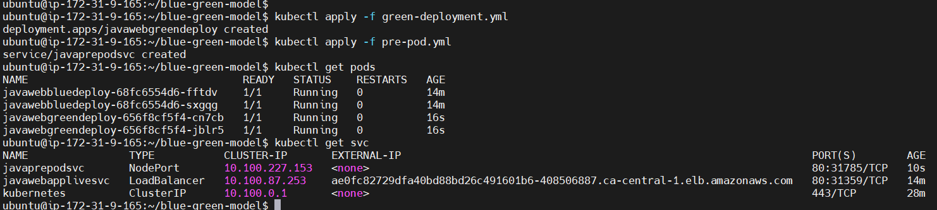

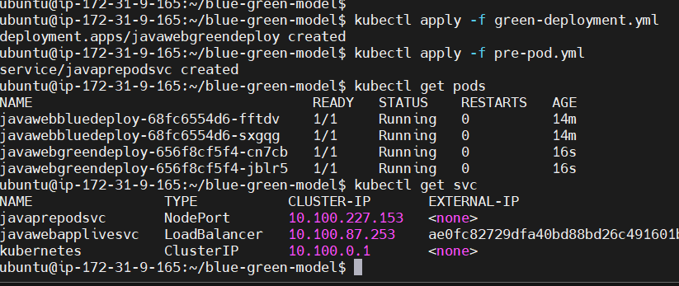

How do we access NodePort?

Which service file I got to make changes now so Green deployment goes live instead of Blue?

live-service.yml

ubuntu@ip-172-31-9-165:~/blue-green-model$ cat live-service.yml

---

apiVersion: v1

kind: Service

metadata:

name: javawebapplivesvc

spec:

type: LoadBalancer

selector:

app: java-web-app # Matches the app

# color: blue # Sends traffic to the blue pods

color: green

ports:

- port: 80

targetPort: 8080

...

ubuntu@ip-172-31-9-165:~/blue-green-model$ kubectl apply -f live-service.yml

service/javawebapplivesvc configured

Whatever seconds it takes to re-apply that’s the only downtime we have here

Updated Docker image in green deployment so we can see which application goes live

ubuntu@ip-172-31-9-165:~/blue-green-model$ cat green-deployment.yml

---

apiVersion: apps/v1

kind: Deployment

metadata:

name: javawebgreendeploy

spec:

replicas: 2

strategy:

type: RollingUpdate

selector:

matchLabels:

app: java-web-app

version: v2

color: green

template:

metadata:

labels:

app: java-web-app

version: v2

color: green

spec:

containers:

- name: javawebappcontainer

image: jmalloc/echo-server

imagePullPolicy: Always

ports:

- containerPort: 8080

...

ubuntu@ip-172-31-9-165:~/blue-green-model$ kubectl apply -f green-deployment.yml

deployment.apps/javawebgreendeploy configured

ubuntu@ip-172-31-9-165:~/blue-green-model$ kubectl apply -f live-service.yml

service/javawebapplivesvc unchanged

Again I go to the same LoadBalancer DNS

<http://ae0fc82729dfa40bd88bd26c491601b6-408506887.ca-central-1.elb.amazonaws.com/>

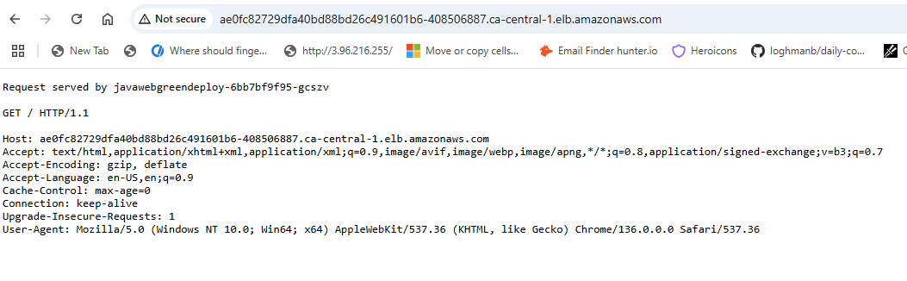

Going back to Blue

ubuntu@ip-172-31-9-165:~/blue-green-model$ cat live-service.yml

---

apiVersion: v1

kind: Service

metadata:

name: javawebapplivesvc

spec:

type: LoadBalancer

selector:

app: java-web-app # Matches the app

color: blue # Sends traffic to the blue pods

#color: green

ports:

- port: 80

targetPort: 8080

...

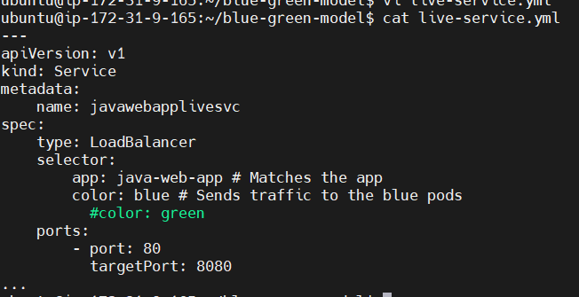

ubuntu@ip-172-31-9-165:~/blue-green-model$ kubectl apply -f live-service.yml

service/javawebapplivesvc configured

Now it switched back to the Old Blue environment

<http://ae0fc82729dfa40bd88bd26c491601b6-408506887.ca-central-1.elb.amazonaws.com/>

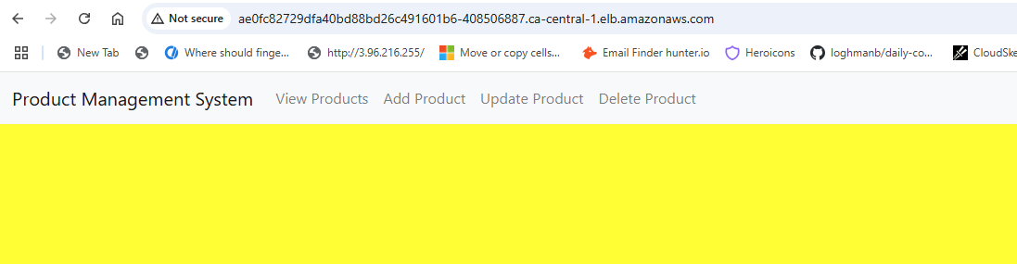

Delete cluster

eksctl delete cluster --name my-eks-cluster --region ca-central-1