Terraform part II:

terraform init

terraform fmt

terraform validate

terraform plan

terraform apply

terraform destroy

inputs.tf, main.tf, provider.tf, output.tf

=> Terraform modules:

Directory:

01-tf-project (one directory where we are creating is called as Module)

provider.tf

inputs.tf

main.tf

output.tf

Module is a set of Terraform configuration files in a single directory

In one directory, what are all Terraform configuration files are there is only called as Module

We specify in the ‘provider’, which resources to use

Whatever we want to see after the Terraform script is executed is displayed in the Output section

Multiple resources I want to write on the same cloud: S3, RDS, VPC, IAM --> All of them in main.tf itself

that’s why we create multiple child modules under one Module

How to write in a better way so it aligns with industry standards

Say we want to create one directory my-infra-app: root module

Within root only, I will create a file ‘provider.tf’

Next we create the modules --> example : Child module:1 EC2 (input.tf, main.tf, output.tf), Child module:2 S3 (input.tf, main.tf, output.tf) ,

In this, we are not writing all resources into one single file, we write in modules

In the root directory only, we create main.tf --> invoke the child modules

In the root, we have output.tf --> invoke modules of output variables

A Terraform module is a set of Terraform configuration files in a single directory

Any directory with one or more configuration files is called as “One module”

Single directory with one or more .tf files even for a simple configuration can be considered as a module

One root module can have any number of child modules in Terraform

Example: Inside one project or module, we can create multiple child modules EC2, S3, RDS, IAM as child modules

Note: We will run terraform commands from root module we will invoke child modules for execution

Terraform project setup with modules

Open Terraform VM

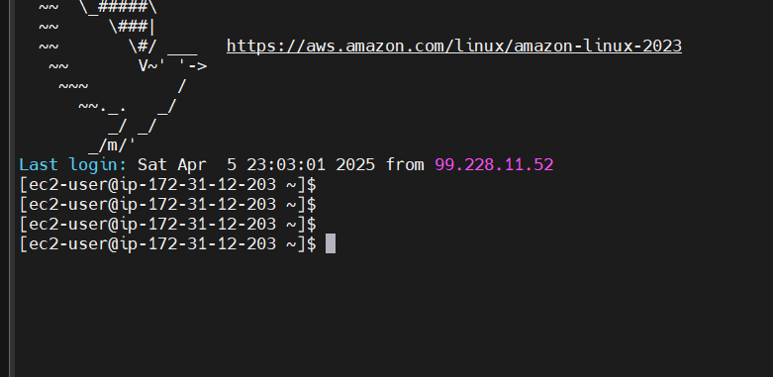

Create Modules folder

[ec2-user@ip-172-31-12-203 ~]$ mkdir 05-terraform-modules-project

[ec2-user@ip-172-31-12-203 ~]$ cd 05-terraform-modules-project/

[ec2-user@ip-172-31-12-203 05-terraform-modules-project]$ vi provider.tf

[ec2-user@ip-172-31-12-203 05-terraform-modules-project]$ mkdir modules

Two folders inside modules

[ec2-user@ip-172-31-12-203 modules]$

[ec2-user@ip-172-31-12-203 modules]$ ls -l

total 0

drwxr-xr-x. 2 ec2-user ec2-user 6 Apr 6 22:10 ec2

drwxr-xr-x. 2 ec2-user ec2-user 6 Apr 6 22:10 s3

[ec2-user@ip-172-31-12-203 modules]$ cd ec2

[ec2-user@ip-172-31-12-203 ec2]$ ls -l

total 0

[ec2-user@ip-172-31-12-203 ec2]$

[ec2-user@ip-172-31-12-203 ec2]$

[ec2-user@ip-172-31-12-203 ec2]$ touch inputs.tf

[ec2-user@ip-172-31-12-203 ec2]$ touch main.tf

[ec2-user@ip-172-31-12-203 ec2]$ touch outputs.tf

[ec2-user@ip-172-31-12-203 ec2]$

[ec2-user@ip-172-31-12-203 modules]$ cd ec2

[ec2-user@ip-172-31-12-203 ec2]$ ls -l

total 0

-rw-r--r--. 1 ec2-user ec2-user 0 Apr 6 22:26 inputs.tf

-rw-r--r--. 1 ec2-user ec2-user 0 Apr 6 22:26 main.tf

-rw-r--r--. 1 ec2-user ec2-user 0 Apr 6 22:26 outputs.tf

[ec2-user@ip-172-31-12-203 s3]$ ls -l

total 0

-rw-r--r--. 1 ec2-user ec2-user 0 Apr 6 22:28 inputs.tf

-rw-r--r--. 1 ec2-user ec2-user 0 Apr 6 22:28 main.tf

-rw-r--r--. 1 ec2-user ec2-user 0 Apr 6 22:28 outputs.tf

Same for S3 folder also

[ec2-user@ip-172-31-12-203 modules]$ cd s3

[ec2-user@ip-172-31-12-203 s3]$

[ec2-user@ip-172-31-12-203 s3]$

[ec2-user@ip-172-31-12-203 s3]$

[ec2-user@ip-172-31-12-203 s3]$ ls -l

total 0

-rw-r--r--. 1 ec2-user ec2-user 0 Apr 6 22:28 inputs.tf

-rw-r--r--. 1 ec2-user ec2-user 0 Apr 6 22:28 main.tf

-rw-r--r--. 1 ec2-user ec2-user 0 Apr 6 22:28 outputs.tf

Root directory:

[ec2-user@ip-172-31-12-203 05-terraform-modules-project]$ ls -l

total 4

drwxr-xr-x. 4 ec2-user ec2-user 27 Apr 6 22:10 modules

-rw-r--r--. 1 ec2-user ec2-user 254 Apr 6 22:07 provider.tf

We have modules folder and provider.tf file

[ec2-user@ip-172-31-12-203 05-terraform-modules-project]$ ls -l modules/

total 0

drwxr-xr-x. 2 ec2-user ec2-user 56 Apr 6 22:26 ec2

drwxr-xr-x. 2 ec2-user ec2-user 56 Apr 6 22:28 s3

[ec2-user@ip-172-31-12-203 ~]$ tree 05-terraform-modules-project/

05-terraform-modules-project/

├── modules

│   ├── ec2

│   │   ├── inputs.tf

│   │   ├── main.tf

│   │   └── outputs.tf

│   └── s3

│   ├── inputs.tf

│   ├── main.tf

│   └── outputs.tf

└── provider.tf

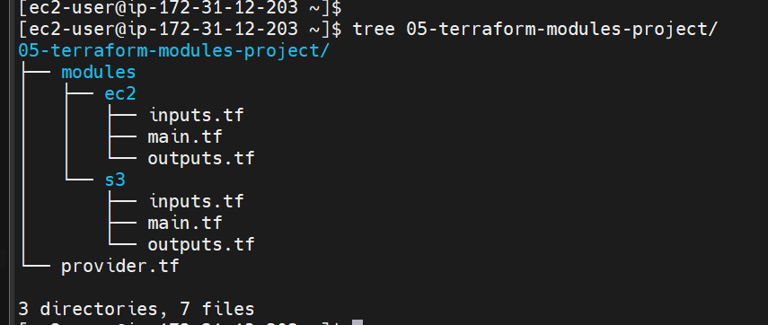

This is the structure

[ec2-user@ip-172-31-12-203 ~]$ tree 05-terraform-modules-project/

05-terraform-modules-project/

├── modules

│   ├── ec2

│   │   ├── inputs.tf

│   │   ├── main.tf

│   │   └── outputs.tf

│   └── s3

│   ├── inputs.tf

│   ├── main.tf

│   └── outputs.tf

└── provider.tf

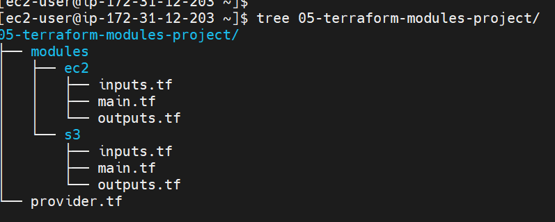

[ec2-user@ip-172-31-12-203 ~]$ ls -l

total 0

drwxr-xr-x. 4 ec2-user ec2-user 152 Apr 5 20:46 01-tf-script

drwxr-xr-x. 4 ec2-user ec2-user 186 Apr 5 22:45 01-tf-script-userdata

drwxr-xr-x. 3 ec2-user ec2-user 180 Apr 6 00:50 04-tf-script-var

drwxr-xr-x. 3 ec2-user ec2-user 40 Apr 6 22:08 05-terraform-modules-project

drwxr-xr-x. 3 ec2-user ec2-user 159 Apr 6 01:56 05-tf-script-var

-rw-r--r--. 1 ec2-user ec2-user 0 Apr 7 00:02 main.tf

[ec2-user@ip-172-31-12-203 05-terraform-modules-project]$ cat provider.tf

provider "aws" {

region = "ca-central-1" # or your preferred AWS region like us-east-1, etc.

# Optional if you have AWS credentials configured via CLI or environment variables

# access_key = "YOUR_ACCESS_KEY"

# secret_key = "YOUR_SECRET_KEY"

}

[ec2-user@ip-172-31-12-203 ec2]$ cat inputs.tf

variable "ami" {

description = "Amazon vm image value"

type = string

}

variable "instance_type" {

description = "Represents the type of instance"

default = "t2.micro"

}

[ec2-user@ip-172-31-12-203 ec2]$ cat main.tf

resource "aws_instance" "linux_vm" {

ami = var.ami

instance_type = var.instance_type

key_name = "DevOpsMar30"

security_groups = ["default"]

tags = {

Name = "modules-Linux-VM"

}

}

[ec2-user@ip-172-31-12-203 ec2]$ cat outputs.tf

output "ec2_vm_public_ip" {

value = aws_instance.linux_vm.public_ip

}

output "ec2_vm_private_ip" {

value = aws_instance.linux_vm.public_ip

}

Now we are going into S3

[ec2-user@ip-172-31-12-203 ec2]$ cd ..

[ec2-user@ip-172-31-12-203 modules]$ cd s3

[ec2-user@ip-172-31-12-203 s3]$ ls -l

total 0

-rw-r--r--. 1 ec2-user ec2-user 0 Apr 6 22:28 inputs.tf

-rw-r--r--. 1 ec2-user ec2-user 0 Apr 6 22:28 main.tf

-rw-r--r--. 1 ec2-user ec2-user 0 Apr 6 22:28 outputs.tf

[ec2-user@ip-172-31-12-203 s3]$

[ec2-user@ip-172-31-12-203 s3]$ cat main.tf

resource "aws_s3_bucket" "terraform_bucket" {

bucket = "terraform_bucket_test"

acl = "private"

}

[ec2-user@ip-172-31-12-203 s3]$

[ec2-user@ip-172-31-12-203 s3]$ cat main.tf

resource "aws_s3_bucket" "terraform_bucket" {

bucket = "terraform_bucket_test"

acl = "private"

}

[ec2-user@ip-172-31-12-203 s3]$ cat main.tf

resource "aws_s3_bucket" "terraform-bucket" {

bucket = "terraform_bucket_test"

acl = "private"

}

In root folder

[ec2-user@ip-172-31-12-203 05-terraform-modules-project]$ cat main.tf

module "my_ec2" {

source = "./modules/ec2"

ami = "ami-02cd5b9bfb2512340"

}

module "my_s3" {

source = "./modules/s3"

}

[ec2-user@ip-172-31-12-203 05-terraform-modules-project]$ cat outputs.tf

output "ec2_vm_public_ip" {

value = module.my_ec2.public_ip

}

output "ec2_vm_private_ip" {

value = module.my_ec2.private_ip

}

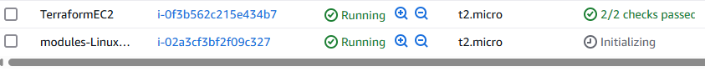

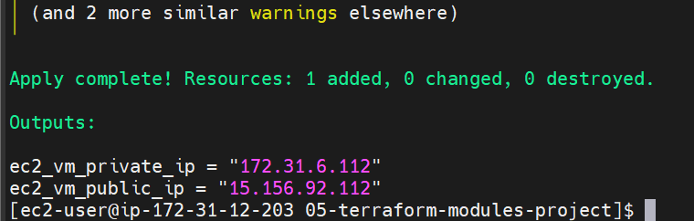

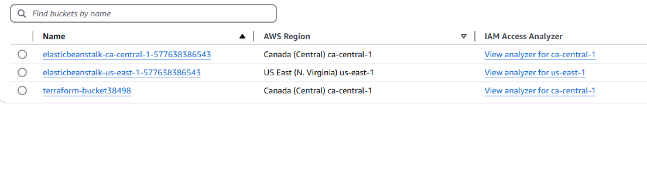

Now it shows the bucket also

