Tomcat server:

It is free and open-source sofware, which is developed by Apache organization

Tomcat server is developed using Java language. Hence, to run Tomcat, Java also has to be installed

Tomcat supports multiple operating system

By default, Tomcat runs on 8080 port number (if needed we can change the port number of Tomcat)

[ec2-user@ip-172-31-5-77 ~]$ sudo yum install maven

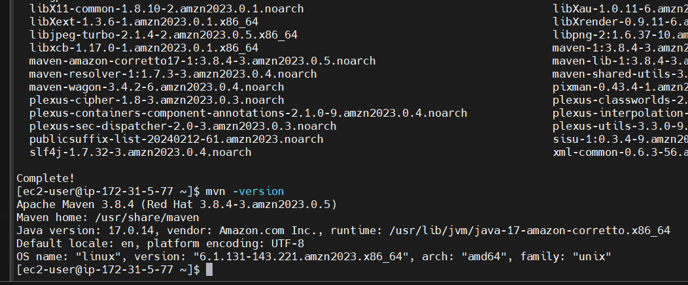

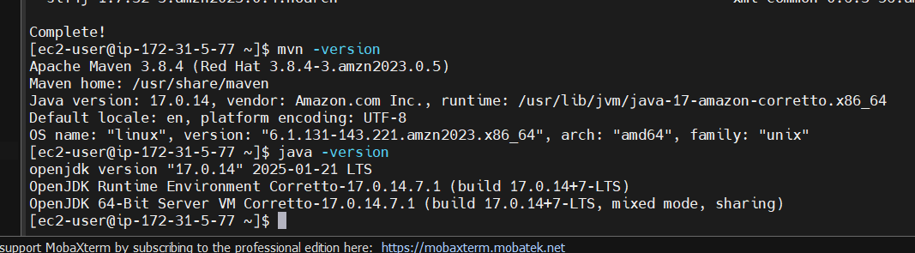

For Tomcat: <https://tomcat.apache.org/>

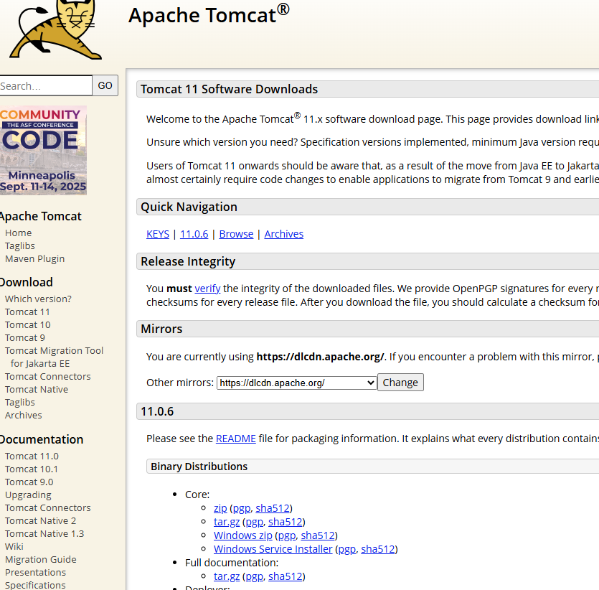

Right click --> Copy link to address on tar.gz link

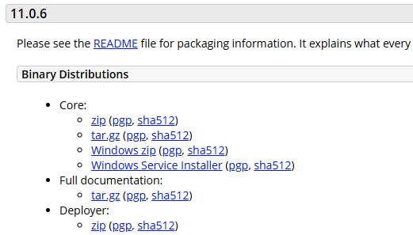

<https://dlcdn.apache.org/tomcat/tomcat-11/v11.0.6/bin/apache-tomcat-11.0.6.tar.gz>

wget https://dlcdn.apache.org/tomcat/tomcat-11/v11.0.6/bin/apache-tomcat-11.0.6.tar.gz

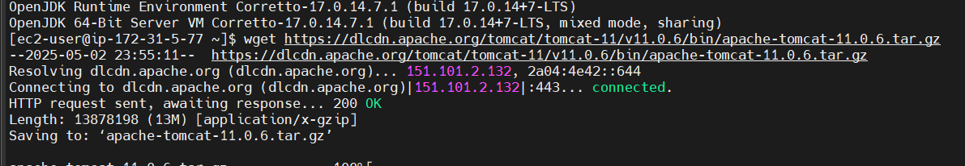

You can see it is downloaded

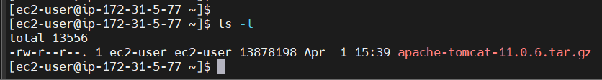

[ec2-user@ip-172-31-5-77 ~]$ tar -xvf apache-tomcat-11.0.6.tar.gz

[ec2-user@ip-172-31-5-77 ~]$ sudo yum install tree

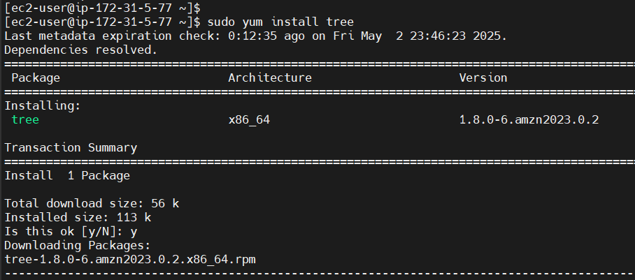

[ec2-user@ip-172-31-5-77 ~]$ tree apache-tomcat-11.0.6

Within Tomcat

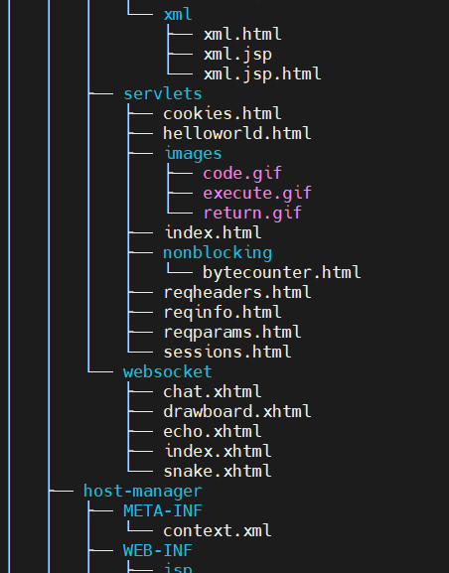

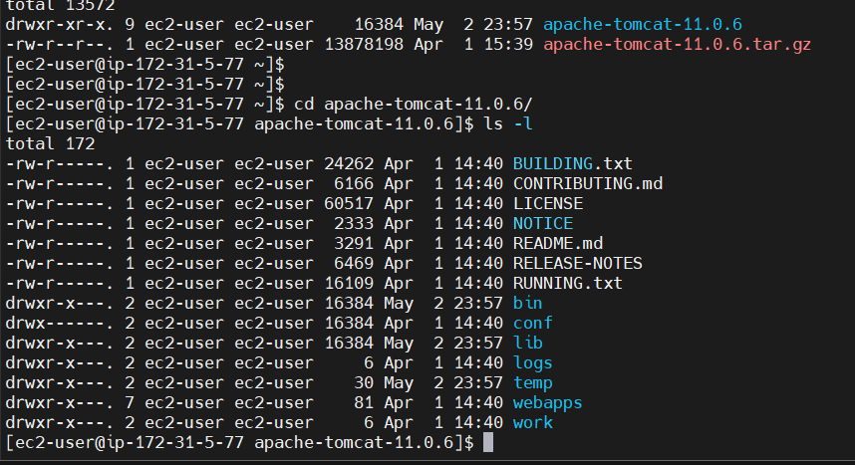

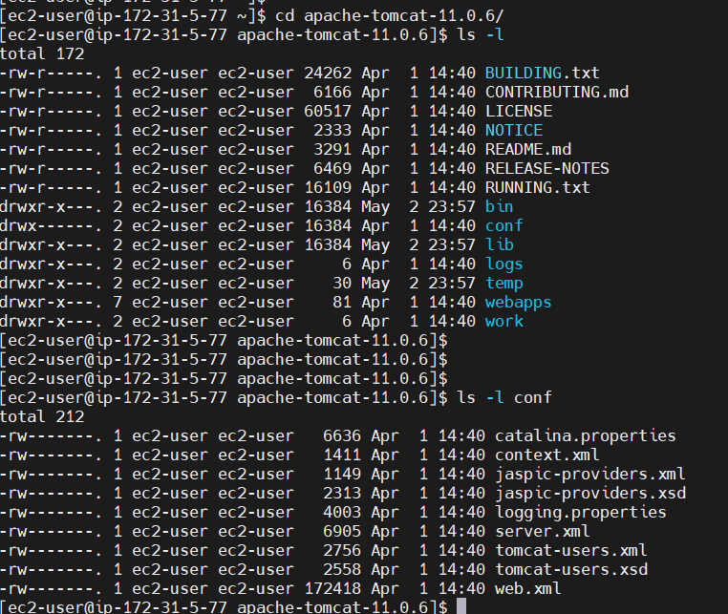

[ec2-user@ip-172-31-5-77 apache-tomcat-11.0.6]$ sh startup.sh

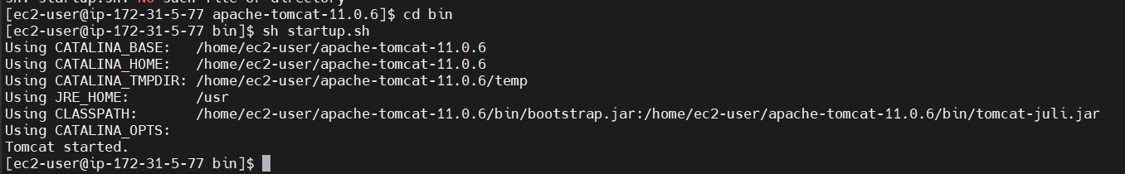

Tomcat has started

chatGPT prompt: create a new maven web application project

Run this command from cd~ home directory

mvn archetype:generate -DgroupId=com.example.webapp \

-DartifactId=my-webapp \

-DarchetypeArtifactId=maven-archetype-webapp \

-DarchetypeVersion=1.4 \

-DinteractiveMode=false

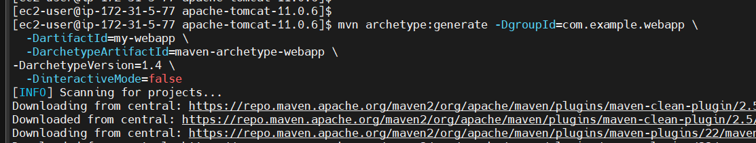

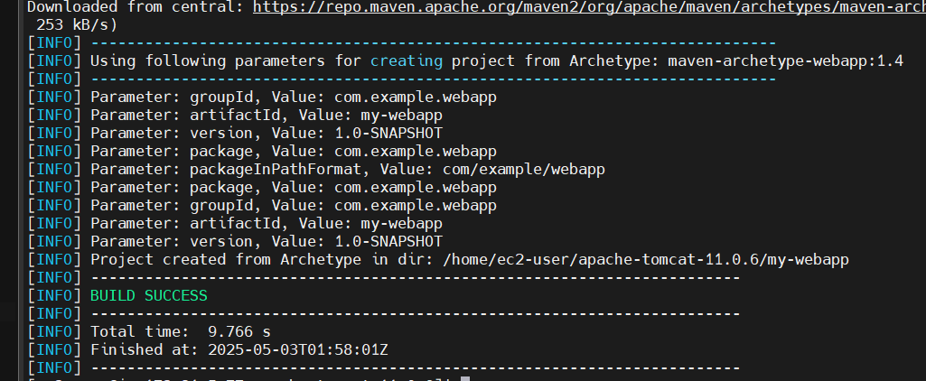

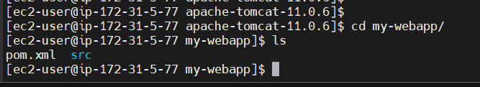

cd my-webapp then run mvn clean package

[ec2-user@ip-172-31-5-77 my-webapp]$ mvn clean package

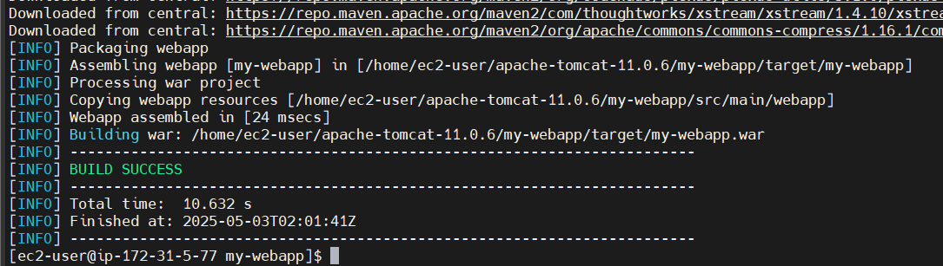

[ec2-user@ip-172-31-5-77 my-webapp]$ ls -l target

total 4

drwxr-xr-x. 2 ec2-user ec2-user 28 May 3 02:01 maven-archiver

drwxr-xr-x. 4 ec2-user ec2-user 54 May 3 02:01 my-webapp

-rw-r--r--. 1 ec2-user ec2-user 2085 May 3 02:01 my-webapp.war

[ec2-user@ip-172-31-5-77 my-webapp]$ cd ~

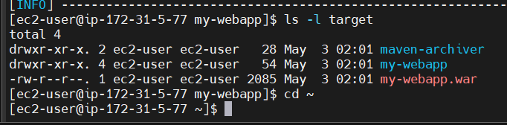

Copy war file from my-webapp into Tomcat webapps folder

[ec2-user@ip-172-31-5-77 ~]$ cp my-web-app/target/my-web-app.war apache-tomcat-11.0.6/webapps/

[ec2-user@ip-172-31-5-77 my-webapp]$ ls -l

total 4

-rw-r--r--. 1 ec2-user ec2-user 2208 May 3 02:15 pom.xml

drwxr-xr-x. 3 ec2-user ec2-user 18 May 3 02:15 src

drwxr-xr-x. 4 ec2-user ec2-user 66 May 3 02:16 target

[ec2-user@ip-172-31-5-77 my-webapp]$ ls -l target/

total 4

drwxr-xr-x. 2 ec2-user ec2-user 28 May 3 02:16 maven-archiver

drwxr-xr-x. 4 ec2-user ec2-user 54 May 3 02:16 my-webapp

-rw-r--r--. 1 ec2-user ec2-user 2085 May 3 02:16 my-webapp.war

Deploy your application into Tomcat so copy war file into Tomcat webapps

[ec2-user@ip-172-31-5-77 ~]$ cp my-webapp/target/my-webapp.war apache-tomcat-11.0.6/webapps/

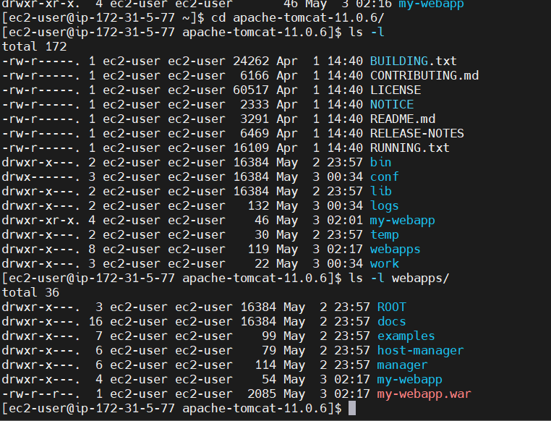

Add Custom TCP 8080

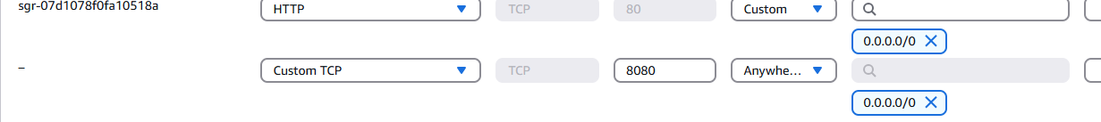

Open the public IP

<http://3.99.219.118:8080/>

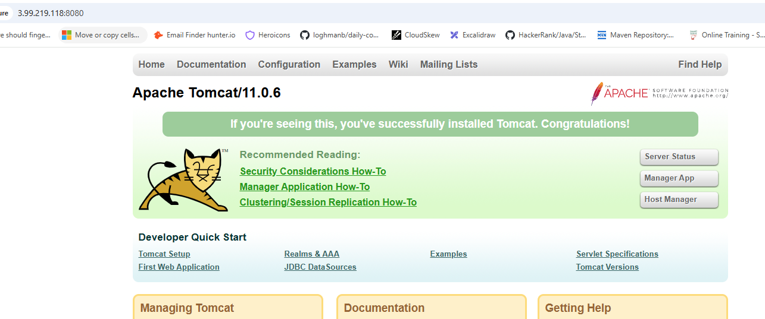

Our application name is: my-webapp

<http://3.99.219.118:8080/my-webapp/>

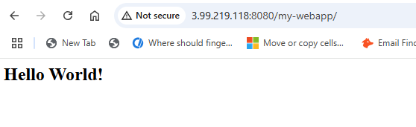

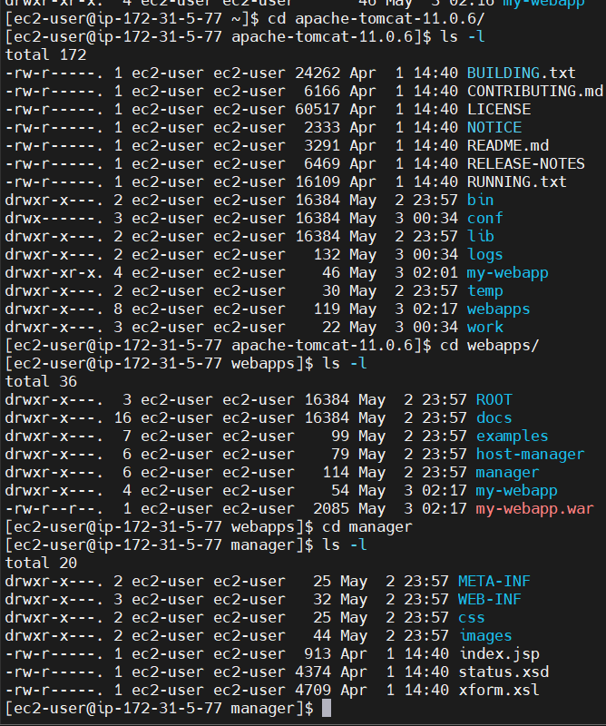

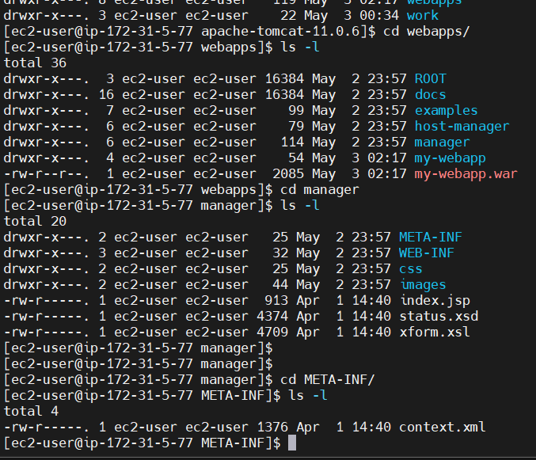

-rw-r-----. 1 ec2-user ec2-user 1376 Apr 1 14:40 context.xml

[ec2-user@ip-172-31-5-77 META-INF]$ vi context.xml

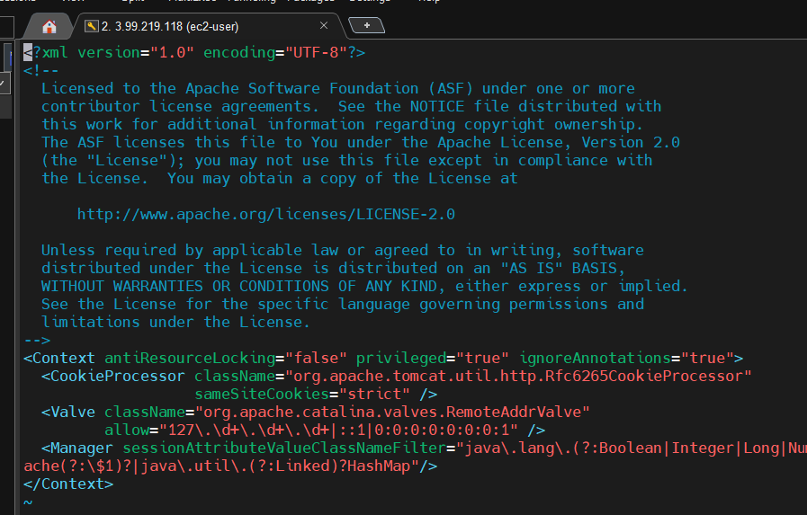

Change allow

allow=".\*" />

I am doing everything to access Tomcat from Windows machine but currently Tomcat is on Linux machine

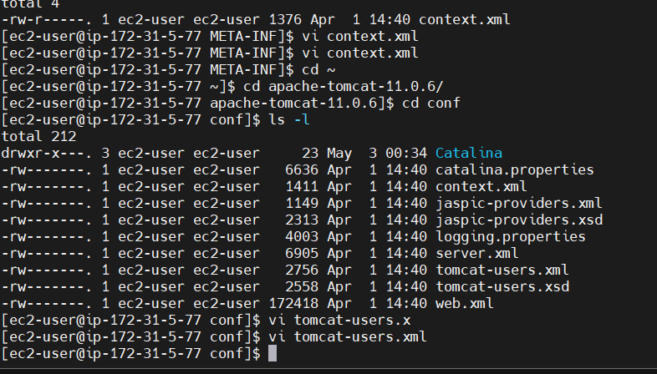

Add two rolenames

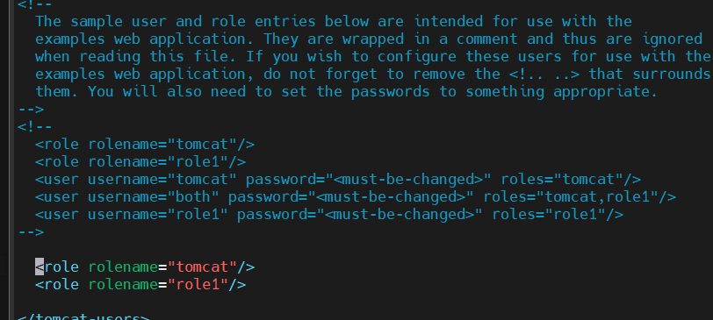

Add new users

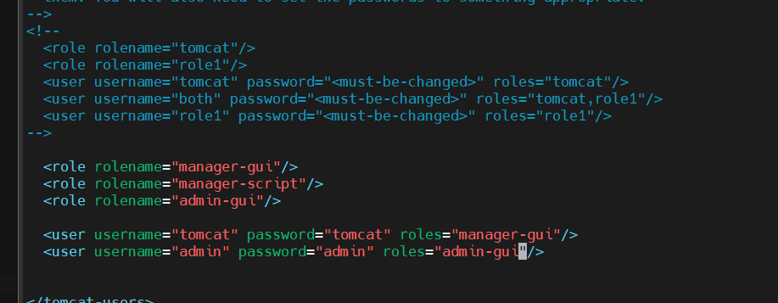

I am doing everything to access Tomcat from Windows machine but currently Tomcat is on Linux machine

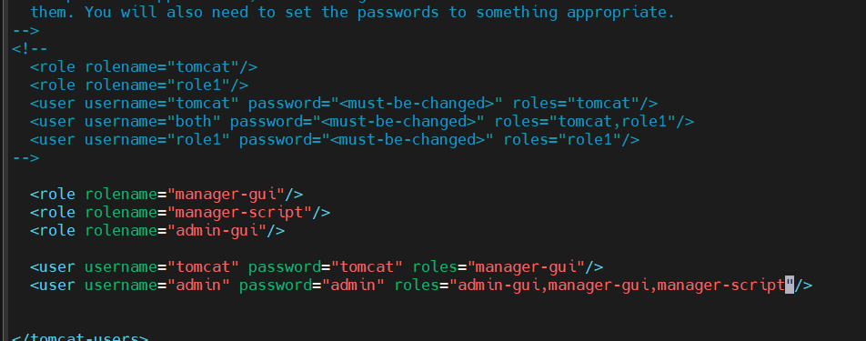

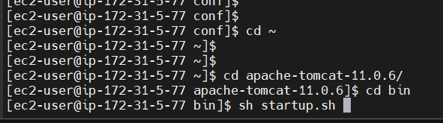

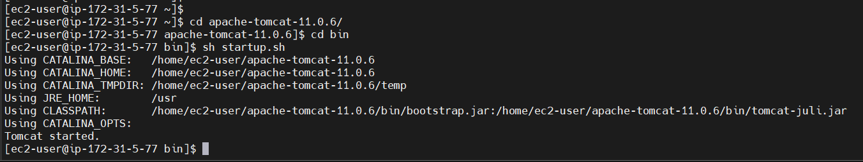

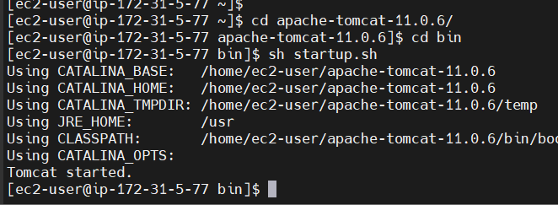

Public IP: http://3.99.219.118:8080/manager/html

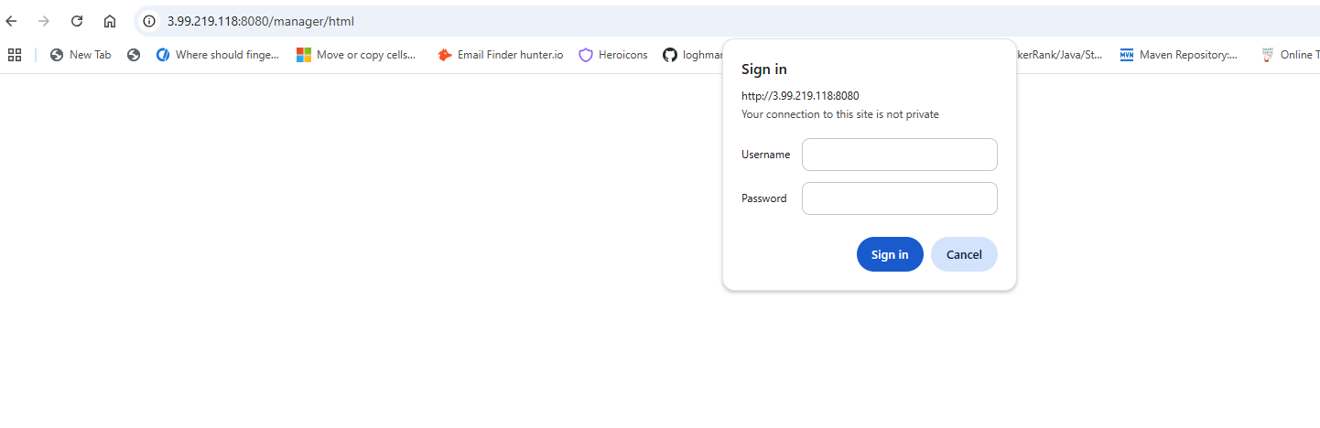

Enter user and password

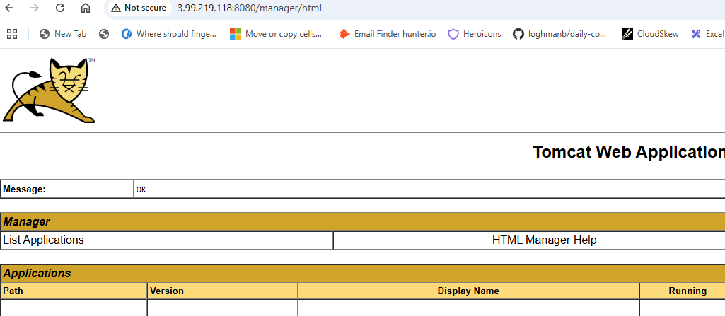

Click on WAR file then Deploy

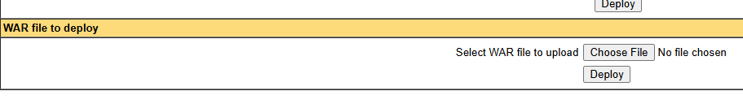

Inside conf folder

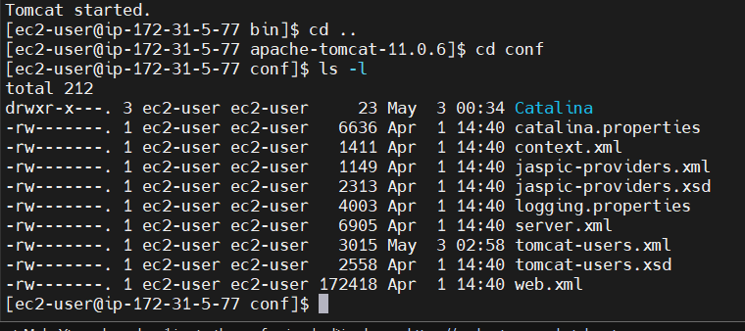

[ec2-user@ip-172-31-5-77 conf]$ vi server.xml

Change to port 8484

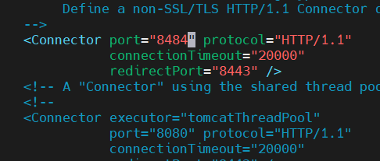

[ec2-user@ip-172-31-5-77 bin]$ sh shutdown.sh

[ec2-user@ip-172-31-5-77 bin]$ sh startup.sh

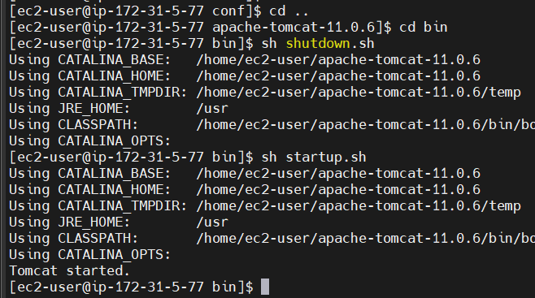

<http://3.99.219.118:8484/>

See now it is running on 8484

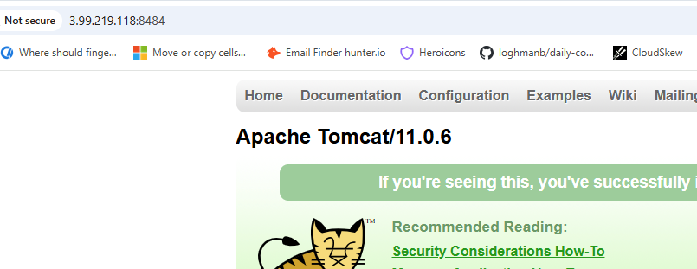

<http://3.99.219.118:8484/manager/html>

