AWS Lambda deployment

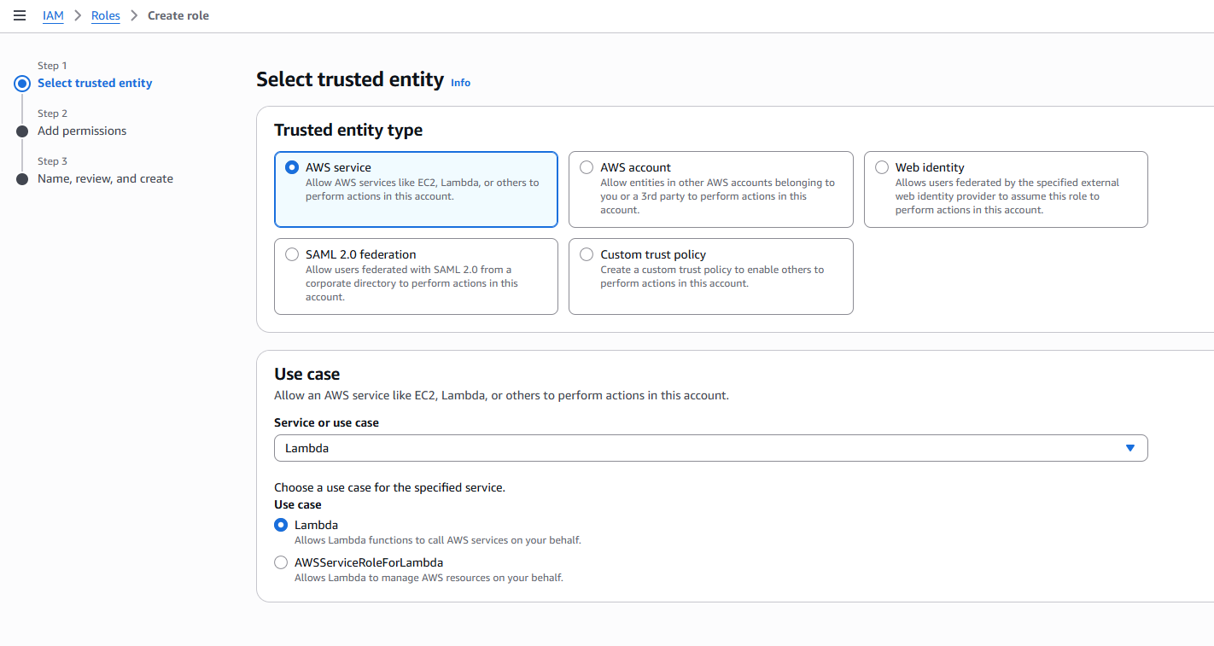

AWSLambdaBasicExecutionRole

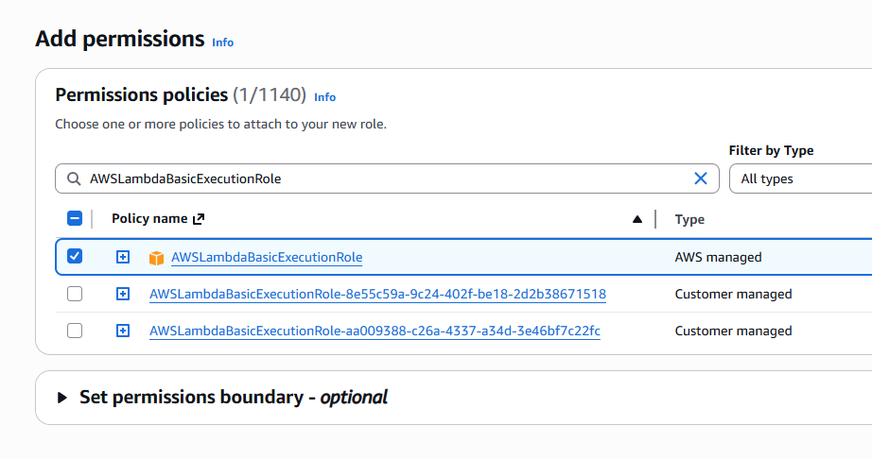

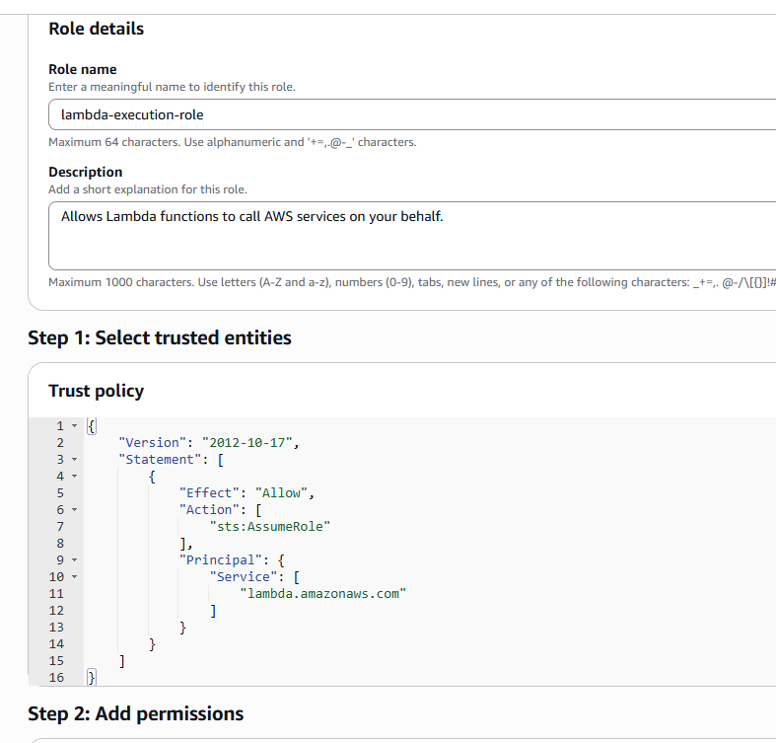

{
"Version": "2012-10-17",
"Statement": [
{
"Effect": "Allow",
"Action": [
"sts:AssumeRole"
],
"Principal": {
"Service": [
"lambda.amazonaws.com"
]
}
}
]
}
Copy role ARN and save for auto-deployment

Create Lambda

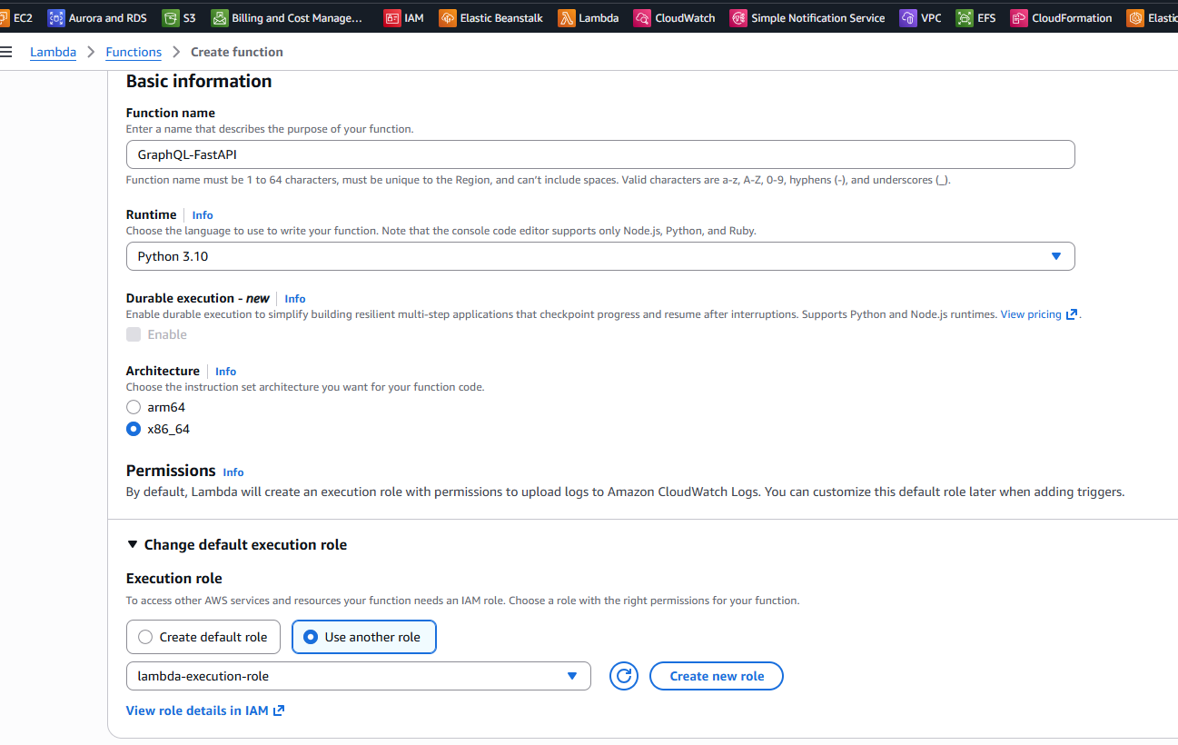
Assign IAM role we just created and Create Function
Upload file

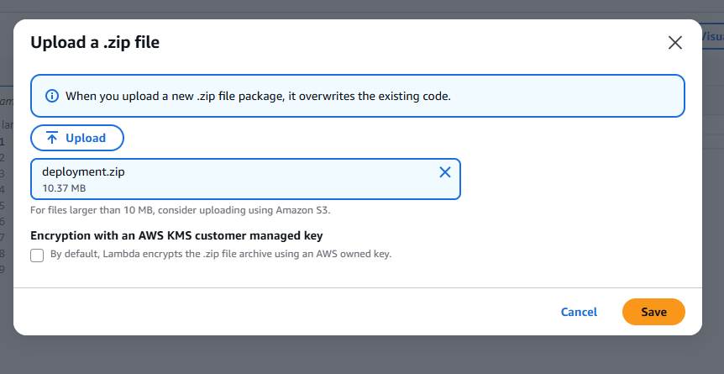

Runtime settings
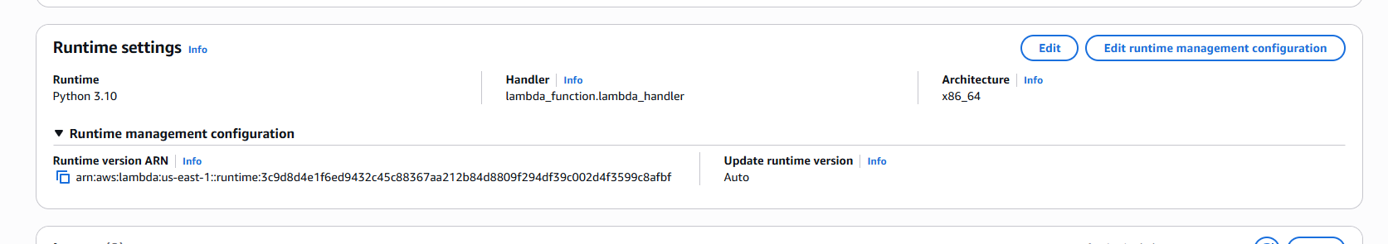

Edit => main.handler

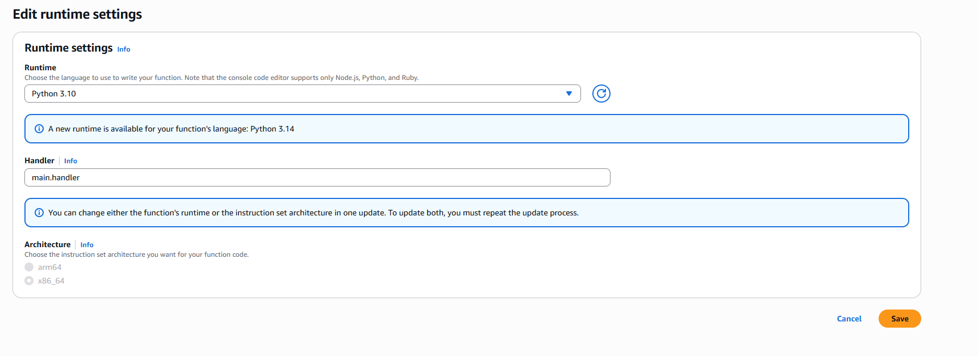

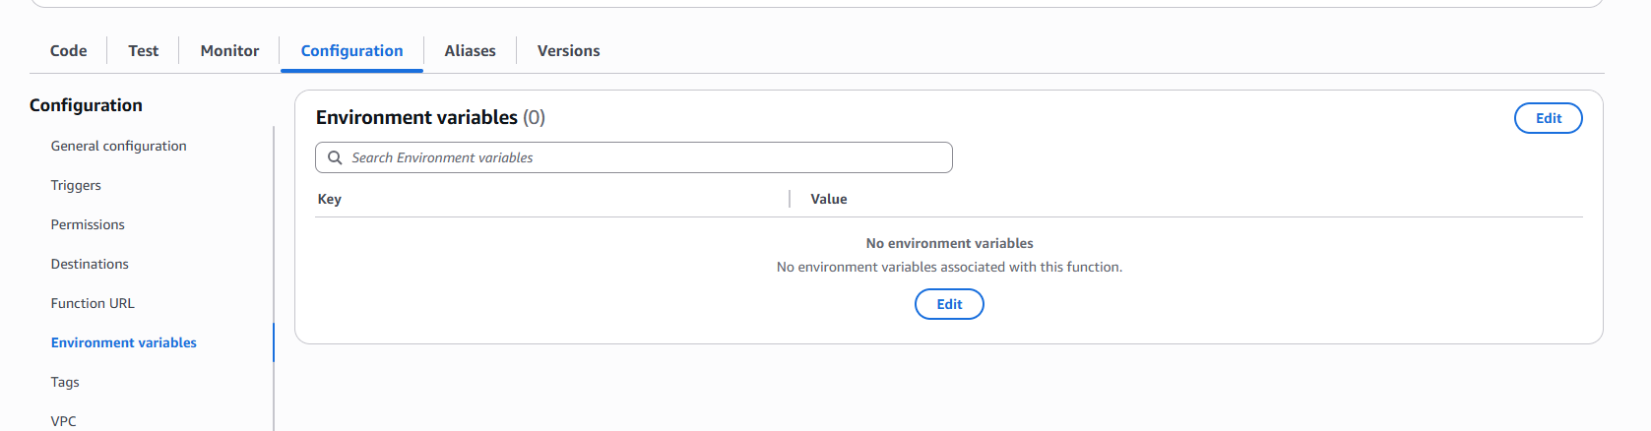

Add Environment variables: MONGODB_URI:
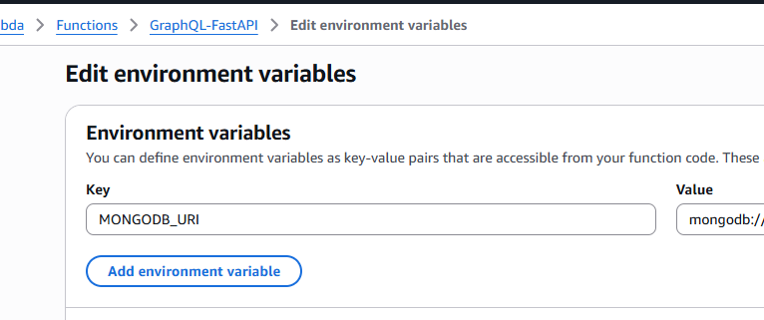
Save

Configuration => General configuration => Timeout 30 sec
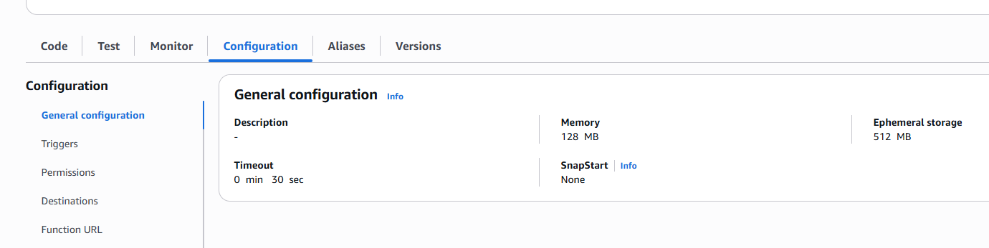

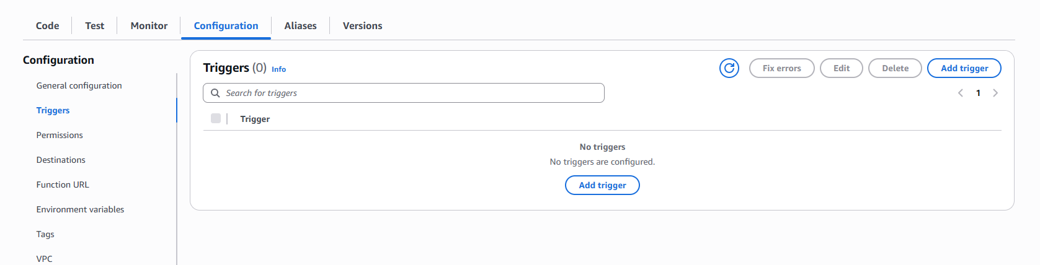

Add trigger
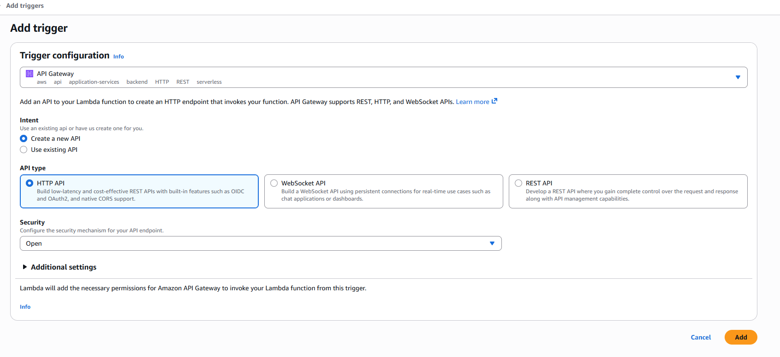
This is the GraphQL URL
https://m6nolf37md.execute-api.us-east-1.amazonaws.com/default/GraphQL-FastAPI

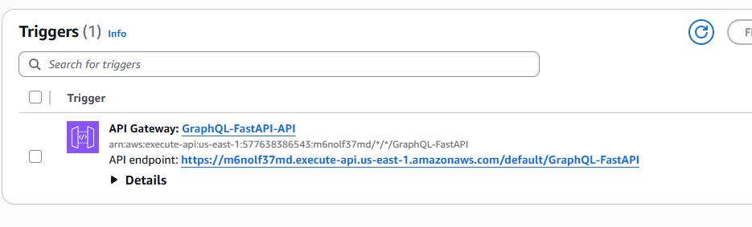

Go to Test page

{
"version": "1.0",
"httpMethod": "GET",
"path": "/GraphQL-FastAPI/graphql",
"headers": {},
"queryStringParameters": null,
"body": null,
"isBase64Encoded": false,
"requestContext": { "stage": "default" }
}

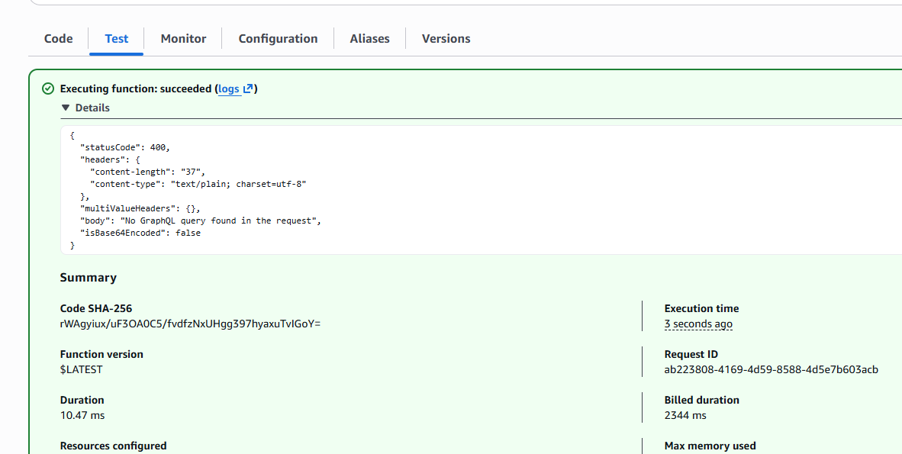

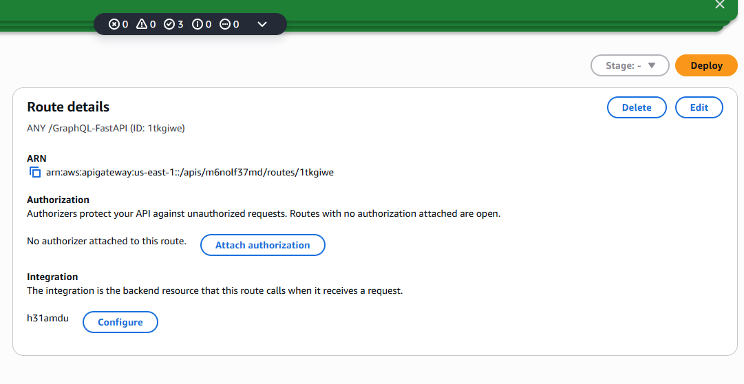
Click Deploy

Make sure we include 0.0.0.0/0 in MongoDB Network access
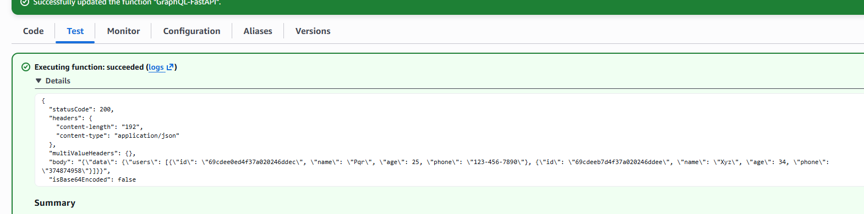
{
"version": "1.0",
"httpMethod": "POST",
"path": "/GraphQL-FastAPI/graphql",
"headers": {
"content-type": "application/json"
},
"queryStringParameters": null,
"body": "{\"query\": \"{ users { id name age phone } }\"}",
"isBase64Encoded": false,
"requestContext": {
"stage": "default",
"identity": { "sourceIp": "127.0.0.1" }
}
}

Deployed on Lambda
https://m6nolf37md.execute-api.us-east-1.amazonaws.com/default/GraphQL-FastAPI/graphql?q=query%20Ex%20%7B%0A%20%20users%20%7B%0A%20%20%20%20name%0A%20%20%20%20age%0A%20%20%20%20phone%0A%20%20%7D%0A%7D

https://m6nolf37md.execute-api.us-east-1.amazonaws.com/default/GraphQL-FastAPI/graphql

