https://fastapi.tiangolo.com/how-to/graphql/

We will use Strawberry: https://strawberry.rocks/docs/integrations/fastapi

uvicorn main:app –reload
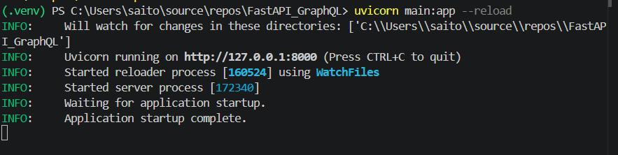

Open: localhost:8000/graphql

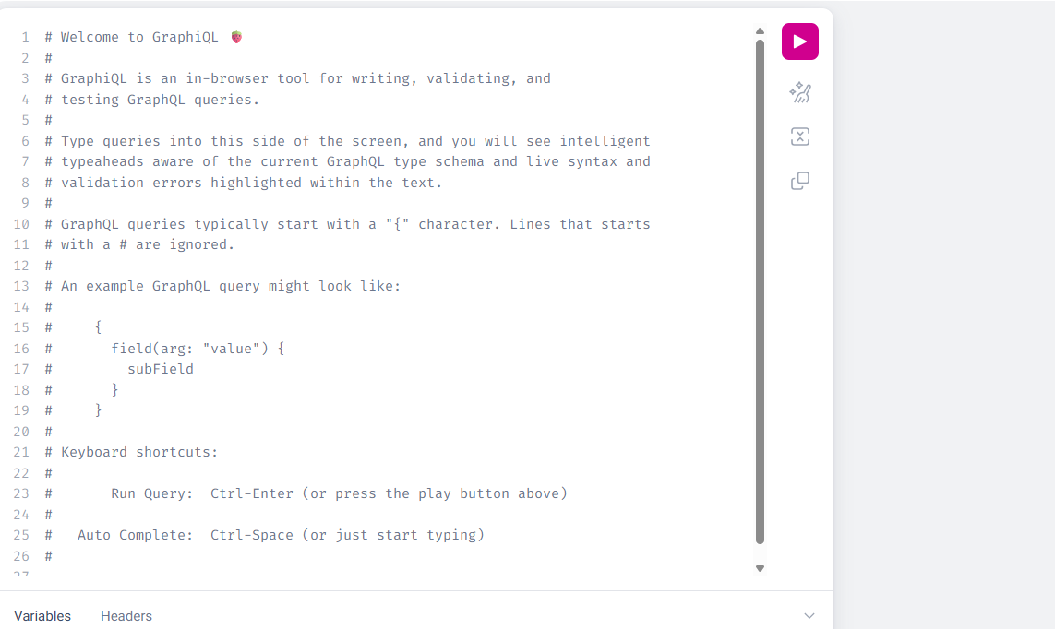

query Ex {
users {
name
age
phone
}
}

mutation MutEx{
createUser(name: "Abc", age: 33, phone: "237837434"){
name
}
}

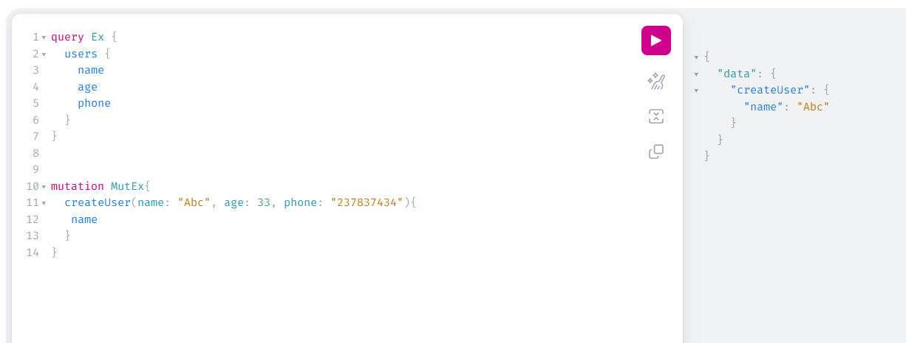

Also created in MongoDB

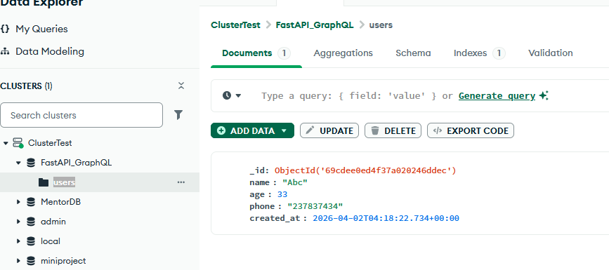
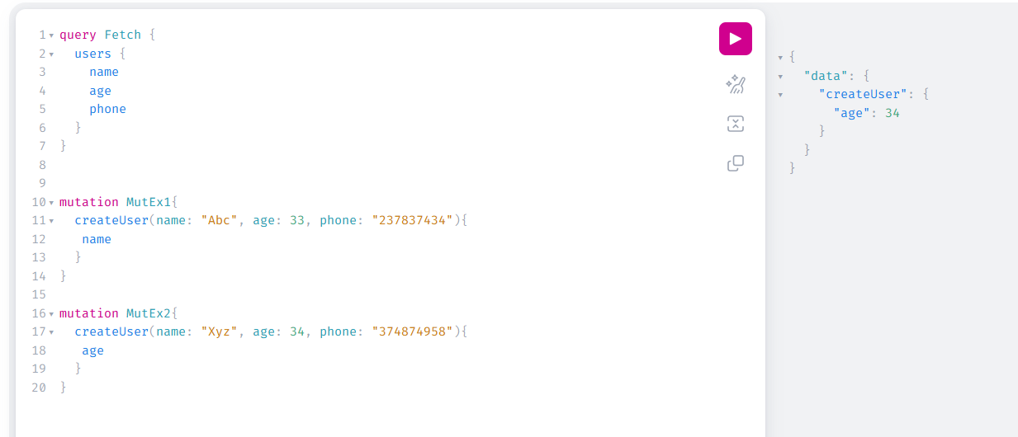

query Fetch {
users {
name
age
phone
}
}

mutation MutEx1{
createUser(name: "Abc", age: 33, phone: "237837434"){
name
}
}

mutation MutEx2{
createUser(name: "Xyz", age: 34, phone: "374874958"){
age
}
}

mutation mutEx3{
updateUser(_id: 69cdee0ed4f37a020246ddec, name: "Pqr", age: 25, phone: "123-456-7890") {
id
name
age
phone
}
}

New
query Fetch {
users {
name
age
phone
}
}

mutation MutEx1{
createUser(name: "Abc", age: 33, phone: "237837434"){
name
}
}

mutation MutEx2{
createUser(name: "Xyz", age: 34, phone: "374874958"){
age
}
}

mutation mutEx3{
updateUser(id: "69cdee0ed4f37a020246ddec", name: "Pqr", age: 25, phone: "123-456-7890") {
id
name
age
phone
}
}

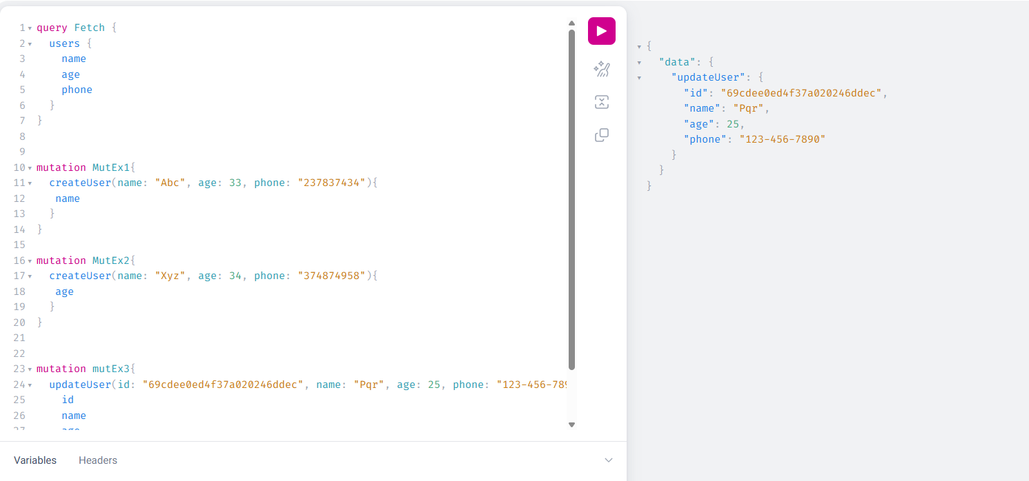

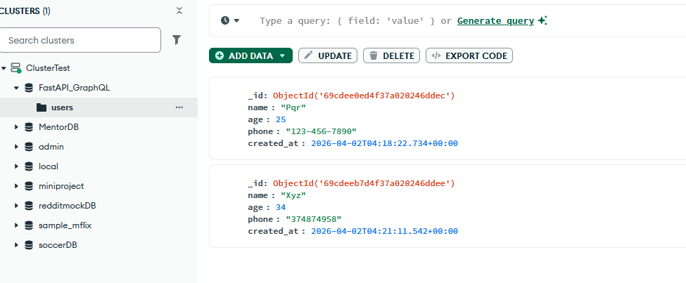

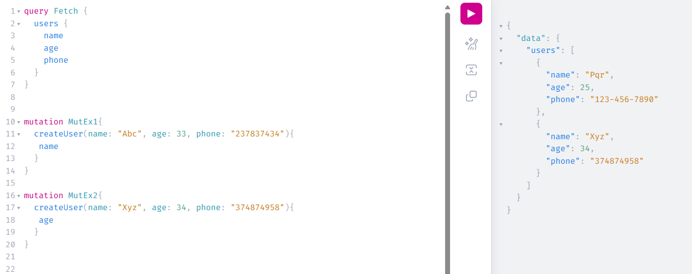

query Fetch {
users {
name
age
phone
}
}

query FetchOne {
user (id: "69cdeeb7d4f37a020246ddee"){
name
age
phone
}
}

mutation MutEx1{
createUser(name: "Abc", age: 33, phone: "237837434"){
name
}
}

mutation MutEx2{
createUser(name: "Xyz", age: 34, phone: "374874958"){
age
}
}

mutation mutEx3{
updateUser(id: "69cdee0ed4f37a020246ddec", name: "Pqr", age: 25, phone: "123-456-7890") {
id
name
age
phone
}
}

