Kafka Setup

https://kafka.apache.org/quickstart/

Download: https://www.apache.org/dyn/closer.cgi?path=/kafka/4.2.0/kafka_2.13-4.2.0.tgz
Extract and rename folders to Kafka
if possible remove the second Kafka folder and move contents to the first folder

Open Powershell go to the Kafka directory

$KAFKA_CLUSTER_ID = .\bin\windows\kafka-storage.bat random-uuid

Write-Output $KAFKA_CLUSTER_ID
f8CoHH7JSqCsDZkkTxMqTQ

.\bin\windows\kafka-storage.bat format --standalone -t $KAFKA_CLUSTER_ID -c .\config\server.properties

Works: bin\windows\kafka-storage.bat format -t YmcxyIfbTJChinnxqMf34w -c config\server.properties

In case of error:
2026-05-26T19:08:29.261447Z main ERROR Reconfiguration failed: No configuration found for '764c12b6' at 'null' in 'null'
Log directory /tmp/kraft-combined-logs is already formatted. Use --ignore-formatted to ignore this directory and format the others.

Delete /tmp/kraft-combined-logs folder

PS C:\Users\saito\Downloads\kafka> bin\windows\kafka-storage.bat format -t YmcxyIfbTJChinnxqMf34w -c config\server.properties
2026-05-26T19:10:58.468210600Z main ERROR Reconfiguration failed: No configuration found for '764c12b6' at 'null' in 'null'
Bootstrap metadata: BootstrapMetadata(records=[ApiMessageAndVersion(FeatureLevelRecord(name='metadata.version', featureLevel=29) at version 0), ApiMessageAndVersion(FeatureLevelRecord(name='eligible.leader.replicas.version', featureLevel=1) at version 0), ApiMessageAndVersion(FeatureLevelRecord(name='group.version', featureLevel=1) at version 0), ApiMessageAndVersion(FeatureLevelRecord(name='share.version', featureLevel=1) at version 0), ApiMessageAndVersion(FeatureLevelRecord(name='streams.version', featureLevel=1) at version 0), ApiMessageAndVersion(FeatureLevelRecord(name='transaction.version', featureLevel=2) at version 0)], metadataVersionLevel=29, source=format command)
Formatting metadata directory /tmp/kraft-combined-logs with metadata.version 4.2-IV1.

Works! bin\windows\kafka-server-start.bat config\server.properties
bin\windows\kafka-topics.bat --list --bootstrap-server localhost:9092 from CMD works!

I ran in Powershell
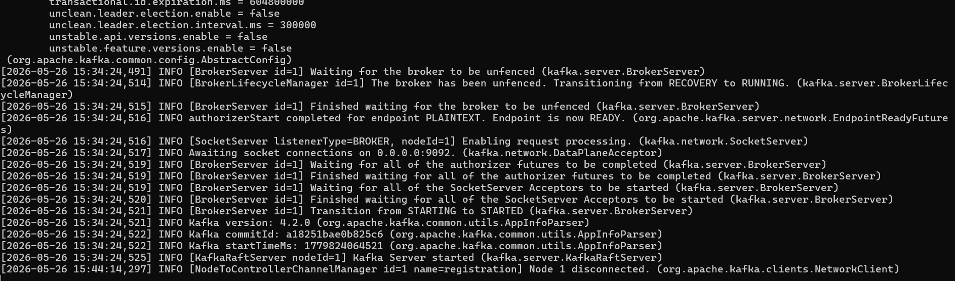

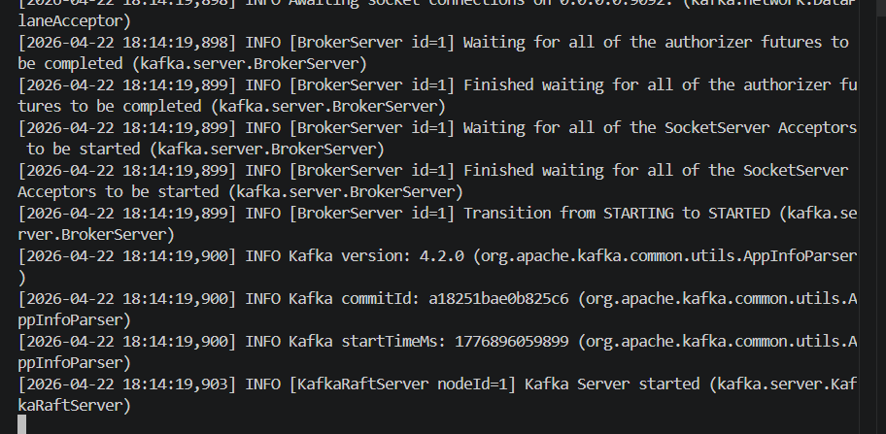

In case of errors: create config/log4j2.properties file

$content = @"
status = error
name = KafkaConfig
packages = org.apache.kafka

appender.console.type = Console
appender.console.name = STDOUT
appender.console.layout.type = PatternLayout
appender.console.layout.pattern = [%-5level] %d{yyyy-MM-dd HH:mm:ss.SSS} [%t] %c{1} - %msg%n

rootLogger.level = INFO
rootLogger.appenderRefs = stdout
rootLogger.appenderRef.stdout.ref = STDOUT

logger.kafka.name = kafka
logger.kafka.level = INFO
logger.kafka.appenderRefs = stdout
logger.kafka.appenderRef.stdout.ref = STDOUT

logger.zookeeper.name = org.apache.zookeeper
logger.zookeeper.level = ERROR
logger.zookeeper.appenderRefs = stdout
logger.zookeeper.appenderRef.stdout.ref = STDOUT

logger.kafka.authorizer.name = kafka.authorizer
logger.kafka.authorizer.level = INFO
logger.kafka.authorizer.appenderRefs = stdout
logger.kafka.authorizer.appenderRef.stdout.ref = STDOUT

logger.kafka.log4j.name = kafka.log4j
logger.kafka.log4j.level = INFO
logger.kafka.log4j.appenderRefs = stdout
logger.kafka.log4j.appenderRef.stdout.ref = STDOUT

logger.kafka.request.name = kafka.request
logger.kafka.request.level = WARN
logger.kafka.request.appenderRefs = stdout
logger.kafka.request.appenderRef.stdout.ref = STDOUT

logger.jetty.name = org.eclipse.jetty
logger.jetty.level = INFO
logger.jetty.appenderRefs = stdout
logger.jetty.appenderRef.stdout.ref = STDOUT

logger.state.change.name = state.change
logger.state.change.level = INFO
logger.state.change.appenderRefs = stdout
logger.state.change.appenderRef.stdout.ref = STDOUT
"@

Set-Content -Path "config\log4j2.properties" -Value $content -Encoding UTF8

Similarly, modify server.properties
Add the 2 lines

node.id=1
controller.quorum.voters=1@localhost:9093

Create topic
bin\windows\kafka-topics.bat --create --topic payment-events --bootstrap-server localhost:9092 --partitions 1 --replication-factor 1

PS C:\Users\saito\Downloads\kafka> bin\windows\kafka-topics.bat --create --topic payment-events --bootstrap-server localhost:9092 --partitions 1 --replication-factor 1
2026-05-26T21:44:33.691418200Z main ERROR Reconfiguration failed: No configuration found for '764c12b6' at 'null' in 'null'
Created topic payment-events.

PS C:\Users\saito\Downloads\kafka> bin\windows\kafka-topics.bat --list --bootstrap-server localhost:9092
2026-05-26T21:45:06.685733100Z main ERROR Reconfiguration failed: No configuration found for '764c12b6' at 'null' in 'null'
payment-events

Powershell

Invoke-WebRequest -Uri "http://localhost:8080/payments/send" -Method POST
or
curl.exe -X POST http://localhost:8080/payments/send

From Powershell
Consumer shows on the Console Log
