SpringBoot Service tests:
Unit tests
This is same as Java “Junit” tests
Go to src/test/java => create a package “service”

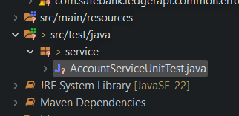

Create a file AccountServiceUnitTest.java

Right-click the Test file and run Junit

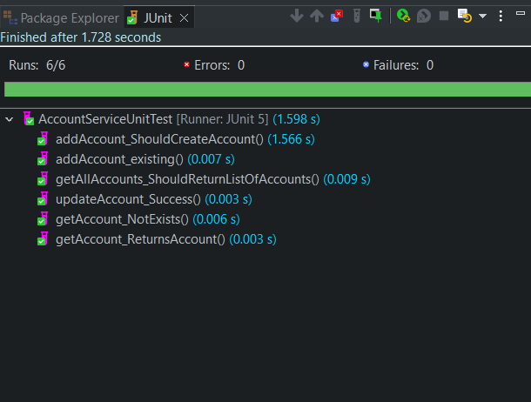

Integration tests:

Setup => go to src/test/java => create a new package “resources”. Copy the .sql files into this folder from /bin
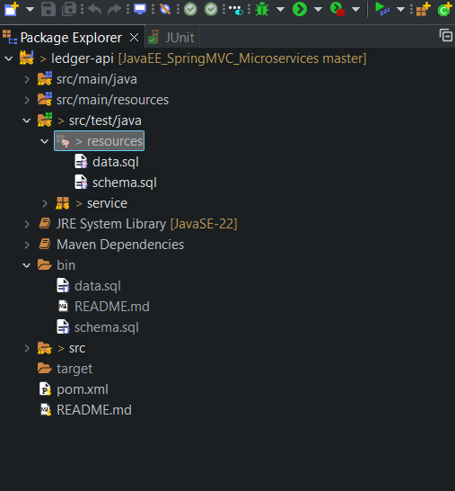

Go to pom.xml and add a new dependency => note “scope” is “test”

<dependency>
<groupId>com.h2database</groupId>
<artifactId>h2</artifactId>
<scope>test</scope>
</dependency>

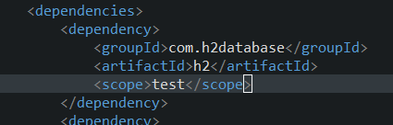

Re-run the application

Create a new Java class => AccountServiceIntegrationTests.java

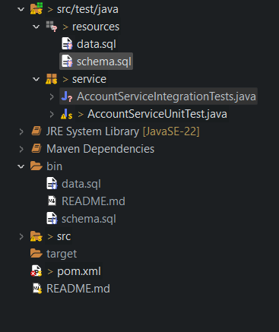

required for SpringBoot tests
// instead of mocking, we will use the Embedded database H2, and we are running the actual seed .sql scripts on H2
@SpringBootTest(classes = com.safebank.ledgerapi.LedgerApiApplication.class)
@ActiveProfiles("test")
//@AutoConfigureTestDatabase(replace=Replace.ANY)
public class AccountServiceIntegrationTests {

# Force Spring Boot to run your schema.sql and data.sql scripts
spring.sql.init.mode=always

# Tell Hibernate to let your manual schema.sql script build the tables
spring.jpa.hibernate.ddl-auto=none

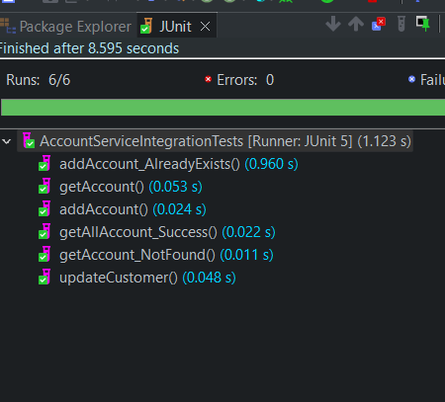

Web Integration tests:

under ledger-api/src/test/java , create new package: “web.controllers”

MockMvc mockMVC; // creates a pseudo-dispatcher servlet, which allows us to test the method as though it were running in its own servlet container

