AWS Toolkit setup in Vscode

Install AWS Toolkit extension
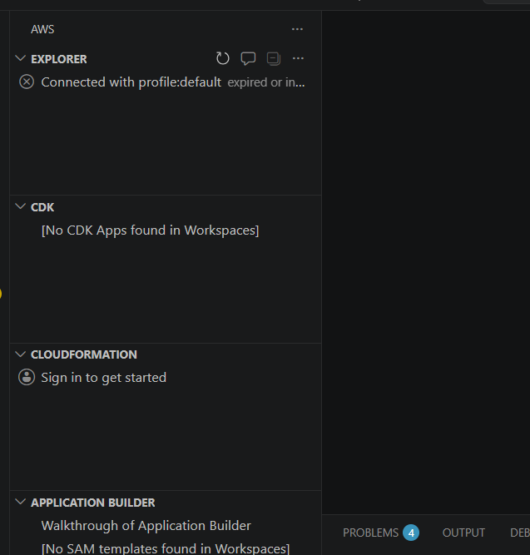

Explorer => Add new connection

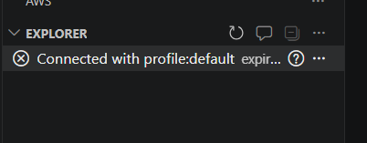

We will use IAM credentials

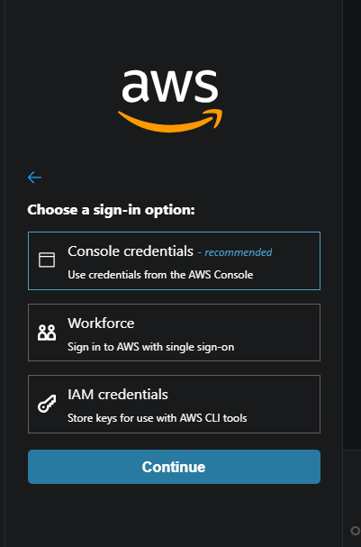

Go to AWS console ==> IAM ==> Create User group
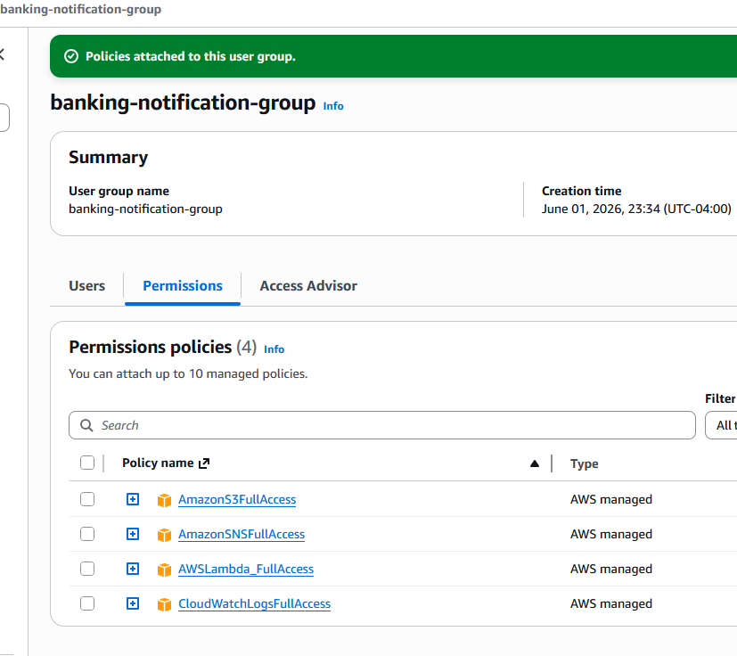
We need these 4 accesses for this project

Create IAM User and add to the banking-notication-group

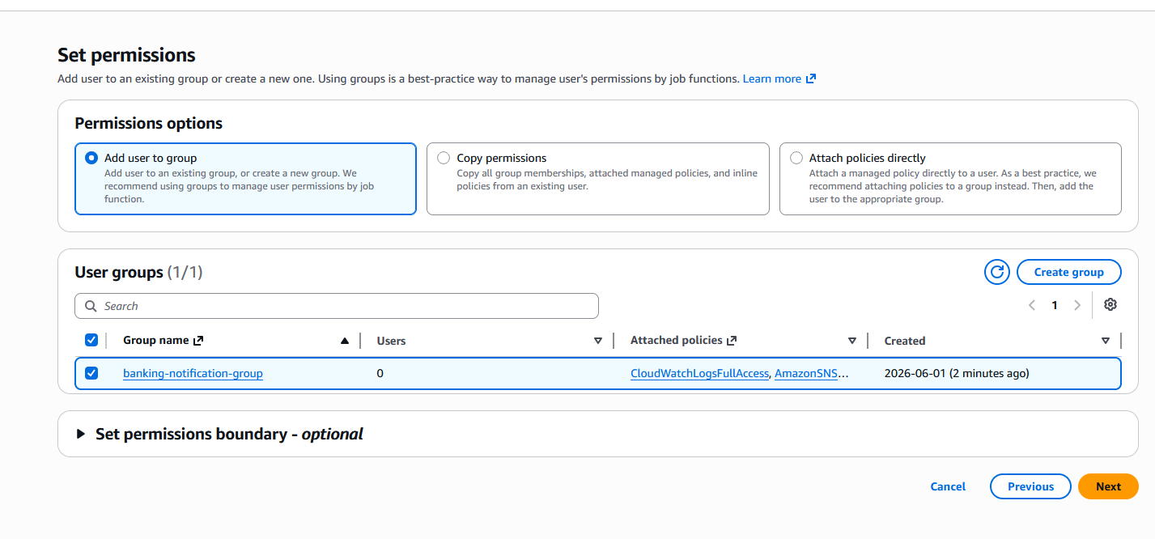

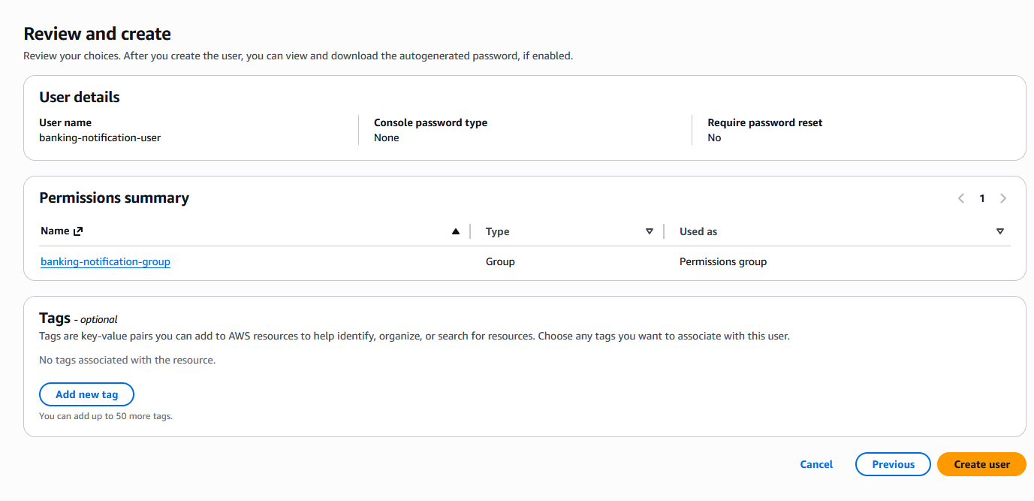
Create User

Go to View user ==> Security credentials

Access keys ==> Create access key

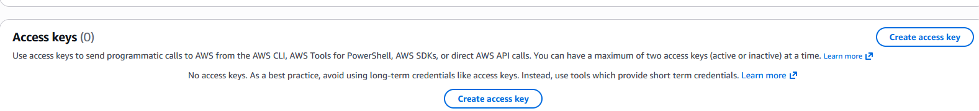
Enter Access key and Secret key in Vscode AWS Toolkit to finish the connection

