Docker Setup

docker build -t user-service ./ecommerce
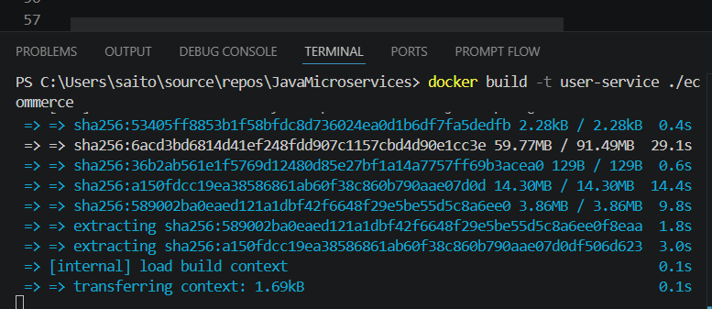
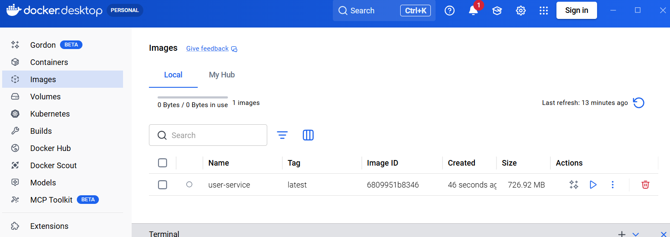

docker run -p 8080:8080 --name User-Service user-service

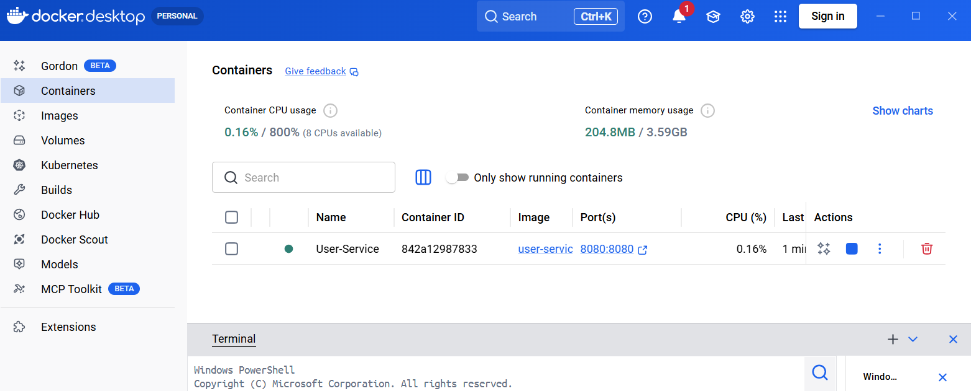

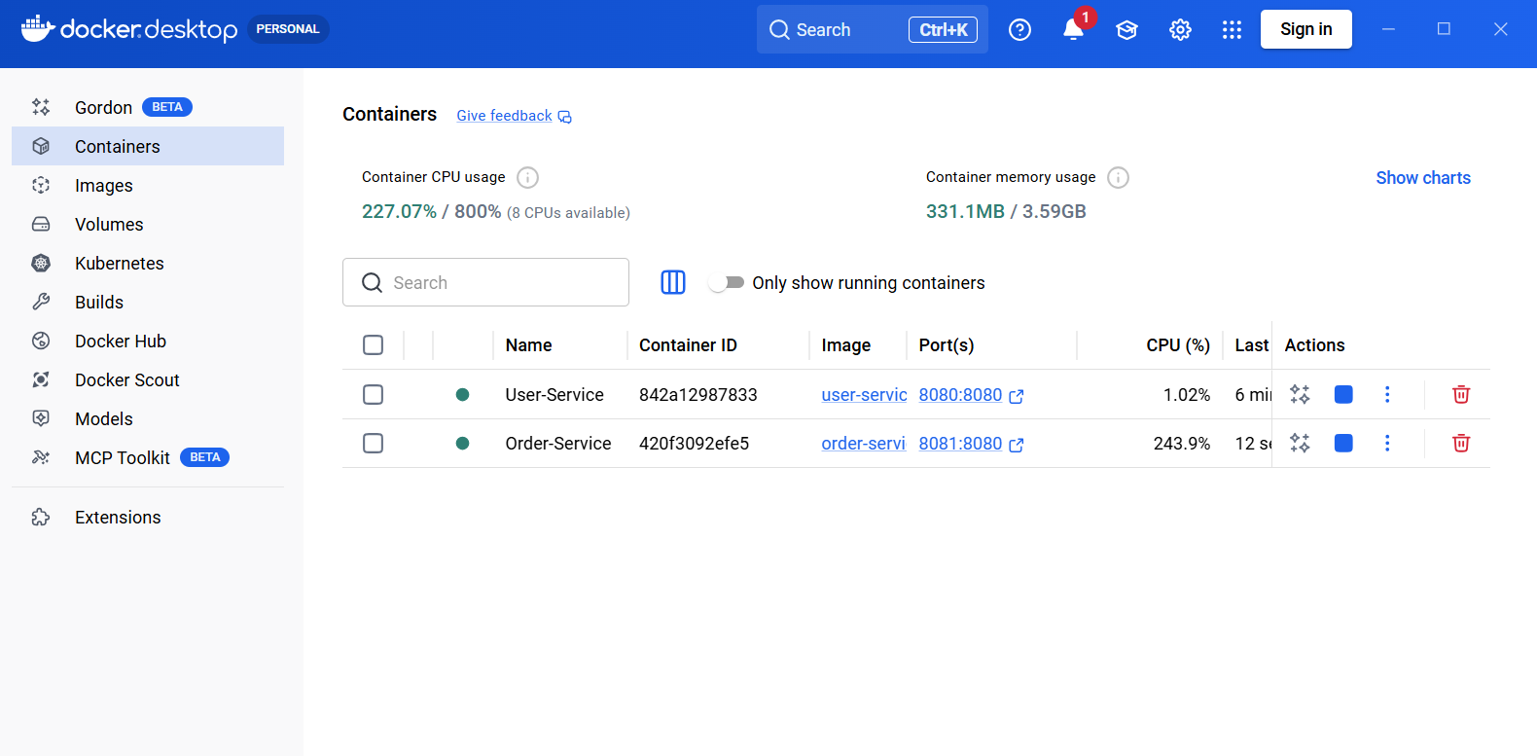

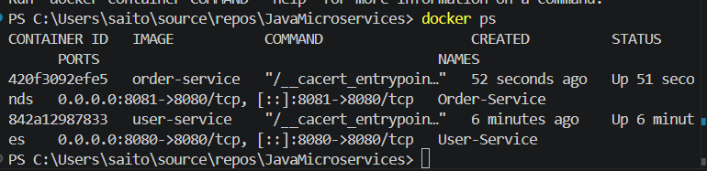

Docker-compose to start everything up in a single command
docker-compose up –build

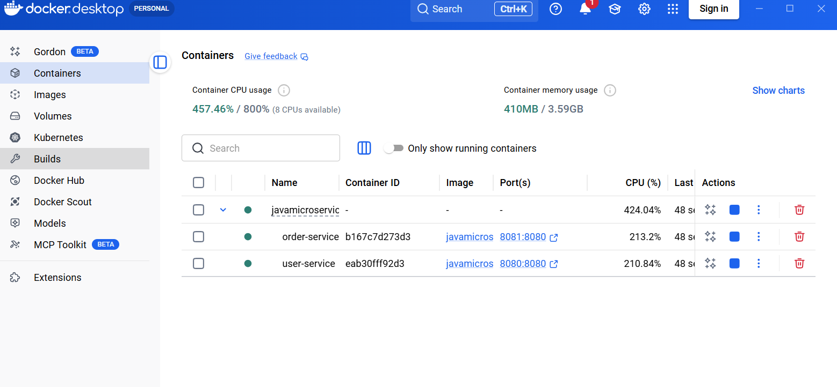

To find logs of failing containers: docker-compose logs user-service

Now rebuild and restart user-service:

docker compose build user-service
docker compose up -d user-service
docker compose logs -f user-service

C:\Users\saito\source\repos\JavaMicroservices>curl -X POST http://localhost:8080/users -H "Content-Type: application/json" -d "{\"name\":\"Sarah\"}"
{"id":1,"name":"Sarah","orders":null}

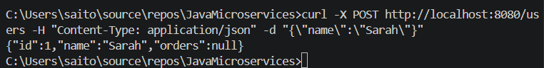

Sarah has no order

curl -X POST http://localhost:8081/orders -H "Content-Type: application/json" -d "{\"userID\":\"1\", \"item\":\"Apple\"}"

curl -X POST http://localhost:8081/orders -H "Content-Type: application/json" -d "{\"userID\":\"1\", \"item\":\"Apple\"}"
{"id":1,"item":"Apple","userID":1}

C:\Users\saito\source\repos\JavaMicroservices>curl -X POST http://localhost:8080/users -H "Content-Type: application/json" -d "{\"name\":\"Sarah\"}"
{"id":1,"name":"Sarah","orders":null}
C:\Users\saito\source\repos\JavaMicroservices>curl -X POST http://localhost:8080/users -H "Content-Type: application/json" -d "{\"name\":\"Amanda\"}"
{"id":2,"name":"Amanda","orders":null}
C:\Users\saito\source\repos\JavaMicroservices>curl -X POST http://localhost:8081/orders -H "Content-Type: application/json" -d "{\"userID\":\"1\", \"item\":\"Orange\"}"
{"id":1,"item":"Orange","userID":1}
C:\Users\saito\source\repos\JavaMicroservices>curl -X POST http://localhost:8081/orders -H "Content-Type: application/json" -d "{\"userID\":\"1\", \"item\":\"Phone\"}"
{"id":2,"item":"Phone","userID":1}
C:\Users\saito\source\repos\JavaMicroservices>curl -X POST http://localhost:8081/orders -H "Content-Type: application/json" -d "{\"userID\":\"2\", \"item\":\"Orange\"}"
{"id":3,"item":"Orange","userID":2}

C:\Users\saito\source\repos\JavaMicroservices>curl -X GET http://localhost:8081/orders/user/1 -H "Content-Type: application/json"
[{"id":1,"item":"Orange","userID":1},{"id":2,"item":"Phone","userID":1}]
C:\Users\saito\source\repos\JavaMicroservices>curl -X GET http://localhost:8081/orders/user/1 -H "Content-Type: application/json"

C:\Users\saito\source\repos\JavaMicroservices>curl -X POST http://localhost:8080/users -H "Content-Type: application/json" -d "{\"name\":\"Sarah\"}"
{"id":1,"name":"Sarah","orders":null}
C:\Users\saito\source\repos\JavaMicroservices>curl -X POST http://localhost:8080/users -H "Content-Type: application/json" -d "{\"name\":\"Amanda\"}"
{"id":2,"name":"Amanda","orders":null}

We are only passing-in UserID but we are pulling the Orders also
C:\Users\saito\source\repos\JavaMicroservices>curl -X GET http://localhost:8080/users/1 -H "Content-Type: application/json"
{"id":1,"name":"Sarah","orders":[{"id":1,"item":"Orange"},{"id":2,"item":"Phone"}]}
C:\Users\saito\source\repos\JavaMicroservices>curl -X GET http://localhost:8080/users/2 -H "Content-Type: application/json"
{"id":2,"name":"Amanda","orders":[{"id":3,"item":"Orange"}]}
C:\Users\saito\source\repos\JavaMicroservices>curl -X GET http://localhost:8080/users/2 -H "Content-Type: application/json"
{"id":2,"name":"Amanda","orders":[{"id":3,"item":"Orange"},{"id":4,"item":"Apple"}]}

Pushing Docker images into Docker hub
Right now, it only works locally, but we want them to work outside also in public spaces

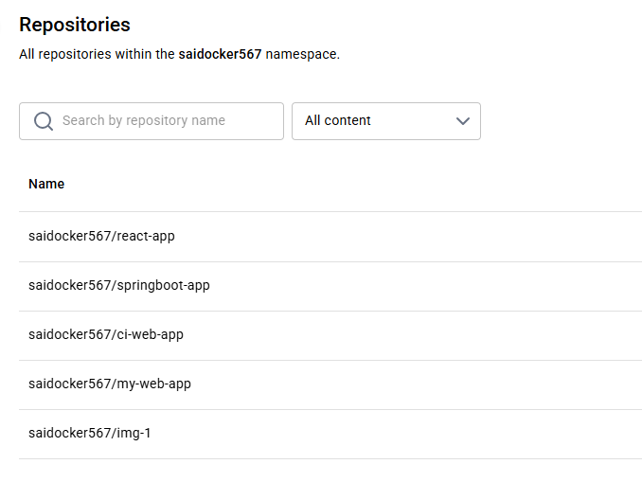

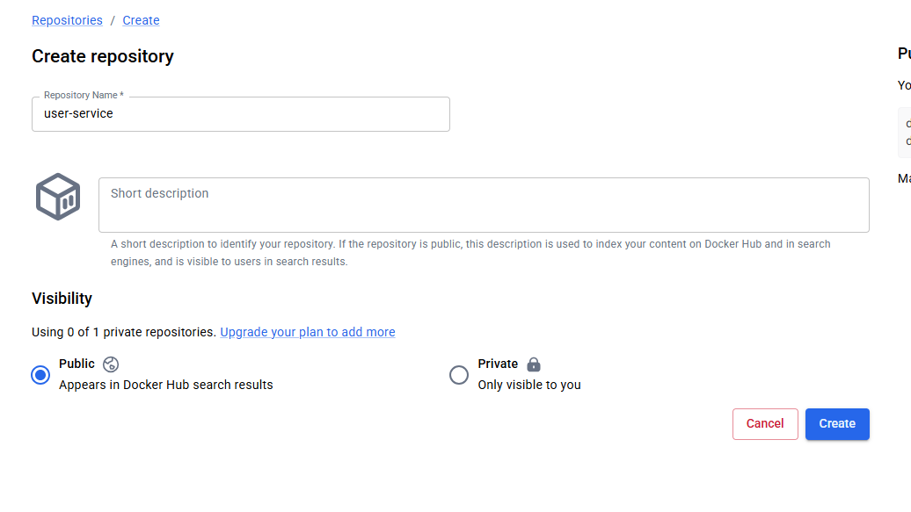
docker login
https://login.docker.com/activate

Enter code

docker images
i Info → U In Use
IMAGE ID DISK USAGE CONTENT SIZE EXTRA
javamicroservices-order-service:latest
e2162e5892fa 727MB 251MB U
javamicroservices-user-service:latest
7b4c3e4bb5cf 727MB 251MB U
PS C:\Users\saito\source\repos\JavaMicroservices> docker tag javamicroservices-order-service:latest saidocker567/order-service
PS C:\Users\saito\source\repos\JavaMicroservices> docker tag javamicroservices-order-service:latest saidocker567/order-service
PS C:\Users\saito\source\repos\JavaMicroservices> docker tag javamicroservices-user-service:latest saidocker567/user-service
PS C:\Users\saito\source\repos\JavaMicroservices> docker push saidocker567/order-service
Using default tag: latest

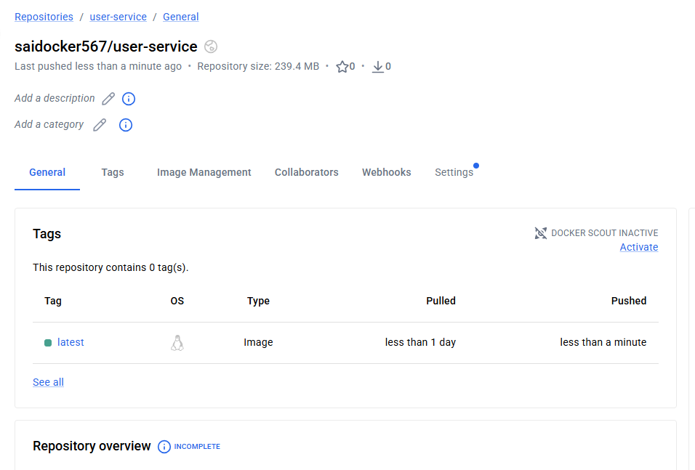

Next step is to automate pushing of images

Deploying using Docker compose
services:
user-service:
build: ./ecommerce
image: saidocker567/user-service:latest
ports:
- "8080:8080"
container_name: user-service
order-service:
build: ./orderservice
image: saidocker567/order-service:latest
ports:
- "8081:8080"
container_name: order-service

docker compose build
docker compose push

image : v1 is pushed as well
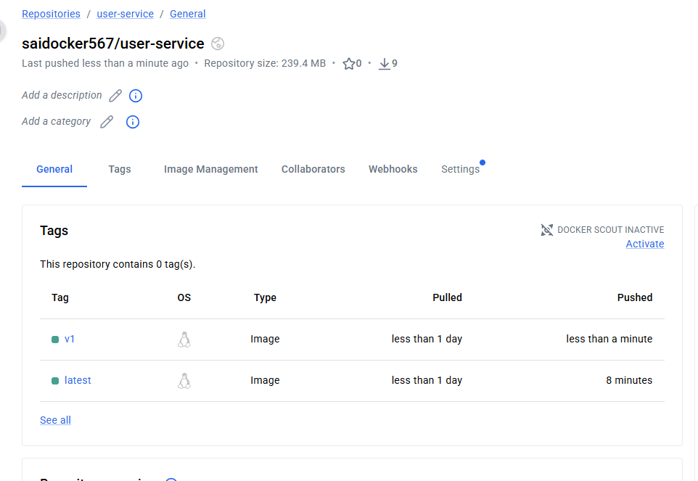
After pushing to Docker hub, i can easily integrate into CI pipeline

