Creating Topics with Partitions

#Create a Topic with multiple partitions

.\bin\windows\kafka-topics.bat --bootstrap-server localhost:9092 --create --topic kafka.learning.orders --partitions 3 --replication-factor 1

number of partitions is 3
Why 3 partitions?
Since you are setting --partitions 3, Kafka will now be able to balance the data across three separate logs. When you use a Key in your producer (like ID_01:order), Kafka will use that key to decide which of the 3 partitions the message goes to.

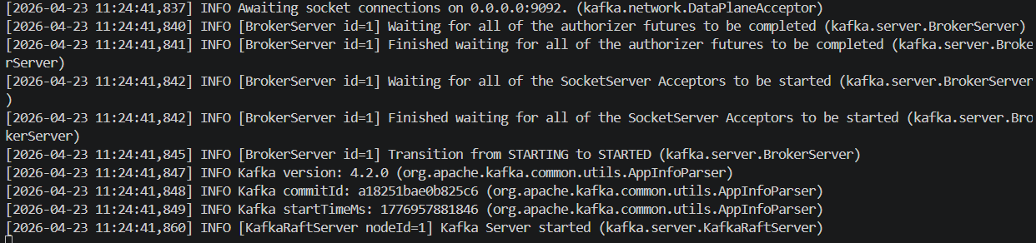
PS C:\Users\saito\Downloads\kafka> .\bin\windows\kafka-topics.bat --bootstrap-server localhost:9092 --create --topic kafka.learning.orders --partitions 3 --replication-factor 1
2026-04-23T15:25:15.465216600Z main ERROR Reconfiguration failed: No configuration found for '764c12b6' at 'null' in 'null'
WARNING: Due to limitations in metric names, topics with a period ('.') or underscore ('_') could collide. To avoid issues it is best to use either, but not both.
Created topic kafka.learning.orders.

#Check topic partitioning

.\bin\windows\kafka-topics.bat --bootstrap-server localhost:9092 --topic kafka.learning.orders –describe

PS C:\Users\saito\Downloads\kafka> .\bin\windows\kafka-topics.bat --bootstrap-server localhost:9092 --topic kafka.learning.orders --describe
2026-04-23T15:26:15.485165100Z main ERROR Reconfiguration failed: No configuration found for '764c12b6' at 'null' in 'null'
Topic: kafka.learning.orders TopicId: rcuxFGKGRVGxK8VdXeqYbg PartitionCount: 3 ReplicationFactor: 1 Configs: min.insync.replicas=1,segment.bytes=1073741824
Topic: kafka.learning.orders Partition: 0 Leader: 1 Replicas: 1 Isr: 1 Elr: LastKnownElr:
Topic: kafka.learning.orders Partition: 1 Leader: 1 Replicas: 1 Isr: 1 Elr: LastKnownElr:
Topic: kafka.learning.orders Partition: 2 Leader: 1 Replicas: 1 Isr: 1 Elr: LastKnownElr:

This Leader is responsible for managing the partition, including receiving messages, storing them in local logs, and pushing them to subscribers

## Publishing Messages to Topics with keys

.\bin\windows\kafka-console-producer.bat --bootstrap-server localhost:9092 --topic kafka.learning.orders --property "parse.key=true" --property "key.separator=:"

To publish messages with Keys, we use the colon operator to separate the key and the value. parse.key=true tells the Producer to read the key also. key.separator specifies the separator character.

Message: 1001:"Keyboard,34.23" 1001 is the order_id (Key), then CSV string

Kafka will distribute messages to various partitions

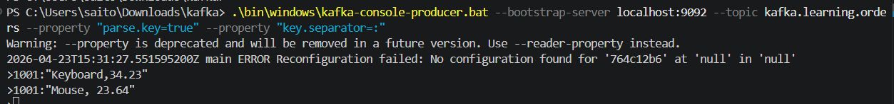

## Consume messages using a consumer group
Consumer group is a group of consumers that share a topic workload
A topic may be generating huge amount of messages in short period of time. It may not be possible for a single consumer to keep track them. For scalability, multiple consumer processes can be started and messages can be distributed among them for load balancing. Consumer group is a logical group of consumers that Kafka uses for load distribution. Each message will be sent to only one consumer within the consumer group and that consumer is responsible for processing the message then acknowledging back to Kafka. It is expected Number of partitions >= Number of consumers in the group. Kafka uses heartbeats for consumers to keep track of their health, if they go down, Kafka knows and rebalances the partitions.

.\bin\windows\kafka-console-consumer.bat --bootstrap-server localhost:9092 --topic kafka.learning.orders --group test-consumer-group --property print.key=true --property key.separator=" = " --from-beginning
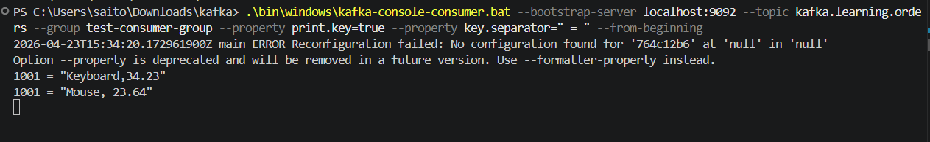

## Check current status of offsets
Consumer offset is a number to track message consumption by consumer and partition.

.\bin\windows\kafka-consumer-groups.bat --bootstrap-server localhost:9092 --describe --all-groups

Consumer groups and track offsets
Monitor: .\bin\windows\kafka-consumer-groups.bat --bootstrap-server localhost:9092 --describe --all-groups

Consumer group shows how the group is setup
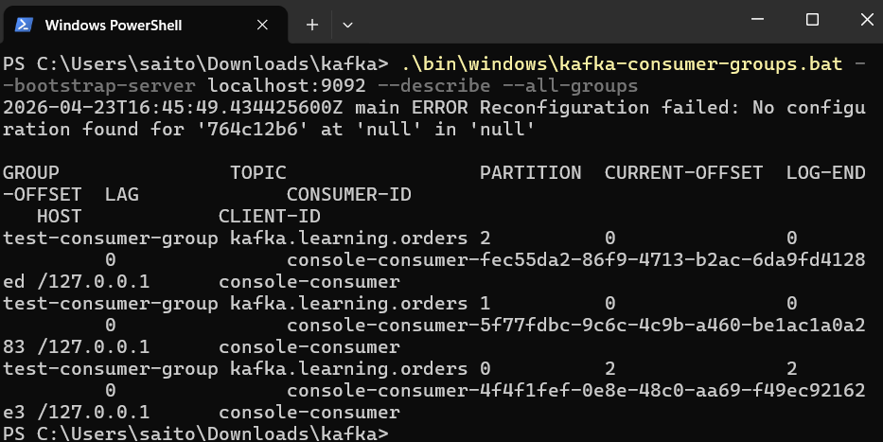
We can see Consumer1’s current and committed offsets are set to 2. Key metric to track if messages are consumed immediately by consumers or not.

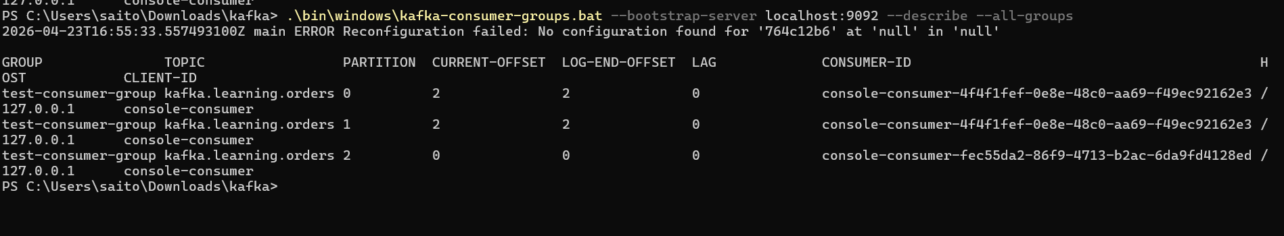

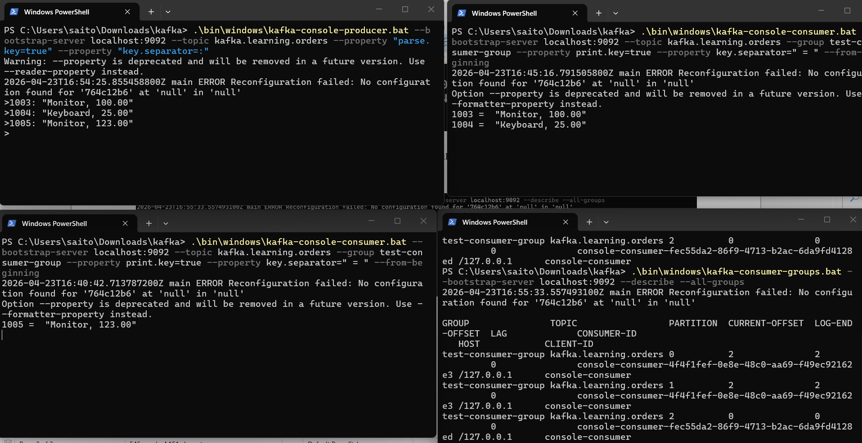
As Producer keeps generating new data, it keeps distributed among Consumers based on the partitions.

