Kafka Topics

## Creating new Topics from CMD not PowerShell

bin\windows\kafka-topics.bat --create --topic kafka.learning.tweets --bootstrap-server localhost:9092 --partitions 1 --replication-factor 1

PS C:\Users\saito\Downloads\kafka> bin\windows\kafka-topics.bat --create --topic kafka.learning.tweets --bootstrap-server localhost:9092 --partitions 1 --replication-factor 1
2026-04-23T03:32:03.295437200Z main ERROR Reconfiguration failed: No configuration found for '764c12b6' at 'null' in 'null'
WARNING: Due to limitations in metric names, topics with a period ('.') or underscore ('_') could collide. To avoid issues it is best to use either, but not both.
Created topic kafka.learning.tweets.

bin\windows\kafka-topics.bat --create --topic kafka.learning.alerts --bootstrap-server localhost:9092 --partitions 1 --replication-factor 1

PS C:\Users\saito\Downloads\kafka> bin\windows\kafka-topics.bat --create --topic kafka.learning.alerts --bootstrap-server localhost:9092 --partitions 1 --replication-factor 1
2026-04-23T03:34:16.886947500Z main ERROR Reconfiguration failed: No configuration found for '764c12b6' at 'null' in 'null'
WARNING: Due to limitations in metric names, topics with a period ('.') or underscore ('_') could collide. To avoid issues it is best to use either, but not both.
Created topic kafka.learning.alerts.

## Listing Topics

bin\windows\kafka-topics.bat --bootstrap-server localhost:9092 –list

S C:\Users\saito\Downloads\kafka> bin\windows\kafka-topics.bat --bootstrap-server localhost:9092 --list
2026-04-23T03:36:56.280354400Z main ERROR Reconfiguration failed: No configuration found for '764c12b6' at 'null' in 'null'
kafka.learning.alerts
kafka.learning.tweets

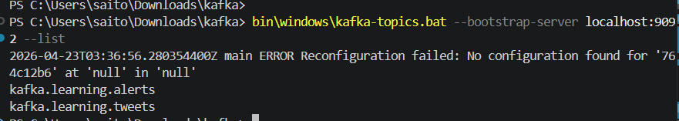

## Getting details about a Topic

.\bin\windows\kafka-topics.bat --bootstrap-server localhost:9092 --describe

PS C:\Users\saito\Downloads\kafka> .\bin\windows\kafka-topics.bat --bootstrap-server localhost:9092 --describe
2026-04-23T03:38:21.009579700Z main ERROR Reconfiguration failed: No configuration found for '764c12b6' at 'null' in 'null'
Topic: kafka.learning.alerts TopicId: IqcucoMTRfSyDiPO1z8S4A PartitionCount: 1 ReplicationFactor: 1 Configs: min.insync.replicas=1,segment.bytes=1073741824
Topic: kafka.learning.alerts Partition: 0 Leader: 1 Replicas: 1 Isr: 1 Elr: LastKnownElr:
Topic: kafka.learning.tweets TopicId: brqsaoiETNK-JTaqU46H7Q PartitionCount: 1 ReplicationFactor: 1 Configs: min.insync.replicas=1,segment.bytes=1073741824
Topic: kafka.learning.tweets Partition: 0 Leader: 1 Replicas: 1 Isr: 1 Elr: LastKnownElr:

## Publishing Messages to Topics

.\bin\windows\kafka-console-producer.bat --bootstrap-server localhost:9092 --topic kafka.learning.tweets

PS C:\Users\saito\Downloads\kafka> .\bin\windows\kafka-console-producer.bat --bootstrap-server localhost:9092 --topic kafka.learning.tweets
2026-04-23T03:41:21.183603200Z main ERROR Reconfiguration failed: No configuration found for '764c12b6' at 'null' in 'null'
>Hello from Producer
>Good night
>Take rest
>Terminate batch job (Y/N)? Y

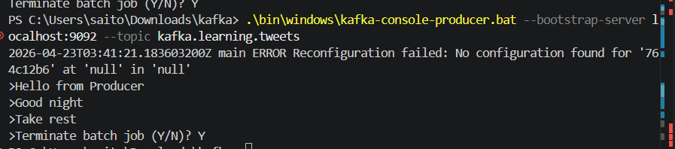

## Consuming Messages from Topics

.\bin\windows\kafka-console-consumer.bat --bootstrap-server localhost:9092 --topic kafka.learning.tweets –from-beginning

PS C:\Users\saito\Downloads\kafka> .\bin\windows\kafka-console-consumer.bat --bootstrap-server localhost:9092 --topic kafka.learning.tweets --from-beginning
2026-04-23T03:42:30.342052500Z main ERROR Reconfiguration failed: No configuration found for '764c12b6' at 'null' in 'null'

Hello from Producer

send
Hello from Producer
Good night
Take rest
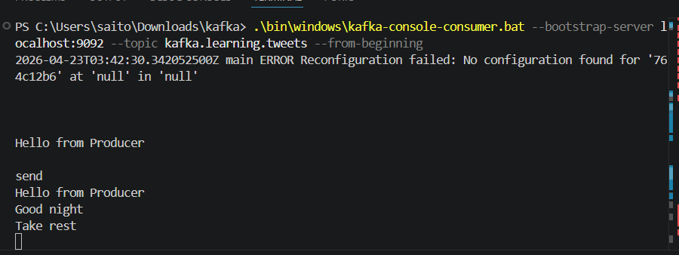
Hello from Producer

send
Hello from Producer
Good night
Take rest
Processed a total of 9 messages
CTRL +C to kill Consumer
Terminate batch job (Y/N)? Y

## Deleting Topics

.\bin\windows\kafka-topics.bat --bootstrap-server localhost:9092 --delete --topic kafka.learning.alerts

.\bin\windows\kafka-topics.bat --bootstrap-server localhost:9092 --delete --topic kafka.learning.alerts
2026-04-23T03:55:24.076769200Z main ERROR Reconfiguration failed: No configuration found for '764c12b6' at 'null' in 'null'

Two Producers and Two Consumers scenario
Producer 1
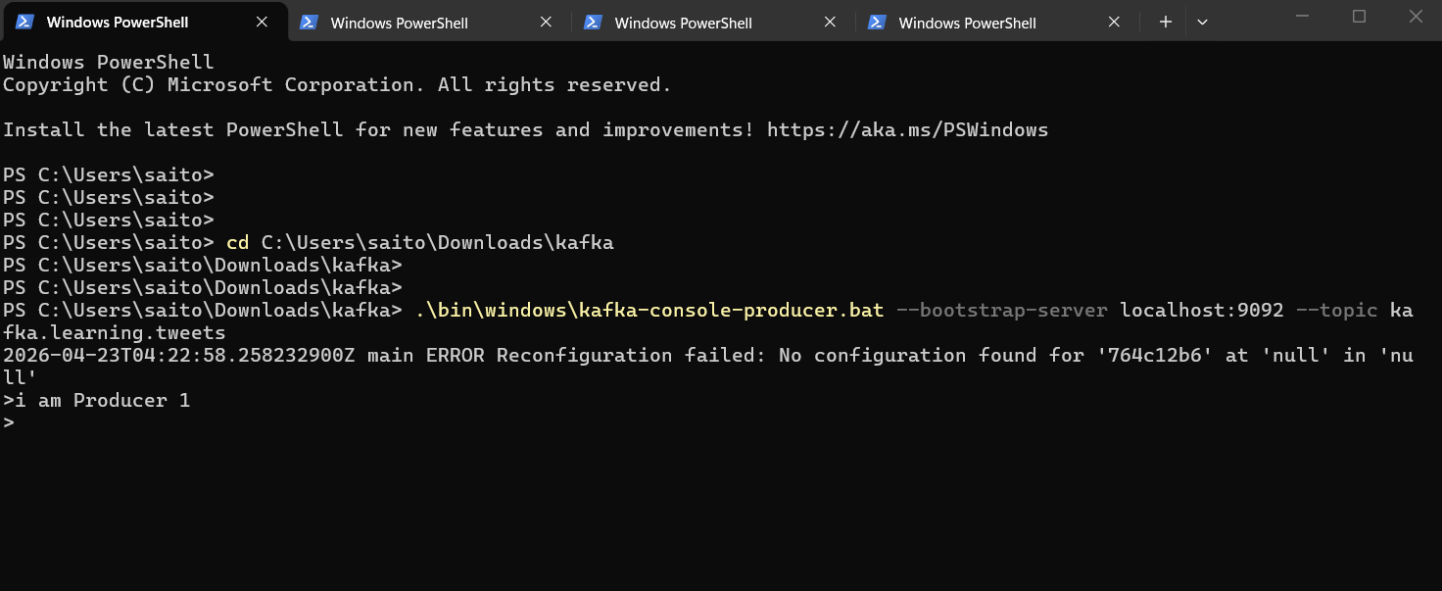
Producer 2
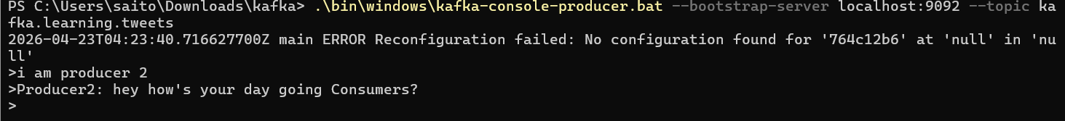
Consumer 1
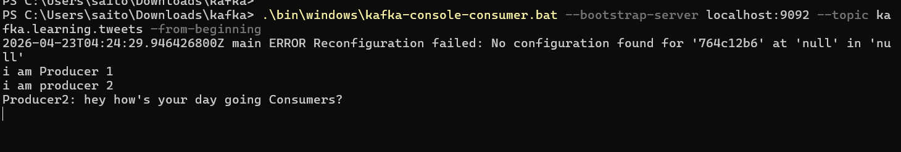
Consumer 2
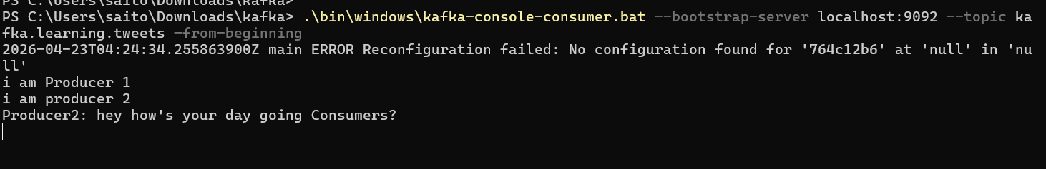

Both Consumers receive messages sent by both Producers

if you go to : C:\tmp\kraft-combined-logs, we can see Consumer-offsets, which manage consumption of messages by various consumers
For each Topic, there is a data directory: kafka.learning.tweets-0

Open kafka.learning.tweets-0 folder
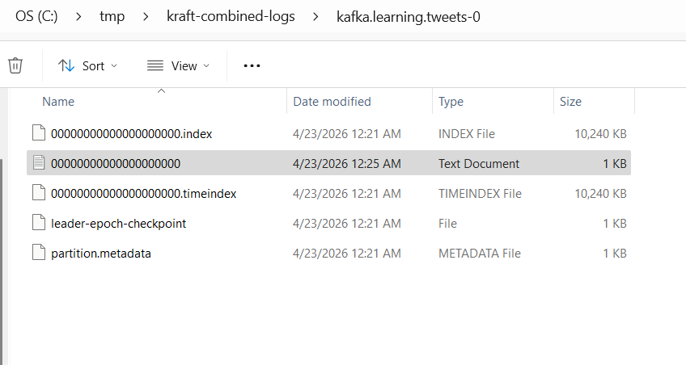
We can see the data we published

