SpringBoot Service tests:
This is same as Java “Junit” tests
Go to src/test/java

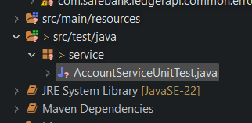

Create a file AccountServiceUnitTest.java

Right-click the Test file and run Junit

