BasicPrompting
You communicate with LLMs by sending Prompt string to it and Language model responds back sending a so called a “completion”. Originally, Language models generated a predicted completion of the initial prompt string. Today’s sophisticated models go beyond completion models. Now we use response instead of completion. Your prompt is guiding the LLM and influencing probabilities of a good response. The better the prompt, higher the quality of your response.

Prompt engineering is the process of designing text that is used to extract useful information from a language model.

Context is additional information in the prompt that further guides the LLM toward a more effective completion or response.
Context window = Prompt + Context
Maximum size of text that a LLM can process and remember per request is called as the Context window. When you exceed the context window of an LLM, the oldest text will be discarded. So we should be careful not to exceed the context window

When deploying a chatbot, we got to consider standard software development practices.

We got to monitor and manage prompt effectiveness
We got to make sure prompts/LLMs are delivering useful information. You must version prompts/LLMs because we keep updating prompts and LLMs. Set alerts on data costs. Track LLM/latencies – if response time in the application is too long, user satisfaction may suffer, you may trigger a notification if latency exceeds a reasonable threshold and switch to another large language model.

You send different kinds of messages to a Language model whether it is a UserMessage or SystemMessage, you get a ChatResponse and you extract text from the response.
In Langchain4J, ChatMessage is a class that represents a message. There are several types of chat messages – UserMessage(): prompt from the user/app and SystemMessage(): instruction for the LLM on behavior/style or which personality to adopt. While SystemMessage() is optional, it is a good idea to state the desired behavior explicitly. AiMessage(): response message returned from the LLM. AiMessage contains results from the Language model.

Best Practices and Tips

1. start with a simple prompt and get the response. If it is not good, then modify prompt to get better response. It’s an iterative process.
2. Be specific and precise. The more precise you are better your result will be
3. When crafting prompts, consider LLM as a helpful intern or student who requires guidance
4. Give instruction on how to behave using SystemMessage()
5. For some models, you should give examples to LLMs on problem-solving. It can use patterns in your steps to solve problems. LLMs are probabilistic engines, guided by the patterns in prompt and context
6. Reasoning models don’t need any examples to give you a response. So be very careful when sending prompts to a reasoning model vs non-reasoning model
7. Continually monitor the effectiveness of the prompts
8. You cannot exceed the context window
9. Different models handle negation differently like “don’t use words like”, “do not respond with..”, “do not do this…” kind of thing. Language models vary in handling negation
HelloWorldSystem.java output

Hello World System ---------------
Hello there! I'm so happy to help you learn about Java today. Java is a programming language, which is like a special language that we use to talk to computers and tell them what to do. Just like how you use English to talk to your friends, we use Java to give instructions to computers.

### Let's Start with Some Basics:

1. **What is a Program?**
- A program is like a set of instructions that tells the computer how to do something. Imagine it like a recipe that tells you how to bake a cake. Each step in the recipe is like a line of code in a program.

2. **What is Java?**
- Java is a type of programming language. It's used all over the world to create things like games, apps, and websites. It's very popular because it can run on lots of different types of computers.

3. **Writing Your First Java Program:**
- When we write a program in Java, we type it out in a special way. Here's a tiny program that says "Hello, World!" when you run it:

```java
public class HelloWorld {
public static void main(String[] args) {
System.out.println("Hello, World!");
}
}
```

- **Breaking it Down:**
- `public class HelloWorld`: This is like saying "I'm going to make something new called HelloWorld."
- `public static void main(String[] args)`: This is the part where the computer starts to read and follow your instructions.
- `System.out.println("Hello, World!");`: This tells the computer to show the words "Hello, World!" on the screen.

4. **Why is Java Special?**
- Java is special because it can run on any computer that has something called the Java Virtual Machine (JVM). It's like a magic box that lets Java programs work anywhere!

5. **Fun Fact:**
- Did you know that Java was named after coffee? The creators liked coffee so much that they named their language after it!

If you have any questions or if there's something specific you want to know about Java, feel free to ask! I'm here to help you understand and have fun with programming.

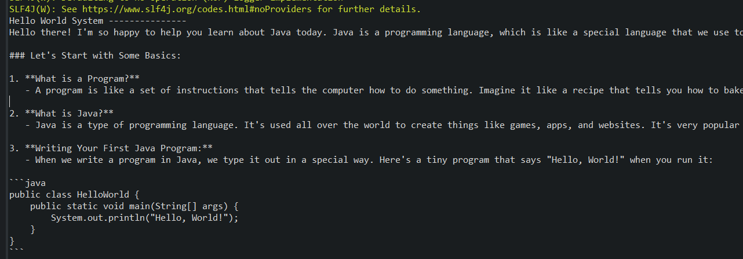

Revised the code

Output
Hello World System ---------------
Imagine you have a box of LEGO bricks, and you want to build something cool with them. Sometimes, you might want to use a special piece that helps you build faster or in a more fun way. Java lambdas are like those special LEGO pieces for your code!

When you write programs in Java, you often tell the computer to do things step by step. But sometimes, you want to tell it to do something in a quicker and neater way. That's where lambdas come in! They help you write less code and make it easier to understand.

For example, if you have a list of toys and you want to find all the red ones, using lambdas can help you do that with just a few lines of code instead of many. It's like having a magic wand that helps you sort and find things faster!

Learning Java lambdas is like adding a new tool to your coding toolbox. It makes your programs cleaner and helps you solve problems in a smart way. Plus, it's fun to learn new things and see how they make your coding adventures even better!

