Zero shot:

A short prompt technique that asks the LLM for a response without any examples or demonstrations. There is no additional context for the model. We are relying purely on what the model already knows.
Zero shot prompts are simple and quick, good for general summarizations, language translation, and basic classification. Not effective when needing something new, creative thinking, or something for a specific scenario.

Few shot prompting:
A prompt technique that gives a small number of examples or demonstrations to the LLM. These are the patterns for the LLM to follow. Few shot prompting is a type of in-context learning. By providing additional patterns, that’s more context, for the language model to follow, we have helped guide it to give us a helpful response. The more context in your prompt, the better.
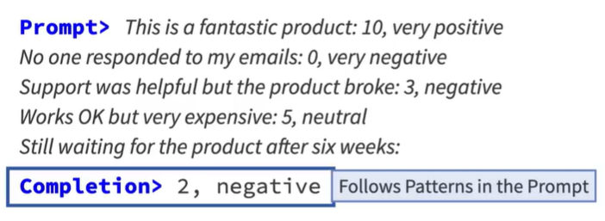

Chain of thought (CoT) prompting:
A prompt technique that demonstrates how to solve sub-problems of a larger problem for a final response. We show the language model, the pattern for breaking-down a problem into a series of sub-problems. Another type of in-context learning. We are guiding the language model by providing with more patterns.

